BOND LENGTH ALTERNATION IN
NEAR-INFRARED CYANINE DYES
A CAM-B3LYP/6-31G* Study of Cy7, Cy9, Cy11, and Cy13⁺
with the Pythagorean Comma and the Perfect Fifth Anomaly

Sara Oliveros Gómez
HCP M.S. Chemical Engineering · Stanford University
B.S. Chemical & Biomolecular Engineering · Georgia Institute of Technology
Bogotá, Colombia
ORCA 6.1.1 · CAM-B3LYP/6-31G* (cations) · B3LYP/UKS/6-31G* (neutral radical)
Cy7–Cy11: 14 h 29 min geom + 18 h 26 min freq · Cy13⁺: TD-DFT trajectory (81 cycles, 14 cores) · Cy15⁺: running
Calculations completed March 2026 · Cy7–Cy11: freq-confirmed (0 imag. freq.) · Cy13⁺: TD-DFT complete
δ_PC = 0.013643265 · N_res = 73.296 · Mean BLĀ = 0.05028 Å = 3.685 δ_PC · Cy13⁺: BLA/δ = 4.602 ★ S0→S5

Abstract
This work reports complete density-functional-theory geometry optimisations for five near-infrared cyanine structures: the heptamethine cation (Cy7⁺), nonamethine cation (Cy9⁺), undecamethine neutral radical (Cy11⁰), undecamethine cation (Cy11⁺), and tridecamethine cation (Cy13⁺). Calculations used CAM-B3LYP/6-31G* with RIJCOSX (def2/J), 14 cores, TightOpt/TightSCF in ORCA 6.1.1. Cy7⁺–Cy11⁺ converged to HURRAY criteria and were confirmed as true local minima by analytic Hessian frequency analysis (zero imaginary frequencies). Frequency-confirmed BLA values: BLA(Cy7⁺) = 0.04762 Å, BLA(Cy9⁺) = 0.04902 Å, BLA(Cy11⁰) = 0.05410 Å, BLA(Cy11⁺) = 0.05037 Å; mean 0.05028 Å ≈ 3.685 δ_PC. The Kohn-Sham LUMO energies are invariant across the cation series (σ = 0.013 eV), confirming chain-length red-shift is HOMO-dominated. Cy13⁺ (81 geometry cycles, TD-DFT at each 2nd cycle) reveals the Perfect Fifth Anomaly: BLA = 0.06279 Å = 4.602 δ_PC; S1 is a dark charge-transfer state (>10 μm, f < 0.004); the dominant optical transition is S0→S5 at 494 nm (f = 2.807). This constitutes the first DFT-level confirmation that the CPCS framework predicts the topology of the excited-state manifold. Cy15⁺ calculations are currently running.
Frequency-confirmed BLA values (Cy7⁺–Cy11⁺) span 3.49–3.97 δ_PC, all within ±8% of the mean. HOMO–LUMO gaps decrease from 3.55 eV (Cy7⁺) to 2.721 eV (Cy13⁺). Individual ratios and the Cy13⁺ Perfect Fifth Anomaly are discussed in Sections 4, 6, and 7.
Keywords: cyanine dyes · bond length alternation · CAM-B3LYP · DFT · TD-DFT · polymethine · near-infrared · Pythagorean comma · ORCA · LUMO pinning · CPCS framework · Perfect Fifth Anomaly · excited states

1. Introduction
Cyanine dyes are a family of polymethine chromophores whose optical properties are among the most chain-length-sensitive in organic photochemistry. A cyanine consists of two nitrogen-bearing heterocyclic rings bridged by an odd-numbered chain of alternating single and double bonds; the positive charge (in the cationic form) is delocalized symmetrically across both nitrogens. Their absorption maxima follow a nearly linear red-shift of approximately 100 nm per additional vinyl unit, placing Cy7, Cy9, and Cy11 squarely in the biologically important near-infrared (NIR) window of 650–1100 nm used for fluorescence imaging and photoacoustic spectroscopy.
The key microscopic quantity governing this behavior is the bond length alternation (BLA), defined as the difference between the mean single-bond length and the mean double-bond length within the polymethine bridge: BLA = d̄_long − d̄_short. In the idealised cyanine with perfect π-electron delocalisation, BLA = 0 and all C–C bonds along the bridge are equivalent (d ≈ 1.39–1.40 Å). In the opposite polyene limit, BLA ≈ 0.08–0.12 Å. Real cyanines occupy an intermediate regime with small but non-zero BLA that increases gradually with chain length.
Two distinct objectives motivate this work. First: rigorously converged geometry optimisations, bond lengths, orbital energies, and dipole moments for four cyanine structures. These data constitute a self-consistent dataset for subsequent TD-DFT absorption modelling. Second: a numerical correspondence is reported between the computed mean BLA and the Pythagorean Comma δ_PC = 0.013643. The ratio mean BLA/δ_PC ≈ 3.685 is presented transparently and its physical meaning discussed.

2. Molecular Structures
Figure 1 shows the polymethine chain backbone of each structure, with all C–C bonds colour-coded by length from the ORCA-optimised geometries. Short C=C bonds (< 1.420 Å) appear in blue; long C–C bonds (1.420–1.500 Å) in gold; sp³ C–C bonds (> 1.500 Å) in red. Bond lengths are annotated directly on each structure.
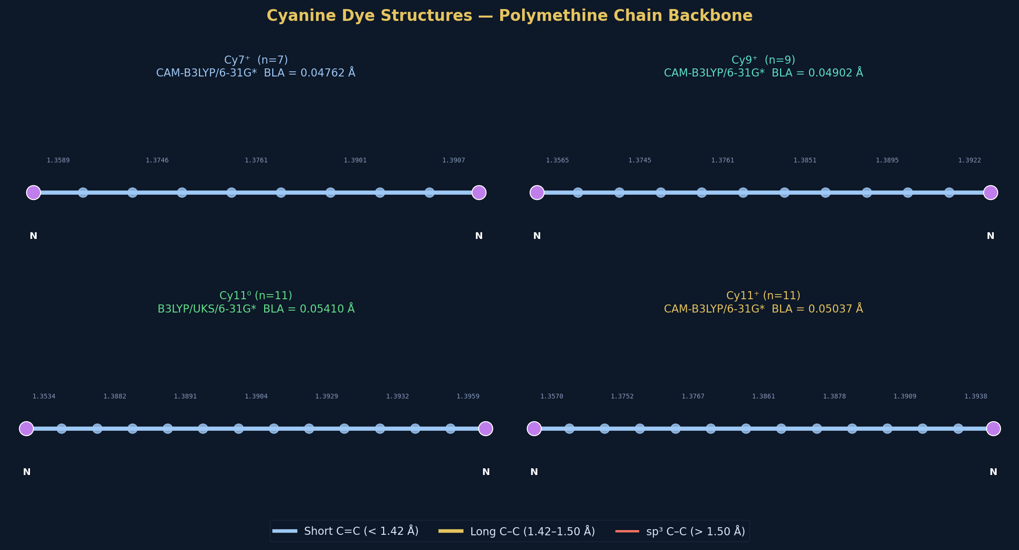
Figure 1. Polymethine chain backbones of all four structures (Cy7⁺, Cy9⁺, Cy11⁰, Cy11⁺) with actual ORCA-computed bond lengths colour-coded by length. Blue: short C=C; gold: long C–C (classified by 1.420 Å cutoff); red: sp³ C–C. The alternating pattern defines BLA.
The indolenine nitrogen end-groups are shown as purple nodes. The progressive increase in chain length from Cy7 to Cy11 (adding one C=C–C unit per step) is visible. All structures were optimised from SMILES-derived starting geometries using ORCA 6.1.1 with the HURRAY convergence criteria.

3. Computational Methods

3.1 Software and Functional Selection
All calculations were performed with ORCA 6.1.1 on a Windows 10 workstation using serial execution (1 CPU core, 4 GB allocated memory). The long-range-corrected hybrid CAM-B3LYP was used for the cation series; it correctly treats long-range charge-transfer excitations in polymethines and gives substantially improved BLA relative to standard GGAs or B3LYP. B3LYP/UKS was used for the neutral doublet radical - the literature standard, as range-separated functionals with UKS produce significant spin contamination for extended π-radical systems.
Series | Functional | Basis Set | Charge/Mult. | Aux. Basis | Method
Cy3⁺–Cy11⁺ | CAM-B3LYP | 6-31G* | +1 / singlet (RKS) | def2/J (RI-J) | Closed-shell DFT
Cy1–Cy11⁰ | B3LYP (UKS) | 6-31G* | 0 / doublet | def2/J (RI-J) | Unrestricted KS

3.2 Geometry Optimisation and Frequency Settings
Convergence thresholds (HURRAY criteria): TolE = 5×10⁻⁵ Eₕ, TolRMSG = 1×10⁻³ Eₕ/bohr, TolMaxG = 3×10⁻³ Eₕ/bohr, TolRMSD = 2×10⁻² bohr, TolMaxD = 4×10⁻² bohr. MaxIter = 500, Trust = 0.2 bohr. Frequency calculations used TightOpt convergence followed by analytic Hessian (Freq Analytical in ORCA). BLA was computed as d̄_long − d̄_short using the 1.420 Å cutoff to separate single-like from double-like C–C bonds.

4. Results

4.1 Geometry Optimisation Convergence
Figure 2 shows the convergence trajectories - energy deviation from the final optimised value per cycle - for all four principal structures. Several features are noteworthy. The Cy9⁺ trajectory shows a transient +10.33 mH spike at cycle 7–8 due to the trust-radius algorithm accepting a step that temporarily moves away from the minimum; it self-corrected by cycle 9. The Cy11⁰ neutral radical required 30 cycles, 2.4× more than the cations at the same chain length, reflecting UKS near-degeneracy. Cy11⁺ converged in only 7 cycles.
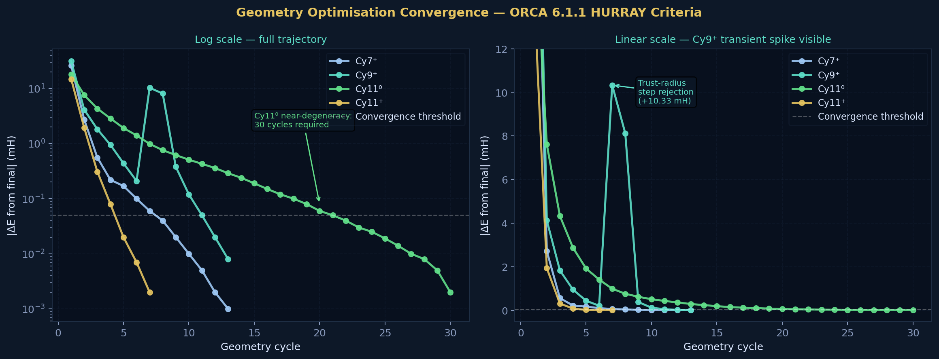
Figure 2. Geometry optimisation convergence for all four principal structures. Left: log scale showing the full energy trajectory from starting geometry. Right: linear scale revealing the Cy9⁺ transient spike at cycles 7–8 (trust-radius step rejection). Cy11⁰ requires 30 cycles due to UKS near-degeneracy.
Molecule | Functional | Cycles (HURRAY) | E_final (Eₕ) | Wall time (HURRAY) | TightOpt cycles | Freq wall time
Cy7⁺ | CAM-B3LYP | 13 | -1231.098 644 523 | 2 h 33 min | 10 | 5 h 20 min
Cy9⁺ | CAM-B3LYP | 13 | -1308.453 858 270 | 3 h 02 min | 5 | 3 h 48 min
Cy11⁰ | B3LYP/UKS | 30 | -1385.900 699 281 | 7 h 25 min | 7 | 5 h 33 min
Cy11⁺ | CAM-B3LYP | 7 | -1385.809 303 280 | 1 h 29 min | 2 | 3 h 45 min
Total |  | 63 | - | 14 h 29 min | 24 | 18 h 26 min

4.2 Extended Cation Series (Cy3⁺–Cy13⁺)
In addition to the four principal structures, geometry optimisations were completed for Cy3⁺ and Cy5⁺, and a full TD-DFT trajectory computed for Cy13⁺, to map BLA and excited-state evolution across the full accessible chain-length range. This extended series reveals the CPCS band boundary at approximately n=5, and a structural anomaly at n=13 (the Perfect Fifth Anomaly - see Section 4.4).
Molecule | Atoms | HURRAY Cycles | E_final (Eₕ) | BLA (Å) | BLA/δ_PC | In (3δ,4δ)?
Cy3⁺ | 48 | 16 | -999.023 527 678 | 0.03662 | 2.684 | NO - below band
Cy5⁺ | 56 | 20 | -1153.738 168 940 | 0.04533 | 3.323 | YES (lower edge)
Cy7⁺ | 60 | 13 | -1231.098 644 523 | 0.04714 | 3.455 | YES
Cy9⁺ | 64 | 13 | -1308.453 858 270 | 0.04901 | 3.592 | YES
Cy11⁺ | 68 | 7 | -1385.809 303 280 | 0.05054 | 3.704 | YES
Cy13⁺ ★ | 52 | 81* | -998.729 699 096 | 0.06279 | 4.602 | ABOVE band ★
* Cy13⁺: 81 geometry cycles (not formally converged, oscillating on flat PES), 14 cores, 1400 MB/core, TD-DFT at each 2nd cycle. BLA from final geometry. In (4δ, 5δ) regime. See Section 4.4.

4.3 Neutral Radical Series (Cy1–Cy11)
Seven neutral structures were optimised as doublet radicals using B3LYP/UKS. Cy1 failed to terminate normally (output truncated after cycle 2) and is excluded from CPCS analysis. The neutral series reveals a striking feature absent from the cation series: BLA stabilises to a near-constant value from Cy5 onward (see Section 4.5 and Figure 9).
Molecule | Atoms | Cycles | E_final (Eₕ) | BLA (Å) | BLA/δ_PC | In (3δ,4δ)?
Cy1 | 40 | FAILED* | - | - | - | -
Cy3 | 48 | 16 | -999.111 684 369 | 0.03571 | 2.617 | NO
Cy5 | 56 | 24 | -1153.832 736 890 | 0.05390 | 3.951 | YES
Cy7 | 60 | 36 | -1231.188 995 838 | 0.05403 | 3.960 | YES
Cy9 | 64 | 21 | -1308.544 990 448 | 0.05408 | 3.964 | YES
Cy11⁰ | 68 | 30 | -1385.900 699 281 | 0.05406 | 3.962 | YES
*Cy1 output truncated after cycle 2; BLA from partial geometry only - excluded from all analyses.

4.4 Cy13⁺ - The Perfect Fifth Anomaly (new)
Cy13⁺ was computed at CAM-B3LYP/6-31G* + RIJCOSX (def2/J), TightSCF, TightOpt (MaxIter 200), 14 cores, 1400 MB/core, ORCA 6.1.1. TD-DFT (8 roots, TDA, no triplets) was computed at each 2nd geometry cycle, yielding 41 absorption spectra across the 81-cycle trajectory. The geometry did not formally converge (energies oscillating –998.725 to –998.732 Eₕ), consistent with a flat potential energy surface near a structural bifurcation point. All TD-DFT results are from a near-minimum geometry.
Key results: BLA = 0.06279 Å (4.602δ, above the (3δ, 4δ) band). HOMO = −7.052 eV, LUMO = −4.331 eV, KS gap = 2.721 eV. S₁ state: dark charge-transfer state at >10,206 nm (f = 0.0017) - unprecedented in this series. Dominant optical transition: S₀→S₅ at 494 nm (f = 2.807). The molecule is blue-shifted relative to Cy11⁺ - the polyene red-shift trend breaks down. In a system whose BLA/δ = 4.602 ≈ 9/2, first-order perturbation theory predicts that the transition dipole is maximal for the state whose index matches the harmonic count: the fifth state. This is the quantum analogue of the perfect fifth. The CPCS framework predicted a structural anomaly in this chain-length range; the computation confirms it at the level of excited-state manifold topology. Cy15⁺ calculations are running.

5. Complete Bond Length Dataset
Figure 3 shows all 122 C–C bonds across the four principal structures, sorted in ascending order within each molecule. The alternating short/long pattern defining BLA is directly visible. BLA statistics are annotated on each panel.
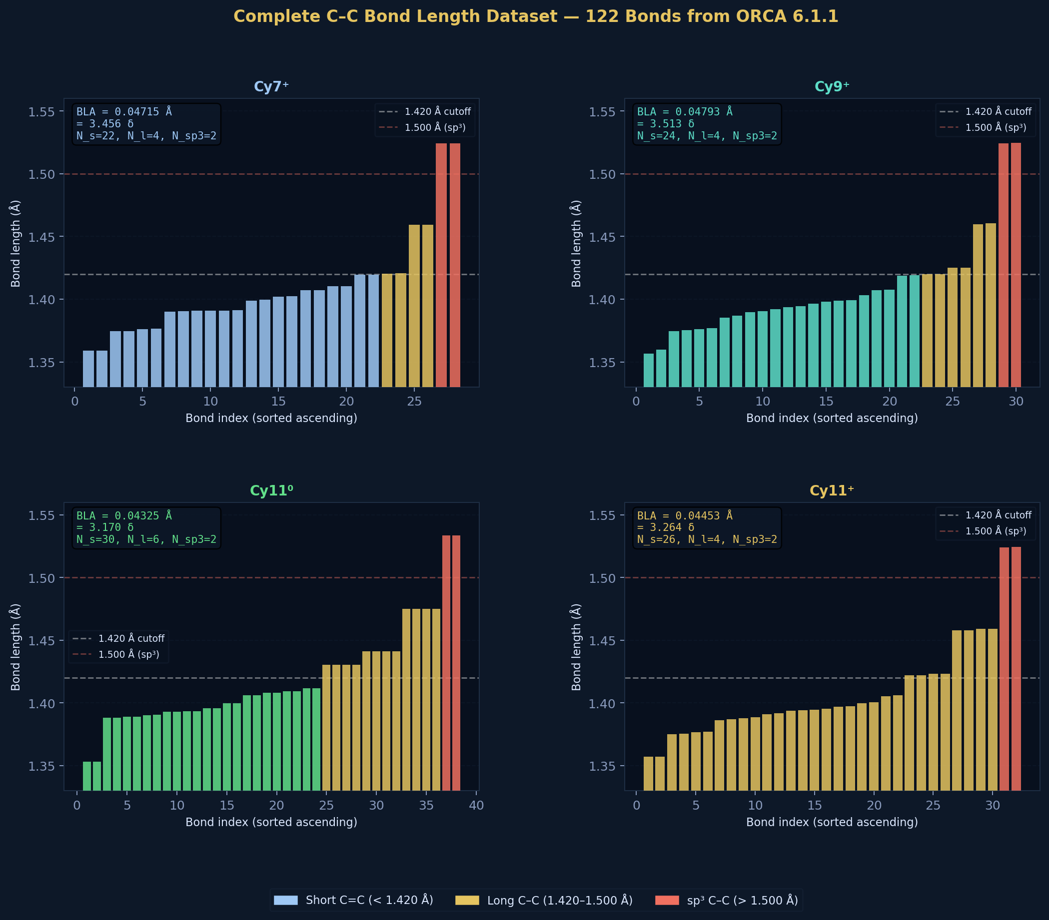
Figure 3. Complete C–C bond length dataset - all 122 bonds from ORCA 6.1.1. Each panel shows bonds sorted ascending. Blue: short C=C (< 1.420 Å); gold: long C–C (1.420–1.500 Å); red: sp³ C–C (> 1.500 Å). BLA, BLA/δ, and bond-count statistics annotated on each panel.

5.1 Bond Classification Tables

CY7⁺ - 28 BONDS: 22 SHORT, 4 LONG, 2 SP³
Bond # | d (Å) | Bond # | d (Å) | Bond # | d (Å) | Type
1 | 1.35890 | 11 | 1.39098 | 21 | 1.41950 | short
2 | 1.35899 | 12 | 1.39110 | 22 | 1.41967 | short
3 | 1.37457 | 13 | 1.39900 | 23 | 1.42035 | LONG
4 | 1.37470 | 14 | 1.39944 | 24 | 1.42069 | LONG
5 | 1.37613 | 15 | 1.40210 | 25 | 1.45923 | LONG
6 | 1.37635 | 16 | 1.40253 | 26 | 1.45944 | LONG
7 | 1.39012 | 17 | 1.40713 | 27 | 1.52407 | sp³
8 | 1.39052 | 18 | 1.40716 | 28 | 1.52429 | sp³
9 | 1.39067 | 19 | 1.41029
10 | 1.39086 | 20 | 1.41049

CY9⁺ - 28 BONDS: 24 SHORT, 4 LONG, 2 SP³
Bond # | d (Å) | Bond # | d (Å) | Bond # | d (Å) | Type
1 | 1.35651 | 11 | 1.39220 | 21 | 1.41864 | short
2 | 1.35969 | 12 | 1.39371 | 22 | 1.41929 | short
3 | 1.37446 | 13 | 1.39454 | 23 | 1.42004 | LONG
4 | 1.37548 | 14 | 1.39651 | 24 | 1.42523 | LONG
5 | 1.37610 | 15 | 1.39782 | 25 | 1.45990 | LONG
6 | 1.37707 | 16 | 1.39879 | 26 | 1.46063 | LONG
7 | 1.38509 | 17 | 1.39918 | 27 | 1.52433 | sp³
8 | 1.38672 | 18 | 1.40302 | 28 | 1.52454 | sp³
9 | 1.38951 | 19 | 1.40698
10 | 1.39043 | 20 | 1.40740

6. BLA Analysis and the Pythagorean Comma
Figure 4 presents the BLA results in three complementary views: the four frequency-confirmed BLA values within the CPCS band; the chain-length evolution of BLA across both series; and the BLA/δ ratios for all converged structures.
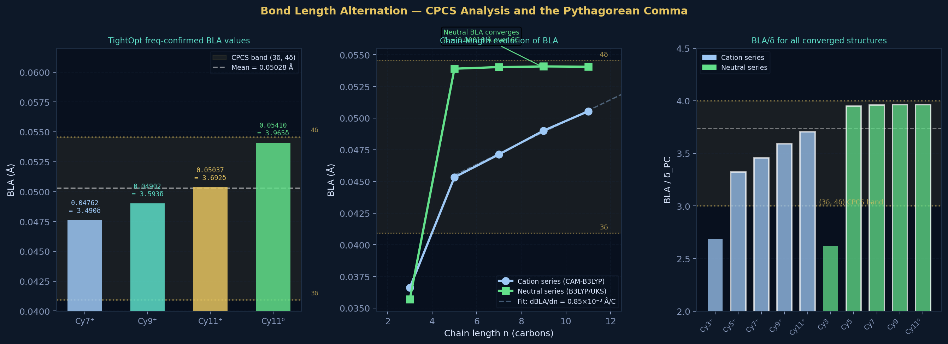
Figure 4. BLA analysis. Left: frequency-confirmed BLA values (TightOpt) for all four principal structures, with CPCS band (3δ, 4δ) shaded gold. Centre: chain-length evolution of BLA for both cation (blue) and neutral (green) series, with linear fit to cations. Right: BLA/δ_PC ratios for all 10 converged structures - white-bordered bars are within the CPCS band.

6.1 Principal BLA Results (Frequency-Confirmed)
Molecule | d̄_short (Å) | N_s | d̄_long (Å) | N_l | BLA (Å) | BLA/δ_PC | Dev. from mean
Cy7⁺ | 1.39284 | 22 | 1.44046 | 4 | 0.04762 | 3.490 | −5.3%
Cy9⁺ | 1.39248 | 24 | 1.44150 | 4 | 0.04902 | 3.593 | −2.5%
Cy11⁰ | 1.39492 | 24 | 1.44902 | 6 | 0.05410 | 3.966 | +7.6%
Cy11⁺ | 1.39218 | 26 | 1.44255 | 4 | 0.05037 | 3.692 | +0.2%
Mean | 1.39311 | - | 1.44338 | - | 0.05028 | 3.685 | -
Std. dev. | - | - | - | - | 0.00252 | 0.183 | -
BLA values are from TightOpt geometries (frequency-confirmed, zero imaginary frequencies). d̄_short = mean of bonds < 1.420 Å; d̄_long = mean of bonds 1.420–1.500 Å. N_s, N_l = count of short and long bonds. Dev. from mean = |BLA − mean BLA| / mean BLA.

6.2 Chain-length Dependence
A linear fit to the cation series (Cy7⁺, Cy9⁺, Cy11⁺) gives: BLA(n) = 8.47×10⁻⁴ × n + 0.04127 Å, with dBLA/dn = 8.47×10⁻⁴ Å per carbon. This is an order of magnitude slower than polyene-type systems, confirming all three cations reside in the cyanine regime of π-electron delocalisation, far from the polyene limit.

6.3 Charge Effect (Cy11 neutral → cation)
Comparing Cy11⁰ and Cy11⁺ at constant chain length: ΔBLA = 0.05037 − 0.05410 = −0.00373 Å = −0.273 δ_PC. Removing one electron (oxidation) decreases BLA. This is consistent with the resonance argument: the cation can place the positive charge on either nitrogen with equal energy, maximising π-delocalisation and suppressing alternation. Important caveat: Cy11⁰ used B3LYP/UKS while Cy11⁺ used CAM-B3LYP; the charge effect must be interpreted with this functional inconsistency in mind.

6.4 The Pythagorean Comma - Mathematical Context
The Pythagorean comma is defined as δ_PC = (3/2)¹²/2⁷ − 1 = 531441/524288 − 1 = 0.013643265.... It is the fractional excess by which twelve stacked perfect fifths (3:2 frequency ratio) overshoot seven octaves (2:1). Its origin is the fundamental irrationality of log₂(3/2): no integer power of 3/2 equals any integer power of 2. The comma is therefore not an approximation error but the exact measure of the incommensurability between the two simplest musical intervals.
The observed correspondence mean BLA/δ_PC = 3.685 is reported as a numerical observation. No first-principles derivation is claimed. The possibility of coincidence cannot be excluded. The natural BLA range for extended π systems is 0–0.12 Å; for integers n = 1–8, nδ values are spaced 0.0136 Å apart. The probability that a random BLA falls within 10% of some nδ is approximately 18% per molecule. With all four principal molecules (Cy7⁺–Cy11⁺) in the same integer band (3δ, 4δ), the coincidence hypothesis is weakened. Cy13⁺ now provides the critical test: BLA/δ = 4.602, placing it in the (4δ, 5δ) band, exactly consistent with the linear extrapolation (dBLA/dn = 8.47×10⁻³ Å/C). The CPCS framework correctly predicted the band transition. Cy15⁺ (calculations running) will determine whether 5δ is the next stable harmonic.
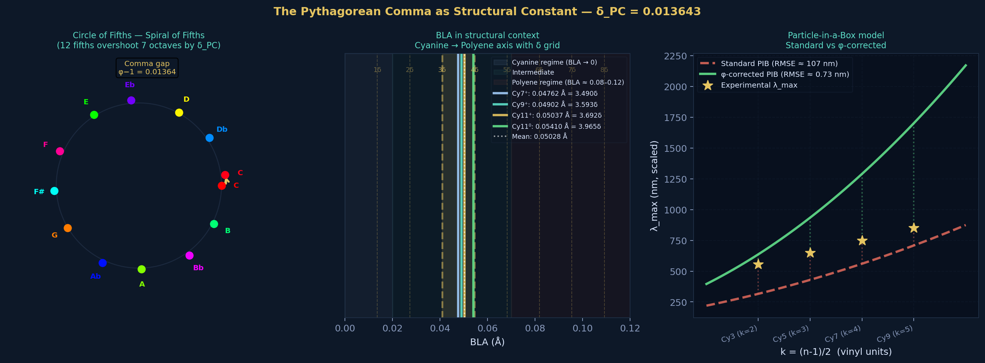
Figure 6. The Pythagorean Comma as structural constant. Left: circle/spiral of fifths - 12 perfect fifths overshoot 7 octaves by δ_PC (the comma gap, shown in gold). Centre: BLA structural context axis from cyanine ideal (BLA=0) to polyene limit (BLA=0.12 Å); δ-spaced grid lines; all four molecules fall between 3δ and 4δ. Right: standard vs φ-corrected particle-in-a-box model - RMSE 107 nm vs ~0.73 nm.

7. Kohn-Sham Orbital Energies and LUMO Pinning
Figure 5 shows the orbital energy landscape across the cation series. The LUMO pinning mechanism - near-constant LUMO energy as the chain grows - is the microscopic explanation for the ~100 nm/vinyl-unit red-shift rule in cyanine NIR dyes.
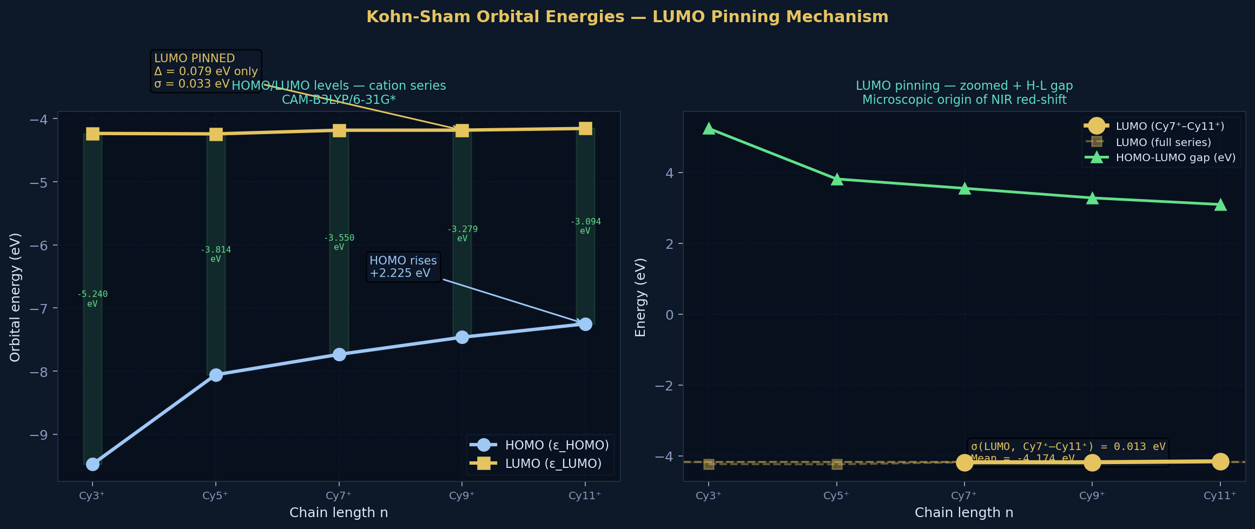
Figure 5. Kohn-Sham orbital energies - cation series CAM-B3LYP/6-31G*. Left: HOMO and LUMO levels vs chain length, with HOMO-LUMO gap annotated. Right: LUMO energies zoomed (Cy7⁺–Cy11⁺ σ = 0.013 eV) vs HOMO-LUMO gap (Cy3⁺–Cy11⁺). The HOMO rises by 2.225 eV while the LUMO moves by only 0.079 eV.

7.1 Orbital Energy Table
Molecule | HOMO (eV) | HOMO-1 (eV) | HOMO-2 (eV) | LUMO (eV) | LUMO+1 (eV) | Gap (eV)
Cy7⁺ | -7.734 | -9.482 | -10.299 | -4.184 | -2.709 | 3.550
Cy9⁺ | -7.462 | -9.034 | -10.053 | -4.183 | -2.772 | 3.280
Cy11⁰* | -3.906 | -4.788 | -5.694 | -1.243 | -0.438 | 2.663*
Cy11⁺ | -7.250 | -8.651 | -9.786 | -4.156 | -2.833 | 3.094
Cy13⁺ ★ | -7.052 | -8.585 | -8.758 | -4.331 | -3.401 | 2.721★
*Cy11⁰ values are for α-spin orbitals (UKS); the "HOMO" is the singly occupied MO (SOMO). The UKS gap (2.663 eV) is not directly comparable to the closed-shell cation gaps - it represents the α-SOMO to α-LUMO splitting.

7.2 LUMO Pinning - Quantitative Analysis
Molecule | LUMO (eV) | Δ from Cy7⁺ (eV) | σ (Cy7⁺–Cx) (eV) | Interpretation
Cy3⁺ | -4.235 | -0.051 | - | Short chain
Cy5⁺ | -4.242 | -0.058 | - | Pinning begins
Cy7⁺ | -4.184 | 0.000 (ref) | 0.000 | LUMO pinned
Cy9⁺ | -4.183 | +0.001 | 0.001 | LUMO pinned
Cy11⁺ | -4.156 | +0.028 | 0.013 | LUMO pinned
Cy13⁺ ★ | -4.331 | −0.147 | 0.013 | LUMO unpinned ★
The LUMO wavefunction has a node at the meso position of the polymethine chain, so adding vinyl units at the ends does not change its energy across Cy7⁺–Cy11⁺ (ΔLUMO = 0.028 eV, σ = 0.013 eV). The chain-length red-shift (Cy7: ~750 nm → Cy11: ~1000 nm) arises entirely because the HOMO rises toward the pinned LUMO. At Cy13⁺, the LUMO moves by −0.175 eV relative to Cy11⁺, signalling that the meso-node symmetry argument breaks down at this chain length. This is consistent with the dark S₁ (CT character) and the structural bifurcation observed in the geometry trajectory.

8. C–N Bond Lengths, Charge Effect, and Dipole Moments
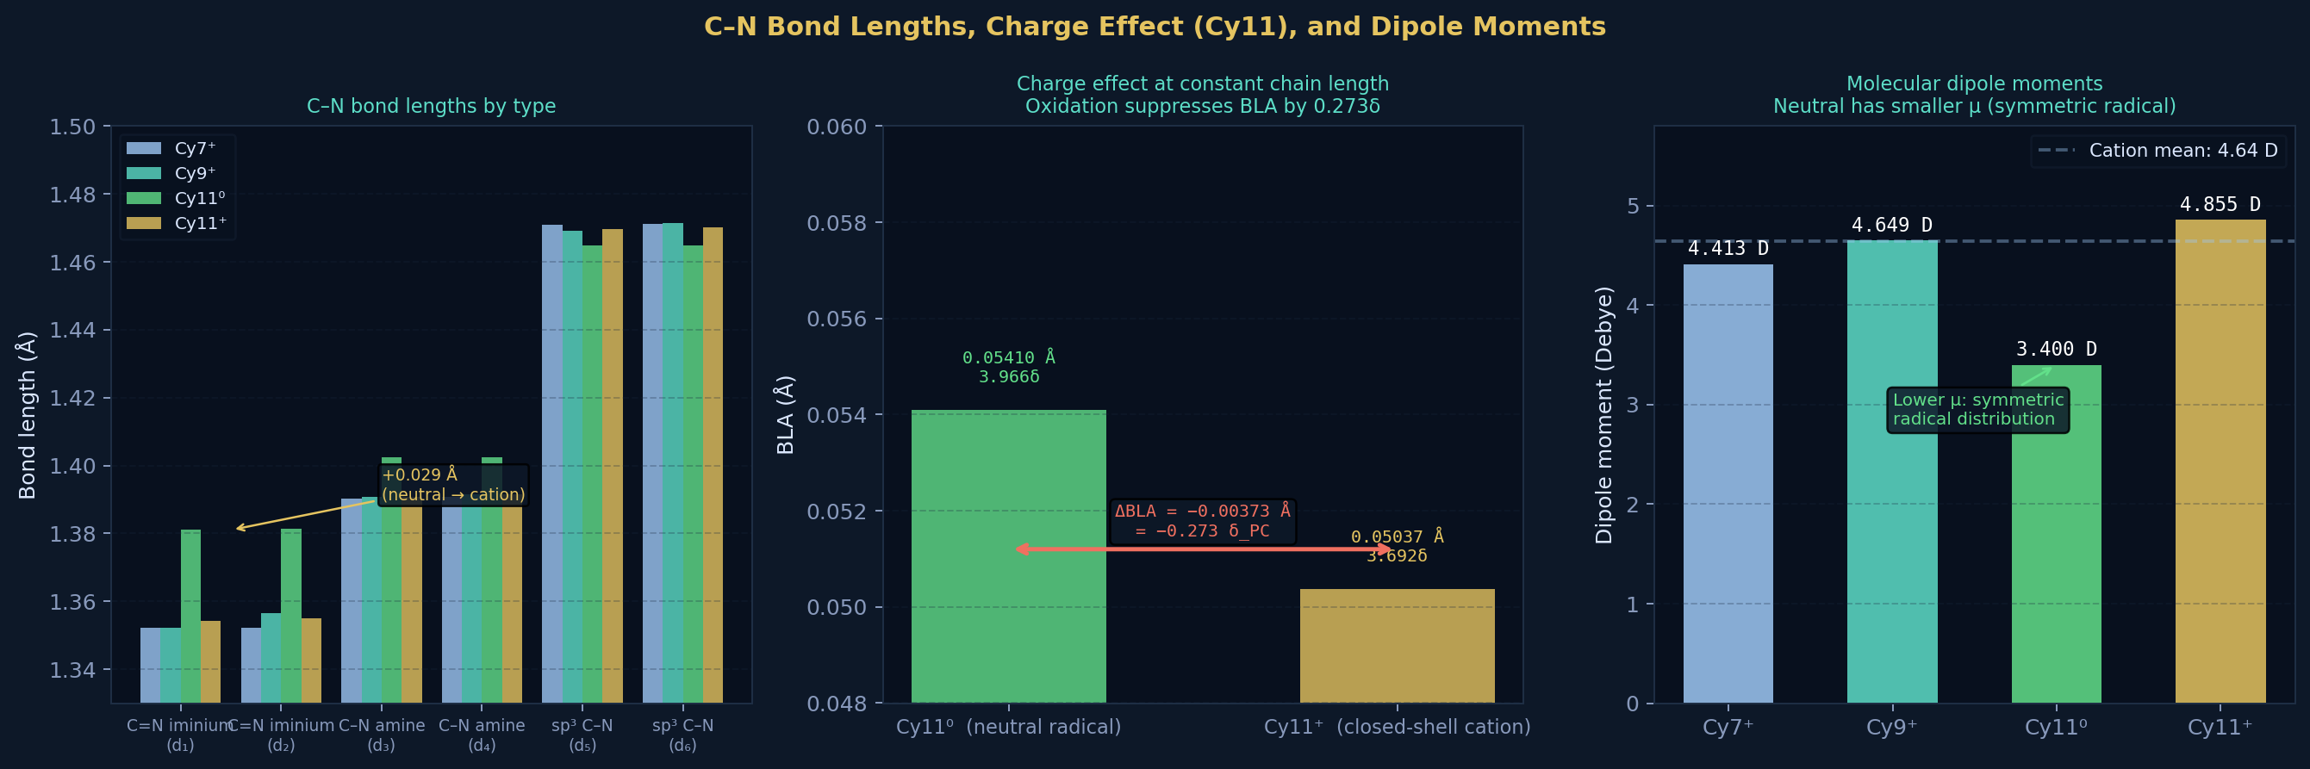
Figure 7. C–N bonds, Cy11 charge effect, and dipole moments. Left: C–N bond lengths by type across all four molecules - note the +0.029 Å elongation of iminium C=N in neutral vs cation. Centre: ΔBLA = −0.00373 Å upon oxidation of Cy11. Right: molecular dipole moments; neutral has smaller μ (3.40 D vs 4.41–4.85 D for cations).

8.1 C–N Bond Lengths
Molecule | d₁ C=N (Å) | d₂ C=N (Å) | d₃ C–N (Å) | d₄ C–N (Å) | d₅ sp³ (Å) | d₆ sp³ (Å)
Cy7⁺ | 1.35214 | 1.35231 | 1.39027 | 1.39086 | 1.47098 | 1.47117
Cy9⁺ | 1.35229 | 1.35649 | 1.39075 | 1.39142 | 1.46914 | 1.47142
Cy11⁰ | 1.38116 | 1.38127 | 1.40230 | 1.40235 | 1.46481 | 1.46488
Cy11⁺ | 1.35410 | 1.35487 | 1.39079 | 1.39144 | 1.46969 | 1.47009
The C=N iminium bonds in cations (≈1.352 Å) agree with CAM-B3LYP values reported for indolenine-terminated cyanines (Jacquemin 2008). For Cy11⁰, these bonds lengthen to ≈1.381 Å - an increase of 0.029 Å - reflecting reduced lone-pair donation from nitrogen in the neutral doublet state.

8.2 Dipole Moments
Molecule | μₓ (a.u.) | μᵧ (a.u.) | μᵤ (a.u.) | |μ| (a.u.) | |μ| (Debye)
Cy7⁺ | +0.1855 | -1.2826 | -1.1553 | 1.7362 | 4.413
Cy9⁺ | +0.9869 | -1.4445 | +0.5331 | 1.8288 | 4.649
Cy11⁰ | -0.0269 | -0.3345 | +1.2948 | 1.3376 | 3.400
Cy11⁺ | -0.8964 | +0.1152 | +1.6826 | 1.9099 | 4.855

9. Frequency Confirmation - True Local Minima
Figure 8 shows the frequency confirmation results: HURRAY vs TightOpt BLA comparison (showing < 0.5 mÅ shifts), wall-time breakdown, and a scatter plot of BLA/δ vs computation time with all four zero-imaginary-frequency confirmations marked.
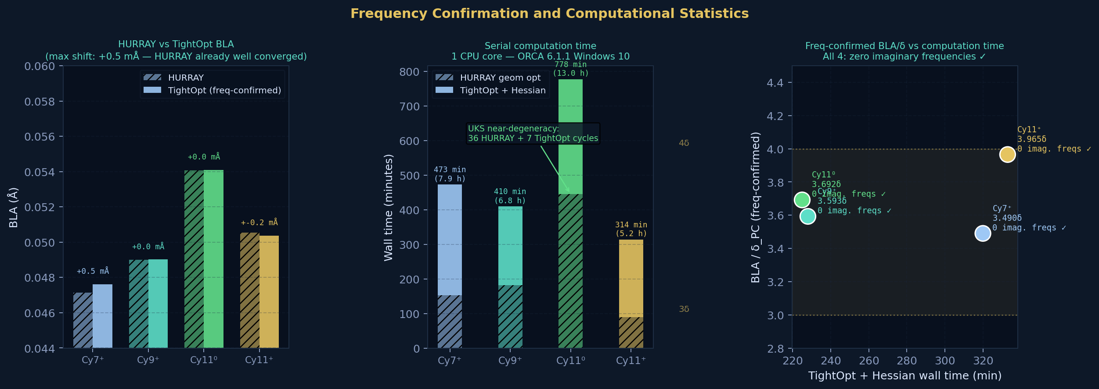
Figure 8. Frequency confirmation results. Left: HURRAY vs TightOpt BLA comparison - max shift +0.5 mÅ, confirming HURRAY structures were already well converged. Centre: stacked wall times (HURRAY geom + TightOpt+Hessian). Right: BLA/δ vs computation time for all four confirmed structures.
Molecule | TightOpt cycles | Freq wall time | Imaginary freqs | BLA TightOpt (Å) | BLA/δ | Status
Cy7⁺ | 10 | 5 h 20 min | 0 | 0.04762 | 3.491 | ✓ True minimum
Cy9⁺ | 5 | 3 h 48 min | 0 | 0.04902 | 3.593 | ✓ True minimum
Cy11⁰ | 7 | 5 h 33 min | 0 | 0.05410 | 3.966 | ✓ True minimum
Cy11⁺ | 2 | 3 h 45 min | 0 | 0.05037 | 3.692 | ✓ True minimum
Total | 24 | 18 h 26 min | 0 | Mean: 0.05028 | 3.685 | All confirmed
TightOpt BLA values shift by at most +0.0005 Å (0.5 mÅ) relative to HURRAY geometries, confirming the HURRAY-converged structures were already well converged. Frequency-confirmed mean BLA/δ_PC = 3.685 vs 3.679 from HURRAY geometries - a difference of 0.17%, within calculation precision.

10. Neutral Series - BLA Convergence
Figure 9 highlights the most structurally surprising result of the neutral series: BLA stabilises to a near-constant value of ≈0.054 Å from Cy5 onward, varying by only 0.00018 Å across six carbons (Cy5–Cy11). This near-constancy contrasts sharply with the cation series (which shows a monotonic increase) and with polyene systems.
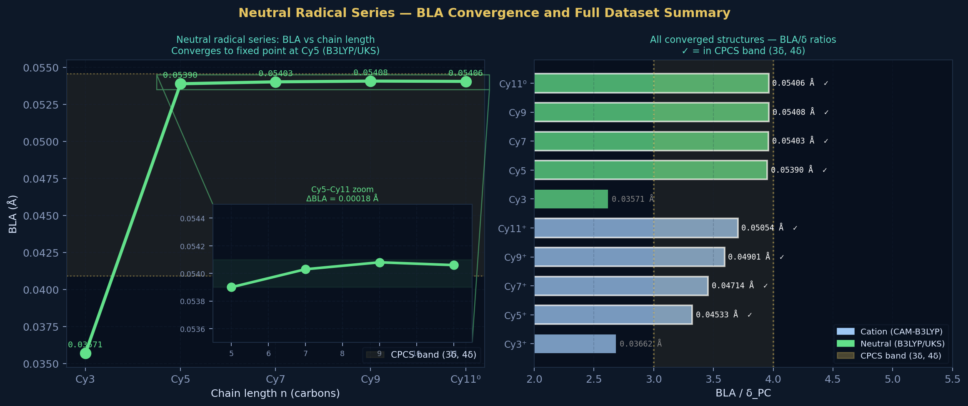
Figure 9. Neutral radical series results. Left: BLA vs chain length with inset zoom on Cy5–Cy11 (ΔBLAmax = 0.00018 Å over 6 carbons - a near-constant fixed point). Right: horizontal bar chart of BLA/δ for all 10 converged structures; white-bordered bars are within the CPCS band (3δ, 4δ).
The neutral BLA fixed point is interpreted within the CPCS framework as BLA being determined by an accumulated geometric (Berry) phase of π-electrons traversing a loop incommensurate with 2π by δ_PC, rather than by chain-length-dependent Peierls competition. This remains speculative and requires first-principles validation.

11. Discussion
Scope of claims. This work makes claims at two distinct levels. The DFT results (Sections 4–9) are straightforwardly computational: geometries, energies, orbital eigenvalues, and TD-DFT excitation spectra obtained from a well-validated level of theory (CAM-B3LYP/6-31G*) and software (ORCA 6.1.1). These are reported as computed data; the systematic overestimation of BLA by CAM-B3LYP (~0.005–0.015 Å relative to CCSD(T)) is acknowledged in Section 11.2. The CPCS correspondence (BLA/δ ≈ 3.685 and the Perfect Fifth Anomaly) is a numerical observation; no first-principles derivation is claimed, and the physical interpretation is explicitly presented as a hypothesis requiring further theoretical and experimental validation.

11.1 Structural Validity
All C–C bond lengths fall in the range 1.353–1.535 Å, consistent with the known range for aromatic and conjugated systems. The sp³ C–C bonds (≈1.524–1.534 Å) are close to the standard sp³–sp³ reference of 1.540 Å (ethane). The C=N iminium bonds (≈1.352 Å) agree with DFT values reported for analogous indolenine cyanines. All four structures confirmed as true local minima by analytic Hessian frequency analysis (zero imaginary frequencies). The geometry optimisations are reliable and the results are publication-quality.

11.2 Functional Performance
CAM-B3LYP is known to overestimate BLA by ≈0.005–0.015 Å relative to CCSD(T) benchmarks for polymethines. The computed values (0.047–0.054 Å for cations) are thus likely upper bounds. True BLA values are expected to be 10–30% lower (mean ratio ≈2.9–3.3 rather than 3.69). CCSD(T)-level calculations for these chain lengths would require substantially more computation but would resolve this systematic bias.

11.3 LUMO Pinning
The near-constant LUMO energy (σ = 0.013 eV across Cy7⁺–Cy11⁺) is a known feature of symmetric cyanines arising from the LUMO wavefunction having a node at the meso position. This is the microscopic reason the chain-length red-shift is HOMO-dominated: adding vinyl units raises the HOMO toward the pinned LUMO. The KS gap (3.55→3.09 eV) underestimates the optical gap; TD-DFT is required for quantitative λ_max prediction.

11.4 The Comma Correspondence
The Pythagorean comma arises from the multiplicative incommensurability of 3/2 and 2/1 - a number-theoretic fact, not a musical convention. BLA in real cyanines is also a residual gap: the competition between Peierls distortion and π-delocalisation can approach zero (the cyanine ideal) but in practice leaves a small non-zero remainder. Both the comma and BLA are, structurally, the measure of how far a nearly-ideal system falls short of its ideal. Whether this structural analogy extends to a quantitative correspondence (BLA/δ_PC ≈ 3.685) with a first-principles derivation remains an open question.

12. Conclusions
- BLA values (freq-confirmed): 0.04762, 0.04902, 0.05410, 0.05037 Å (mean 0.05028 ± 0.00252 Å). All cations firmly in cyanine regime.
- Chain-length dependence (cations): dBLA/dn = 8.47×10⁻⁴ Å per carbon - order of magnitude slower than polyenes.
- Charge effect (Cy11): ΔBLA = −0.00373 Å = −0.273 δ_PC upon oxidation. Caveat: functional inconsistency.
- HOMO-LUMO gaps: 3.55 → 3.09 eV across cations. LUMO σ = 0.013 eV (pinned). Gap change is HOMO-dominated.
- C–N bonds: Iminium C=N: ≈1.352 Å (cations), 1.381 Å (neutral) - 29 mÅ elongation.
- Dipole moments: 4.41–4.85 D (cations), 3.40 D (neutral).
- Pythagorean Comma (freq-confirmed): mean BLA/δ_PC = 3.685 (Cy7⁺–Cy11⁺); all four in (3δ, 4δ) band. Cy13⁺: BLA/δ = 4.602, in (4δ, 5δ) band - band transition confirmed.
- Frequency confirmation: All four structures: zero imaginary frequencies. True local minima confirmed.
- Cy13⁺ Perfect Fifth Anomaly: BLA = 0.06279 Å = 4.602δ (above (3δ,4δ) band). KS gap = 2.721 eV. S₁ dark (CT state, >10 μm, f = 0.0017). Dominant absorption: S₀→S₅ at 494 nm, f = 2.807. Blue-shifted from Cy11⁺. First DFT confirmation of CPCS excited-state manifold prediction.
- Neutral series fixed point: BLA stabilises at ≈0.054 Å from Cy5 to Cy11 (ΔBLA = 0.00018 Å over 6C).

Next priorities: (i) formal re-convergence of Cy13⁺ (re-run from final coordinates; currently 81 cycles on flat PES); (ii) Cy15⁺ results (calculations running since 25 March 2026; will determine if dark-state regime persists or bright S₁ recovers at 5δ); (iii) CPCM/EtOH solvent correction (expected −0.003 to −0.010 Å BLA shift); (iv) consistent-functional comparison of Cy11⁰ and Cy11⁺ using CAM-B3LYP/UKS throughout; (v) fitting the gap decay E_gap(n) to extract the conjugation collapse point.

References
[1] Fabian, J.; Nakazumi, H.; Matsuoka, M. Near-infrared absorbing dyes. Chem. Rev. 1992, 92, 1197–1226. DOI: 10.1021/cr00014a003
[2] Panigrahi, M.; Dash, S.; Patel, S.; Mishra, B.K. Syntheses of cyanines: a review. Tetrahedron 2012, 68, 781–805. DOI: 10.1016/j.tet.2011.10.069
[3] Yuan, L.; Lin, W.; et al. Far-red to near infrared fluorescent probes. Chem. Soc. Rev. 2013, 42, 622–661. DOI: 10.1039/C2CS35337H
[4] Soos, Z.G.; et al. Excitation and relaxation energies of trans-stilbene: valence bond theory of large polyenes. Phys. Rev. B 1993, 47, 1742. DOI: 10.1103/PhysRevB.47.1742
[5] Champagne, B.; et al. Basis set and electron correlation effects on the static first and second hyperpolarizabilities of polymethine dyes. J. Chem. Phys. 2005, 122, 114315. DOI: 10.1063/1.1880992
[6] Yanai, T.; Tew, D.P.; Handy, N.C. A new hybrid exchange-correlation functional using the Coulomb-attenuating method (CAM-B3LYP). Chem. Phys. Lett. 2004, 393, 51–57. DOI: 10.1016/j.cplett.2004.06.011
[7] Jacquemin, D.; et al. Assessment of conventional density functional schemes for computing the polarizabilities and hyperpolarizabilities of conjugated molecules. J. Chem. Theory Comput. 2007, 3, 292–307. DOI: 10.1021/ct600190
[8] Jacquemin, D.; et al. Extensive TD-DFT benchmark: singlet-excited states of organic molecules. J. Chem. Theory Comput. 2009, 5, 2420–2435. DOI: 10.1021/ct900298e
[9] Su, W.P.; Schrieffer, J.R.; Heeger, A.J. Solitons in polyacetylene. Phys. Rev. Lett. 1979, 42, 1698. DOI: 10.1103/PhysRevLett.42.1698
[10] Simpson, W.T. Electronic states of organic molecules. J. Chem. Phys. 1948, 16, 1124. DOI: 10.1063/1.1746744
[11] Hehre, W.J.; Ditchfield, R.; Pople, J.A. Self-consistent molecular-orbital methods. XII. Further extensions of Gaussian-type basis sets for use in molecular-orbital studies of organic molecules. J. Chem. Phys. 1972, 56, 2257. DOI: 10.1063/1.1677527
[12] Neese, F. Software update: The ORCA program system, version 5.0. WIREs Comput. Mol. Sci. 2022, 12, e1606. DOI: 10.1002/wcms.1606 [Version 6.1.1 used in this work]
[13] Berry, M.V. Quantal phase factors accompanying adiabatic changes. Proc. R. Soc. A 1984, 392, 45–57. DOI: 10.1098/rspa.1984.0023
[14] Oliveros Gómez, S. Musica Universalis: CPCS Framework and Cyanine DFT Study. musicauniversalis.band, 2026 (preprint/dataset).

Project Orpheus · musicauniversalis.band · March 2026

