

UNDERGRADUATE PROJECT PROPOSAL

|  |  |
| --- | --- |
| **Project Title:** | **Deep Learning for** **Predicting Solar Cell Degradation using Thermal Imaging** |
| **Surname:** | **Gao** |
| **First Name:** | **Rui (Olivia)** |
| **Student Number:** | **202118010407** |
| **Supervisor Name:** | **Dr. Happy Nkanta Monday** |
| **Module Code:** | **CHC 6096** |
| **Module Name:** | **Project** |
| **Date Submitted:** | **4 November 2024** |

**Table of Contents**

**1** **Introduction** 2

**1.1** **Background** 2

**1.2** **Aim** 3

**1.3** **Objectives** 3

**1.4** **Project Overview** 3

**1.4.1** **Scope** 3

**1.4.2** **Audience** 3

**2** **Background Review** 4

**3** **Methodology** 6

**3.1** **Approach** 6

**3.2** **Technology** 9

**3.3** **Version management plan** 9

**4** **Project Management** 9

**4.1** **Activities** 9

**4.2** **Schedule** 10

**4.3** **Data management plan** 11

**4.4** **Project Deliverables** 11

**5** **References** 13

# **Introduction**

## **Background**

People now focus more on renewable and clean resource due to the impact of global warming and fossil fuels. More usage of clean resource can make a difference on protecting the environment. In this case, solar energy has gotten more and more attention. Solar energy is mainly harvested by photovoltaic plants which have numerous advantages, including extended lifespan, sustainability, low-noise performance, and cleanliness [1].

However, solar panels may incur damage when exposed to humid and high-temperature environments or become hotspots due to partial shading from surrounding objects [2]. So, it’s essential for people to find the potential failure points and predict the solar cell degradation.

## **Aim**

The aim of the project is to develop a deep learning-based model to detect solar cell degradation by analyzing thermal imaging data of solar panels.

## **Objectives**

The objectives to reach the project aim are:

1. Understand the aim of the project and have a brief idea about the project.
2. Research the existing researches and the models they used.
3. Collect the dataset of thermal imaging data of solar panels and preprocess the data.
4. Select and design the model for analyzing thermal images.
5. Train and test the model with the dataset and optimize it.
6. Present the result of the project.

## **Project Overview**

### **Scope**

The purpose of the project is to develop a deep learning-based model to detect solar cell degradation. By training the model to test the failure points such as the hotspots, material fatigue and so on. Through this model, it can find the failures and enable the timely maintenance, which will extend the lifespan of solar panels and optimize energy production. To be specific, it can reduce the maintenance fee, increase the efficiency of the solar panels and so on.

### **Audience**

The audience of the project will benefit from the result such as:

1. Solar energy companies and operators: reduce the costs, enhance the solar energy efficiency and extend the lifespan of the solar panels.
2. Countries and governments: enhance energy safety, reduce the overall cost of energy production.
3. Consumers: lower energy costs.

# **Background Review**

Some researches have been done to research the deep learning model for the solar panels degradation, this part I will introduction some existing works about the topic.

Ali et al. proposed a model combined hybrid features and Support Vector Machine (SVM) algorithm to identify and classify the hot spots on the photovoltaic panel by analyzing the infrared thermal imaging data [3]. Wang et al. proposed an improved Mask R-CNN algorithm that is specifically designed to segment thermal images of PV panels in order to detect and identify hot spots in them [4]. Shaik et al. proposed a novel deep learning architecture for the segmentation of solar plant aerial images, along with a transfer learning-based model for classifying solar panel damage by U-Net and VGG-19 [1]. Haidari et al. proposed a method using deep learning algorithms according to VGG-16 to detect two types of defects in photovoltaic power stations: hotspots and hot substrings [2]. Yousif and Al-Milaji introduced an end-to-end deep learning model according to VGG-16 to produce better PV image classification accuracy [5]. Kirubakaran et al. aimed to use a thermal imaging system to identify PV panels and processes thermal images through image processing techniques. They used FLIR maker thermal imager and MATLAB to process the images [6]. Dunderdale et al. proposed a method based on deep learning and features to detect and classify defective photovoltaic modules using thermal infrared images. They used VGG-16, MobileNet and SVM in the research [7]. Jaybhaye et al. introduced a method for detecting and localizing solar panel damage and surface hotspots using image processing of thermal images [8]. Vega Díaz et al. proposed two approaches in automated solar power station inspection: one based on classical techniques (Edge detection and classification) and the other based on deep learning (CNN). And both panel detection methods are highly effective in complex backgrounds [9].

Table 1 shows the Researchers, the methods and deep learning models they used and the performance.

|  |  |  |
| --- | --- | --- |
| Researchers | Methods & models | Performance |
| Ali et al. [3] | hybrid features + SVM | Training Accuracy: 96.8%  Testing Accuracy: 92% |
| Wang et al. [4] | Improved Mask R-CNN | Precision: 75.04%  Recall: 97.4% |
| Shaik et al. [1] | U-Net + VGG-19 | 1. Segmentation:   Pixel Accuracy: 98%  Mean IoU: 95%   1. Classification:   Accuracy: 98% |
| Haidari et al. [2] | VGG-16 | Accuracy: 0.98  Precision: 0.98  Recall: 0.97 |
| Yousif and Al-Milaji [5] | VGG-16 | Accuracy: 0.9055  Precision: 0.9043 |
| Kirubakaran et al. [6] | FLIR maker thermal imager + MATLAB to process the images | Verified that the old panels give less power output than the new panels. |
| Dunderdale et al. [7] | VGG-16 + MobileNet +SVM | Overall Accuracy: 91.2%  VGG-16 using SGD optimizer and data augmentation: accuracy was 85.8%  MobileNet using Adam optimizer: accuracy was 89.5% |
| Jaybhaye et al. [8] | CNN | Mean Average Precision on the training set: 0.69  Mean Average Precision on testing set: 0.47 |
| Vega Díaz et al. [9] | Edge detection and classification  CNN + SVM | 1. Classical techniques:   Precision: 0.997  Recall: 0.970   1. Deep learning:   Precision: 0.996  Recall: 0.981 |

Table 1: Comparison of different works

# **Methodology**

## **Approach**

Since Convolutional Neural Network (CNN) has the advantage of automatically extracting features without human intervention, it has become the most widely used model [10]. In addition, CNN has the ability to learn highly abstract features and can efficiently recognize objects, which further highlights its superiority [11]. The weight sharing feature of CNN can reduce training time and the number of training parameters, avoid model overfitting, and also improve generalization ability [12].

3.1.1 CNN Layers

Table 2 shows the details of the CNN layers.

|  |  |
| --- | --- |
| Layer | Detail |
| Input Layer | * receive the image data. |
| Convolutional Layer | * It contains a set of convolutional kernels (filters), which can do the convolution operations [12]. * The input image represents as N-dimensional metrics. |
| Activation Layer | * It aims to convert the input received by the neuron into an output [10]. |
| Pooling Layer | * It can help the network process the data more efficiently while preserving the most important features [12]. |
| Fully Connected Layer | * It combines and maps the previously extracted features to the output space. |
| Output Layer | * The final layer makes different outputs which depend on the task of the model. |

Table 2: The layer of CNN structure and its details.

3.1.2 Three Common Activation Functions

* Sigmoid function: the input is real numbers, while the output is restricted to between 0 and 1. The sigmoid function curve is S-shaped.

$$Sigmoid\left(x\right)= \frac{1}{1 + e^\{-x\}}$$

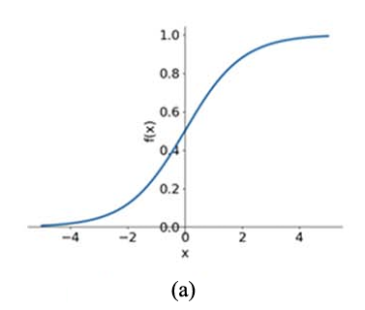

Figure 1. Diagrams of Sigmoid function [13]

* Tanh function: the input id real number, while the output is restricted to between -1 and 1. The Tanh function curve is S-shaped.

$$Tanh\left(x\right)= \frac{e^x - e^\{-x\}}{e^\{x\} + e^\{-x\}}$$

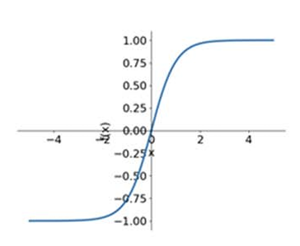

Figure 2. Diagrams of Tanh function [13]

* ReLU function: this function converts the input value to a nonnegative number. When the input is negative, the output is 0. When the input value is positive, the output remains unchanged.

$$ReLU(x) = \max{(0,x)}$$

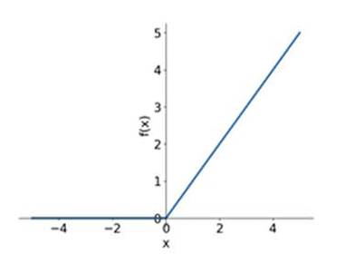

Figure 3. Diagrams of ReLU function [13]

3.1.3 Optimization Strategy

* Optimizer selection: The optimizer determines how to tune the parameters by calculating the gradient of the loss function with respect to the model parameters.
* Enhancement technique: Learning Rate Decay, Early Stopping, Data Augmentation, Batch Normalization, dropout and so on.

3.1.4 Data Processing Techniques

The pre-process is to transfer some dataset to make the data cleaner and more learnable which is process before input the data to the CNN model [12]. For example, Normalization, data cleaning, data augmentation are the common techniques.

## **Technology**

|  |  |
| --- | --- |
| Tools & Resources | |
| hardware | software |
| Central Processing Unit (CPU): Intel Core i9 14900HX | Framework: Tensorflow |
| Graphic Processing Unit (GPU): NVIDIA RTX 4070 | Language: Python |
|  | Libraries: numpy, keras |

Table 3: Tools and Resources for developing

## **Version management plan**

I will use GitHub to manage the different versions of codes.

Here is the link: <https://github.com/Olivia-Gao/Deep-Learning-Project.git>

# **Project Management**

## **Activities**

|  |  |
| --- | --- |
| Objectives | Activities |
| 1. Understand the aim of the project and have a brief idea about the project. | 1. Read the title of the project and find the keywords of the project. 2. Search the keywords in the internet to learn about the background about the topic. 3. Learn about the deep learning models. |
| 1. Research the existing researches and the models they used. | 1. Search the keywords in the internet to find existing works. 2. Research the existing works and find the models they used. 3. Analyze the result and accuracy of their models. |
| 1. Collect the dataset of thermal imaging data of solar panels and preprocess the data. | 1. Find the dataset which is suitable for the topic on the website. 2. View the dataset and check its usability. 3. Preprocess the data of the thermal images of solar panels. |
| 1. Select and design the model for analyzing thermal images. | 1. Find and select the suitable models for the topic. 2. Learn more about the deep knowledge of CNN models. 3. Design the deep learning model. |
| 1. Train and test the model with the dataset and optimize it. | 1. Train the model with the dataset and find the result of the accuracy and the loss. 2. Analyze the result and summarize the advantages and limitations 3. Optimize the model result. |
| 1. Present the result of the project. | 1. Conclude all the contribution and result. 2. Prepare the final report and presentation. |

Table 4: Activities of the objectives

## **Schedule**

NB: 1.1 represent Objective 1, Activity 1.

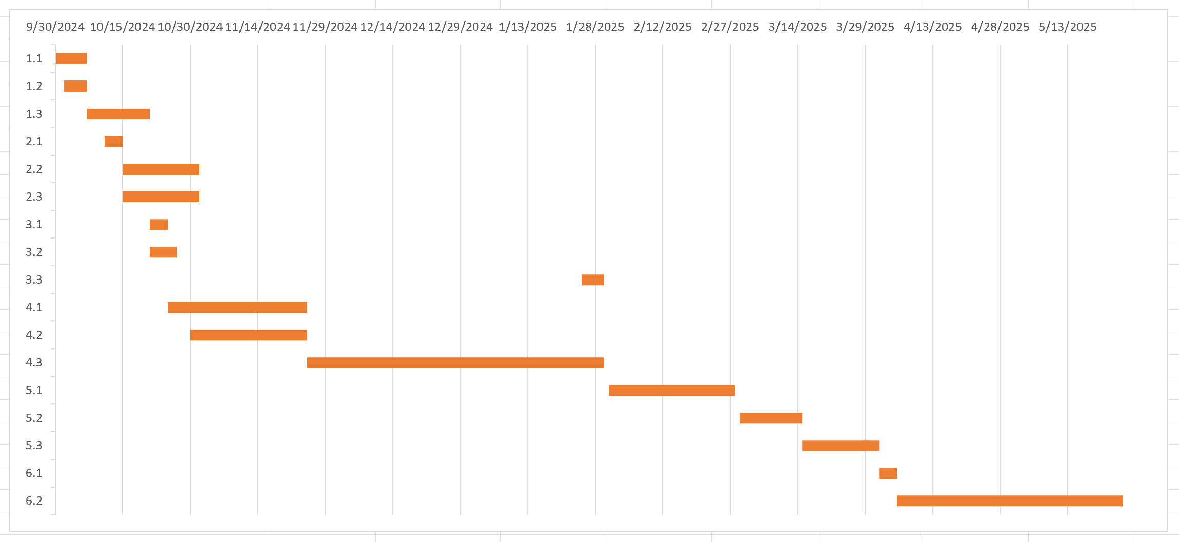

Figure 5. Gantt chart of the activities

## **Data management plan**

1. All the files will be store on the local computer and upload to GitHub.
2. The local folder structure will be:



Figure 6: Folder structure

## **Project Deliverables**

1. Project proposal
2. Weekly report
3. Progress report
4. Final report
5. Project codes
6. Presentation & PPT
7. Ethics for project
8. Dataset link

# **References**

[1] A. Shaik, A. Balasundaram, L. S. Kakarla, and N. Murugan, “Deep Learning-Based Detection and Segmentation of Damage in Solar Panels,” *Automation*, vol. 5, no. 2, pp. 128–150, May 2024, doi: 10.3390/automation5020009.

[2] P. Haidari, A. Hajiahmad, A. Jafari, and A. Nasiri, “Deep learning-based model for fault classification in solar modules using infrared images,” *Sustain. Energy Technol. Assess.*, vol. 52, p. 102110, Aug. 2022, doi: 10.1016/j.seta.2022.102110.

[3] M. U. Ali, H. F. Khan, M. Masud, K. D. Kallu, and A. Zafar, “A machine learning framework to identify the hotspot in photovoltaic module using infrared thermography,” *Sol. Energy*, vol. 208, pp. 643–651, Sep. 2020, doi: 10.1016/j.solener.2020.08.027.

[4] F. Wang, Z. Wang, Z. Chen, D. Zhu, X. Gong, and W. Cong, “An Edge-Guided Deep Learning Solar Panel Hotspot Thermal Image Segmentation Algorithm,” *Appl. Sci.*, vol. 13, no. 19, p. 11031, Oct. 2023, doi: 10.3390/app131911031.

[5] H. Yousif and Z. Al-Milaji, “Fault detection from PV images using hybrid deep learning model,” *Sol. Energy*, vol. 267, p. 112207, Jan. 2024, doi: 10.1016/j.solener.2023.112207.

[6] V. Kirubakaran *et al.*, “Infrared Thermal Images of Solar PV Panels for Fault Identification Using Image Processing Technique,” *Int. J. Photoenergy*, vol. 2022, pp. 1–10, Jun. 2022, doi: 10.1155/2022/6427076.

[7] C. Dunderdale, W. Brettenny, C. Clohessy, and E. E. Van Dyk, “Photovoltaic defect classification through thermal infrared imaging using a machine learning approach,” *Prog. Photovolt. Res. Appl.*, vol. 28, no. 3, pp. 177–188, Mar. 2020, doi: 10.1002/pip.3191.

[8] S. Jaybhaye, O. Thakur, R. Yardi, V. Raut, and A. Raut, “Solar Panel Damage Detection and Localization of Thermal Images,” *J. Fail. Anal. Prev.*, vol. 23, no. 5, pp. 1980–1990, Oct. 2023, doi: 10.1007/s11668-023-01747-z.

[9] J. J. Vega Díaz, M. Vlaminck, D. Lefkaditis, S. A. Orjuela Vargas, and H. Luong, “Solar Panel Detection within Complex Backgrounds Using Thermal Images Acquired by UAVs,” *Sensors*, vol. 20, no. 21, p. 6219, Oct. 2020, doi: 10.3390/s20216219.

[10] L. Alzubaidi *et al.*, “Review of deep learning: concepts, CNN architectures, challenges, applications, future directions,” *J. Big Data*, vol. 8, no. 1, p. 53, Mar. 2021, doi: 10.1186/s40537-021-00444-8.

[11] S. Indolia, A. K. Goswami, S. P. Mishra, and P. Asopa, “Conceptual Understanding of Convolutional Neural Network- A Deep Learning Approach,” *Procedia Comput. Sci.*, vol. 132, pp. 679–688, 2018, doi: 10.1016/j.procs.2018.05.069.

[12] A. Ghosh, A. Sufian, F. Sultana, A. Chakrabarti, and D. De, “Fundamental Concepts of Convolutional Neural Network,” in *Recent Trends and Advances in Artificial Intelligence and Internet of Things*, vol. 172, V. E. Balas, R. Kumar, and R. Srivastava, Eds., in Intelligent Systems Reference Library, vol. 172. , Cham: Springer International Publishing, 2020, pp. 519–567. doi: 10.1007/978-3-030-32644-9_36.

[13] Z. Li, F. Liu, W. Yang, S. Peng, and J. Zhou, “A Survey of Convolutional Neural Networks: Analysis, Applications, and Prospects,” *IEEE Trans. Neural Netw. Learn. Syst.*, vol. 33, no. 12, pp. 6999–7019, Dec. 2022, doi: 10.1109/TNNLS.2021.3084827.