Project: 311 Call Center Tracking Data for City of Los Angeles

Summary

Content

Tables and Charts

Ⅰ. Visualization of Peak Season/Month/Hour

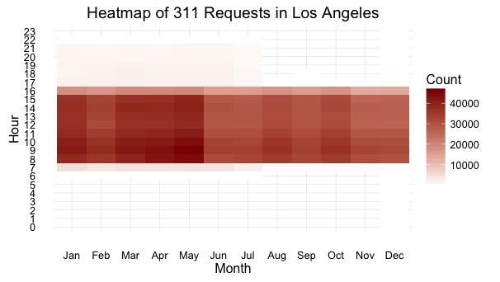

Graph 1.1

It can be seen that March-May stands out with more calls than other months, suggesting that call center can should pay attention on spring term (peak season).

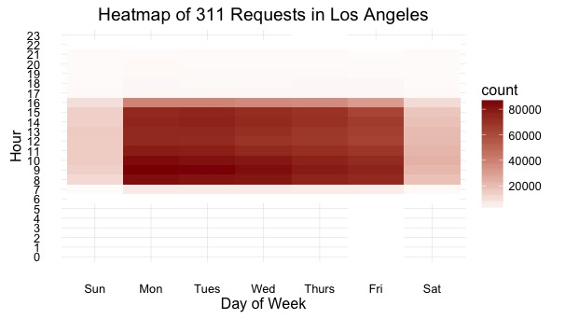

Graph 1.2

This graph shows that weekdays from 9 to 11 am are the times that have most concentrated calls; during lunch break of the day, there are much less calls, and calls start to increase after lunch break.

Ⅱ. Overall Referred Rate Is High Across Departments

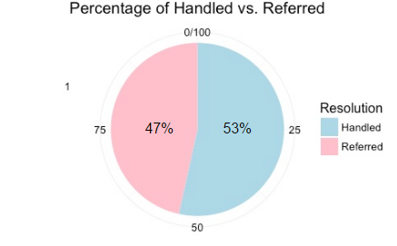

Graph 2.1

Based on the column “Call Resolution”, we defined a new variable “Resolution” by ourselves. We labeled "Referred To 411","Referred To County", "Referred To Other Governmental", "Referred To State", "Transfer (City)","Transferred To 411", "Warm Transfer (City)","Got Voicemail (City)" as “Referred”; and labeled "Call Resolution", "Escalate To Supervisor", "Escalated To Office of Finance", "Gave Caller Information", "Service Request Processed" as “Handled”; and treated the rest as “NA” and filtered them.

Then we calculate the percentage of cases of handled and referred and visualize via pie chart, from which we can see the cases that were handled just weighs a little bit than referred ones. Such high referred rate may due to the confusions of citizens towards the duty of each department. This suggests 311 call center should lower its referred rate by increasing public awareness of duty of each department.

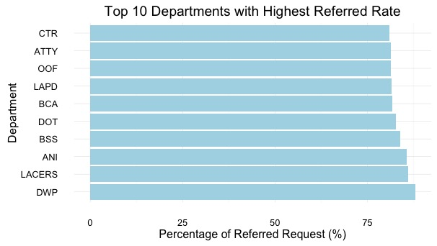

Graph 2.2

Take a further look at the top 10 departments with highest referred rate, Graph 2.2 shows that their referred rates are even greater than 75%. To avoid such referred rate, LA 311 call center can clarify what kind of services each department offer to residents more clearly.

Ⅲ. Department with Good Performance (Low Transferred Rate)

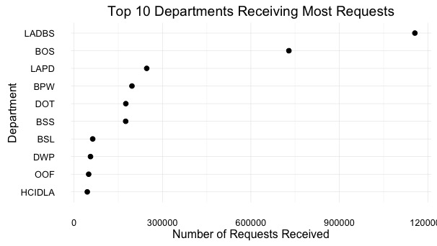

Graph 3.1

From Graph 3.1, we can see that the top 10 departments receiving most requests. Combining Graph 3.2, which displays the top 10 departments with lowest referred rate, we can see that LADBS, BOS, BPW, BSL have both high volumes of requests and relatively low rates of transferred calls. This implies that these departments might did well jobs in getting public known about their functions.

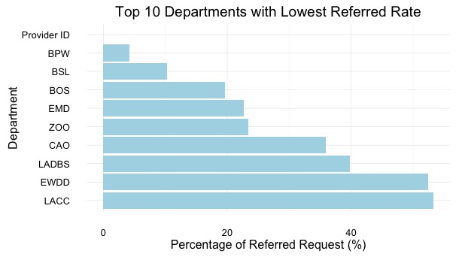

Graph 3.2

Ⅳ. Visualize request distribution on geographic level

To better visualize on a geographic level, we found the data for U.S. zip codes with their corresponding latitude and longitude coordinates and merged the table to raw data. As show in graph 4.1, it ca

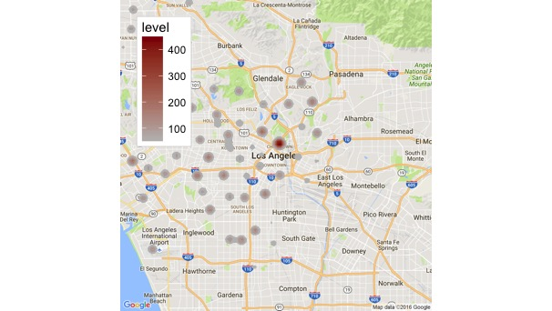

Graph 4.1

Discussion

Conclusion