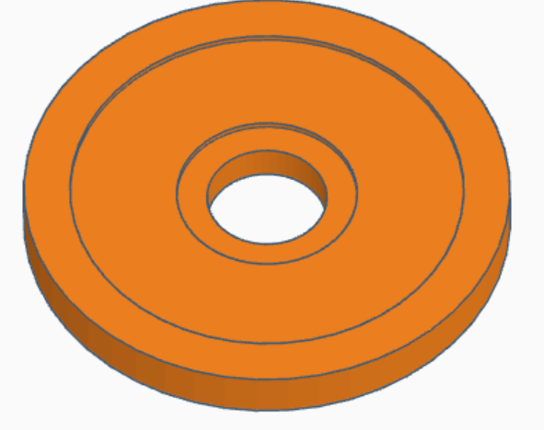
Irradiance Sensor
The diameter of the hole is 20mm. The diameter just has to be more than 10mm, a precise measurement isn’t needed here
The diameter of the lip around the hole is 30mm – that’s what I have light filters sized at so that metric does matter
The depth of each lip is 1mm – the lip around the hole depth does matter as the Teflon needs to stick slightly up from its surroundings
If you flip the cap over, I want to also embed a glass lens for waterproofing. The lens is 15mm diameter and 1.1mm tall. So it would be another negative space lip that’s 1.1mm deep I can fit the glass lens into. (link to lens)

Radiance Sensor – Gershun Tube

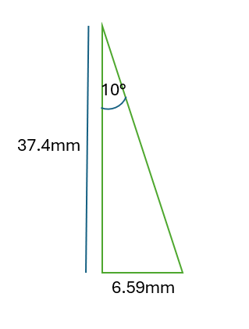
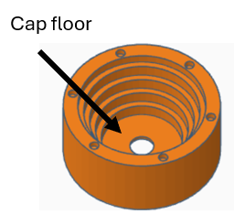
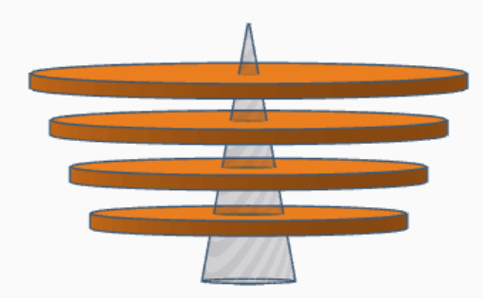
The distance between each disk is 5mm, the thickness of each disk is 2mm
The cone’s height is 37.4mm, the half FOV is 10deg, and the radius is 6.59mm.
The radii of the holes in the disk, top-down, in mm, are:
Radii: 1.48, 2.72, 3.95, 5.18, 6.59.
I found it easier to do the cone slicing method
The diameters of the disks themselves don’t matter, just the hole sizes in the middle.
However, I also want to be able to embed the glass lens like in the irradiance sensor. So the diameter of the floor of the cap will have to be at least 20mm to hold the 15mm glass lens

Mount

The angle off the water and off NADIR are both 30degrees (you can see that one is at 40deg right now which is wrong)
The irradiance sensor must be taller than the radiance sensor (gershun tube)
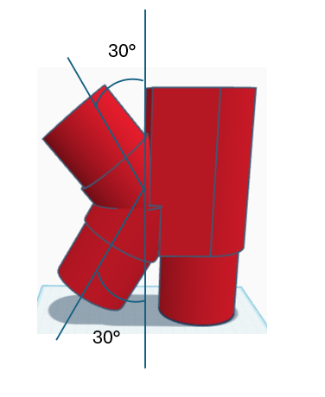
This is where the light sensor is embedded. The sensor is 25.6mm x 17.8mm x 4.6mm or 1.0" x 0.7" x 0.2" (as length X width X height, height includes components
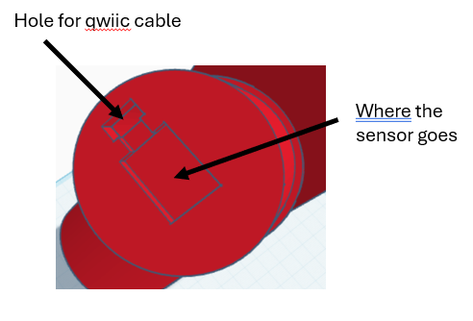
The light sensor itself is centered (I think)
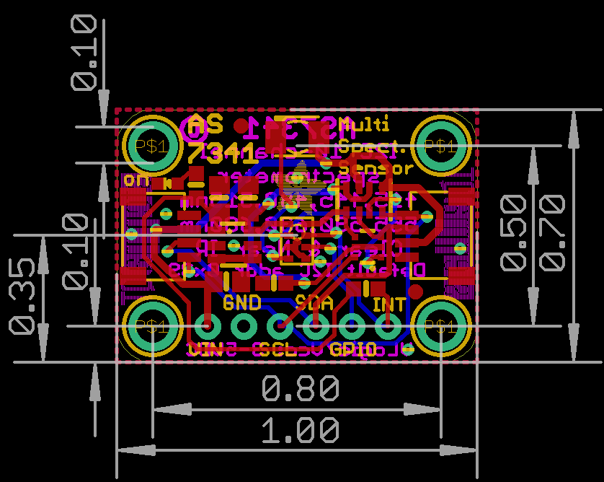
Here’s a 3d render link: https://github.com/adafruit/Adafruit_CAD_Parts/blob/main/4698%20AS7341%20Light%20Color%20Sensor/4698%20AS7341%20Light%20Color%20Sensor.stl
The hole for the stemma cable just has to be big enough for the plug piece of the cable to pass through.

Improvements:
- Way to secure the light sensor in its bed
- Locking mechanism for cap
- Easier access to the interior – side door
- Holder for electronics – esp tilt sensor needs to lie flat
- PLA warped in heat – print in ADA? Paint with resin? Do I need to order anything?
- Fix arm angles and lengths
- Nubs for gimbal

Pictures of mounting locations

