**Analysis of Environmental Data – Using Models 2**

**Olivia Dinkelacker**

**Q1 (4 pts.): Re-create the conditional boxplot of penguin body mass conditioned on sex and species. Include your boxplot as a figure in your report.**

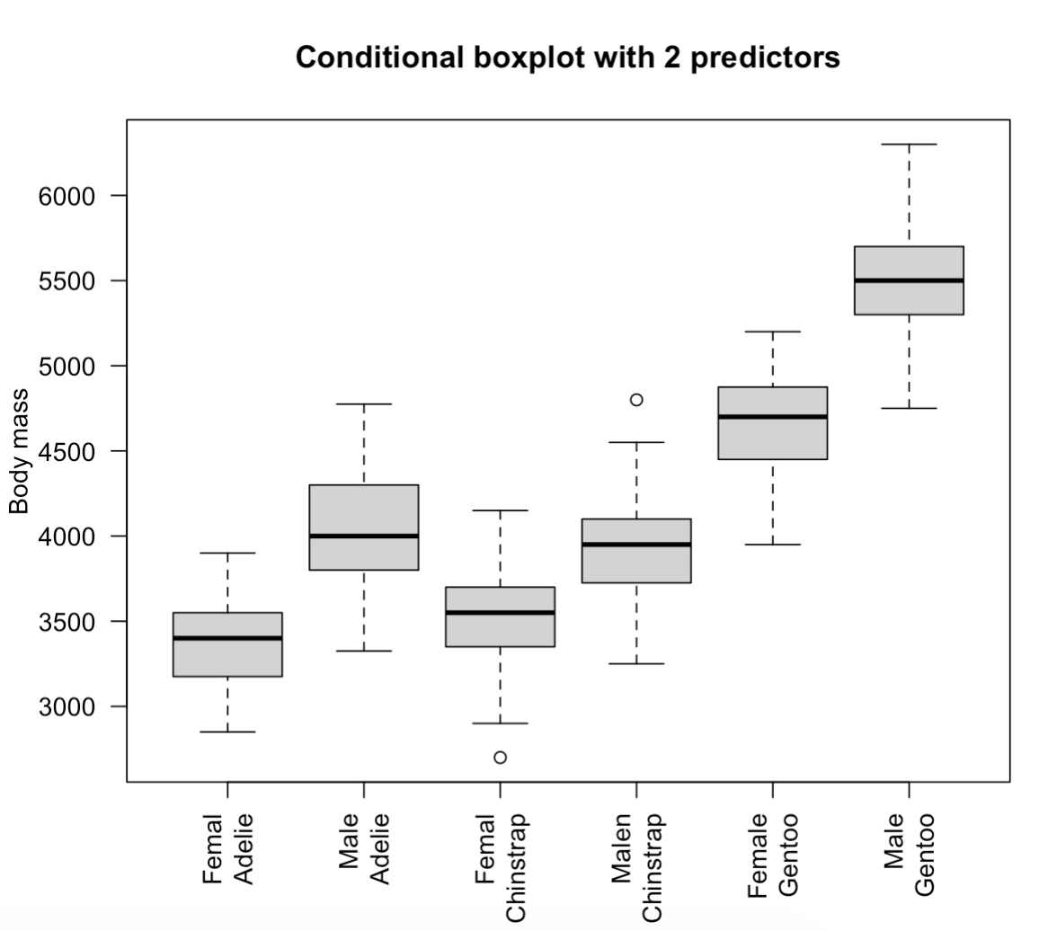

**Q2 (2 pts.): Based on the boxplots, do you think male penguins are *significantly* heavier than female penguins of the same species? Explain your reasoning, and be sure to explain why you think any observed differences are significant or not.**

Based on the boxplot I assume sexual dimorphism in weight across all species. Males seem to be significantly heavier than females indicated through the higher mean in body weight.

**Q3 (2 pts.): Do you think adding sex to a model that already includes species will improve the model fit?**

**Make sure you justify your answer based on the boxplots and not results of a statistical test.**

I think it will improve the model fit, because it seems like that sex plays an important role in the difference of body mass within a species, indicated through the higher means of male body mass in the third boxplot.

**Q4 (2 pts.): Show the R-code you used to build fit_both.**

fit_both = lm(body_mass_g ~ sex * species, data = penguins)

**Q5 (2 pts.): What is the base case for the two-way model that includes sex and species?**

sexfemale:speciesAdelie

**Q6 (2 pts.): What are the names of the *two* coefficients (from the first column of the coefficient table) that you need to calculate the average mass of female Chinstrap penguins?**

Intercept

speciesChinstrap

**Q7 (2 pts.): What is the predicted average mass of female Chinstrap penguins in the interactive model?**

3527.21

**Q8 (2 pts.): What is the observed average mass of female Chinstrap penguins, calculated from the penguins data?**

aggregate(body_mass_g ~ species:sex, data = penguins, FUN = mean)

3527.206