**Analysis of Environmental Data – Lab 6**

**Olivia Dinkelacker**

Q1:

rm(list = ls())

sse_mean = function(x)

{

sse = sd(x, na.rm = TRUE)/sqrt(length(x) - sum(is.na(x)))

return(sse)

}

sum(is.na(penguins$body_mass_g) #example

sse_mean(penguins$body_mass_g)

sse_mean(mtcars$mpg)

Q2:

two_group_resample_diff = function(x, n_1, n_2)

{

x_ok = x[!is.na(x)]

x1 = sample(x_ok, n_1, replace = TRUE)

x2 = sample(x_ok, n_2, replace = TRUE)

difference_in_means =

mean(x1, na.rm = TRUE) - mean(x2, na.rm = TRUE)

return(difference_in_means)

}

set.seed(54321)

two_group_resample_diff(dat_pen$flipper_length_mm, 68, 152)

Q3:

It is Monte Carlo because its’s shuffling and randomly selecting from one of the two species. We don’t specify from which species we want the value.

Q4+5

sum(abs(mean_differences) > 5.8)

result: 0

Q6:

You would never observe a mean greater than 5.8 because there is no flipper length greater than 5.8 in both ways (+/-).

Q7:

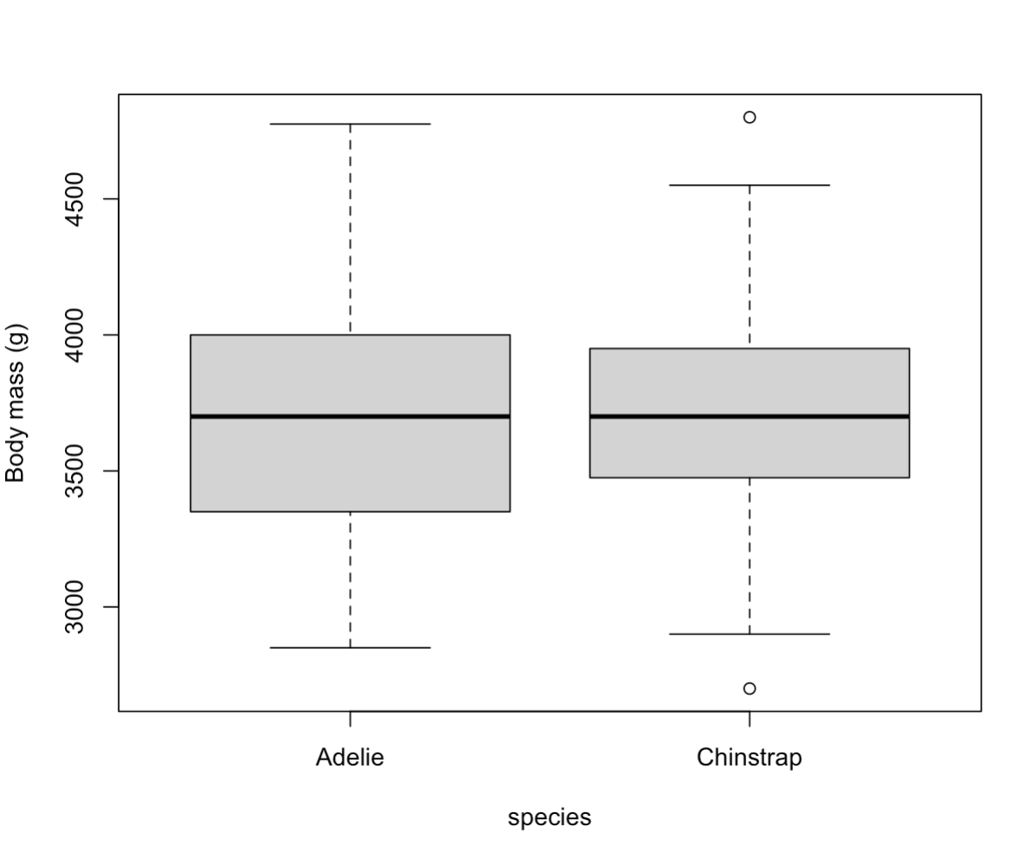

8Q:

agg_means

species body_mass_g

Adelie 3700.662

Chinstrap 3733.088

> diff_observed

[1] 32.42598

Q9:

p-value = 0.5879

There is no significant difference in the body mass between the two species. If the result would be less than 0.05 there would be a significant difference.

Q10:

sum(abs(mean_differences)> diff_crit)

result: 628

Q11:

