Elizabeth Clark

Lab 12

* **Q1 (2 pts.):** Include your plot in your lab report.

plot(

x = newdata_sample_size$sample_size,

y = predict(fit_lowess_30, newdata = newdata_sample_size), type="l",xlab = 'Sample size', ylab = 'Power',main="Sim and Lowess 30% graph")

points(

power ~ sample_size, data = sim_sample_size, type="p", main="Sim and Lowess 30% graph")

legend("bottomright", legend = c("Lowess", "Simulation"), lty = c(1,NA),pch=c(NA, 1), col = c("black"))

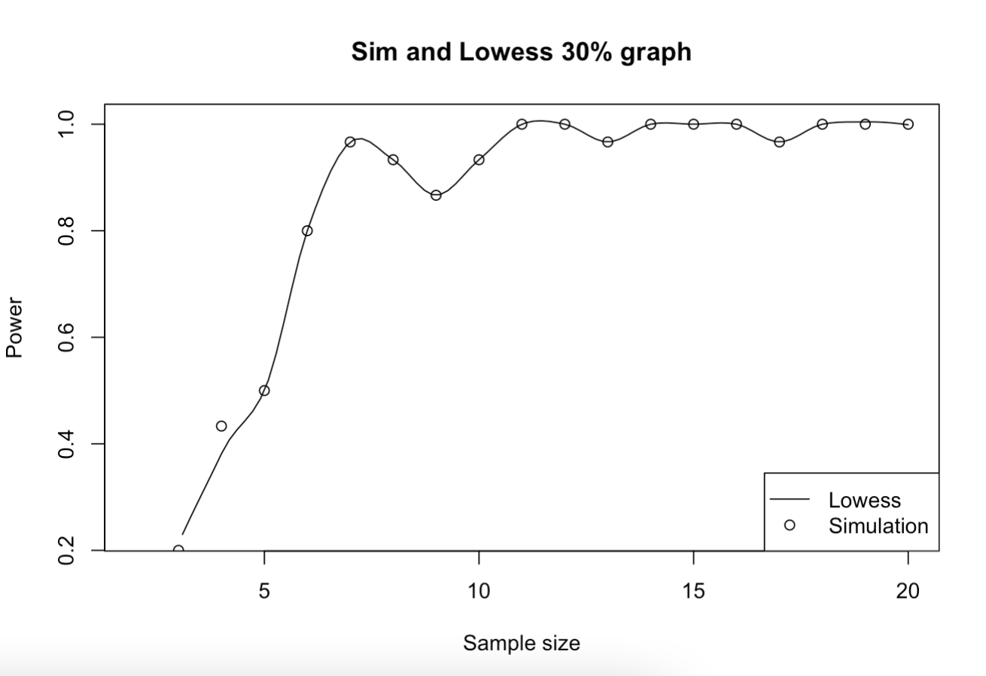

* **Q2 (2 pts.):** Include your plot in your lab report.

fit_exp_nls = nls(

disp.rate.ftb ~ exp_fun(dist.class, a, b),

data = dat_dispersal,

start = list(b = 0, a = 1))

lines(predict(fit_exp_nls, newdata = dist_newdata))

curve(

exp_fun(x, 1.55, .0039), add = TRUE, from = 0, to = 1500,

ann = FALSE, axes = TRUE, ylab = "f(x)", col = "red"); box()

legend("topright", legend = c("nls exp fit", "visual exp fit"), lty = 1, col = c("black", "red"))

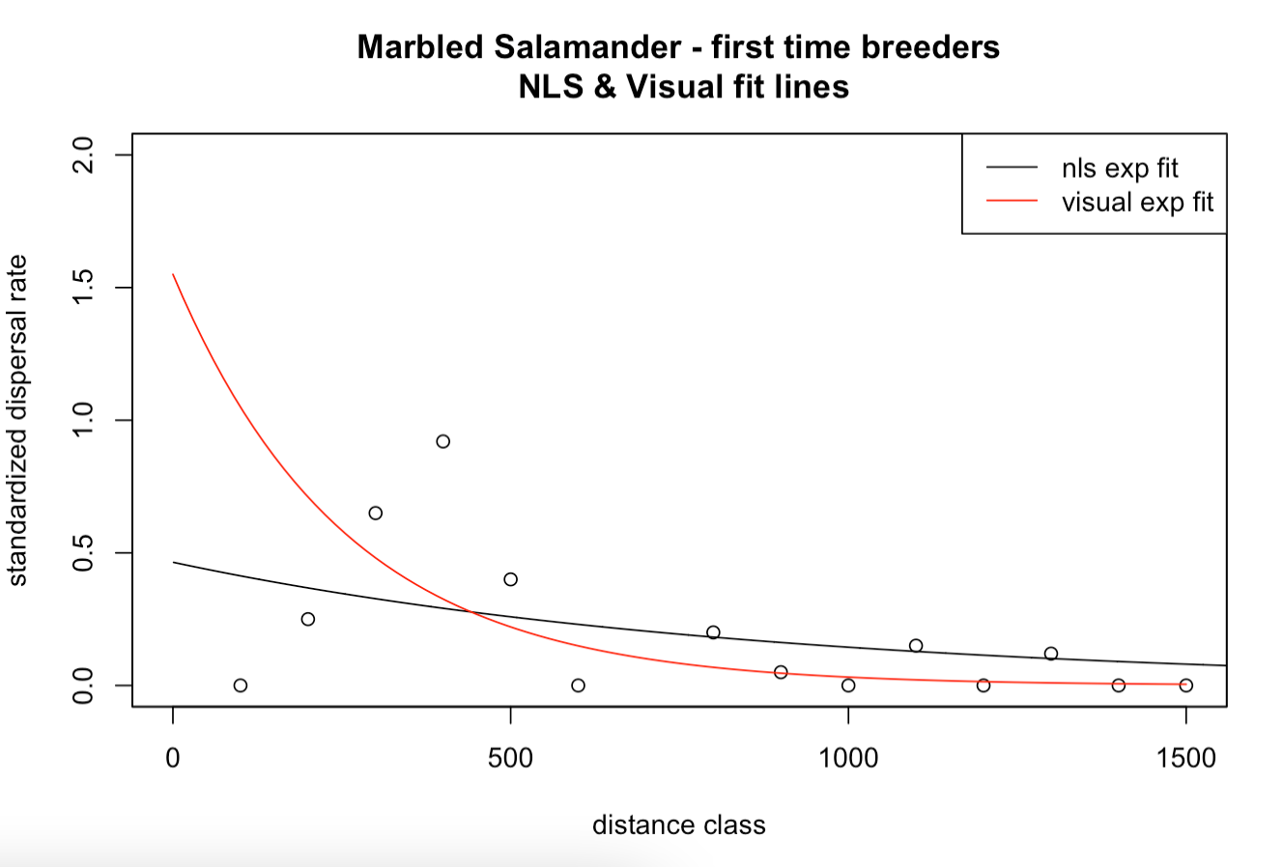

**Q3 (1 pt.):** What are the AIC values for each of the 4 models?

fit_GCKI_ba_tot 1369.379

fit_GCKI_slope 1432.615

fit_GCKI_both_additive 1355.951

fit_GCKI_both_interactive 1353.007

**Q4 (1 pt.):** Which model would you choose, and why?

Model selection based on AICc:

K AICc Delta_AICc AICcWt Cum.Wt LL

fit_GCKI_both_interactive 4 1353.04 0.00 0.81 0.81 -672.50

fit_GCKI_both_additive 3 1355.97 2.93 0.19 1.00 -674.98

fit_GCKI_ba_tot 2 1369.39 16.35 0.00 1.00 -682.69

fit_GCKI_slope 2 1432.63 79.58 0.00 1.00 -714.31

fit_GCKI_both_interactive because it has the lowest AIC value

**Q5 (1 pt.):** Based on the model coefficient table of your chosen model, describe the direction and significance of the relationship(s) of the predictor variable or variables to the binary response. Make sure your answer is in terms of the ecological context.

Coefficients:

Estimate Std. Error z value Pr(>|z|)

(Intercept) -0.2643673 0.2500615 -1.057 0.2904

slope -0.0040863 0.0045338 -0.901 0.3674

ba.tot 0.0532974 0.0109776 4.855 1.2e-06 ***

slope:ba.tot -0.0004131 0.0001866 -2.214 0.0269 *

---

Signif. codes: 0 ‘***’ 0.001 ‘**’ 0.01 ‘*’ 0.05 ‘.’ 0.1 ‘ ’ 1

This is the best fit because the coefficient table shows that when slope and total basal area data are combined into a model and compared with all of the GCKI data, the model has a very slightly negative relationship to the intercept, meaning, that this model will represent the GCKI dataset as a whole when fitting model predictions.

* **Q6 (2 pts.):** Include your two single-predictor model plots in your report

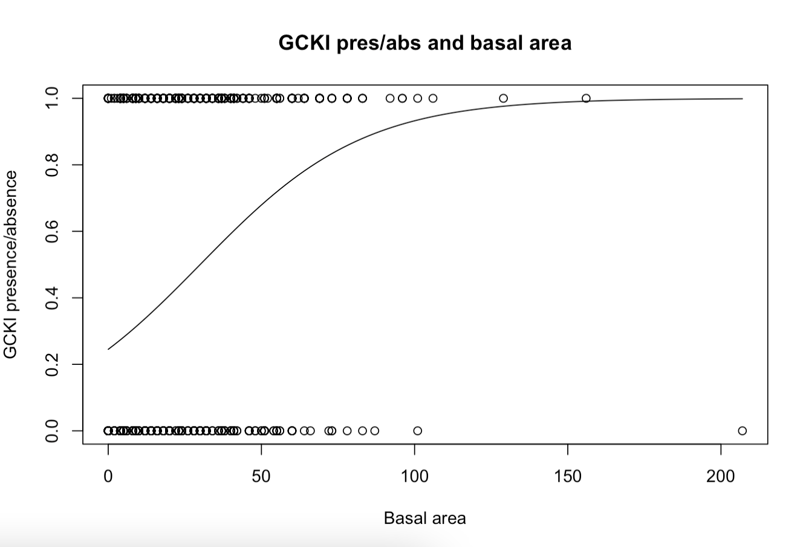

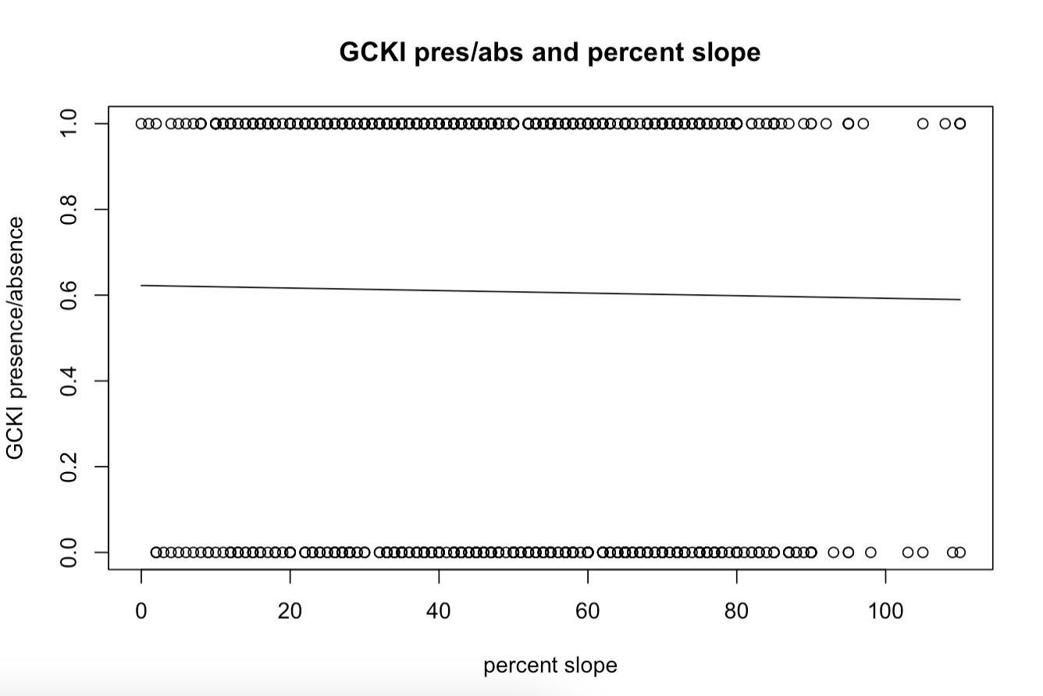

* **Q7 (4 pts.):** Include contour plots (or interactive 3D perspective plots) in your report.

