**BSc. (Honours) Computer and Digital Forensics**

**Terms of Reference**

**Using LoRa to Track a High Altitude Balloon**

***Olivia Beresford***

***W15011146***

***2018/2019***

**General Computing Project**

# Project Title:

Using LoRa to Track a High Altitude Balloon.

# Background to Project:

The Product:

To facilitate an investigation into tracking methods, a High Altitude Balloon (HAB) is a physical element of the product to be produced. A HAB is comprised of a weather balloon filled with helium, and a payload of sensors and tracking equipment and has a multitude of purposes within the scientific community. The main developmental aspect of the HAB is the payload itself. The main components within the payload to enable the investigation are: a radio transmitter, a LoRaWAN transceiver, a micro-processor, and a sensor board (containing GPS).

The main product to be made however is the software which will run on the payload itself. The processor is contains an Mbed enabled chip, facilitating the development of C/C++ programming to interconnect the sensors with the trackers. The software will control the sensor sampling rate, the encoding of the data, and the transmission via the two tracking technologies.

The Main Concepts:

HAB:

Developing HAB’s is common place within the scientific and hobbyist circles. In the UK, the MET Office is a prime example of the sheer usefulness of using HAB to enable the collection of environmental data. The Met Office launch around 4300 weather balloons per year in the UK alone to observe the atmospheric conditions at high altitude, this data is then used to feedback and improve the forecasting system (Office, 2017). The use of HAB’s in science extends to the Antarctic, where a similar experiment takes place each day. The payload is fitted with a weather sensor and launched to altitudes of 35km and transmits data back to the ground station. This data has been used to demonstrate the warming in the earth’s atmosphere over the past 30 years (Bas.ac.uk, n.d.).

Commercially, there is also a growing trend in using HAB’s to increase connectivity in remote areas where either the price of internet is too high for the population or the areas are too remote to connect the population. Google is at the forefront of commercialising the use of HAB’s in this area. Project Loon is in development with the ambition to provide free or cheap internet access to the 4.5 billion people (as of 2017) without access. The solar powered system is designed to stay at an altitude of 20km for up to two years (Nagpal and Samdani, 2017).

LoRa:

As stated in the title for this project, LoRa (an abbreviation of Long Range) is the main concept which needs to be grasped in order to understand the fundamentals of this project and the questions it poses. LoRa is a method of transferring data between devices using low power – to extend battery life time, and a low data rate, which facilitates the long range communication between devices and the network, with connectivity at 5km in built up areas, and 15km in more sparsely populated regions (Adelantado et al., 2017). To enable these long distance communications, LoRa adopts the Chirp Spread Spectrum (CSS) technique, which uses the whole bandwidth available to it (Ghoslya, n.d.). The use of CSS safeguards the signal (and therefore data) against interference from other sources and the Doppler Effect (James and Nair, 2017).

A similar investigation to this one has recently taken place in Antarctica, carried out by the scientist inhabiting the research facilities. The basis of the experiment was a frequency comparison between normal radio and Lora transmitters, analysing the data loss and interference from each. It is important in this region that any communication method used is low power (attributing to the long winters which disable the use of solar panels in power production) and effective. The study found that LoRa was a viable method of long range data transmission, depending primarily on Line of Sight (LoS) (Gaelens et al., 2017). Although taking place at ground level, this experiment can be seen as relevant to this one as it shares a lot of the same factors: good LoS for the majority of the experiment, sub-zero temperatures, and a demonstration of long range communication up to 30km with good LoS. All of these were important factors in the success of this experiment, and also inform this one of the possible outcomes and issues that could arise.

Why this project?

This project idea came about following a year in industry, where I gained experience in embedded programming and worked with sensors and senor data on a regular basis. The idea of an investigation into tracking methods came about as a product of collaboration between me and my supervisor, as it offered an interesting basis for a project.

The main questions which arise from this project are: Is it possible to track a HAB using LoRa? What benefits does it have over traditional methods of tracking such as radio?

The report will use the results from the tests and the final launch/recovery data to answer these questions. This investigation is not new within the HAB community, experimenting with LoRa as a tracking method has become much more common place. Raspberry Pi have launched a hobbyist kit which is comprised of a RTTY and LoRa transmitter, which is intended for use in HAB payloads for data transmission and tracking (Pi-in-the-sky.com, 2016).

The technologies involved in this project present interesting features and challenges. Firstly LoRa, the key component of the investigation, is a device I have not worked with before. However, its use in recent studies and growing popularity demonstrate that it is possible to use it within the confines of the project and my own personal skill level. The use of LoRa in HAB payloads is still relatively new. While there are plenty of studies done on using it at ground level and low altitude, there are not many which demonstrate its use it at an altitude of 30km+. This project is an opportunity to try and use the technology in combination with the Mbed enabled processor on board to answer the questions presented. To compare the results to those of the radio transmitter is an interesting experiment in data transmission between two different methods of connectivity at high altitude.

# Proposed Work:

To complete this project, a high altitude balloon must be developed. The payload will contain a sensor board, a micro-processor, a LoRa transceiver, radio transmitter, battery and antenna. The main piece of work that needs to be carried out within this project is the development of the embedded software which will run on the processor and control the sensors and the transmission of data to the ground station. Another area of work which is required is involve the creation of the sensor board using PCB design software, building it, and testing it. The two sections will be tested independently before being integrated and tested as a unit. When these tests are complete and any problems are resolved, the payload will be launched and data gathered by both the ground station and a data logger on board.

To further this project, academic research will be done alongside the technical aspects to create a basis of understanding for the work which is being done and also to write the project report.

The biggest question to be answered in this project is: Can a High Altitude Balloon be tracked using LoRa technology? To answer this question, the areas that must be investigated to complete project work are:

* LoRa
  + What is it?
  + How is it currently used?
  + What are the alternatives?
* High Altitude Balloons
  + What are they?
  + What is their relevance to technology?
  + What is the point?

Alongside the theoretical knowledge that will be acquired from the investigations above, practical knowledge is also vital to answering the question. These areas which need investigating are:

* Embedded software
  + Using an mbed enabled microprocessor is a new learning curve, therefore needs thorough investigating to complete the project.
* Electronics
  + It is important that the modules within the payload work together to enable the successful tracking of the flight. This will require in depth investigation to build the system correctly.

The areas to be covered by the literature review will be:

* LoRa
  + As this is one of the main components to the project, forming the title and basis of the project, the literature review on this topic will be extensive. This is important because it will form the basis of understanding for the practical work of the project and also provide the reasoning behind the project and investigation.
* Radio communications
  + This is another significant area of research which needs to be covered thoroughly within the literature review, as it too is significant to the project. A radio transmitter will be used as a secondary tracking system within the HAB, and will therefore provide a comparison of the capabilities between the two tracking methods.
* High Altitude Balloon
  + This section of the literature review will cover the platform on which the tracking investigation takes place. This is an important topic to cover in this stage of the project as it is part of the basis of the project. Understanding the past, current, and future uses of this technology is key to understanding the potential usefulness of the investigation taking place.

# Aims of the Project:

For this project the Aims are as follows:

* To develop a High Altitude Balloon to enable an investigation into tracking methods.
* To investigate the use of LoRa as an effective tracking method compared with traditional radio methods at high altitude.

# Objectives:

1. Identify relevant sources of information to give background to the project and support the creation and growth of relevant skills.
2. Identify tools and methods which be useful in the process of creating the product.
3. Create the requirements specification for both hardware and software elements.
4. Creation of designs for both the embedded software and hardware.
5. Write embedded software.
6. Creation of test documents for both hardware and software elements.
7. Creation of comprehensive integration documents.
8. Production of documentation for product implementation.
9. Launch the high altitude balloon and get data.
10. Write dissertation.
11. In depth evaluation of work produced.
12. Evaluation of investigation results.

# Skills:

|  |  |
| --- | --- |
| **Skills** | **How Acquired?** |
| Theoretical electronics and PCB design | This is a skill is based on one I gained during my industrial placement. This project will continue to build upon it as schematics will need to be drawn, converted into PCB and designed to maximise efficiency of the board. This process will also help to develop an understanding of how the complete payload hardware and software works together. |
| Practical electronics skills | This skill is also based on a skill learnt during the year in industry. This skill includes soldering the PCB and testing the built boards using the appropriate equipment. |
| Embedded software development | This is another skill created on placement, and will be the integral part of the project. This will involve using C to program the Mbed enabled chip. |
| Report writing skills | This skill will build on previous experience at university where report writing has been prevalent. To develop this skill, Skills Plus – provided by the university, will be used. |
| Research methods | As above, this will build on previous university assignment experience with the additional help from the university service of Skills Plus. |
| Wireless and radio communications | This is a new skill which will be developed using the knowledge gained during the module EN0639 Mobile, Communications and Security. This is vital area of knowledge which needs to be developed to achieve the highest understanding of the project. |

# Sources of Information/Bibliography:

References:

Adelantado, F., Vilajosana, X., Tuset-Peiro, P., Martinez, B., Melia-Segui, J. and Watteyne, T. (2017). Understanding the Limits of LoRaWAN. *IEEE Communications Magazine*, [online] (9), pp.34-40. Available at: https://ieeexplore.ieee.org/document/8030482 [Accessed 1 Oct. 2018].

Bas.ac.uk. (n.d.). *Halley weather balloons - British Antarctic Survey*. [online] Available at: https://www.bas.ac.uk/polar-operations/sites-and-facilities/facility/halley/weather-balloons/ [Accessed 20 Oct. 2018].

Gaelens, J., Van Torre, P., Verhaevert, J. and Rogier, H. (2017). LoRa Mobile-To-Base-Station Channel Characterization in the Antarctic. *Sensors*, [online] 17(8), p.1903. Available at: https://www.mdpi.com/1424-8220/17/8/1903 [Accessed 2 Oct. 2018].

Ghoslya, S. (n.d.). *LoRa: Symbol Generation*. [online] Sghoslya.com. Available at: http://www.sghoslya.com/p/lora-is-chirp-spread-spectrum.html [Accessed 2 Oct. 2018].

James, J. and Nair, S. (2017). Efficient, real-time tracking of public transport, using LoRaWAN and RF transceivers. In: *TENCON 2017 - 2017 IEEE Region 10 Conference*. IEEE, pp.2258-2261.

Nagpal, L. and Samdani, K. (2017). Project Loon: Innovating the connectivity worldwide. In: *2017 2nd IEEE International Conference on Recent Trends in Electronics, Information & Communication Technology (RTEICT)*. [online] IEEE, pp.1778 - 1784. Available at: https://ieeexplore.ieee.org/document/8256905 [Accessed 6 Oct. 2018].

Office, M. (2017). *Did You Know? We’re testing new weather balloons: from Cornwall to Antarctica!*. [online] Official blog of the Met Office news team. Available at: https://blog.metoffice.gov.uk/2017/10/27/did-you-know-were-testing-new-weather-balloons-from-cornwall-to-antarctica/ [Accessed 18 Oct. 2018].

Pi-in-the-sky.com. (2016). *Welcome to the Pi In The Sky Project - Pi In The Sky Project*. [online] Available at: http://www.pi-in-the-sky.com/ [Accessed 11 Oct. 2018].

Bibliography:

Arm Mbed. (n.d.). *Mbed OS | Mbed*. [online] Available at: https://www.mbed.com/en/platform/mbed-os/ [Accessed 15 Oct. 2018].

Carbonés Fargas, B. and Nordal Petersen, M. (2017). GPS-free Geolocation using LoRa in Low-Power WANs. In: *2017 Global Internet of Things Summit (GIoTS)*. IEEE.

Georgiou, O. and Raza, U. (2017). Low Power Wide Area Network Analysis: Can LoRa Scale?. *IEEE Wireless Communications Letters*, 6(2), pp.162-165.

Low-Cost High-Altitude Ballooning. (2017). *Computer*, 50(7), pp.26-28.

Mahmood, A., Sisinni, E., Guntupalli, L., Rondon, R., Hassan, S. and Gidlund, M. (2018). Scalability Analysis of a LoRa Network under Imperfect Orthogonality. *IEEE Transactions on Industrial Informatics*, pp.1-1.

Physicsclassroom.com. (n.d.). *The Doppler Effect*. [online] Available at: https://www.physicsclassroom.com/class/waves/Lesson-3/The-Doppler-Effect [Accessed 23 Oct. 2018].

Ukhas.org.uk. (n.d.). *general:beginners_guide_to_high_altitude_ballooning [UKHAS Wiki]*. [online] Available at: https://ukhas.org.uk/general:beginners_guide_to_high_altitude_ballooning [Accessed 1 Oct. 2018].

# Resources:

|  |  |  |  |  |
| --- | --- | --- | --- | --- |
| **Hardware** | **What is it?** | **How provided?** | **Purpose** | **Back –up** |
| Solder Iron | Enable the building of the PCBs produced. | External resources. | Will be used to build the sensor board. | University resources. |
| Computer | Enable the production of the report and coding the micro-processor. | Personal laptop. | Will be used to write report and code the processor. | University resources. |

|  |  |
| --- | --- |
| **Equipment** | **Purpose** |
| FRDM-K64F micro-processor | To run the software controlling the processes of the sensor board, both transmitters and cameras. |
| Sensor board (GPS, Data Logger, Pressure Sensor, Temperature Sensor, Accelerometer) | A basic board to hold the sensors required for the payload. |
| LoRa Transceiver | Tracking method 1. Receives a position from a (insert word here when you remember it) and transmits to the ground station. |
| Radio Transmitter | Tracking method 2. Uses the data from the GPS module and transmits to the ground station. |
| Battery | Power boards and modules. |
| Camera Modules | Take pictures of the view from the payload. |

|  |  |  |  |  |
| --- | --- | --- | --- | --- |
| **Software** | **What is it?** | **How Provided?** | **Purpose** | **Back-up** |
| DipTrace | Schematic and PCB design suite. | Available for download online from the DipTrace website | Will be used for the creation of the sensor board which will be part of the payload electronics. | Eagle – available for free on the Eagle website. |
| Mbed | Online Mbed development IDE. | Available free online. | Will be used to develop the software which will run on the micro-processor within the payload. | Seggar Embedded Studio – Available to download free from the Seggar website. |
| dl-fldigi | Software to decode radio signals from balloon. | Available for download free from github | Listens and decodes radio signals and uploads location to a map via the internet. |  |
| Habitat | Web tracking tool. | Website. | Uses the signal from dl-fldigi, and plots it on the map. | Google Earth can also be used. |
| Virtual Box | Virtual machine creation software. | Available online. | Will be used to interface with the processor and to load the compiled code onto it. | VMWare – available online. |

During the preparation for the Terms of Reference, a rough cost estimate was drafted to a cost of £300-£350. This included the hardware in the payload, the peripherals, and the ground equipment. Although the University is supplying the LoRa kit and the FRDM-K64F micro-processor, the rest of the cost will be my responsibility. It is also my responsibility to replace any of the equipment I buy if it should break in the process of the project.

# Structure of the Report:

Report Structure:

Abstract: (Objective 9)

This brief section will give an overview of the aims and objectives of the project, detailing the findings of the report.

Introduction: (Objective 9)

Building on the Abstract, the introduction will provide more detail into the aims and objectives of the investigation, as well as introducing the themes which will occur throughout the project report. The introduction will also lay out the final results found as a result of the investigation undertaken during the time frame.

LoRa vs Radio: (Objective 1, 9)

This chapter will introduce the concepts of LoRa and radio, using scientific articles and journals. This chapter will discuss the current uses of both in technology and technology related to the investigation. The main part of this chapter will be looking at both methods; specifically looking into the advantages and disadvantages of both. The final part of this chapter will be a comparison between the two technologies.

Using High Altitude Balloons to advance technology: (Objective 1, 9)

This will be a shorter analysis chapter than the technologies chapter as it is not directly relevant to the computing investigation of the project. However, this platform is required to complete the investigation. This chapter will use scientific journals and articles to give the reader an understanding into the use of high altitude balloons and their relevance in technology, as well as framing their short falls.

The Investigation: (Objective 1, 9)

This chapter uses the understanding gained in the two previous chapters, as well as previously completed studies into the topic (or similar) to set out the premise of the investigation and the question is endeavouring to answer. This will include expected issues and challenges as well as a hypothesised answer, according to the second hand information gathered.

Tools and methods: (Objective 2, 9)

(Could this be included in the above chapter?)

This chapter will be an explanation and a justification into the tools and methods needed to complete the investigation. This will include both software and hardware sides of the project, but will focus on the software development tools and methods.

Requirements of the product: (Objective 3, 9)

This will be a chapter to explain and justify the requirements for both the hardware and the software, in order to assist in the successful investigation, the project is undertaking.

Software design and implementation: (Objective 4, 9)

This chapter on the design and implementation of the software necessary for the product will be at a high level, drawing on the documents created (in appendices) to explain and justify design decisions. It will also explain the basic structure of the code, explaining how it works and will be implemented in the final product, the full code will not be given in this section but short, selective, areas of interest will be included to give depth to the understanding.

Software testing and results: (Objective 5, 9)

The software testing and development chapter will be another high level view of the test plan and test results which are given in full in the appendices. This will justify the test plan and explain points of interest within the results. Also included in this section will be the main problems found when testing the software and how these were resolved.

Hardware: (Objective 3, 4, 5, 9)

As the hardware element of the project is not the most important element in terms of computing, this section will encompass the same elements as the above two chapters but adapted to suit the hardware. The same documentation (designs, test plan, test results) will be included in the appendices, and explained in this chapter.

Integration: (Objective 6, 9)

This chapter will briefly discuss the process of integrating the software and hardware, drawing on the test plan and results within the appendices. It will also give a quick overview of the problems found and resolutions.

Product Implementation (Launch Day): (Objective 6, 7, 9, 8)

This chapter will discuss the processes of launching the product, from the legal issues and pre-launch procedures. Documentation in the form of images of the launch will be included in the appendices. Also included will be the process of tracking the payload and hopeful recovery.

Investigation results: (Objective 11, 9)

This chapter will use the data (in the appendices) to explain the results of the investigation, using graphs created from the raw data and an analysis of what they show. This will also include the analysis of LoRa vs radio methods of tracking.

Software evaluation: (Objective 10, 9)

This chapter will evaluate the embedded software produced in light of the completed investigation. Stating what worked well and what could have been done better.

Conclusion: (Objective 9)

The conclusion chapter will state whether or not LoRa can be used as a viable tracking method for High Altitude Balloons, drawing on the investigation results evaluated.

List of Appendices:

In this project report, the appendices which will be included in the final submission are:

* Project Initiation Document
* Terms of Reference
* Risk assessment
* Ethical assessment
* Software
  + Requirements specification
  + Designs (UML diagram)
  + Test plan
  + Results
* Hardware
  + Requirements specification
  + Designs (schematics, board designs)
  + Test plan
  + Test results
* Integration
  + Test plan
  + Test results
* Documentation relating to launch day
  + Images of launch process
  + Legal documents (CAA)
  + Results

# Marking Scheme:

Project type:

This project will be assessed against the criteria for a General Computing Project. The mark scheme for this type of project is as follows:

|  |  |
| --- | --- |
| Report | 60% |
| Product | 30% |
| Viva | 10% |

Project Report:

For the project report structure, the sections and corresponding weight to fit a report for a General Computing Project is detailed below:

|  |  |
| --- | --- |
| Abstract and Introduction | 5% |
| Analysis | 30% |
| Synthesis | 30% |
| Evaluation and Conclusions | 30% |
| Presentation | 5% |

To ensure that the mark scheme for the project is met to a high standard the following chapters (as framed above) can be contained within the sections listed below.

Analysis:

* LoRa vs Radio
* Using High Altitude Balloons to advance technology
* The Investigation
* Tools and methods
* Requirements of the product

Synthesis:

* Software design and implementation
* Software testing and results
* Hardware
* Integration
* Product Implementation (Launch Day)

Evaluation and Conclusion:

* Investigation results
* Software evaluation
* Conclusion

Product:

The mark scheme to be followed for the product that is produced as part of the General Computing Project is:

|  |  |
| --- | --- |
| Fitness for Purpose | 50% |
| Build Quality | 50% |

Hardware:

The hardware which will be produced in the process of this project is a High Altitude Balloon (HAB) consisting of a payload which will contain a group of sensors, a microprocessor running Mbed code, a radio transmitter, and a LoRa transceiver. The sensors will be on their own specially designed board which will connect via wires to the processor, the processor will also connect to the two transmitters, and the battery unit. Two camera units will also be included within the payload to capture images of the flight. The payload has to be carefully designed to cope with the freezing temperatures at high altitude, the drop in pressure, be low-power to ensure maximum battery life, and finally – it must survive impact with earth.

Software:

The main computing aspect of this project is the software by which the elements of the payload are linked and utilised, with the data they produce being saved onto an SSD card and also adapted to be transmitted via radio-waves to the ground station. Another piece of software will be needed at ground level to receive and parse data from the two tracking devices into interpretable information, such as a GPS location and other important sensor data. These can then be compared and used to provide an accurate position of the HAB. As well as provide results for analysis in case of a failed recovery. This will be written on the Mbed online platform using C++.

Documentation:

The documentation to be produced for this product is:

* Requirements specification (for both hardware and software)
* Designs (for both hardware and software)
  + Hardware:
    - Schematics
    - Board designs
  + Software
    - UML diagrams
* Test plan (for both hardware and software)
* Test results (for both hardware and software)

# Project Plan:

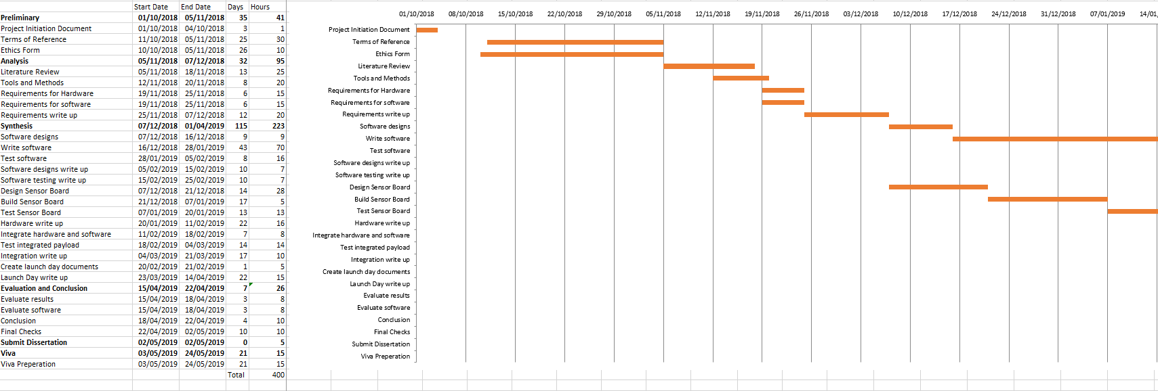

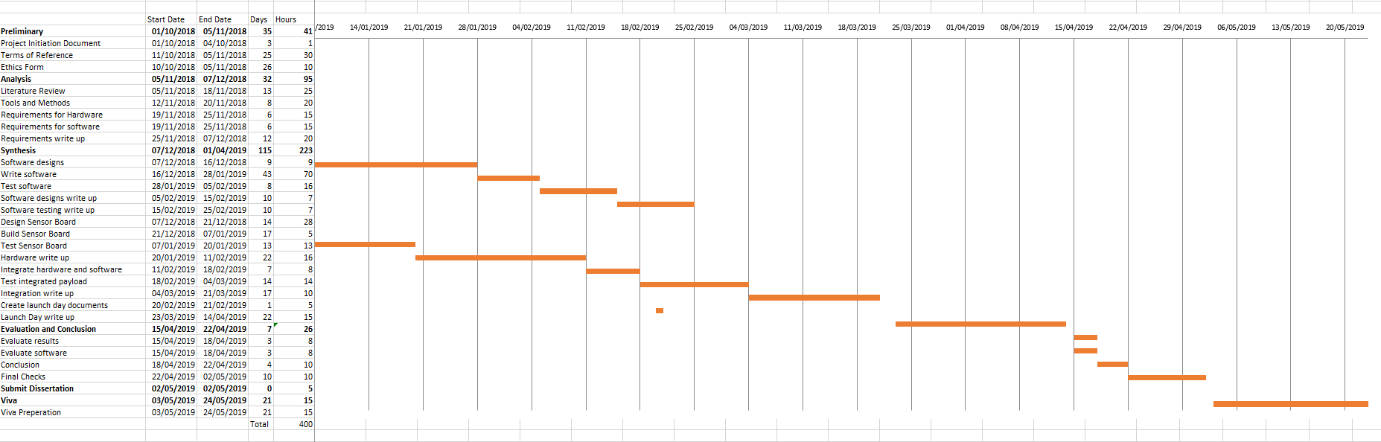

# Appendix:

Supporting Material:

Risk Assessment Form:

|  |  |
| --- | --- |
| **Student Name** | Olivia Beresford |
| **Student ID** | W15011146 |
| **Student Email** | olivia.beresford@northumbria.ac.uk |
| **Course Title** | Computer and Digital Forensics |
| **Project Title** | Using LoRa to track a High Altitude Balloon |
| **Project Location** | Newcastle/Cambridge |
| **List the Significant Hazards associated with your project** *(continue on a separate sheet if necessary)* | Soldering  RF sources  Hazardous Chemicals (Flux, Flux Cleaner, Isopropyl Alcohol)  Risk to aircraft  Risk to public |
| **List the other people at risk** *(continue on a separate sheet if necessary)* | (Team members on launch day – RF sources) |
| **Describe the working procedures to be used to minimise risk** *(continue on a separate sheet if necessary)* | Soldering – Appropriate stand and heat protective mats, as well as the use of an extraction system and safety glasses.  RF sources – both the radio and LoRa transmit in the licensed exempt part of the spectrum (863 – 870Mhz) but this is not harmful for the amount of time exposed.  Hazardous Chemicals – Extraction system, safety glasses to be worn, spills reported and cleaned. Exposure intermittent, as such is unlikely to cause a major issue.  Risk to aircraft – to reduce the risk to aircraft, permission must be requested and granted by the Civil Aviation Authority, who issues a Notice to Airmen (NOTAM). Furthermore, just before launch, Air Traffic Control (ATC) must be contacted to confirm the launch and get the go ahead.  Risk to public – to reduce this risk, the payload container is made of polystyrene, and the total mass of the payload is kept below 2kg to minimise the risk to the public and property on landing, any antenna which are visible are kept flexible. The payload is also launched with a pre-deployed parachute; this slows the rate of descent of the payload and reduces the risk of serious damage on landing.  Prediction software is available free online to calculate the landing site. Permission from ATC is gained after a predicted flight path which avoids a landing in densely populated areas, such as towns and cities, as well as avoiding other air traffic. |
| **Are any other Risk Control Measures needed?** *(continue on a separate sheet if necessary)* |  |
| **When will you and your supervisor review the risk assessment? How will the risk be monitored on an on-going basis?** | Week 2 of Semester 2.  Closer to the flight day, the risk assessment will be re-assessed and adapted to fit any changes or new risks. |
| **Are you aware that no one is allowed to work alone in the specialist laboratories?** | Yes/No |

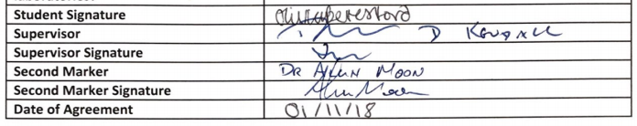

Sent Into Space (<https://sentintospace.com/>) Testimony:

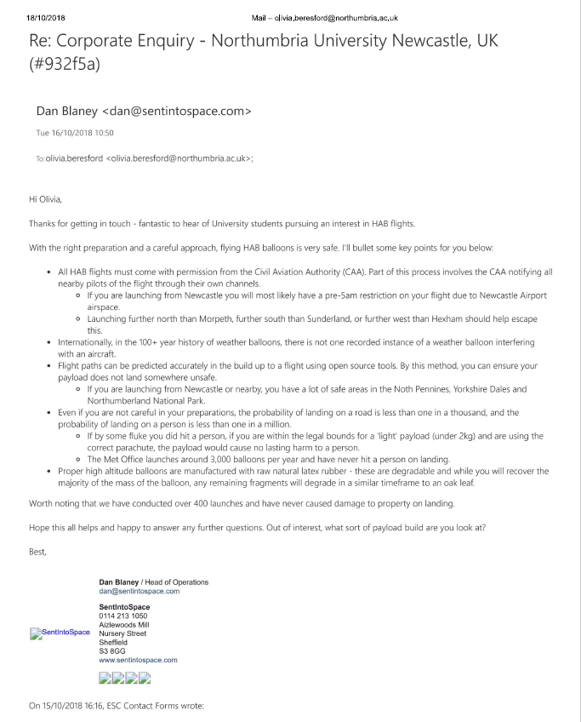

Air Navigation Order Form (Sent to CAA 28 days in advance)



Page 24 of the SERA, AIR NAVIGATION ORDER 2009 AND RULES OF THE AIR REGULATIONS 2015

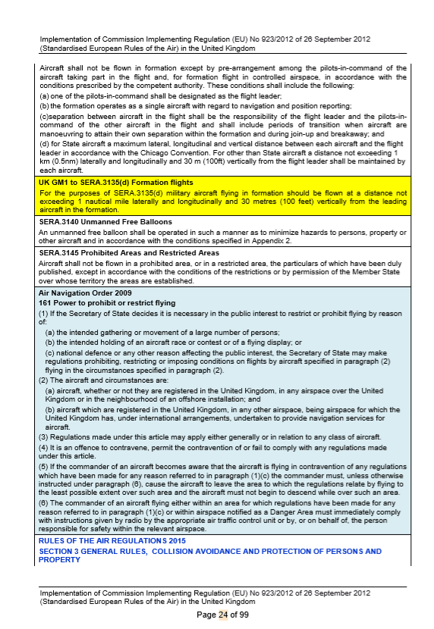

Appendix 2, pg. 88 of the SERA, AIR NAVIGATION ORDER 2009 AND RULES OF THE AIR REGULATIONS 2015

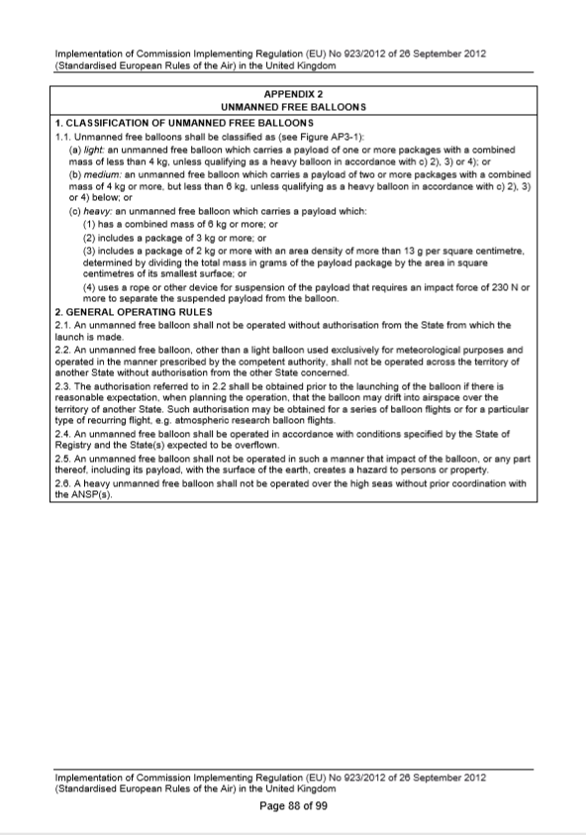

Links:

UK High Altitude Society:

<https://ukhas.org.uk/guides:guidelines>

Met Office:

<https://blog.metoffice.gov.uk/2017/10/27/did-you-know-were-testing-new-weather-balloons-from-cornwall-to-antarctica/>

MetLink:

<http://www.metlink.org/observations-and-data/balloon-launch/>

Sandringham School:

<https://www.sandringham.herts.sch.uk/sandringham-launch-a-spacecraft/>

European Astrotech:

<http://www.spaceballoons.co.uk/index.php>