**CS673 - Homework1 - Xiaohong Chen**

Question2:

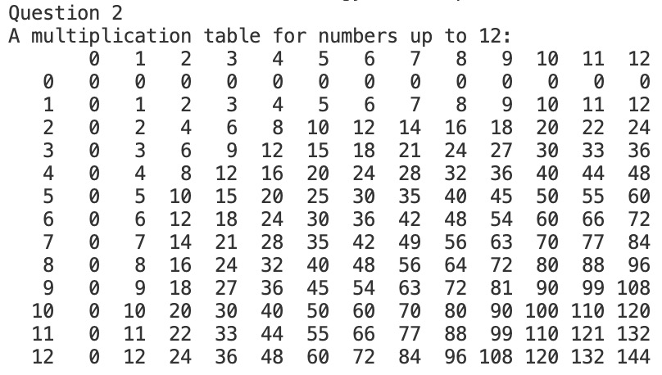

Question3:

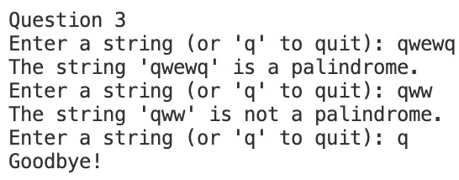

Question4:

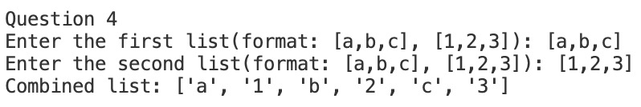

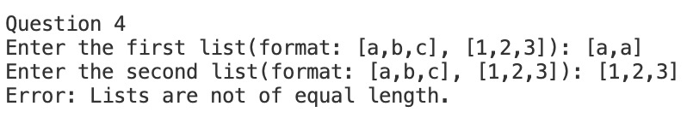

Question5:

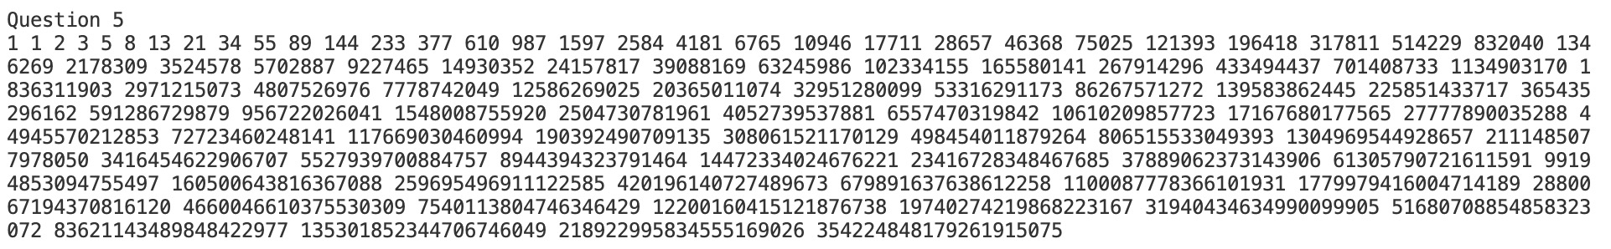

Question6:

