1.Home | Laptop → Wi-Fi ping | www.kth.se

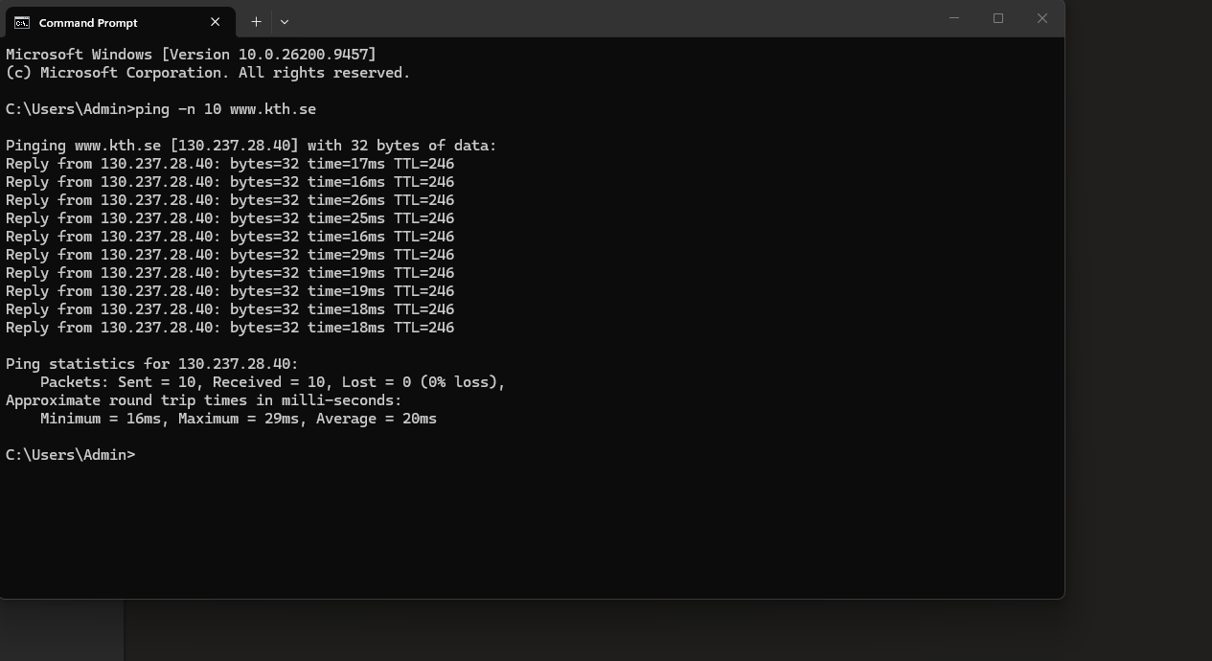
2.Mobile | Mobile → Hotspot ping | www.kth.se

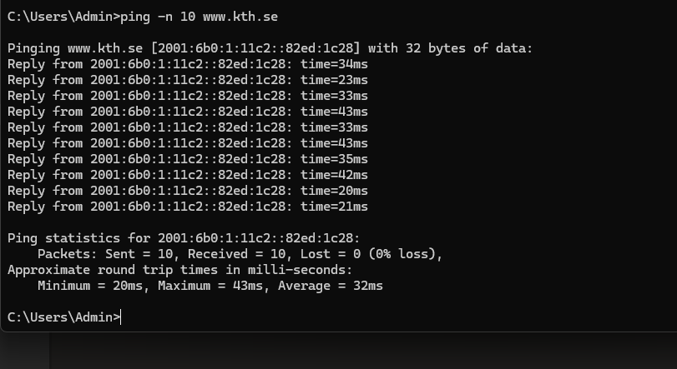
3.Long distance | laptop → wifi ping mirror.aarnet.edu.au

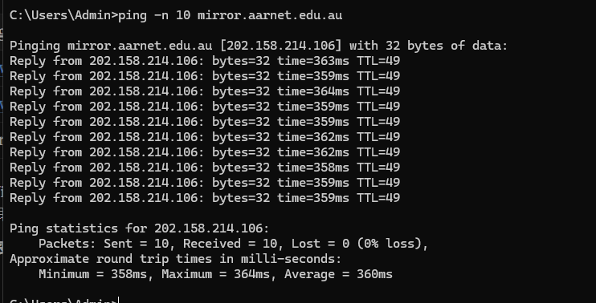

4. mobile hotspot and Home wifi speed
