7.1.2 Workflow Calibration Result of Stage 2
Stage 2 calibration used the frozen maturity-scoring prompt as P0 and applied it to the indicator-defined V4 evidence bank. Five subsequent prompt variants were evaluated after targeted refinements. The comparison did not use the existing Togo maturity assessment as an optimisation target; instead, outputs were scored on procedural qualities required by the workflow: parseability, indicator coverage, evidence-ID traceability, phase-gate consistency, justification depth, treatment of contrary or limiting evidence, and specificity of the next-phase gap.
Prompt | Refinement | Score | Parse failures | Coverage | Unknown IDs | Gate failures | Thin reasoning | Weak gaps
P0 | Frozen baseline prompt; no additional refinement. | 203/217 | 0 | Yes | 1 | 0 | 9 | 3
P1 | Direct-support evidence list restricted to IDs supporting the assigned phase. | 206/217 | 0 | Yes | 2 | 2 | 6 | 1
P2 | Scope-limiting and implementation-limiting evidence added to contrary/limiting logic. | 200/217 | 0 | Yes | 1 | 0 | 15 | 1
P3 | Next-phase gap required to name the exact unmet requirement and proof needed. | 139/217 | 1 | No | 9 | 2 | 5 | 0
P4 | Reasoning required to name concrete institutions, instruments, systems or practices. | 212/217 | 0 | Yes | 0 | 1 | 4 | 0
P5 | Final consistency audit across phase, requirement checks, limitations and gap. | 212/217 | 0 | Yes | 0 | 0 | 5 | 0
Column definitions: Score is the composite procedural score out of 217. Parse failures count dimension-level outputs that could not be parsed as JSON. Coverage indicates whether all 31 expected indicators were returned exactly once. Unknown IDs count citations not present in the supplied evidence bank. Gate failures count indicators whose assigned-phase requirement checks were missing or not all SUPPORTED. Thin reasoning counts justifications below the minimum depth threshold. Weak gaps count next-phase-gap fields that were too generic or insufficiently evidence-sensitive.
P5 was selected and frozen because it tied P4 on the aggregate score (212/217) while eliminating the remaining phase-gate failure. The frozen prompt hash is A3734A364931D5AAA90188C82EEE400B0812023A5D4DCB14DA70D917067669AF. This result supports a bounded workflow-calibration claim: the selected prompt showed the strongest procedural compliance in this Stage 2 calibration, but the substantive correctness of the resulting maturity phases remains dependent on expert review.
Figure file: Figure_7_1_2_Full_Frozen_Stage2_Prompt_P5.png. This image renders the full frozen P5 prompt used after calibration.

Figure 7.1.2a. Stage 2 calibration scores by seven procedural checks.
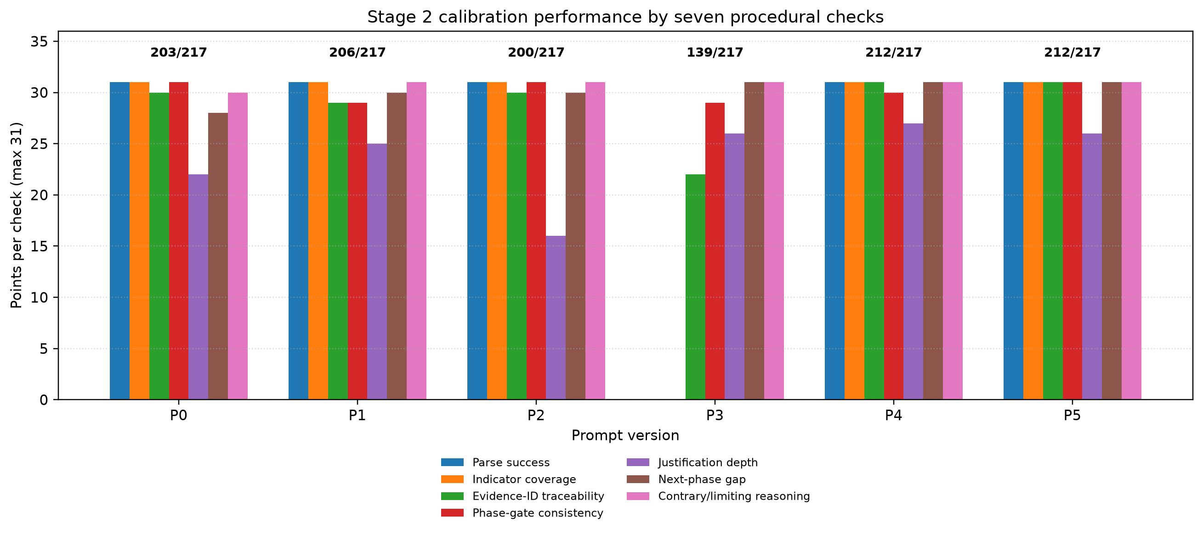
Each bar group shows the points awarded to a prompt version for the seven output-quality checks. Each check contributes up to 31 points, corresponding to the 31 DEMA indicators. Labels above the groups show the total procedural score out of 217.

Figure 7.1.2b. Example Stage 2 output for one indicator.
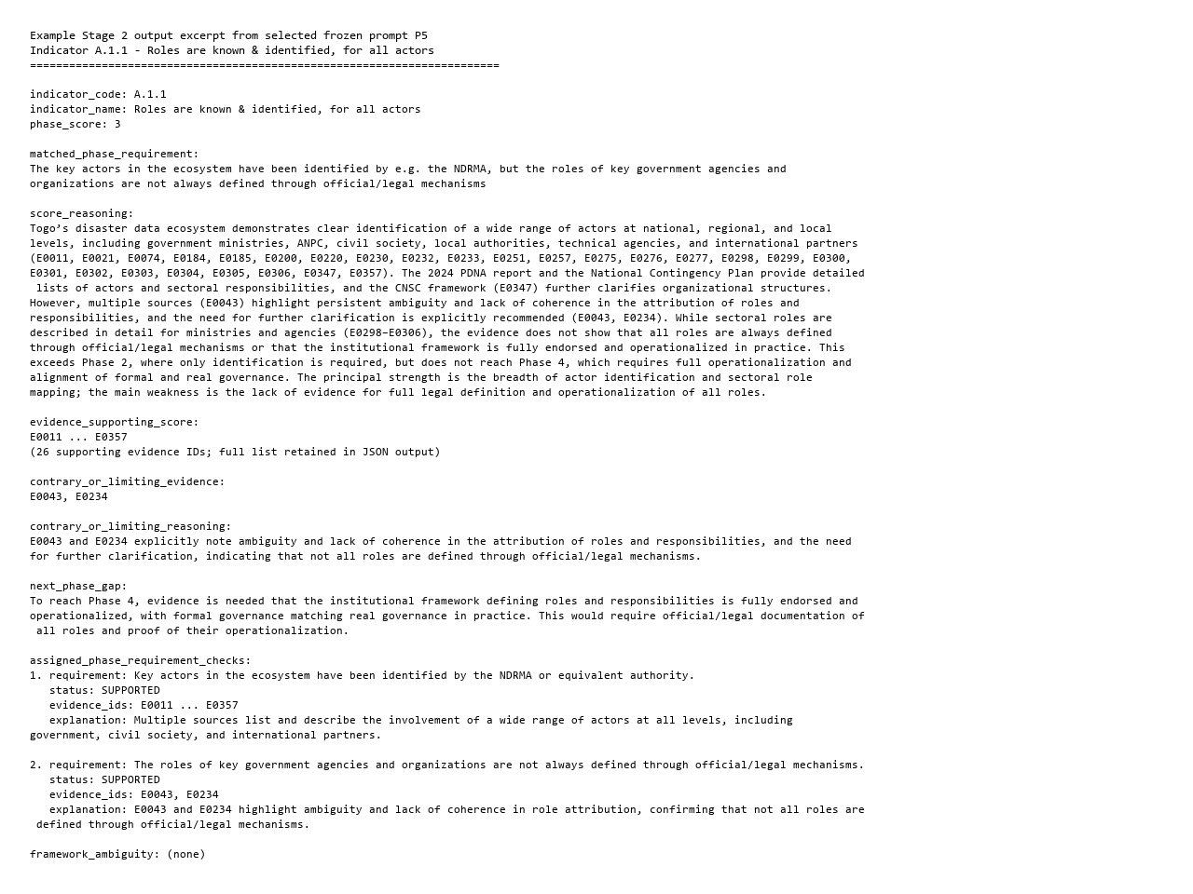
The example shows the selected P5 prompt's JSON structure for one indicator, including the assigned phase, supporting evidence IDs, limiting evidence, next-phase gap and assigned-phase requirement checks.

