MLDR

Regle2 :
images = (id_img COUNTER, url_img VARCHAR(250), nom_img VARCHAR(100), text_img VARCHAR(300), ext_img TEXT);
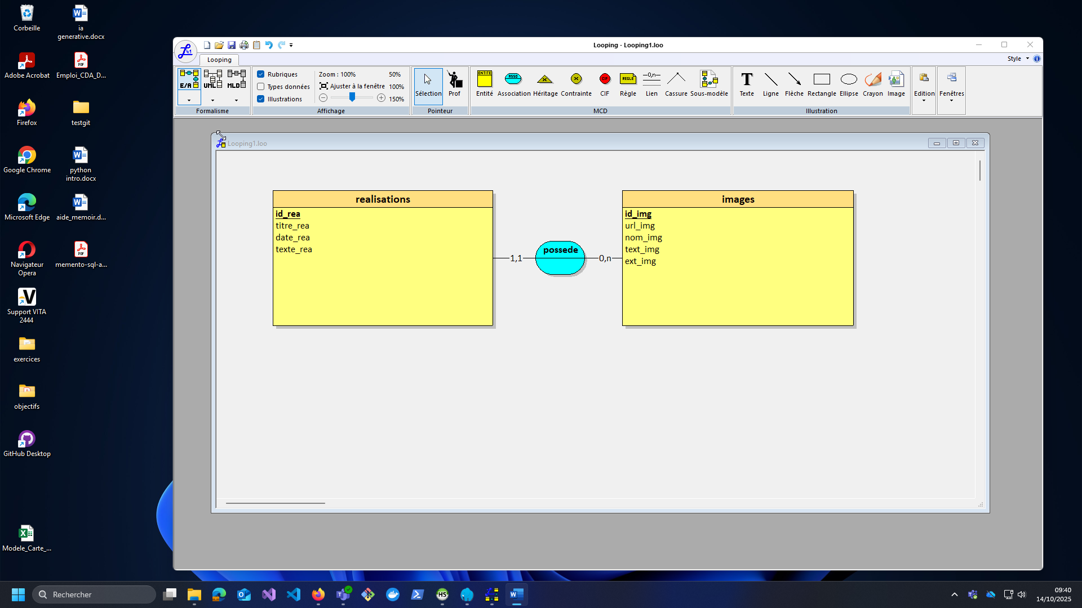
realisations = (id_rea COUNTER, titre_rea VARCHAR(250), date_rea DATE, texte_rea TEXT, #id_img);

ALTER TABLE realisations ADD FOREIGN KEY (id_img) REFERENCES images(id_img);
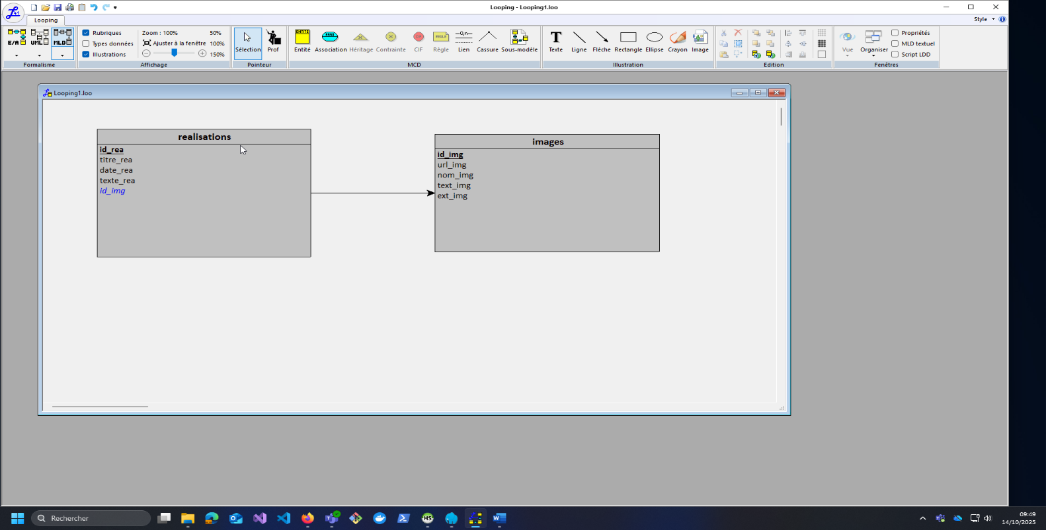
Regle1 :
realisations = (id_rea COUNTER, titre_rea VARCHAR(250), date_rea DATE, texte_rea TEXT);
images = (id_img COUNTER, url_img VARCHAR(250), nom_img VARCHAR(100), text_img VARCHAR(300), ext_img TEXT, #id_rea);

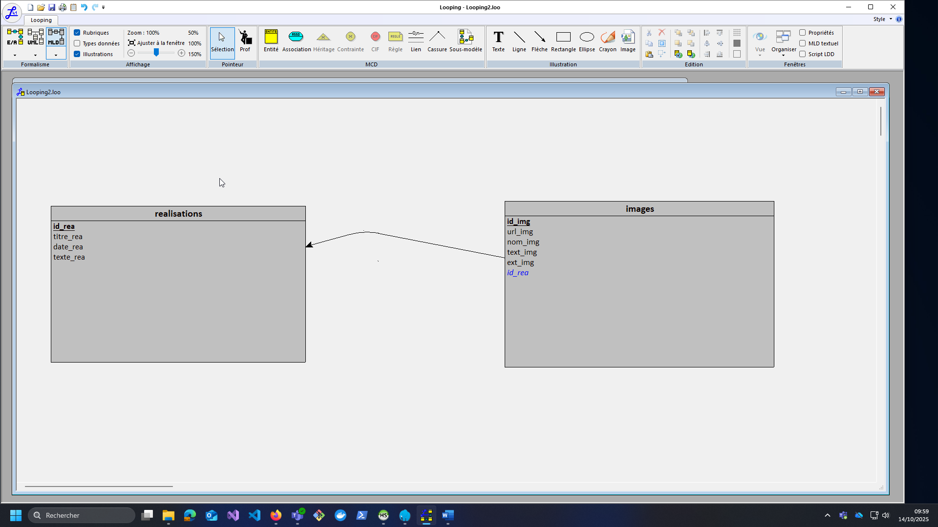

ALTER TABLE images ADD FOREIGN KEY (id_rea) REFERENCES realisations(id_rea);

/* partie 2 question 3 */
SELECT nom_img, ext_img
FROM images
WHERE id_rea = 1;
