lightest_focuserwheel
This project has been highly inspired by astroberry-diy (https://github.com/rkaczorek/astroberry-diy) and indi-wheel (https://github.com/Blueshawk/indi-wheel) .
Objective is to have the lightest setup with a minimum of cables to command diy focuser and diy filter wheel. Indeed, astroberry-diy focuser is a great use of raspberry pi connections but you need a minimum of 8 wires from pi to motor driver (MS1,MS2,MS3, GND, VDD, STEP, DIR and RST) and potentially 2 additional wires to connect buttons. So you need to know how-to build a good reliable and plugable 10 pin wire. RJ45 is a good candidate but if you connect the 8 pins to an RJ45 female, link to the focuser with RJ45 cable, and, then, same from driver and buttons, it becomes a little bit messy to connect. Additionally, you could do the same for the Wheel and all this becomes a cable nightmare.
My first idea was to use one of the USB connection and a USB to Serial cable to an Arduino device. As a direct consequence this enable the project to:
- Connect from any indi machine (not only rasperry device)
- Use BlueTooth as an alternative to USB cable as BlueTooth is also “seen” from the system as a serial port. If, like me, you have an astro setup with too many wires, and risk to block the mount tracking, each wire saving is an increase chance to follow correctly the stars.

As the weight is key, I also wanted to design a “3D” box which contains all arduino hardware, ie, the 2 stepper motors drivers, the optional connections to buttons and the Arduino device. This came to a choice, either to use an onboard BlueTooth device (ESP32) or an external BlueTooth connection (HC-05 for example). I ended up to do a system which can work with both.

Option ESP32
Install ESP32 board in arduino IDE: https://randomnerdtutorials.com/installing-the-esp32-board-in-arduino-ide-mac-and-linux-instructions/
For security (in case of ESP32 is replaced by different system), I have downloaded the files and instructions in ESP32. Use only in case of instructions in previous link does not work.
I used the ESP32-CAM version because… I had one :) Additionnaly this is the smallest version available at cheap cost and, why not, find a future use of the Camera feature

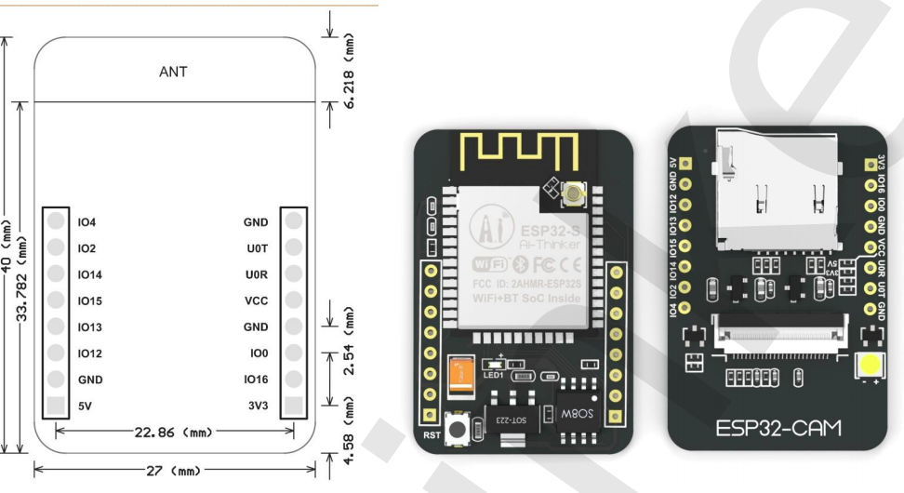

The A4988 and stepper motor option
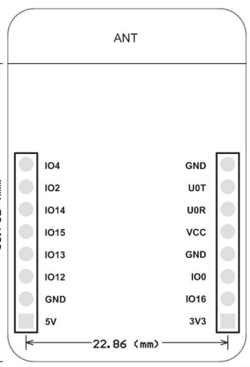
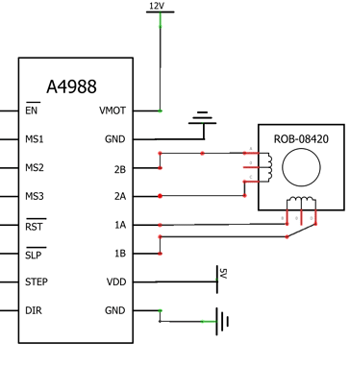
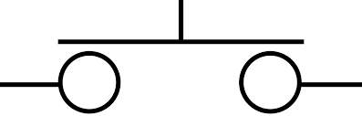

WARNING: Unlike what I initially thought, IO0 CANNOT BE USED. Connected to ground, this pin will put the ESP32 in Flashing mode.
The problem is the weight of the motors. A nema 17 weight is about 250g which, when installed at the end of my Newton telescope is really heavy, especially if you need two (one for the wheel and one for the focuser). Half a kilo does not deserve the “lightest” term.
Looking to different options, I found out that one of the lightest option I could find was a servo motor sg90 hacked to be able to turn endlessly, and this is only 14.5g. Speeking of “power”, sg90, because of its gearbox has a torque of 2.5kg/cm when the nema 17 is ‘only’ also 2.5kg/cm (well depends on model and available current. 2.5 seems an average of datasheets I found).
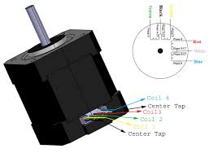  Nema 17: 250g for a Torque of 2.5kg/cm. Needs 12V to run and a specific “driver” | 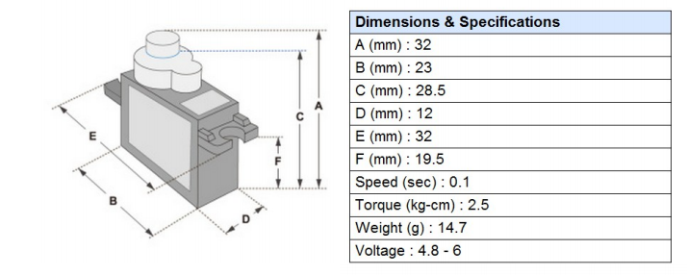  SG90: 14.5g for a Torque of 1.8kg/cm. Operates at 5V directly driven by micro-controller signal.

Another benefit is that you need only 1 power source (5V) to operate logic and motors while the first option requested a 12V and 5V power source. Finally, SG90 needs only 1 wire to control direction (the length of the impulsion sets the direction of the motor). This will free the UOT and UOR so we can keep them for a RS232 transmit only usage.

The SG90 option
One of my concern using this option is the precision and the main outcome of the Hack which is finding the “0” position.
To make it short, this servo motor is using an internal potentiometer to know its position. With the “servo.h” arduino library, you encode a value between 0 and 180° which is converted to a signal sent to a wire.
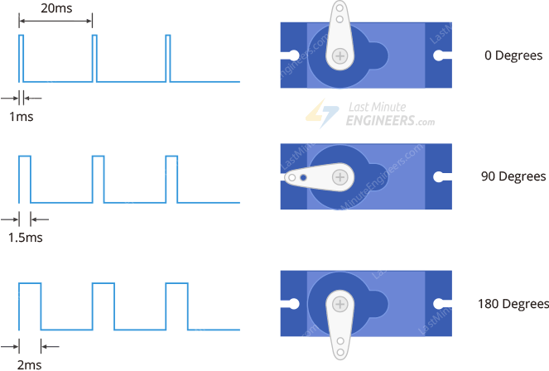
The internal circuitry converts back the signal to the desired position and turn until the internal potentiometer gives a tension which map to the correct angle.
With the hack, you hard remove the “stop” pin and, either replace the potentiometer with a bunch of fixed resistor or plug-in a power source and move the potentiometer until it stops spinning, then glue the potentiometer so it will not move.
For having read a lot and having experienced a little bit these devices I know that these cheap pieces are usually not very well tuned and that temperature or available current or V variation can change the “middle” value. This can also vary with time and oxidation of circuitry and its resistance, therefore, the hack makes it pretty complex to find the value to send to the servo if this value changes over time. As a result, not having the correct “middle” value introduce vibrations and even, sometime, un-sollicited moves.
The option will be to use the servo.attach() before and servo.detach() after each move, so the signal will just release the motor.
Another option could be to use one of the ESP32 pin to drive a NPN transistor to shut down the power source of the servo when we don’t need it to turn (99% of the time though).

Option1: Attach/Detach in arduino sketch:
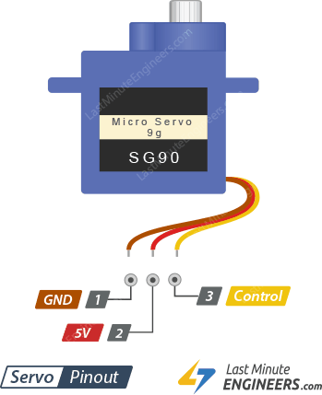

Option2: NPN Driven power to enable/disable servos:
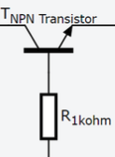

To enable both option, the 3D box has holes for 4 NPN transistors. Indeed, one transistor may not be enough to drain enough current for servo motor. Note that I have not planned holes for the 1kOhm resistors so to choose this option, resistors has to be placed between Transistor base and GPIO12 / GPIO13.
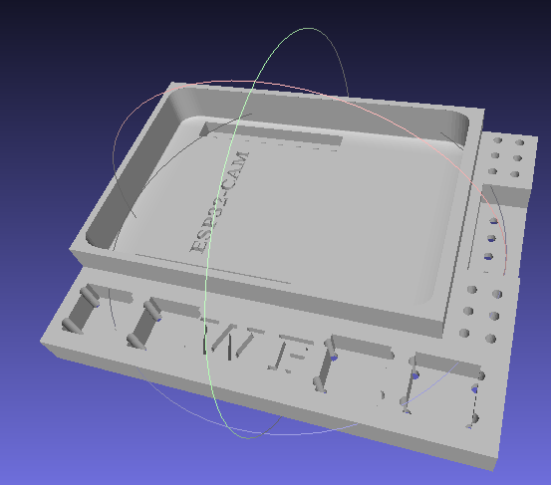
Wheel Buttons
ESP32 slot
2xNPN Slots
2xNPN Slots
4 pin connect
Focuser Buttons

Programming BlueTooth under Linux Ubuntu
Took here: http://tvaira.free.fr/bts-sn/activites/activite-ble/activite-ble-qt.html

ESP32 DevKit option
This option gives all advantages of previous solutions, it is still light, can be very low consuming (BLE), has a lot of possible wired which are for major part of them PWN and/or internally pull/up or Pull/down wired, which simplifies external wiring.
