JERICHO is safe! But there is still a long way to go!
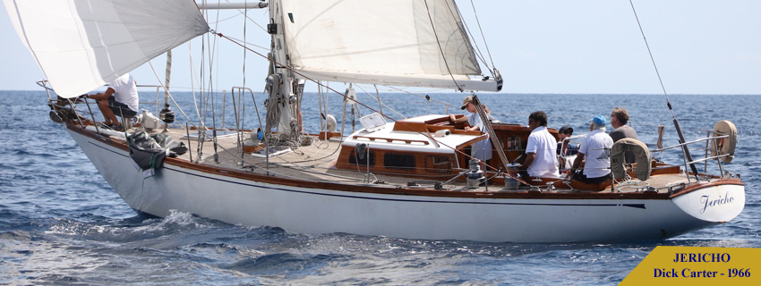

JERICHO
LOA: 13m85
Rigging: Sloop
BOA: 3m70
Draft: 2m10
Shipyard: Frans Maas
Material: Steel
Disp: 13 t
Dick Carter, the architect of Pordin Nancq, Passe-Coque's Carter 37, did not know that we could still save Jericho when he came to the Carter Cup we organized in 2023 in La Trinité sur Mer.
Jericho, like Pordin Nancq in 79, participated in the 1967 Fastnet under the name Gerfault. Connoisseurs of the Tina will recognize the characteristic shapes of the Carters. But Jericho's hull needs care and her former owners for 30 years were forced to consider deconstruction. Faced with the emergency, Passe-Coque took the lead and we became the owner, so she could leaves the SNM before the end of the year.
She is now in Port-Corbières where we will analyze the amount of work to be done.
Her steel hull must undergo a complete survey. Dismantle the interior equipment, sand and treat the hull from the inside, reassemble the equipment and take the opportunity to survey the electricity and plumbing as well as the mechanics so that Jericho can live again.
A team made of an integration yard and Classic enthusiasts is being set up around Passe-Coque to "revitalize" it and get it sailing again as part of social and solidarity actions. We will therefore still need you through your donations, your technical and logistical support or simply your membership in our association, recognized as being of general interest.
For all your questions about the project: contact@passe-coque.com and to help and support us use the following link or the website www.passe-coque.com. Thank you all in advance.
Salut et fraternité
Pierre-Jean Jannin
Président de Passe-Coque

