# LAB OBJECTIVE

The objective of this lab is to get familiar with the following:

* Demonstrate your ability to work with arrays and suberglobals in PHP.

# Earning

To earn your mark for this lab, each student should finish the lab’s requirements, submit your lab on the Brightspace and demonstrate the working code to the instructor.

# Assignment

Read the entire lab instruction before starting.

This lab is to be completed on BrightSpace any lab worksheets handed in will be discarded. Carefully follow the procedures outlined in this lab worksheet. If at any time you are unsure or are having problems, consult your lab instructor.

This assignment will introduce you to PHP. PHP is executed on the server side (back end) so that clients cannot see any of the PHP code you are running. What is sent to their browser (front end) is HTML, CSS, and JavaScript. PHP will assemble and customize the HTML page sent to the client’s browser. We will simulate a database backend so that we can focus on the PHP interactions.

In this lab you will take the starter HMTL code “index.html”, “headerM.php”, and “footrtM.php”.

Update the “index.html” it to do the following:

* If we bring up the page without any php code, then it will give you the basic page shown in figure
* Modify index.html file so that it uses the post method and specify “process.php” as the form action.
* Define three string arrays, one containing the genres action, adventure, comedy, and drama, and the other containing the subject Animation, Children and Youth, and People. The third one for the list of directors
* Write a function that accepts string array as a parameter and returns a string containing the embedded value between <option>,</option> and their concatenations. Then you apply the same function to process and display the following arrays: $genres, $subjects, $MainDirectors to be viewed in drop down menus (Figure 1.).

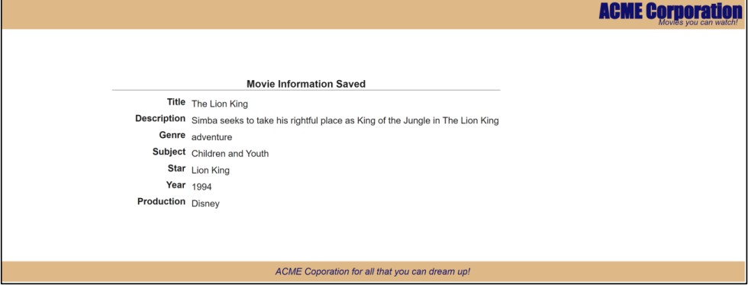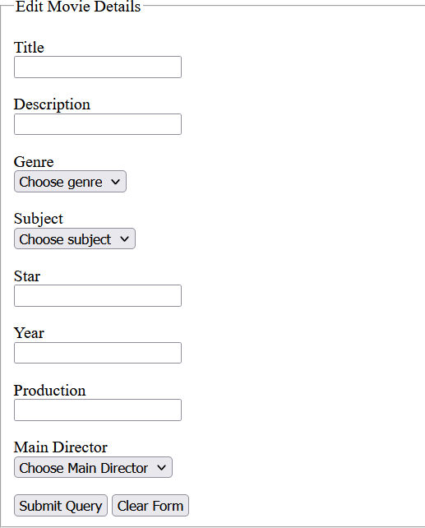

**Main Director**: Roger Allers

Figure 1

Figure 2

* You also need to change the file extension to be .php
* Create a new file”process.php” so that it displays all the values that were entered into the form , as shown in figure 2. This will require using the appropriate superglobals array.

Sample processing of array($array) passed as a parameter and returning the $options:

$options = "";

foreach ($array as $value) {

$options .= "<option>$value</option>";

}

return $options;

# Submission

To submit the assignment, you must upload all the files in a .zip.

Full mark considered to be 20% (form & the output page need to match exactly as in figure 1,2 & follows perfect coding standards) and mark out of 80% for the rest of the requirements.