Fear of the invader: a predatory invader may provoke stronger non-consumptive effects on a keystone native prey than a native predator
Olivier V. Raven
Calum MacNeil
Finnbar Lee
Robin Holmes
Ian A. Kusabs
Francis J. Burdon
Deniz Özkundakci
2026-05-22
Abstract
Non-consumptive effects (NCEs) of predators on prey encompass costly antipredator behaviours such as increased refuge use and reduced foraging, which can influence prey population dynamics and community structure, particularly when the prey themselves are keystone species. In Aotearoa-New Zealand, the native freshwater crayfish kōura (Paranephrops planifrons) is a keystone species, an ecosystem engineer with a critical functional role in sediment dynamics, nutrient cycling and benthic community structure. Kōura are preyed upon by both the co-evolved native longfin eel (Anguilla dieffenbachii) and invasive brown bullhead catfish (Ameiurus nebulosus), a species introduced less than two centuries ago. Under laboratory conditions, we tested whether visual and chemical cues from these two predators induced different refuge-seeking and feeding behaviour responses by kōura. Predator presence produced a NCE on refuge use, with kōura exposed to catfish cues showing significantly greater refuge-seeking behaviour than those exposed to eel cues. This is consistent with the generalisation theory triggered by unfamiliar predator cues rather than classic prey naivety . Our study indicates catfish incursions may provoke a greater NCEs on kōura refuge use than resident eels. As catfish range expansion continues, these NCEs represent an ecologically significant and underappreciated threat to kōura populations, compounding the direct predation pressure already documented for this invader.

Introduction
Biological invasions can have profound impacts on invaded ecosystems, particularly through the introduction of novel predators that prey upon native species lacking an evolutionary history with them (Doherty et al., 2016). Native prey may be naïve not just to a specific invader, but to entire functional groups of predators, making them especially vulnerable to direct predation when an invasion introduces a predator type entirely absent from their evolutionary history [Sih2010; Carthey2014]. In addition to these consumptive effects, native prey may exhibit heightened fear responses to invasive predators, leading to the development of anti-predator behaviours such as increased refuge use and avoidance of open habitats (Kindinger & Albins, 2017). These behavioural changes, termed non-consumptive effects (NCEs), can substantially influence population dynamics by reducing foraging activity, growth, and reproductive output (Preisser et al., 2005). In contrast, native predators generally elicit different responses because prey and predators have co-evolved, resulting in behavioural and physiological adaptations that stabilise predator–prey interactions (Abrams, 2000).
Freshwater crayfish often live in turbid flowing water or in the dark depths of lakes where they rely primarily on chemical cues (kairomones) rather than visual cues to detect and respond to predatory fish (Blake & Hart, 1993; Brönmark & Hansson, 2012; Wood & Moore, 2020b). These kairomones carry signals via excreta, mucus, or skin, that crayfish use to assess predator risk, responding more strongly to predators that have consumed conspecifics and to alarm cues released when prey is injured or killed (Beattie & Moore, 2018; Gherardi et al., 2011). Exposure to kairomones from predatory fish can generate NCEs, including reduced growth and reduced activity levels in crayfish (Adams, 2007; Ramberg-Pihl & Yurewicz, 2020), and even non-predatory fish can cause these behaviour changes, likely through heightened generalised awareness of risk (Nyström, 2005). However, the strength of these responses depends on prior experience as wild-caught individual crayfish show stronger antipredator responses than farmed conspecifics naive to predators (Martin, 2014), indicating that both learned behavior and evolutionary history shape kairomone detection.
In Aotearoa-New Zealand (hereafter Aotearoa), the endemic northern freshwater crayfish Paranephrops planifrons (White, 1842) commonly known as kōura is a taonga (‘culturally treasured’) species for Māori, the indigenous people of Aotearoa and is valued as a food resource (Kusabs & Quinn, 2009). Ecologically, kōura play a critical role in freshwater ecosystems as ecosystem engineers through their effects on sediment dynamics, nutrient cycling, and benthic community structure, and have been described as keystone species in many freshwater systems (Collier et al., 1997; Parkyn et al., 2001; Usio & Townsend, 2004). Currently kōura are threatened by multiple interacting stressors, including climate change, water-quality degradation and invasive species, contributing to widespread population declines (Kusabs et al., n.d.; Lee et al., 2025).
Kōura have a long co-evolutionary history with the native longfin eel (Anguilla dieffenbachii) (hereafter eel) and shortfin eel (A. australis) (L. A. Brown, 2009; MacNeil et al., 2025). Reflecting this history, kōura respond more strongly to eel kairomones than to those of introduced non-native brown trout (Salmo trutta), even when sourced from streams where both predators were present, suggesting that co-evolutionary history, rather than individual experience alone, shaped kōura predator recognition (Shave et al., 1994). One of the invasive species that threatens kōura is the non-native brown bullhead catfish (Ameiurus nebulosus) (hereafter catfish) which was introduced to Aotearoa in 1877 and has since spread through many waterways on the North Island (Barnes & Hicks, 2003; Dedual, 2019; McDowall, 1990). For example, a decade ago catfish were confirmed present in two large volcanic lakes, Lakes Rotoiti and Rotorua in the Bay of Plenty region, which also contain kōura (Lee et al., 2025). The catfish is highly tolerant of a wide range of environmental conditions (Lee et al., 2025; Scott & Crossman, 1973) and, due to its broad gape and opportunistic feeding behaviour, is capable of consuming a wide variety of native aquatic organisms (Dedual, 2019; Scott & Crossman, 1973). In Aotearoa, which originally has no native fish remotely similar to a catfish the recent and ongoing spread of catfish into North Island waterways represents a truly novel predation threat to which kōura may lack adequate behavioural or sensory adaptations.
In this study, controlled laboratory experiments were used to test whether novel vs native predator presence and associated chemical cues induced changes in NCEs (refuge-seeking and feeding behaviour) by kōura. Our experiments were designed to test which of two competing hypotheses best describes kōura behavioural responses to native and invasive predator cues. 1. Kōura would show more shelter-seeking behaviour when presented with eels compared to catfish, due to naivety of the kōura towards a novel predator such as catfish (Carthey & Banks, 2014). Or 2, kōura would respond more strongly to unfamiliar catfish cues than to the co-evolved eel, consistent with a generalised fear response to a novel predator type (Sih et al., 2023). Further, we expected that light regime would have an influence on shelter seeking behaviour of kōura, which like many crayfish, are most active nocturnally (Devcich, 1979; Johnson et al., 2014). We also predicted that kōura feeding would be more inhibited when exposed to eel kairomones than to those of the catfish, reflecting the same co-evolutionary recognition expected to drive greater refuge use in response to eels. The overall aim of the refuge and feeding behaviour studies were to contribute to understanding the behavioural mechanisms underlying kōura vulnerability to invasive catfish and how these may differ from and be additional to, those already manifested in the presence of native predators such as eels.

Materials and Methods

Animal collection and preparation
In mid-August 2025, 92 kōura were sourced from two catfish-free lakes, (Ōkāreka and Tikitapu (Blue Lake)) in the Rotorua Te Arawa Lakes area, Bay of Plenty region of the North Island. Eels are present in most of the rivers and lakes of Aotearoa (McDowall 1990) and may be present in both lakes, but scarce. In late September 2025, catfish and eels were sourced from Lake Rotoroa in Hamilton in the Waikato region of the North Island. Experiments were conducted at the Aquatic Research Centre of the University of Waikato. All three species were held separately in holding tanks and acclimated for a week in dechlorinated tap water under the following controlled regime: a 10:14 light: dark cycle reflecting the correct seasonal day-length at a stable temperature of 15.6 °C, pH 8.4 and 10 mg l⁻¹ dissolved oxygen, the latter parameters reflecting typical physiochemical condition in source lakes. Kōura and fish were fed every other day on Hikari Tropical carnivore fish food pellets (animal protein 47%). Because kōura are taonga (culturally treasured) species, permission had to be sought from relevant iwi (Māori tribal unit), as well as relevant government. All experimental procedures were conducted under University of Waikato animal ethics committee approval (protocol number: 1232; see Ethical Approval section).

Refuge experiment
Prior to the experiments all animals were individually weighed and measured. Only male kōura were used as male crustaceans are usually the most bold and aggressive (Figler et al., 2005; Stein & Magnuson, 1976) and restricting test animals to a single sex allowed a smaller overall number of kōura to be used. Kōura had a mean (± SD) orbital carapace length (OCL) of 26.0 mm (± 3.08) (18.35-32.95 mm range) and a mean (± SD) wet weight of 11.7 g (± 4.25) (3–23 g range). Catfish ranged in length from 260-267 mm and 2.34–3.16 kg wet weight and eels ranged in wet weight from 2.50-3.52 kg, both these size ranges being able to consume adult kōura (Barnes & Hicks, 2003; Hicks, 1997; Ryan, 2009).
Experiments were conducted in 38 L glass tanks (600 × 200 × 220 mm) with each tank having three sides (apart from front of tank) blacked out to block visual cues from neighbouring tanks. Each tank was divided into two compartments by a 0.5 mm steel mesh divider, allowing visual and chemical cues between compartments, while preventing any physical contact between fish and kōura on either side of the barrier (Figure 1). All tanks were filled with ~26 L dechlorinated tap water and had identical environmental regimes as previously detailed for acclimatisation tanks, with water flow provided by an air stone. Each tank housed a single kōura on one side of the barrier and either a single predator (catfish or eel) or no predator (control) on the other side. A halved terracotta pot (90 mm diameter × 90 mm depth) was positioned on the kōura side of the tank to serve as a potential refuge. To control for potential tank location or compartment side effects, the position of predator treatments within the aquaria was systematically rotated between experimental rounds. The experiment was repeated across five rounds, resulting in 11 catfish replicates, 11 eel replicates, and 10 control replicates and was first carried out in the light (~400 lux; n = 32) before being repeated in the dark (~70 lux; n = 32). Observations were made in the dark using red lighting positioned centrally above the tanks to minimize disturbance, as many aquatic species have limited sensitivity to red wavelengths and are unlikely to perceive this light. Following each individual experimental run, each tank was thoroughly cleaned and refilled with dechlorinated tap water before reuse. Each individual kōura was only exposed once to a fish predator and there were no mortalities of kōura or fish during experiments. All experiments were conducted within a three-week period during October 2025.
At the beginning of each experiment, an individual kōura was placed in the middle of the tank compartment containing the refuge and observations of each kōura location were recorded at 21 time intervals within a 5 hour period (the intervals being: 0, 5, 10, 20, 30, 45, 60, 61, 65, 70, 80, 90, 120, 150, 210, 240, 245, 260, 275, 290, and 300 minutes). The 0-minute recording was the individual’s initial immediate location after its addition to the tank. Kōura location was recorded as either refuge (the animal was using the refuge, being inside it or immediately behind it and touching it) or non-refuge/ in the open (any other location in the tank where the animal was not in the refuge or touching the refuge). The fish predator was introduced into the tank on the other side of the barrier from the kōura compartment, after 60 minutes and removed after 240 minutes. The compressed intervals around 60–65 minutes and 240–245 minutes were designed to capture immediate behavioural responses at the point of predator introduction and removal respectively. The control tanks had no fish added but at 60 minutes and again at 240 minutes, the water in the ‘predator’ compartment was mechanically disturbed by agitating the water with a small hand net for approximately 30 seconds. This was to simulate the disturbance time associated with adding and removing fish in the other treatments with the same size hand net. At the end of each experiment, the kōura was removed after the final 300-minute observation.
To analyse kōura refuge use, a beta-binomial generalized linear mixed-effects model (GLMM) was fitted using the glmmTMB package in R (Brooks et al., 2017; R Core Team, 2025). To address potential non-independence of repeated observations within tanks, raw observations were first aggregated into three experimental periods (before, during, and after predator introduction) per individual kōura, with the number of observations in refuge our of total observations per period used as the response variable. Treatment (catfish, eel, control), light condition (light, dark), and period (before, during, after) were included as fixed effects. A beta-binomial distribution was used to account for overdispersion in the binomial proportion data. Nine candidate models were compared, differing in fixed effect structure (main effects only, two-way interactions, and full three-way interaction) and random effects inclusion (no random effects, tank identity, and tank plus experimental round as random intercepts), using the corrected Akaike Information Criterion (AICc), appropriate given the ratio of sample size to estimated parameters (n/k < 40; Burnham & Anderson (2002)). The best-supported model included treatment, light condition, and period as fixed effects with no random intercept, indicating that variance among tanks and rounds did not improve model fit beyond the fixed effect’s structure. Model fit of the final model was assessed using DHARMa simulation-based residuals, including tests for overdispersion and zero-inflation (Hartig et al., 2024). Marginal means and pairwise contrasts between factor levels were obtained using the emmeans package (Lenth et al., 2026). Spearman rank correlations with Bonferroni-adjusted p-values were also used to investigate potential relationships between kōura body size (OCL) and overall refuge use (all time intervals combined) in the three treatments.

Feeding experiment
Experiments were conducted in glass tanks (320 × 170 × 170 mm), containing 5 L dechlorinated tap water and a halved terracotta pot (90 mm diameter × 90 mm depth). Catfish and eels had been held at the same density in separate identical holding tanks for a week prior to experiment. Fish exudates were collected by placing four fish (catfish or eel) in a 10 L bucket filled with water from the holding tanks for 15 minutes to concentrate the kairomones in the water. For eel and catfish treatments, 1 L from the buckets was added to each tank already holding 5 L of tap water, and for control an additional 1 L of dechlorinated tap water was added. Next, 10 Hikari Tropical carnivore pellets were added to each tank. Trial experiments showed these pellets remained intact for over 24 hours in tap water. In three rounds, a total of 46 male kōura were measured and weighed. Their mean (± SD) OCL was 27.93 mm (± 4.80), with a range of 20.48 to 40.88 mm, and the mean (± SD) wet weight of 15.83 g (± 8.99), ranging from 6.00 to 42.00 g. Each kōura was then placed individually in a tank. For each round kōura were starved for different periods (either 0, 3 or 4 days) prior to the feeding experiment to also investigate how starvation period influenced feeding motivation. After 0 days starvation, 14 kōura were exposed to eel water (n = 4), catfish water (n = 6) or control water (n = 4). After 3 days starvation, 16 kōura were exposed to eel water (n = 6), catfish water (n = 5) or control water (n = 5). After 4 days starvation, 16 kōura were exposed to eel water (n = 5), catfish water (n = 5) or control water (n = 6). After 24 hours, when each experiment was terminated, the number of pellets eaten (to the nearest quarter pellet) was counted and the feeding rate (pellets eaten per gram of wet weight (WW) of kōura) calculated. Kōura feeding rate was analysed using a linear model with pellets consumed per gram wet weight as the response, with treatment (catfish, eel, control) and starvation period (0, 3, 4) as fixed effects. Because each starvation period was conducted in a separate experimental round, starvation period and round were fully confounded by design, precluding the inclusion of round as a random effect. Overall significance of fixed effects was assessed using Type III ANOVA (car package; Fox & Weisberg (2018)), and model assumptions were verified using residual plots and testing normality of residuals using the Shapiro-Wilk test. Pairwise comparisons between treatment and starvation level combinations were conducted using estimated marginal means.

Results

Refuge experiment
The proportion of time kōura spent in refuge varied across treatments, experimental periods, and light conditions (Figure 2, Table 3). A beta-binomial GLMM without a random intercept was the best-supported model based on the lowest AICc (Table 1). Refuge use by kōura was consistently higher when exposed to catfish than eel (p = 0.01, Figure 2, Table 2). However, there were no significant differences in kōura refuge use between either fish treatment and the control (both p = 0.314 for catfish and control and eel and control; Figure 2). Under light conditions, the pattern of refuge use in the control treatment was more similar to the catfish treatment, whereas under dark conditions it more resembled the eel treatment (Figure 3). Light regime had a significant effect on refuge use (p = 0.006), with greater refuge use under light compared to dark conditions (Figure 2 and Figure 3). Regarding experimental periods, refuge use was significantly lower in the period just before fish were introduced (or first 30-second mechanical disturbance initiated) compared to period just after the fish had been removed (or second mechanical disturbance ceased) (p = 0.007; Figure 2 and Figure 3). No significant differences were found between the before and during periods, or between the during and after periods. There was also no relationship between kōura OCL and refuge use in any of the three treatments (rs = -0.09, 0.09 and 0.17 for catfish, eel and control treatments respectively, all NS).
For all treatments individual kōura were highly variable in their movement around tanks and use of refuges, even in the time intervals comprising the first 60 minutes of the experiment, before fish were introduced. The coefficient of variations (CVs) for kōura refuge use in the light and the dark before fish introduction were similarly high, being 60.4 % and 58.2 % (both n = 32) respectively, confirming high baseline variation in kōura refuge use, regardless of treatment type. Despite this inherent variation in individual kōura behaviour, clear patterns in kōura refuge use were evident over the course of the experiment. Under light conditions, the control showed the largest overall increase in refuge use (40% to 82%), driven primarily by a sharp rise in the ‘after’ period, while the catfish treatment showed a more sustained increase across all periods (52% to 73%) and the eel treatment the smallest increase (35% to 53% Figure 3). Under dark conditions, the pattern shifted, with the catfish treatment showing the greatest increase (39% to 70%), while the eel treatment showed a modest and non-sustained increase (27% to 41% during exposure, returning to 36% after), and the control remained comparatively low throughout (37% to 47%).

Feeding experiment
While the linear model showed starvation period had a significant effect on feeding rate (p = 7^{-4}, Figure 4; Table 4), there was no significant difference in feeding rate between catfish, eel, and control treatments (p = 0.332). After 4 days starvation, the mean (±SE) kōura feeding rate (pellets g WW⁻¹) for the control was over two and a half times that of the catfish and eel treatments (0.148 ± 0.05 pellets g WW⁻¹ compared to 0.059 ± 0.017 and 0.052 ± 0.028 pellets g WW⁻¹ respectively).

Discussion
Prey modify their behaviour in response to predation risk, creating a ‘landscape’ of fear that affects foraging, movement, and habitat use independently of actual predation events (Laundré et al., 2001). However, until relatively recently, most ecological models still assumed that predator and prey populations interacted solely through predator-prey densities by killing and consuming prey despite it being evident that by forcing prey to adopt energetically costly defensive strategies, predators can also reduce prey densities through NCEs (Preisser & Bolnick, 2008) Our study joins a number of recent studies (ie., (Sniegula et al., 2025)) showing invasive predators can generate stronger NCEs on native prey than native predators, which consequently have more profound far- reaching impacts on invaded ecosystems. Our study suggests the introduction of a novel predator effectively changes the prey’s fear landscape in ways that a co-evolved predator does not. Kōura are a keystone species in Aotearoa and an ecosystem engineer and so when a predator alters kōura behaviour, this in turn could affect resources or other species through non-consumptive pathways (Peacor & Werner, 2001). Such trait-mediated indirect effects represent a form of behavioural trophic cascade (Schmitz et al., 1997), whereby predator presence alone drives ecosystem-level change. Our results also highlight that prey naivety does not always show a failure to respond but can instead produce a generalised over-response consistent with the generalisation theory (Ehlman et al., 2019; Sih et al., 2010), which is important for predicting the ecological impacts of invasive species.

Refuge use
Kōura demonstrated greater refuge-seeking behaviour when exposed to the novel catfish than to native eel. This result is notable because it contradicts the classic prey naivety hypothesis, which predicts that prey fail to respond to novel predators (Carthey & Banks, 2014). Over-responses to novel predators are less commonly reported but are consistent with fear generalisation theory, whereby prior experience with native predators primes a generalised heightened vigilance response to any unfamiliar threat (Ehlman et al., 2019; Sih et al., 2023). For naïve prey, unfamiliar cues could trigger such a response because the consequences of ignoring a potential predation threat could be fatal, even when, in reality, the actual predation risk is absent (Dawkins & Krebs, 1979; Lima & Dill, 1990). Such generalised responses to novel stimuli tend to be overcautious and energetically costly and are characteristic of prey with no evolutionary history with the encountered predator (Sih et al., 2010). Unlike classic prey naivety scenarios where the novel predator poses no actual threat, catfish genuinely predate kōura, meaning the heightened refuge response carries a real energetic cost but is not disproportionate to actual risk. Elevated refuge use is itself a meaningful NCE, reducing foraging time with potential consequences for growth, reproduction, and population persistence (Preisser et al., 2005; Sheriff et al., 2020). However, this behaviour may simultaneously confer protection against direct predation; experimental evidence shows that shelter significantly reduces catfish predation on crayfish (Adams, 2007; Zhao et al., 2024), suggesting that enhancing or restoring habitat complexity in catfish-invaded lakes could mitigate both direct predation and fear-driven reductions in foraging, though direct field testing is needed.
Before treatments were added, refuge use was similar across treatments but highly variable, reflecting substantial individual behavioural variation. The control treatment showed increasing refuge use over time, particularly under light conditions, which is unsurprising given that kōura are nocturnally adapted and need to remain hidden during daylight to avoid visual predators such as birds (Devcich, 1979). While neither predator treatment differed significantly from the control, this likely reflects the influence of light regime on baseline refuge use rather than a true absence of NCEs; under light conditions control refuge use approached that of the catfish treatment, while under dark conditions it more closely resembled the eel treatment, effectively inflating variance around the control mean. Despite this, the consistent pattern of catfish provoking greater refuge use than eels under both light and dark conditions supports a genuine difference in NCEs between novel and native predator exposure.
In contrast to catfish exposure, kōura reduced their refuge use when exposed to eels. This likely reflects the co-evolutionary history the two species share, as kōura are able to recognise eel chemical and visual cues and respond in an appropriate rather than precautionary way (Shave et al., 1994). Instead of hiding, kōura may rely on contextual information, such as predator size, movement patterns, or chemical concentrations, to modulate their response (Wood & Moore, 2020a). This calibrated response makes ecological sense as longfin eels are the most widely distributed fish in Aotearoa’s freshwaters (McDowall, 1990), and a kōura living in constant fear of eels would have severely limited opportunity to forage. Co-evolutionary pressure may therefore have favoured a nuanced, context-dependent response to eels rather than a blanket avoidance strategy. This pattern was most pronounced in the dark conditions, where all three treatments began similarly but changed progressively over the course of the experiment. The catfish treatment steadily increased in refuge use, while eel treatment stayed alongside the control, declining to baseline levels by the end of the during period. This suggests that under conditions most relevant to kōura natural activity, chemical recognition of the familiar eel predator is sufficient to enable a calibrated, low-cost response, while the unfamiliar catfish continues to elicit sustained precautionary refuge use (Shave et al., 1994; Wood & Moore, 2020b). Beyond predator recognition, the reduced refuge use observed in eel-exposed kōura may not simply reflect a lack of response, but could instead represent active escape-searching behaviour, kōura moving away from an area where they perceived themselves as vulnerable in the confined tank space, rather than retreating to a refuge that may offer limited protection against a predator capable of pursuing prey into confined spaces.

Feeding
NCEs are not a single process but emerge from the interaction between sensory ecology and environmental context, and the absence of a kairomone effect on feeding in this study likely reflects a combination of methodological constraints rather than an absence of NCEs on foraging behaviour. The feeding experiment which unlike the refuge-use experiment, relied purely on non-visual cues, did not demonstrate a clear fish predator NCE on kōura. This may have been due to the concentration of predator kairomones not being high enough to exceed detection thresholds (G. E. Brown et al., 2004), the relatively short pre-experiment starvation period for kōura and the restricted time frame of the experiment or a combination of all three factors. Kōura can readily detect necrotic fish tissue and readily leave refuges to scavenge on catfish, eel, and marine fish carcasses with little discrimination between fish species, indicating that chemosensory responses in kōura may depend on cue type, context, and concentration rather than predator identity alone (MacNeil et al., 2025). The concentration of live fish exudates in our experiment relative to natural conditions is difficult to determine, while kairomones were concentrated by confining fish in a bucket, in our experimental tanks they were subsequently diluted in 5 L of water and not replenished over 24 hours. Whether the resulting concentration reflects, exceeds or falls below ecologically relevant levels in lakes where kōura and predators coexist remains unclear, and future studies should attempt to quantify natural kairomone concentrations to better calibrate experimental designs (Achtymichuk et al., 2025). In addition, many crayfishes show a stronger response to alarm cues of conspecifics (Gherardi et al., 2011; Ramberg-Pihl & Yurewicz, 2020; Stebbing et al., 2010), and to kairomones from predators on a conspecifics diet (Beattie & Moore, 2018). Fish predators in our experiments were kept for a prolonged period on the same diet as kōura, which may have further diminished or blunted the threatening nature of signals received from kairomones (Smee & Weissburg, 2006). Furthermore, the pre-experiment starvation period for kōura may have been insufficient to elicit a very strong feeding response, as crayfish such as kōura are opportunistic foragers which are necessarily adapted to going for prolonged periods without feeding (Hazlett, 2003). The length of time since feeding can influence foraging behaviour, with previous studies indicating that crayfish will be more active foragers after being starved for at least three days (Hazlett, 2003). In the current study, the longest starvation period was four days and at this point there was a clear discrepancy between the control feeding rate and the much lower feeding rates in the two fish treatments. Allowing for ethics and welfare concerns, if we had extended the starvation period, this may have elicited a stronger and prolonged response. Additionally, the stress of confinement in an artificial setting may itself have altered normal kōura feeding responses, as elevated baseline stress hormones are known to modify foraging behaviour independently of predator cue exposure (Clinchy et al., 2012). Finally, feeding was measured as a single endpoint after 24 hours, providing no information on whether kōura initially suppressed feeding after kairomone exposure before eventually resuming normal feeding activity (Wright et al. (2010)). Further experiments using higher kairomone concentrations, longer starvation periods, and continuous feeding monitoring would help clarify whether non-visual predator cues generate NCEs on kōura foraging behaviour.

Conclusions
As ecosystems become increasingly novel under global change, the reliability of historical predator–prey cues may decline, amplifying behavioural mismatches (Sih et al., 2011). This study provides experimental evidence that the invasive brown bullhead catfish exerts stronger NCEs on the native freshwater crayfish kōura than the co-evolved native longfin eel. The heightened refuge-seeking response to catfish likely reflects a generalised antipredator response triggered by unfamiliar chemical and visual cues, consistent with a fear generalisation framework. In contrast, the reduced response to eels suggests that co-evolutionary experience enables kōura to make more calibrated risk assessments. Comparative studies of kōura sourced from catfish-invaded versus catfish-free catchments would be worthwhile to assess whether repeated exposure over multiple generations has resulted in rapid evolution or behavioural plasticity in antipredator responses, and whether catfish-experienced kōura show more calibrated responses to catfish presence than naïve kōura. Such evolutionary dynamics could have important implications for predicting kōura persistence in catfish-invaded systems (Sih et al., 2010). From a management perspective, translocation of kōura from catfish-experienced source populations into catchments facing imminent catfish invasion may represent a more feasible strategy for seeding populations with individuals capable of more calibrated responses. Although we found no significant NCE of fish exudates on feeding behaviour, our study suggests further investigations of non-visual predator cues on kōura foraging behaviour is warranted. Because kōura are keystone species and ecosystem engineers, even a small increase in refuge use driven by catfish presence could have cascading effects on sediment dynamics, decomposition, and nutrient cycling in invaded lakes. As brown bullhead catfish continue to spread across Aotearoa’s rivers and lakes, management strategies aimed at protecting kōura should account for the behavioural cost of catfish NCEs alongside direct predation pressure as an underappreciated and ecologically significant dimension to this invasion.

Acknowledgements
We thank Te Arawa Lakes Trust and Te Komiti Whakahaere for the opportunity to collect and study the treasured kōura. We are grateful to Soweeta Fort-D’ath and William Anaru (Te Arawa Lakes Trust), and Tihini Grant (Ngāti Pikiao). We also thank Nick Ling and Ben Roche (University of Waikato) for assisting with catfish and eel collection. This research was supported by the Fish Futures programme funded through a Ministry of Business, Innovation and Employment grant (CAWX2101).

Authors’ contributions
Study conception and design were undertaken by O.V.R, C.M. and R.H. Experiments were executed by O.V.R. and C.M. Data analysis was performed by O.V.R. and F.L. Local ecological knowledge kōura were supplied by I.A.K.K. Manuscript drafting was led by O.V.R. and C.M. All authors contributed to manuscript revision, approved the results, and the final manuscript.

Ethical approval
This study received ethical approval by University of Waikato animal ethics committee, protocol number: 1232. Additional permission to conduct experiments with kōura was granted by Te Arawa Lakes Trust and Te Komiti Whakahaere.

Declarations
The corresponding author has declared that none of the authors has any competing interests.

Data availability statement
The code and derived data supporting the findings of this study are openly available on GitHub (https://github.com/OlivierRaven/NCE_Koura_catfish)and a rendered version of the analysis is hosted at https://olivierraven.github.io/NCE_Koura_catfish/. The primary raw dataset is archived on Zenodo (https://doi.org/10.5281/zenodo.19716761). Peer review documents, including the cover letter and reviewer responses, are available in the manuscript repository in the interest of open and transparent science.

Tables
Table 1: Fixed effects of the beta-binomial GLMM for kōura refuge use.
Term | Estimate | Std. Error | z value | p value
(Intercept) | -0.058 | 0.282 | -0.206 | 0.837
treatmentcatfish | 0.424 | 0.292 | 1.452 | 0.146
treatmenteel | -0.427 | 0.294 | -1.452 | 0.147
lightdark | -0.654 | 0.239 | -2.737 | 0.006
periodduring | 0.530 | 0.282 | 1.881 | 0.060
periodafter | 0.912 | 0.300 | 3.040 | 0.002

_{Source: Analysis Notebook}
Table 2: Pairwise contrasts from the beta-binomial GLMM for kōura refuge use. Odds ratios and p-values are shown for treatment, light condition, and period comparisons. P-values are Tukey-adjusted for multiple comparisons within each factor.
Contrast | Odds ratio | SE | df | Null | z value | p value | Factor
control / catfish | 0.655 | 0.191 | Inf | 1 | -1.452 | 0.314 | treatment
control / eel | 1.533 | 0.451 | Inf | 1 | 1.452 | 0.314 | treatment
catfish / eel | 2.341 | 0.681 | Inf | 1 | 2.924 | 0.010 | treatment
light / dark | 1.924 | 0.460 | Inf | 1 | 2.737 | 0.006 | light
before / during | 0.589 | 0.166 | Inf | 1 | -1.881 | 0.144 | period
before / after | 0.402 | 0.121 | Inf | 1 | -3.040 | 0.007 | period
during / after | 0.682 | 0.205 | Inf | 1 | -1.276 | 0.409 | period

_{Source: Analysis Notebook}

Figures
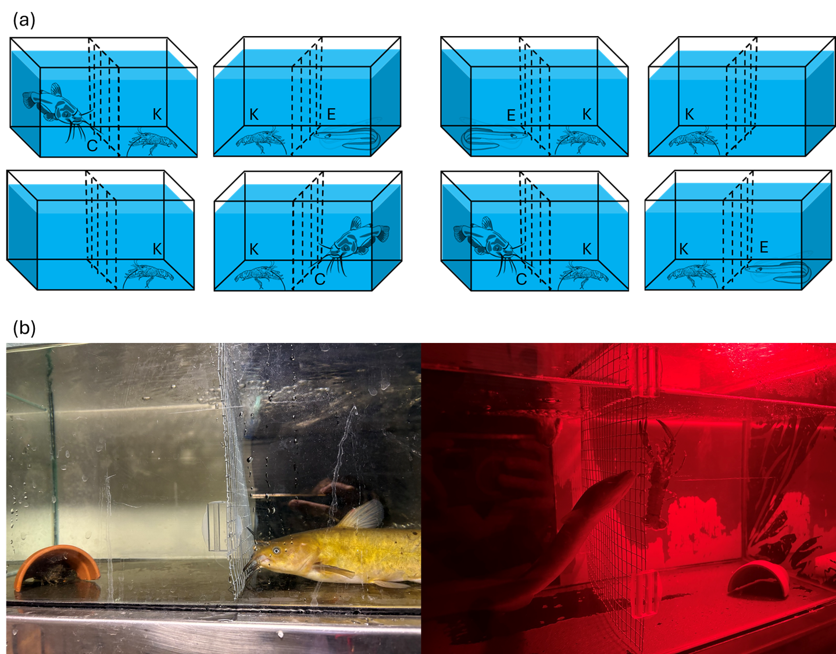
Figure 1: (a) Aquarium layout for kōura refuge seeking behaviour experiment. Each experimental round consisted of eight aquaria run simultaneously. Each tank contained a single kōura (K) and refuge (half terracotta plant pot) on one side of a mesh divider. On the other side was either a single catfish (C), eel (E) or a control with no fish. The mesh divider allowed visual and chemical cues while preventing direct physical contact between tank occupants. (b) Experiments were repeated in light and dark (red light), with photographs showing a catfish in the light regime (left) and and an eel in the dark regime (red light) (right) separated from kōura by mesh dividers.
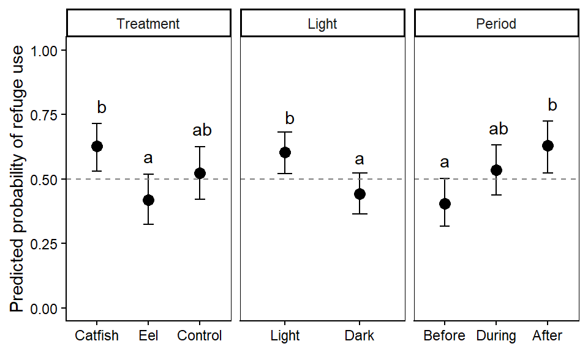
Figure 2: Predicted marginal probabilities of refuge use from the beta-binomial GLMM for each level of treatment, light condition, and experimental period. Points represent model-estimated marginal means averaged over other factors, with 95% confidence intervals shown as error bars. Different letters (a, b) indicate statistically significant differences between groups within each factor based on multiple comparison-adjusted pairwise comparisons. The dashed line at 0.5 marks the threshold where kōura spend half their time in refuge.
_{Source: Analysis Notebook}
systemfonts and textshaping have been compiled with different versions of Freetype. Because of this, textshaping will not use the font cache provided by systemfonts
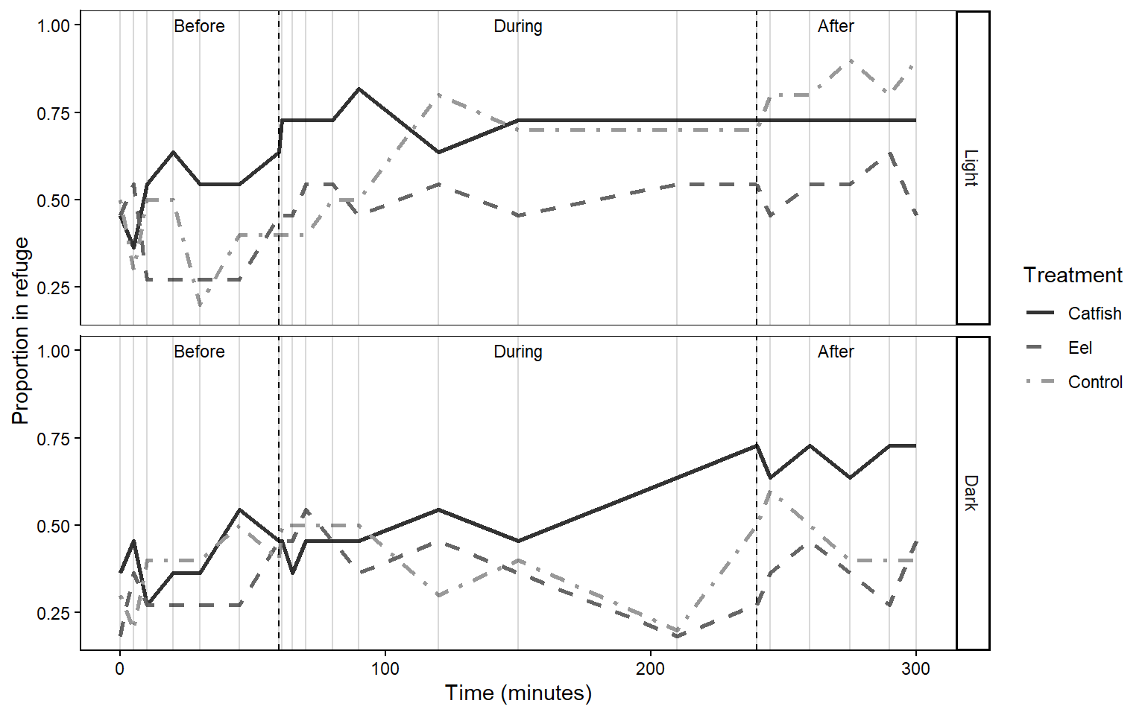
Figure 3: Kōura refuge use over the course of the experiment, showing the proportion of time spent in refuge across three periods (before, during, and after predator exposure) for each treatment (catfish: dark grey solid line; eel: medium grey dashed line; control: light grey dot-dash line) under light (top) and dark (bottom) conditions. Black dashed vertical lines indicate the start and end of predator exposure and grey vertical lines show individual observation times.
_{Source: Analysis Notebook}
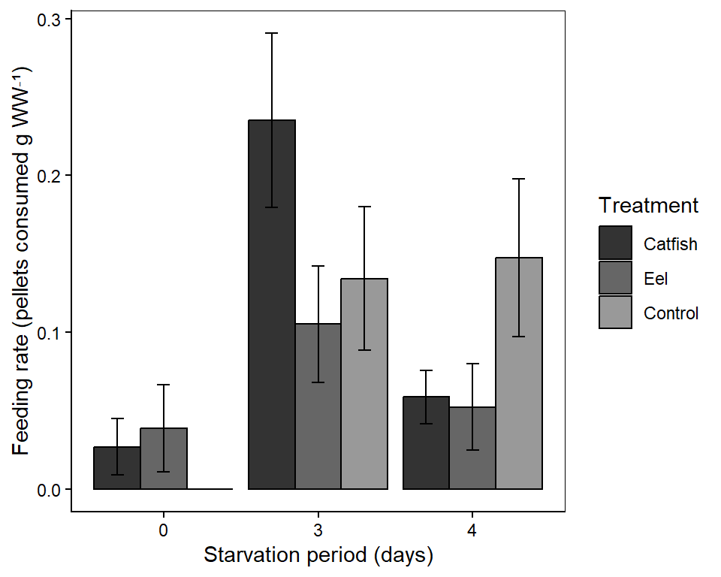
Figure 4: Mean (±SE) kōura feeding rate (pellets consumed per gram wet weight kōura) across predator treatments (catfish, eel, control) and starvation periods (0, 3, and 4 days).
_{Source: Analysis Notebook}

Supplementary information
Table 3: Proportion of kōura observations recorded in refuge across experimental treatments (catfish, eel, control), light conditions (light, dark), and periods (before, during, and after predator exposure). Combined rows summarise across all levels of a given factor. Values represent the proportion of total observations where kōura were located in the refuge.
Unable to display output for mime type(s): text/html
_{Source: Analysis Notebook}
Table 4: Type III ANOVA table for the linear model of kōura feeding rate (pellets consumed per gram body weight). Treatment and starvation period included as fixed effects.
Term | Sum Sq | Df | F value | p value
(Intercept) | 0.014 | 1 | 1.734 | 0.195
treatment | 0.018 | 2 | 1.133 | 0.332
day_starve | 0.137 | 2 | 8.632 | 0.001
Residuals | 0.327 | 41 | NA | NA

_{Source: Analysis Notebook}
Abrams, P. A. (2000). The evolution of predator-prey interactions: Theory and evidence. Annual Review of Ecology and Systematics, 31(1), 79–105. https://doi.org/10.1146/annurev.ecolsys.31.1.79
Achtymichuk, G. H., Fish, K. M., & Ferrari, M. C. O. (2025). The power of concentration: Antipredator responses to diluted frozen crayfish alarm cues provide insights on ecologically relevant concentrations and updates to methodology. PLOS One, 20(12), e0340001. https://doi.org/10.1371/journal.pone.0340001
Adams, S. B. (2007). Direct and indirect effects of channel catfish (ictalurus punctatus) on native crayfishes (cambaridae) in experimental tanks. The American Midland Naturalist, 158(1), 85–96. https://doi.org/10.1674/0003-0031(2007)158[85:daieoc]2.0.co;2
Barnes, G. E., & Hicks, B. J. (2003). Brown bullhead catfish (ameiurus nebulosus) in lake taupo (managing invasive freshwater fish in new zealand). Department of Conservation.
Beattie, M. C., & Moore, P. A. (2018). Predator recognition of chemical cues in crayfish: Diet and experience influence the ability to detect predation threats. Behaviour, 155(6), 505–530. https://doi.org/10.1163/1568539x-00003501
Blake, M. A., & Hart, P. J. B. (1993). The behavioural responses of juvenile signal crayfish pacifastacus leniusculus to stimuli from perch and eels. Freshwater Biology, 29(1), 89–97. https://doi.org/10.1111/j.1365-2427.1993.tb00747.x
Brönmark, C., & Hansson, L.-A. (2012). Chemical ecology in aquatic systems. Oxford University Press.
Brooks, E., Mollie, Kristensen, K., Benthem, J., Koen, Magnusson, A., Berg, W., Casper, Nielsen, A., Skaug, J., Hans, Mächler, M., & Bolker, M., Benjamin. (2017). glmmTMB balances speed and flexibility among packages for zero-inflated generalized linear mixed modeling. The R Journal, 9(2), 378. https://doi.org/10.32614/rj-2017-066
Brown, G. E., Poirier, J.-F., & Adrian, J. C. (2004). Assessment of local predation risk: The role of subthreshold concentrations of chemical alarm cues. Behavioral Ecology, 15(5), 810–815. https://doi.org/10.1093/beheco/arh084
Brown, L. A. (2009). Habitat determinants and predatory interactions of the endemic freshwater crayfish (koura, paranephrops planifrons) in the lower north island, new zealand [Massey University]. http://hdl.handle.net/10179/1168
Burnham, K. P., & Anderson, D. R. (2002). (pp. 267–351). Springer New York. https://doi.org/10.1007/978-0-387-22456-5_6
Carthey, A. J. R., & Banks, P. B. (2014). Naïveté in novel ecological interactions: Lessons from theory and experimental evidence. Biological Reviews, 89(4), 932–949. https://doi.org/10.1111/brv.12087
Clinchy, M., Sheriff, M. J., & Zanette, L. Y. (2012). Predator‐induced stress and the ecology of fear. Functional Ecology, 27(1), 56–65. https://doi.org/10.1111/1365-2435.12007
Collier, K. J., Parkyn, S. M., & Rabeni, C. F. (1997). Koura: A keystone species. Water and Atmosphere, 5(1), 18–20.
Dawkins, R., & Krebs, J. R. (1979). Arms races between and within species. Proceedings of the Royal Society of London. B. Biological Sciences, 205(1161), 489–511. https://doi.org/10.1098/rspb.1979.0081
Dedual, M. (2019). Summary of the impacts and control methods of brown bullhead catfish (ameiurus nebulosus lesueur 1815) in new zealand and overseas. Bay of Plenty Regional Council. https://atlas.boprc.govt.nz/api/v1/edms/document/A3591759/content
Devcich, A. A. (1979). An ecological study of paranephrops planifrons white (decapoda: Parastacidae) in lake rotoiti, north island [PhD thesis]. University of Waikato.
Doherty, T. S., Glen, A. S., Nimmo, D. G., Ritchie, E. G., & Dickman, C. R. (2016). Invasive predators and global biodiversity loss. Proceedings of the National Academy of Sciences, 113(40), 11261–11265. https://doi.org/10.1073/pnas.1602480113
Ehlman, S. M., Trimmer, P. C., & Sih, A. (2019). Prey responses to exotic predators: Effects of old risks and new cues. The American Naturalist, 193(4), 575–587. https://doi.org/10.1086/702252
Figler, M. H., Blank, G. S., & Peeke, H. V. S. (2005). Shelter competition between resident male red swamp crayfish procambarus clarkii (girard) and conspecific intruders varying by sex and reproductive status. Marine and Freshwater Behaviour and Physiology, 38(4), 237–248. https://doi.org/10.1080/10236240500376477
Fox, J., & Weisberg, S. (2018). An r companion to applied regression. SAGE Publications.
Gherardi, F., Mavuti, K. M., Pacini, N., Tricarico, E., & Harper, D. M. (2011). The smell of danger: Chemical recognition of fish predators by the invasive crayfish procambarus clarkii. Freshwater Biology, 56(8), 1567–1578. https://doi.org/10.1111/j.1365-2427.2011.02595.x
Hartig, F., Lohse, L., & leite, M. de S. (2024). DHARMa: Residual diagnostics for hierarchical (multi-level / mixed) regression models (Version 0.4.7) [Computer software]. https://cran.r-project.org/web/packages/DHARMa/index.html
Hazlett, B. A. (2003). The effects of starvation on crayfish responses to alarm odor. Ethology, 109(7), 587–592. https://doi.org/10.1046/j.1439-0310.2003.00902.x
Hicks, B. J. (1997). Food webs in forest and pasture streams in the waikato region, new zealand: A study based on analyses of stable isotopes of carbon and nitrogen, and fish gut contents. New Zealand Journal of Marine and Freshwater Research, 31(5), 651–664. https://doi.org/10.1080/00288330.1997.9516796
Johnson, M. F., Rice, S. P., & Reid, I. (2014). The activity of signal crayfish (pacifastacus leniusculus) in relation to thermal and hydraulic dynamics of an alluvial stream, UK. Hydrobiologia, 724(1), 41–54. https://doi.org/10.1007/s10750-013-1708-1
Kindinger, T. L., & Albins, M. A. (2017). Consumptive and non-consumptive effects of an invasive marine predator on native coral-reef herbivores. Biological Invasions, 19(1), 131–146. https://doi.org/10.1007/s10530-016-1268-1
Kusabs, I. A., Duggan, I. C., Scholes, P., Bruere, A., Te Kurapa, T. W., Grant, T., & Burdon, F. J. (n.d.). Invasive catfish linked to the decline of freshwater crayfish in two aotearoa new zealand lakes. Manuscript Submitted for Publication.
Kusabs, I. A., & Quinn, J. M. (2009). Use of a traditional maori harvesting method, the tau kōura, for monitoring kōura (freshwater crayfish, paranephrops planifrons) in lake rotoiti, north island, new zealand. New Zealand Journal of Marine and Freshwater Research, 43(3), 713–722. https://doi.org/10.1080/00288330909510036
Laundré, J. W., Hernández, L., & Altendorf, K. B. (2001). Wolves, elk, and bison: Reestablishing the “landscape of fear” in yellowstone national park, u.s.a. Canadian Journal of Zoology, 79(8), 1401–1409. https://doi.org/10.1139/z01-094
Lee, F., Kusabs, I. A. K., Perry, G. L. W., & MacNeil, C. (2025). Identifying refugia from the synergistic threats of climate change and invasive species. Web Ecology, 25(2), 221–239. https://doi.org/10.5194/we-25-221-2025
Lenth, R. V., Piaskowski, J., Banfai, B., Bolker, B., Buerkner, P., Giné-Vázquez, I., Hervé, M., Jung, M., Love, J., Miguez, F., Riebl, H., & Singmann, H. (2026). Emmeans: Estimated marginal means, aka least-squares means (Version 2.0.2) [Computer software]. https://cran.r-project.org/web/packages/emmeans/index.html
Lima, S. L., & Dill, L. M. (1990). Behavioral decisions made under the risk of predation: A review and prospectus. Canadian Journal of Zoology, 68(4), 619–640. https://doi.org/10.1139/z90-092
MacNeil, C., Lee, F., Kusabs, I., & Holmes, R. (2025). The biter bit; scavenging behaviour of native freshwater crayfish on the carrion of native and introduced fish predators in aotearoa-new zealand. Knowledge & Management of Aquatic Ecosystems, (426), 29. https://doi.org/10.1051/kmae/2025022
Martin, C. W. (2014). Naïve prey exhibit reduced antipredator behavior and survivorship. PeerJ, 2, e665. https://doi.org/10.7717/peerj.665
McDowall, R. M. (1990). New zealand freshwater fishes: A natural history and guide. https://agris.fao.org/search/en/providers/122621/records/6473966cce9437aa76003d0e
Nyström, P. (2005). Non‐lethal predator effects on the performance of a native and an exotic crayfish species. Freshwater Biology, 50(12), 1938–1949. https://doi.org/10.1111/j.1365-2427.2005.01438.x
Parkyn, S. M., Collier, K. J., & Hicks, B. J. (2001). New zealand stream crayfish: Functional omnivores but trophic predators? Freshwater Biology, 46(5), 641–652. https://doi.org/10.1046/j.1365-2427.2001.00702.x
Peacor, S. D., & Werner, E. E. (2001). The contribution of trait-mediated indirect effects to the net effects of a predator. Proceedings of the National Academy of Sciences, 98(7), 3904–3908. https://doi.org/10.1073/pnas.071061998
Preisser, E. L., Bolnick, D. I., & Benard, M. F. (2005). Scared to death? The effects of intimidation and consumption in predator–prey interactions. Ecology, 86(2), 501–509. https://doi.org/10.1890/04-0719
Preisser, E. L., & Bolnick, D. I. (2008). The many faces of fear: Comparing the pathways and impacts of nonconsumptive predator effects on prey populations. PLoS ONE, 3(6), e2465. https://doi.org/10.1371/journal.pone.0002465
R Core Team. (2025). R: A language and environment for statistical computing [Computer software]. R Foundation for Statistical Computing. https://www.R-project.org/
Ramberg-Pihl, N. C., & Yurewicz, K. L. (2020). Behavioral responses of northern crayfish (faxonius virilis) to conspecific alarm cues and predator cues from smallmouth bass (micropterus dolomieu). Marine and Freshwater Behaviour and Physiology, 53(1), 1–16. https://doi.org/10.1080/10236244.2020.1717338
Ryan, P. (2009). Eels | te ara encyclopedia of new zealand. https://teara.govt.nz/en/eels
Schmitz, O. J., Beckerman, A. P., & O’Brien, K. M. (1997). Behaviorally mediated trophic cascades: Effects of predation risk on food web interactions. Ecology, 78(5), 1388–1399. https://doi.org/10.1890/0012-9658(1997)078[1388:bmtceo]2.0.co;2
Scott, W. B., & Crossman, E. J. (1973). Freshwater fishes of canada. Fisheries Research Board of Canada.
Shave, Cathy. R., Townsend, C. R., & Crowl, T. A. (1994). Anti-predator behaviours of a freshwater crayfish (paranephrops zealandicus) to a native and an introduced predator. New Zealand Journal of Ecology, 18(1), 1–10.
Sheriff, M. J., Peacor, S. D., Hawlena, D., & Thaker, M. (2020). Non-consumptive predator effects on prey population size: A dearth of evidence. Journal of Animal Ecology, 89(6), 1302–1316. https://doi.org/10.1111/1365-2656.13213
Sih, A., Bolnick, D. I., Luttbeg, B., Orrock, J. L., Peacor, S. D., Pintor, L. M., Preisser, E., Rehage, J. S., & Vonesh, J. R. (2010). Predator–prey naïveté, antipredator behavior, and the ecology of predator invasions. Oikos, 119(4), 610–621. https://doi.org/10.1111/j.1600-0706.2009.18039.x
Sih, A., Chung, H. J., Neylan, I., Ortiz-Jimenez, C., Sakai, O., & Szeligowski, R. (2023). Fear generalization and behavioral responses to multiple dangers. Trends in Ecology & Evolution, 38(4), 369–380. https://doi.org/10.1016/j.tree.2022.11.001
Sih, A., Ferrari, M. C. O., & Harris, D. J. (2011). Evolution and behavioural responses to human‐induced rapid environmental change. Evolutionary Applications, 4(2), 367–387. https://doi.org/10.1111/j.1752-4571.2010.00166.x
Smee, D. L., & Weissburg, M. J. (2006). Hard clams (mercenaria mercenaria) evaluate predation risk using chemical signals from predators and injured conspecifics. Journal of Chemical Ecology, 32(3), 605–619. https://doi.org/10.1007/s10886-005-9021-8
Sniegula, S., Konczarek, D., Bonk, M., Antoł, A., Amer, N. R., & Stoks, R. (2025). Non-consumptive effects of native, alien and invasive alien crayfish on damselfly egg life history and carry-over effects on larval physiology. NeoBiota, 97, 215–235. https://doi.org/10.3897/neobiota.97.139760
Stebbing, P. D., Watson, G. J., & Bentley, M. G. (2010). The response to disturbance chemicals and predator odours of juvenile and adult signal crayfish pacifastacus leniusculus (dana). Marine and Freshwater Behaviour and Physiology, 43(3), 183–195. https://doi.org/10.1080/10236244.2010.487301
Stein, R. A., & Magnuson, J. J. (1976). Behavioral response of crayfish to a fish predator. Ecology, 57(4), 751–761. https://doi.org/10.2307/1936188
Usio, N., & Townsend, C. R. (2004). Roles of crayfish: Consequences of predation and bioturbation for stream invertebrates. Ecology, 85(3), 807–822. https://doi.org/10.1890/02-0618
Wood, T. C., & Moore, P. A. (2020a). Big and bad: How relative predator size and dietary information influence rusty crayfish (faxonius rusticus) behavior and resource-use decisions. Canadian Journal of Zoology, 98(1), 62–72. https://doi.org/10.1139/cjz-2019-0089
Wood, T. C., & Moore, P. A. (2020b). Fine-tuned responses to chemical landscapes: Crayfish use predator odors to assess threats based on relative size ratios. Ecosphere, 11(9), e03188. https://doi.org/10.1002/ecs2.3188
Wright, T. F., Eberhard, J. R., Hobson, E. A., Avery, M. L., & Russello, M. A. (2010). Behavioral flexibility and species invasions: The adaptive flexibility hypothesis. Ethology Ecology & Evolution, 22(4), 393–404. https://doi.org/10.1080/03949370.2010.505580
Zhao, M., Feng, G., Wang, H., Shen, C., Fu, Y., Zhang, Y., Zhang, H., Yao, Y., Chen, J., & Xu, W. (2024). The influence of shelter type and coverage on crayfish (procambarus clarkii) predation by catfish (silurus asotus): A controlled environment study. Animals, 14(8), 1147. https://doi.org/10.3390/ani14081147

