Structure over material: mesocosm experiments reveal shelter design principles for threatened freshwater crayfish restoration
Olivier V. Raven
Robin Holmes
Ian A. K. Kusabs
Francis J. Burdon
Deniz Özkundakci
2026-05-28
Abstract
Freshwater crayfish are among the most threatened invertebrates globally, with habitat loss a primary driver of population decline, yet the optimal design of habitat enhancement structures for their restoration remains largely unknown. Four controlled mesocosm experiments with the endemic Aotearoa-New Zealand freshwater crayfish kōura (Paranephrops planifrons) examined how shelter structure, material composition, body size, and group dynamics influence refuge selection. Individual kōura strongly preferred a wooden log with enclosed drilled holes, but when housed in mixed-size groups, kōura preference shifted to flat and piled stone configurations, providing more complex refugia for different-size individuals simultaneously. Flat stone structures were preferred over wood splits and this was strongest for large individuals. When structural dimensions were held constant, no significant preference was detected between concrete and wooden brick structures, indicating that material composition alone does not drive refuge selection. Size class effects on shelter preference were quantified using Bayesian categorical mixed-effects models, which provide an appropriate framework for multi-choice repeated-measures designs with categorical outcomes and nested group structures. These mesocosm findings suggest that stone-based configurations warrant field evaluation as habitat enhancement structures for kōura restoration, given their structural complexity across size classes and alignment with the cultural values associated with restoring this taonga species.

Introduction
Crayfish are among the most threatened freshwater invertebrates globally, with 32% of species assessed as threatened with extinction due to habitat loss, water quality decline, and invasive species (Richman et al., 2015). As keystone species and ecosystem engineers, crayfish play crucial roles in freshwater food webs through shredding of leaf litter, bioturbation of sediments, and nutrient cycling, and their loss can have profound cascading effects on freshwater ecosystems (Collier et al., 1997; Momot, 1995; Parkyn et al., 2001). The increasing degradation of freshwater habitats therefore not only threatens crayfish populations, but also risks disrupting the ecosystem processes crayfish sustain.
Habitat complexity is a key driver of crayfish population persistence, as structurally diverse habitats provide physical refugia from predators, foraging opportunities, and shelter during moulting when individuals are particularly vulnerable (Hammond et al., 2006). Shelter availability directly increases crayfish survival and growth under predation pressure (Adams, 2007), making refuge quality a critical consideration for both natural habitat persistence and restoration design. Crayfish use a wide variety of natural and artificial structures as shelter, including rocks, woody debris, and even anthropogenic objects such as bottles and discarded appliances (Adams, 2014; Parkyn et al., 2009), demonstrating considerable flexibility in habitat use. In the context of freshwater restoration, increasing structural complexity through providing shelters has improved crayfish abundance and restocking success in degraded streams and lakes (Huolila et al., 1997; Johnsen & Taugbøl, 2008), and the availability of coarser substrate has also been shown to improve juvenile survival rates (Mazlum et al., 2017). These findings indicate that enhancing habitat complexity can be a useful management tool for threatened crayfish populations. While artificial aquatic habitats have received attention in marine systems (Frehse et al., 2025), equivalent systematic comparisons of shelter configurations for freshwater crayfish restoration remain largely absent from the literature.
Shelter selection in crayfish is strongly influenced by body size, as individuals actively select refugia proportional to their dimensions. Crayfish individuals selected stones more than 3 times longer and 1.25 times wider than their carapace length, with larger males consistently selecting larger stones (Streissl & Hödl, 2002). Body size and shelter dimensions have direct competitive consequences as crayfish in undersized shelters initiated and won more fight than those in appropriately sized shelters, suggesting that shelter fit influences an individual’s assessment of its own fighting ability (Percival & Moore, 2010). Social dynamics further complicate shelter use when refuge availability is limited, as competitive interactions among conspecifics determine which individuals gain access to preferred shelters. Dominance hierarchies based on body size and reproductive status show that males and maternal females often are able to overtake shelters from non-maternal females, while adults consistently outcompete juveniles for shelter access (Figler et al., 2005). Body weight ratio between contestants is a strong predictor of shelter takeover success, although prior ownership can offset size disadvantages (Ranta & Lindström, 1993), particularly when both individuals hold high-quality shelters (Takahashi et al., 2019). At the population level, habitat complexity buffers these competitive effects, with juveniles in structurally complex habitats showing higher survival, faster growth, and greater moulting rates as more shelter availability reduces agonistic interactions (Olsson & Nyström, 2009). Together, shelter use in crayfish reflects an interaction between individual body size and social competitive dynamics, suggesting that effective habitat enhancement structures must provide a range of shelter sizes to support different life stages and size classes simultaneously.
The material and structural properties of shelters influence their value as refugia. Studies comparing shelter configurations show that the availability and size of enclosed spaces matters more than total structure volume on reef fish assemblages (Hylkema et al., 2020), while enclosed structures such as PVC pipes provided greater protection against predatory fish than stone or vegetation structures, likely due to their consistent hole dimensions (Zhao et al., 2024). However, the use of synthetic materials in restoration ecology brings ecological concerns, particularly in contexts where introducing non-native materials may conflict with conservation values or indigenous cultural frameworks (Cooke et al., 2023; Wehi & Lord, 2017). Natural materials such as stones and wood offer ecologically compatible alternatives, yet the importance of structural configuration versus material composition for crayfish shelter preference remains largely unknown.
In Aotearoa-New Zealand (hereafter Aotearoa), the endemic freshwater crayfish kōura (Paranephrops planifrons) faces conservation pressure from habitat loss, water quality degradation, and predation by invasive species (Kusabs et al., inpress; Lee et al., 2025). Kōura are taonga (culturally treasured) species for Māori, the indigenous people of Aotearoa, and hold significant ecological and cultural value in freshwater ecosystems (Kusabs & Quinn, 2009). In their natural habitat, kōura are positively associated with overhanging banks, coarse substrates, and woody debris (Jowett et al., 2008; Parkyn et al., 2009; Raven et al., inreview; Usio & Townsend, 2000). Kōura have been shown to significantly increase refuge use in the presence of predators (Raven et al., indraft; Shave et al., 1994). However, a systematic study on shelter design preference on crayfish remains largely absent from the literature. Habitat restoration by increasing shelter availability represents a promising management tool for kōura recovery, and the use of natural materials aligns with ecological and cultural values set for these naturally and culturally important lakes.
In this study four controlled mesocosm experiments were conducted to identify kōura preferences among different structures varying in material and configuration, to examine how individual behaviour, body size, and group interactions influence refuge selection. We predicted that 1) Structurally complex structures providing enclosed crevices would be preferred over isolated or open structures, as enclosed spaces reduce predation risk. 2) Structure preference would be size-dependent, with larger kōura selecting structures with larger refuge spaces (Percival & Moore, 2010; Streissl & Hödl, 2002). 3) Stone-based structures would be preferred over wood due to greater structural stability, and 4) material type alone would not influence refuge preference between concrete and wooden bricks. The results provide practical guidance for designing cost-effective, ecologically appropriate habitat enhancement structures to support kōura population recovery.

Materials and Methods

Animal collection and tank setup
In mid-August 2025, 72 kōura were sourced from lakes Ōkāreka and Tikitapu, located within the Rotorua Te Arawa Lakes area in the North Island of Aotearoa. Collected animals were transported to the Aquatic Research Centre at the University of Waikato in Hamilton. Individuals were assigned to one of three size classes based on orbital carapace length (OCL): small (< 22 mm), medium (22–30 mm), and large (> 30 mm). Each animal was marked with a unique identification number written on the carapace using an orange oil-based paint marker (Sharpie, medium point) (Ramalho et al., 2010).
Kōura were acclimatised for 12 days in outdoor concrete holding tanks (Ø 1.4 m, 0.5 m deep), each filled to a depth of 0.4 m with dechlorinated tab water conditioned for three months. Paving sand was used as substrate, and shelters were provided as PVC pipes, broken terracotta pots, and perforated building bricks. Each holding tank housed 10–12 kōura. Kōura were fed every second day with commercial carnivore pellets (Hikari Tropical, Kyorin Food Industries Ltd., Japan; animal protein 47%).
Experiments were conducted outside in six circular concrete tanks (1425 L; Ø 1.85 m, 0.53 m deep), each filled to a depth of 0.4 m with dechlorinated tab water conditioned for three months. Paving sand was used as substrate and tanks were closed off with a lid constructed of two layers of shade cloth to prevent escape and minimise sun activity. Fresh dechlorinated tap water and an air stone were added to each tank in between the experimental rounds. To prevent temperatures in the tanks getting too high the experiments were conducted in spring (September till October). Because kōura are a taonga (treasured) species, permission was obtained from Te Arawa Lakes Trust and Te Komiti Whakahaere. All experimental procedures were conducted under University of Waikato animal ethics committee approval (protocol number: 1207; see Ethical Approval section).

Exp 1: Single kōura
This experiment assessed individual kōura structure preference by offering single animals a choice among four structures (Figure 1). The structure-types were: SingleStone (ten quarried stones (150–250 mm) placed separately), FlatStone (ten quarried stones arranged tightly without stacking), StonePile (ten quarried stones stacked to form a pile), and WoodLog (a tānekaha (Phyllocladus trichomanoides) log (500 mm long, 150 mm diameter) containing six drilled holes (70 mm deep, 32 mm diameter)). Six experimental tanks were used, each housing a single medium-sized kōura. In total 30 kōura consisting of 15 females with mean OCL and weight ± SD: 26.9 ± 2 mm, range: 23.2–29.8 mm, 12.5 ± 3.3 g and 15 males: 26.1 ± 2.2 mm, range: 22.6–30 mm, 11.9 ± 3.1 g were tested across five experimental replicates, with each replicate lasting 22 hours.
Each experimental tank was divided into four quadrants, with one structure type placed at random (randomizer.org) in each quadrant. If a kōura was not using a structure, TankWall was noted as location which represents the wall of the tank. For each trial, a single kōura was placed inside a vertically oriented plastic tube (50 mm long, open at one end and sealed at the other) positioned at the centre of the tank, with the sealed end resting on the substrate. This ensured a standardised starting position from which the kōura could exit in any direction. The time taken for the kōura to locate its first structure was recorded (L0). On the following day, the final location of the kōura was noted (L1) after which it was removed from the tank. Tanks were reset and structure placements re-randomised prior to the next trial. Each kōura was used in a single trial only and was not reused across replicates.
To test the difference between the structure types selected the next day, a multinomial goodness-of-fit test was performed using the XNomial package (Engels, 2014). TankWall was excluded from preference tests as it represents the absence of structure choice rather than a structure type preference. Additionally, pairwise likelihood-ratio G-tests with Bonferroni correction were used to identify which structure types differed significantly from each other. To test whether structure type use differed between sexes, Fisher’s exact test with simulated p-values (9999 replicates) was used due to small expected counts. A permutation-based symmetry test was applied to assess whether structure type transitions between L0 and L1 were directional rather than random. To confirm nocturnal activity, three GoPros (Hero 3) were placed in one tank at the end of the day and recorded for five hours.

Exp 2: Group kōura
Building on experiment 1, this experiment examined how group dynamics and body size influenced structure preference when kōura were housed together. The six experimental tanks were used and configured with the same structure types and randomisation procedure as in experiment 1 (Figure 1). In contrast to the single-animal trials, each tank housed a group of six male kōura, comprising two small, two medium, and two large individuals. Size classes were defined by OCL: small (mean OCL and weight ± SD: 19.2 ± 2 mm, range: 15.8–21.6 mm, 3.9 ± 2.1 g), medium (26.4 ± 1.6 mm, 23.5–29.5 mm, 11.6 ± 2.4 g), and large (36.3 ± 4.2 mm, 30.7–43.3 mm, 31.8 ± 11.2 g). Each group was introduced to the centre of the tank within an open-top plastic container (150 × 150 × 85 mm). The container was removed, and the initial location of each individual was recorded. On the following day, the final location of each kōura was documented, before all individuals were removed from the tank. This procedure was repeated across five experimental replicates reusing the same six groups of animals.

Exp 3: Wood vs Stone
Using the same groups from experiment 2, this experiment narrowed the choice to two structure types, stone and wood, to directly compare preference between these materials. The structure types were: (1) a flat stone structure (FlatStone) constructed from twelve stones placed tightly together, and (2) a wood structure consisting of twelve wood splits (WoodSplit) made from the tānekaha logs (Figure 1). Each group was released at the centre of the tank, and the initial structure selected by each kōura was recorded. The following day, the final location of each kōura was documented. This procedure was repeated three times, reusing the same six groups of animals.

Exp 4: Bricks
This experiment tested whether kōura showed a preference between concrete and wooden perforated brick structures, to isolate the effect of material on structure preference. Two perforated building bricks (BrickConcrete) of 80 × 80 × 225 mm with five holes (Ø 30 mm) were tested against two wooden bricks (BrickWood) made from Western red cedar (Thuja plicata), constructed to match the building bricks in external dimensions and hole size. To prevent floating a solid clay brick of identical dimensions was placed on top of each wooden brick (Figure 1). New groups of ten kōura and four experiment tanks were used for this experiment, comprising a total of 40 individuals consitting of 18 females with mean OCL and weight ± SD: 26.2 ± 3.1 mm, range: 20.2–30.8 mm, 12.2 ± 4.2 g and 22 males: 26 ± 2.1 mm, range: 20.9–29.5 mm, 11.6 ± 3.2 g. Due to reduced animal availability, individuals were drawn from a slightly broader size range than medium sized individuals, resulting in unbalanced size class representation (small: n = 4, medium: n = 35, large: n = 1). In each of the four experimental tank quadrants one brick was placed, with similar brick types positioned opposite to one another. Each group of kōura was released at the centre of the tank and the following day, the final location of each kōura was documented. This experiment was repeated four times by reusing the four groups of ten kōura.

Data analysis
To test whether overall structure preference existed at the group level, one-sample Wilcoxon signed-rank tests were applied to group-round proportions for each structure type, testing against a null expectation of 0.25 (equal distribution among four structure types). P-values were Bonferroni adjusted for multiple comparisons. Normal approximation was used due to ties arising from discrete group counts. To test whether size classes affected structure preference while accounting for repeated measurement of individuals and groups, a Bayesian categorical mixed-effects model was fitted using the brms package (Bürkner et al., 2025), with structure type as the outcome, size class as a fixed effect, and group identity, individual identity nested within group, and experimental round as random intercepts. The Stuart-Maxwell test was used to test for statistical differences between stage L0 and L1. The Bayesian categorical mixed-effects model was used for this analysis as the outcome is categorical and individual animals within group within round create a three-level nested random effect structure. Group numbers are also relatively low with only six groups, and standard frequentist mixed-effect approaches such as lme4 (Bates et al., 2015) does not support categorical outcomes with complex nested random effects structures, making Bayesian estimation the appropriate choice for this design (Bolker et al., 2009; McCarthy, 2007). Model convergence was assessed using the Gelman-Rubin diagnostic (all $\hat{R}$ = 1.00) and divergent transition counts (all experiments: 0 divergences), confirming reliable posterior sampling (Gelman & Rubin, 1992). The same modelling framework and convergence criteria were applied in experiments 3 and 4.
To test the difference between FlatStone and WoodSplit the Wilcoxon signed-rank test was applied to group-round proportions for each structure type, testing against a null expectation of 0.5. P-values were Bonferroni adjusted. To test whether size classes affected structure preference while accounting for repeated measurement of individuals and groups, a similar Bayesian categorical mixed-effects model was fitted. The Stuart-Maxwell test was used to test for statistical differences between stage L0 and L1.
To test whether kōura showed a preference between BrickConcrete and BrickWood, the Wilcoxon signed-rank test was applied to group-round proportions for each brick type, testing against a null expectation of 0.5 and P-values were Bonferroni adjusted. A paired Wilcoxon signed-rank test was used to directly compare group-round proportions between BrickConcrete and BrickWood. As size class was unbalanced, the effect of sex on brick preference was tested using a similar Bayesian categorical mixed-effects model. Finally, as only next-day locations (L1) were recorded in this experiment, no directional shift analysis was performed.

Results

Exp 1: Single kōura
Individual kōura showed a strong preference for WoodLog, selecting it significantly more often than SingleStone, FlatStone, and StonePile (pairwise G-test, Bonferroni adjusted: p = <0.001, 0.011, 0.004, respectively; overall multinomial test: p = <0.001; Figure 2). No significant differences were found among the stone structure types. Overall, WoodLog was selected by 67% of kōura at L1 (males: 80%; females: 53%), and no kōura were found at TankWall, indicating all individuals actively selected a structure. Structure preference did not differ significantly between sexes (Fisher’s exact test: p = 0.457). The symmetry test indicated that structure type use shifted between L0 and L1 (p = <0.001), suggesting kōura actively relocated to preferred structure types overnight rather than remaining at their initial location. The GoPro footage also shows kōura emerging, walking and climbing on the structures after sunset.

Exp 2: Group kōura
When housed in mixed-size groups, kōura showed a significant overall preference for stone-based structures (Figure 3). FlatStone was used significantly more (p = 0.004), while SingleStone (p = <0.001) and WoodLog (p = 0.039) were significantly avoided. StonePile did not differ from random expectation (p = 1.000), and did not differ significantly from FlatStone (p = 0.117). No kōura were found at TankWall, indicating active structure selection across the group. Size classes had limited but credible effect on structure preference. Medium sized kōura showed a weaker preference for FlatStone over SingleStone compared to small kōura (β = -1.75, 95% CI: -3.66 to -0.09; posterior probability = 0.98), while no other size class effect was credible. Overall, FlatStone remained the most selected structure type across all size classes, but its strength of preference declined from small (posterior probability of top choice = 85%) to medium (53%), and with large kōura showing similar preference between FlatStone and StonePile (41% vs 38%). Structure type use shifted directionally between L0 and L1 (Stuart-Maxwell test: p = 0.001), indicating that kōura actively relocated to preferred structure types overnight.

Exp 3: Wood vs Stone
Kōura consistently selected FlatStone over WoodSplit, with the preference growing with body size (Figure 4). At the group level, FlatStone was used significantly more than expected (p = 0.001), while WoodSplit was significantly avoided (p = 0.004). Only 1% of kōura were found at TankWall, suggesting almost all kōura selected one of the two structure types. The Bayesian model indicated that preference for FlatStone strengthened with body size, with the posterior probability of FlatStone being the top-ranked structure increasing from small (62%) to medium (78%), to large kōura (96%). Large kōura showed a particularly strong and credible preference for FlatStone over WoodSplit (β = -2.4, 95% CI: -4.39 to -0.8; posterior probability = > 0.99), while medium kōura did not differ from small kōura. Structure type use shifted directionally between L0 and L1 (Stuart-Maxwell test: p = 0.003), with kōura relocating toward FlatStone overnight.

Exp 4: Bricks
Kōura used both brick types, showing no significant preference between BrickConcrete and BrickWood (p = 0.137; Figure 5), with mean group proportions of 47% and 53% respectively. Neither brick type differed significantly from equal distribution (p = 0.273). 9% of kōura were found at TankWall, which is higher than in any previous experiment. Sex had no credible effect on preference between brick types (β = -0.18, 95% CI: -1.29 to 0.85; posterior probability = 0.64), indicating that concrete and wooden perforated brick structures of identical dimensions were both suitable refuge for male and female kōura.

Discussion

Structure matters more than material
Across four experiments, refuge configuration and structural stability consistently predicted kōura habitat selection more strongly than material composition alone. Experiment 4 shows that when kōura were presented with similar refuge sizes in concrete bricks and wooden bricks no preference for material was detected. In experiment 3 FlatStone and WoodSplits were tested against each other and showed a difference in structure preference likely due to the stability of the stones compared to the wood splits. The WoodSplits were sinking but created less structurally stable refuge places in the sandy substrate than the FlatStone structures [O.V. Raven, pers. obs.]. Experiment 2 showed that when a group of kōura is presented with multiple structure types the structures that provide the most crevice complexity drive group-level preference. This was the case for FlatStone followed by StonePile for harbouring the most kōura. In experiment 1 the preference was different as individual kōura preferred WoodLog as refuge, this is consistent with prediction 1, as single kōura probably searched the refuge that would give most protection (Jurcak et al., 2016), and the drilled holes in the WoodLog offer most protection similar to what has been found for perforated brick and PVC tube shelters under catfish predation (Adams, 2007; Zhao et al., 2024). The directional shift in structure type use between L0 and L1 confirmed across all experiments that kōura actively relocated overnight rather than remaining at their initial location, supporting the interpretation that next-day locations reflect genuine refuge preference rather than chance displacement. The preference shift from WoodLog in single to stone structures in group experiments was unexpected. It might be explained by size mismatch between fixed hole dimensions and the range of body sizes present in each group, while the large surface area of FlatStone allowed multiple individuals to shelter simultaneously and reduce competitive displacement. Learning across rounds may also have contributed, as WoodLog was most selected structure in round 1 of experiment 2 (17 out of 36 times) but not in subsequent rounds, suggesting kōura may have shifted preference after initial exploration. This learning was possible as the groups of kōura in experiment 2 were reused all five rounds, while the single kōura in experiment 1 were only used once. The reuse of groups across rounds was necessary given the limited availability of kōura and ethical constraints on collection numbers. The number of independent groups was low across experiments (six in experiments 2 and 3, four in experiment 4), constraining the statistical power for detecting group-level effects (Hurlbert, 1984). Despite these constraints, consistent patterns in size-dependent preference were evident across experiments.

Body size and competitive dynamics
Size class consistently influenced refuge preference across experiments, but the pattern differed by context. In experiment 3, larger kōura showed a stronger preference for FlatStone over WoodSplit than smaller individuals. This may reflect larger kōura being more capable of asserting dominance over preferred stable refugia through competitive displacement, consistent with size-based dominance hierarchy documented in kōura populations (Figler et al., 2005; Ranta & Lindström, 1993; Stewart & Tabak, 2011). In experiment 2, where four structure types were available, small kōura showed the strongest preference for FlatStone while large kōura distributed more evenly between FlatStone and StonePile, suggesting that when multiple stone structures are available larger individuals are less selective between stone configurations, likely because both provide suitable sized crevices for larger bodies. Small kōura may have particularly benefited from FlatStone’s large continuous surface area, which provides the most accessible refuge spaces also for smaller body dimensions without creating competition with larger individuals. The absence of sex effects in experiment 1 and 4 suggests that refuge preference in kōura is driven primarily by body size and social dominance rather than sex.
When refuge availability is limited, competitive hierarchies lead to smaller and recently moulted crayfish to be displaced from refuge and left exposed (Figler et al., 2005; Ranta & Lindström, 1993). Providing sufficient refuge spaces with a range of crevice size can reduce agonistic interactions and benefits the whole population (Olsson & Nyström, 2009), supporting complex structure configurations over structures with fixed hole dimensions.

Restoration implications
The finding that structural configuration and stability drive refuge preference more strongly than material composition has broad implications for habitat enhancement structure design beyond kōura restoration. The availability of appropriate size and structurally stable crevices appears to be the most important driver for use by crayfish (Huolila et al., 1997; Streissl & Hödl, 2002). Also in marine environments these principles may be applicable to other refuge-dependent species including lobsters and reef fish (Hylkema et al., 2020; Spanier, 1994). Other important factors are that habitat enhancement structures need to provide protection from predators, and there need to be food in the vicinity (Huolila et al., 1997), therefore understanding of local dynamics is important. When building habitat enhancement structures the use of locally sourced natural materials should be favoured as these align with both ecological best practice (Cooke et al., 2023) and with indigenous principles of guardianship over natural character of culturally significant lake environments. Natural wood structures have been shown to outperform bare substrates and plastic structures by attracting more marine shrimp and freshwater fish (Dickson et al., 2023; Magnelia et al., 2008).
For kōura restoration in lake environments, stone pile configurations are recommended over flat arrangements. Pile structures provide a range of crevice sizes accommodating multiple size classes simultaneously and are less likely to gradually sink into soft substrates than flat configurations (Garron et al., 2024). For in-lake deployment, cobble substrate of 100–300 mm is recommended as kōura are positively associated with coarser substrate in this size range (Johnsen & Taugbøl, 2008; Jowett et al., 2008; Kusabs et al., 2015; Olsson et al., 2006). Providing enclosed crevice spaces within structures is important in lakes where kōura are preyed upon by invasive species such as catfish (Kusabs et al., inpress; Raven et al., inreview), as refuge quality directly influences predation survival (Zhao et al., 2024). While these mesocosm findings provide clear design guidance, field validation in lake environments remains an essential next step, as in-lake conditions including water movement, natural substrate, and predator pressure may modify kōura preferences in ways not captured under controlled conditions.

Conclusion
Many crayfish species around the world live in degraded habitats with habitat complexity as the limiting factor. Restoration tools are needed to help them and protect their role in freshwater ecosystems. This study contributes to the understanding that structure and crevice complexity matter more than material. This study suggests that for lake-based kōura restoration, stone pile configurations represent the most effective and cost-efficient habitat enhancement structure design, provide a wide range and structurally stable crevices of different sizes for all life stages. Locally sourced rocks align also with ecological and cultural values of restoring taonga species habitat using natural materials. Field validation of these mesocosm-derived preferences remains an important next step for translating these findings into effective restoration practice.

Acknowledgements
We thank Te Arawa Lakes Trust and Te Komiti Whakahaere for the opportunity to collect and study the treasured kōura. We are grateful to Soweeta Fort-D’ath and William Anaru (Te Arawa Lakes Trust), and Tihini Grant (Ngāti Pikiao). This research was supported by the Fish Futures programme funded through a Ministry of Business, Innovation and Employment grant (CAWX2101).

Authors’ contributions
Study conception and design were undertaken by O.V.R., R.H. and F.J.B. Experiments were conducted by O.V.R. Data analysis was performed by O.V.R. Local ecological knowledge and kōura were supplied by I.A.K.K. Manuscript drafting was led by O.V.R. All authors contributed to manuscript revision, approved the results, and the final manuscript.

Ethical approval
This study received ethical approval by University of Waikato animal ethics committee, protocol number: 1207. Additional permission to conduct experiments with kōura was granted by Te Arawa Lakes Trust and Te Komiti Whakahaere.

Declarations
The corresponding author has declared that none of the authors has any competing interests.

Data availability statement
The code and derived data supporting the findings of this study are openly available on GitHub (https://github.com/OlivierRaven/Koura_Mesocosm)and a rendered version of the analysis is hosted at https://olivierraven.github.io/Koura_Mesocosm/. The primary raw dataset is archived on Zenodo (https://doi.org/……). Peer review documents, including the cover letter and reviewer responses, are available in the manuscript repository in the interest of open and transparent science.

Tables

Figures
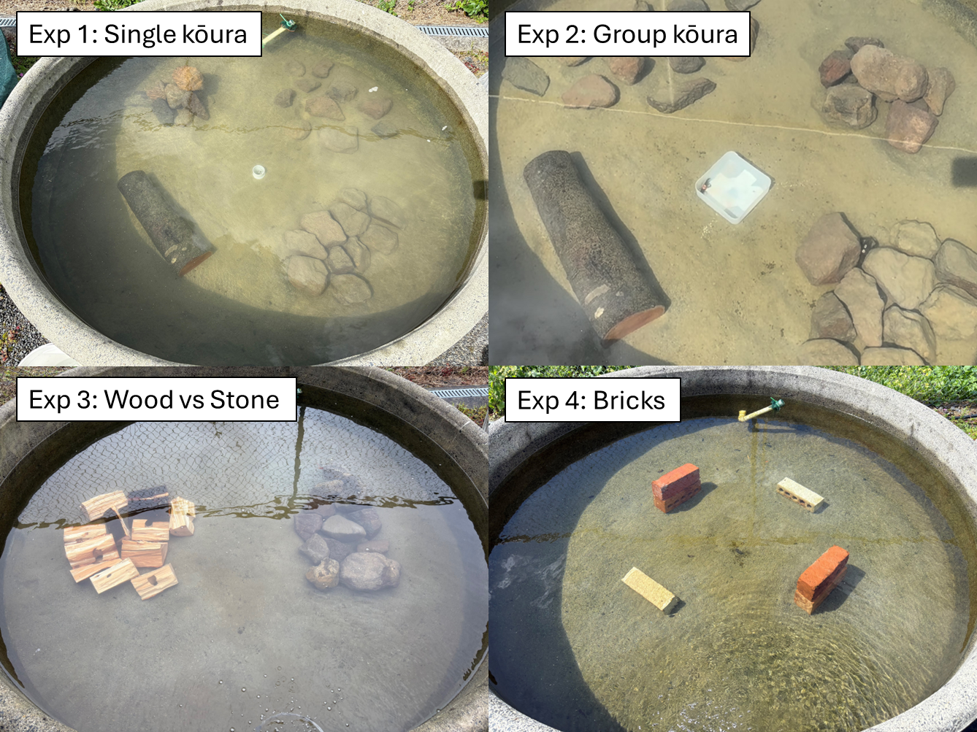
Figure 1: Overhead photographs of experimental tank configurations for each of the four mesocosm experiments. Experiment 1 (Single kōura) and Experiment 2 (Group kōura): four shelter types, WoodLog (tānekaha log with drilled holes), FlatStone (stones arranged flat), StonePile (stones stacked), and SingleStone (individual stones placed separately). Experiment 3 (Wood vs Stone): WoodSplit shelter (tānekaha wood splits) and FlatStone shelter placed in opposing halves of the tank. Experiment 4 (Bricks): BrickConcrete (perforated concrete bricks) and BrickWood (wooden bricks of identical dimensions) placed in opposing quadrants of the tank.
systemfonts and textshaping have been compiled with different versions of Freetype. Because of this, textshaping will not use the font cache provided by systemfonts
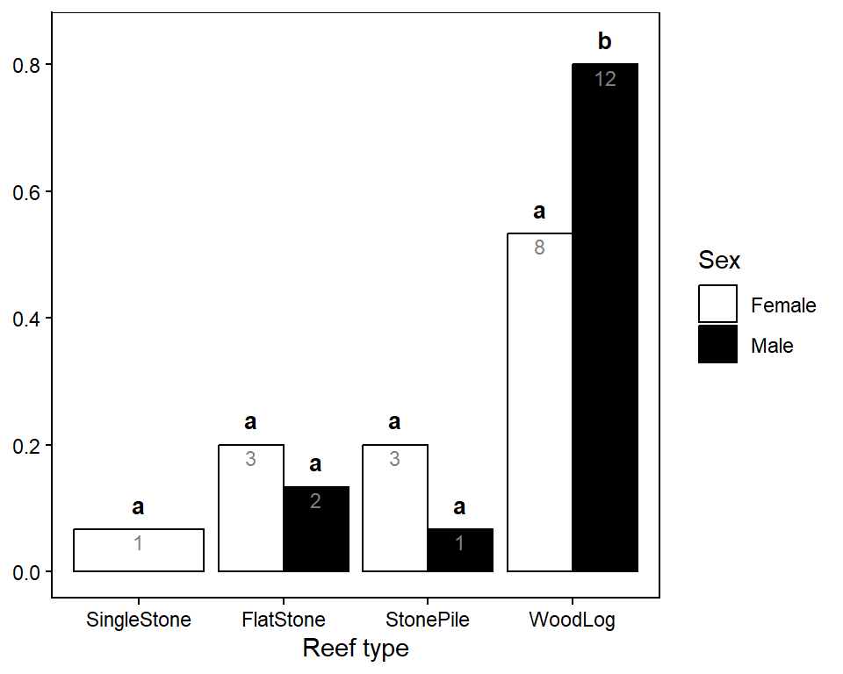
Figure 2: Proportion of individual kōura (Experiment 1) found at each reef type at final observation (L1), shown separately for female and male kōura. Bars show observed proportions with sample sizes (n) shown in white. Letters above bars indicate significant pairwise differences (G-test, Bonferroni adjusted).
_{Source: Analysis Notebook}
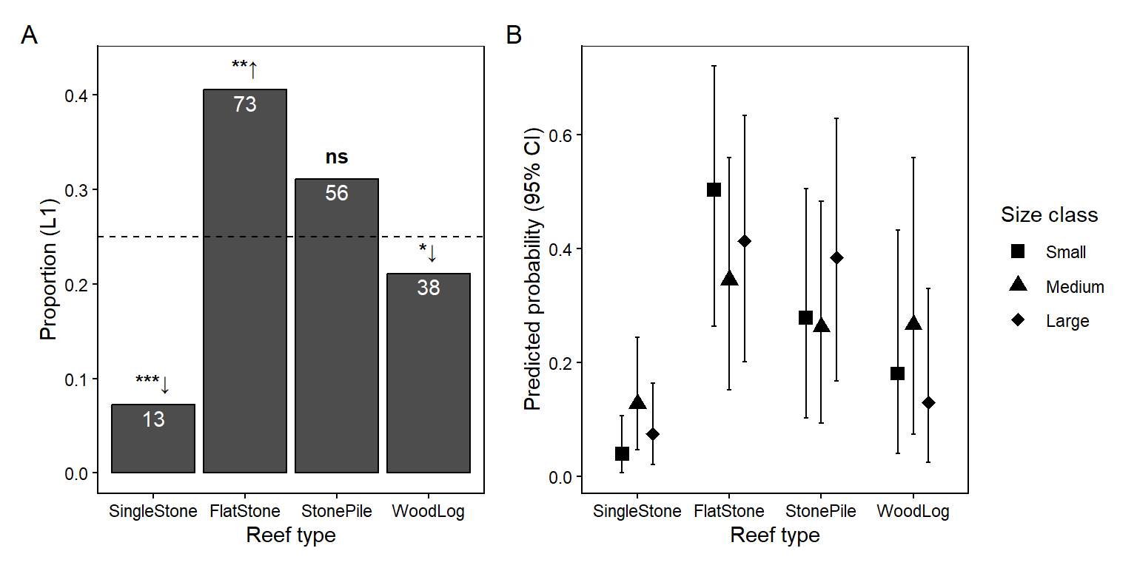
Figure 3: Reef type preference of group kōura (Experiment 2). (A) Proportion of kōura found at each reef type at L1 across all groups and rounds. The dashed line indicates the null expectation of equal distribution (0.25). Significance symbols indicate deviation from null expectation (Wilcoxon signed-rank test, Bonferroni adjusted): ↑ used more than expected, ↓ used less than expected. Sample sizes shown in white. (B) Posterior predicted probability of reef type use by size class from Bayesian categorical mixed model, with 95% credible intervals.
_{Source: Analysis Notebook}
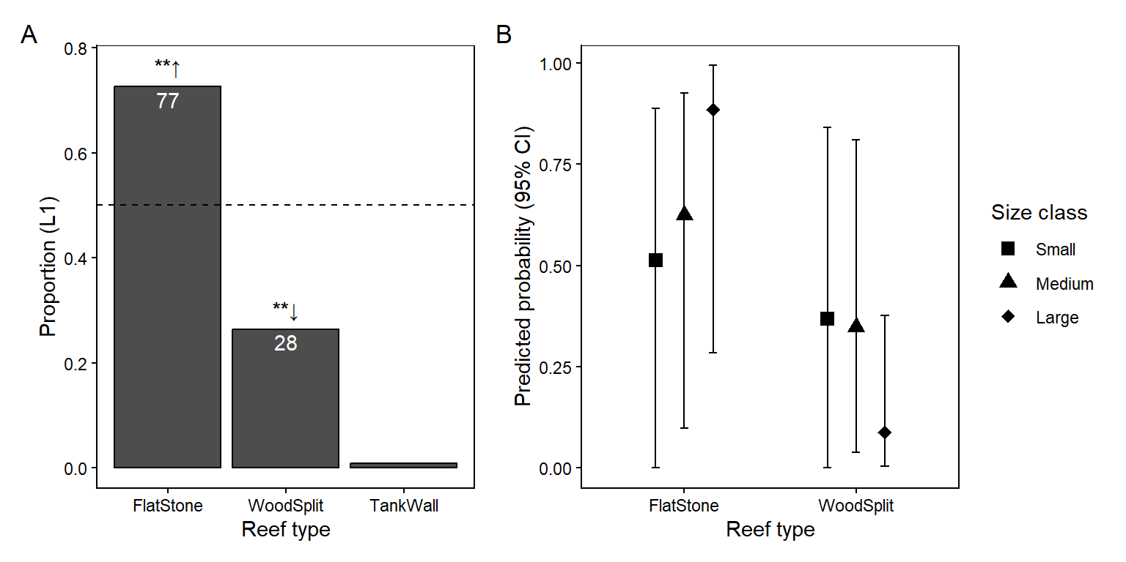
Figure 4: Reef type preference in stone versus wood comparison (Experiment 3). (A) Proportion of kōura found at each reef type at L1 across all groups and rounds. The dashed line indicates the null expectation of equal distribution (0.5). Significance symbols as in Figure 3. (B) Posterior predicted probability of reef type use by size class from Bayesian categorical mixed model, with 95% credible intervals. TankWall excluded from model predictions.
_{Source: Analysis Notebook}
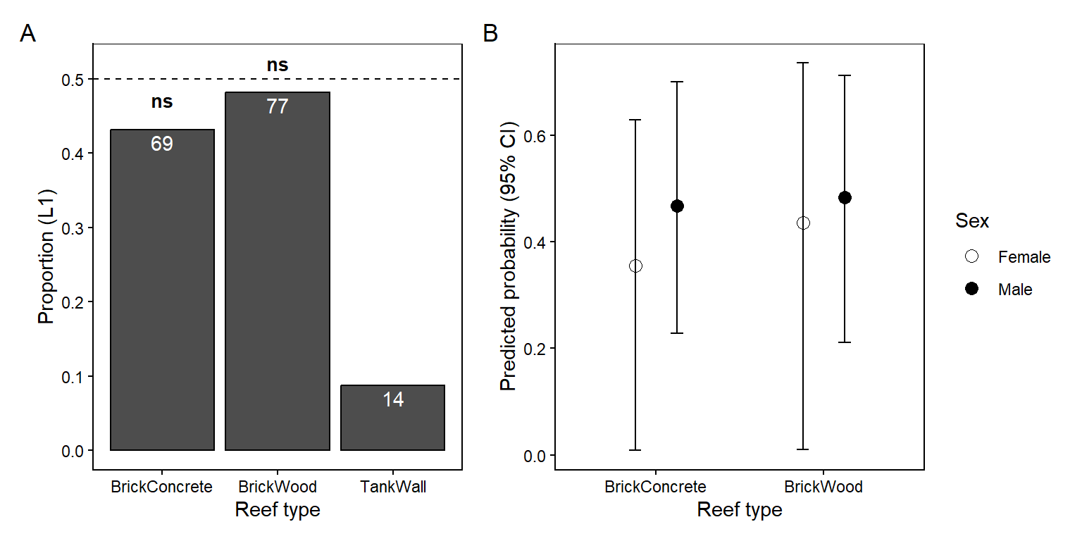
Figure 5: Brick material preference (Experiment 4). (A) Proportion of kōura found at each reef type at L1 across all groups and rounds. The dashed line indicates the null expectation of equal distribution (0.5). (B) Posterior predicted probability of reef type use by sex from Bayesian categorical mixed model, with 95% credible intervals. TankWall excluded from model predictions.
_{Source: Analysis Notebook}
Adams, S. B. (2007). Direct and indirect effects of channel catfish (ictalurus punctatus) on native crayfishes (cambaridae) in experimental tanks. The American Midland Naturalist, 158(1), 85--96. https://doi.org/10.1674/0003-0031(2007)158[85:daieoc]2.0.co;2
Adams, S. B. (2014). Crayfish use of trash versus natural cover in incised, sand-bed streams. Environmental Management, 53(2), 382--392. https://doi.org/10.1007/s00267-013-0197-3
Bates, D., Mächler, M., Bolker, B., & Walker, S. (2015). Fitting linear mixed-effects models using lme4. Journal of Statistical Software, 67(1), 1–48. https://doi.org/10.18637/jss.v067.i01
Bolker, B. M., Brooks, M. E., Clark, C. J., Geange, S. W., Poulsen, J. R., Stevens, M. H. H., & White, J.-S. S. (2009). Generalized linear mixed models: A practical guide for ecology and evolution. Trends in Ecology & Evolution, 24(3), 127--135. https://doi.org/10.1016/j.tree.2008.10.008
Bürkner, P.-C., Gabry, J., Weber, S., & Johnson, A. (2025). brms: Bayesian regression models using Stan (Version 2.23.0) [Computer software]. https://cran.r-project.org/web/packages/brms/index.html
Collier, K. J., Parkyn, S. M., & Rabeni, C. F. (1997). Koura: A keystone species. Water and Atmosphere, 5(1), 18–20.
Cooke, S. J., Piczak, M. L., Vermaire, J. C., & Kirkwood, A. E. (2023). On the troubling use of plastic “habitat” structures for fish in freshwater ecosystems – or – when restoration is just littering. FACETS, 8, 1--19. https://doi.org/10.1139/facets-2022-0210
Dickson, J., Franken, O., Watson, M. S., Monnich, B., Holthuijsen, S., Eriksson, B. K., Govers, L. L., Heide, T. van der, & Bouma, T. J. (2023). Who lives in a pear tree under the sea? A first look at tree reefs as a complex natural biodegradable structure to enhance biodiversity in marine systems. Frontiers in Marine Science, 10, 1213790. https://doi.org/10.3389/fmars.2023.1213790
Engels, B. (2014). XNomial: Exact goodness-of-fit test for multinomial data with fixed probabilities. In CRAN: Contributed Packages. The R Foundation. https://doi.org/10.32614/cran.package.xnomial
Figler, M. H., Blank, G. S., & Peeke, H. V. S. (2005). Shelter competition between resident male red swamp crayfish Procambarus clarkii (girard) and conspecific intruders varying by sex and reproductive status. Marine and Freshwater Behaviour and Physiology, 38(4), 237--248. https://doi.org/10.1080/10236240500376477
Frehse, F. de A., Derviche, P., Pereira, F. W., Hostim-Silva, M., & Vitule, J. R. S. (2025). Artificial aquatic habitats: A systematic literature review and new perspectives. Hydrobiologia, 852(8), 1997–2012. https://doi.org/10.1007/s10750-024-05589-0
Garron, C., Pangaud, A., Taubaty, M., Rolan‐Meynard, M., Argillier, C., Raymond, J., Dublon, J., & Westrelin, S. (2024). Towards the development of a standardized method to monitor lakeshore hydromorphological restoration measures. Aquatic Conservation: Marine and Freshwater Ecosystems, 34(4). https://doi.org/10.1002/aqc.4152
Gelman, A., & Rubin, D. B. (1992). Inference from iterative simulation using multiple sequences. Statistical Science, 7(4), 457–472. https://doi.org/10.1214/ss/1177011136
Hammond, K. S., Hollows, J. W., Townsend, C. R., & Lokman, P. M. (2006). Effects of temperature and water calcium concentration on growth, survival and moulting of freshwater crayfish, paranephrops zealandicus. Aquaculture, 251(2-4), 271--279. https://doi.org/10.1016/j.aquaculture.2005.05.032
Huolila, M., Marjomäki, T. J., & Laukkanen, E. (1997). The success of crayfish stocking in a dredged river with and without artificial shelter increase. Fisheries Research, 32(2), 185--189. https://doi.org/10.1016/s0165-7836(97)00046-5
Hurlbert, S. H. (1984). Pseudoreplication and the design of ecological field experiments. Ecological Monographs, 54(2), 187--211. https://doi.org/10.2307/1942661
Hylkema, A., Debrot, A. O., Osinga, R., Bron, P. S., Heesink, D. B., Izioka, A. K., Reid, C. B., Rippen, J. C., Treibitz, T., Yuval, M., & Murk, A. J. (2020). Fish assemblages of three common artificial reef designs during early colonization. Ecological Engineering, 157, 105994. https://doi.org/10.1016/j.ecoleng.2020.105994
Johnsen, S. I., & Taugbøl, T. (2008). Add stones, get crayfish – is it that simple? Freshwater Crayfish, 16(1), 47–50.
Jowett, I. G., Parkyn, S. M., & Richardson, J. (2008). Habitat characteristics of crayfish (paranephrops planifrons) in new zealand streams using generalised additive models (GAMs). Hydrobiologia, 596(1), 353--365. https://doi.org/10.1007/s10750-007-9108-z
Jurcak, A. M., Lahman, S. E., Wofford, S. J., & Moore, P. A. (2016). Behavior of crayfish. In Biology and ecology of crayfish. CRC Press.
Kusabs, I. A., Duggan, I. C., Scholes, P., Bruere, A., Te Kurapa, T. W., Grant, T., & Burdon, F. J. (inpress). Invasive catfish linked to the decline of freshwater crayfish in two aotearoa new zealand lakes. Manuscript Submitted for Publication.
Kusabs, I. A., & Quinn, J. M. (2009). Use of a traditional maori harvesting method, the tau kōura, for monitoring kōura (freshwater crayfish, paranephrops planifrons) in lake rotoiti, north island, new zealand. New Zealand Journal of Marine and Freshwater Research, 43(3), 713–722. https://doi.org/10.1080/00288330909510036
Kusabs, I. A., Quinn, J. M., & Hamilton, D. P. (2015). Effects of benthic substrate, nutrient enrichment and predatory fish on freshwater crayfish (koura, paranephrops planifrons) population characteristics in seven te arawa (rotorua) lakes, north island, new zealand. Marine and Freshwater Research, 66(7), 631–643. https://doi.org/10.1071/mf14148
Lee, F., Kusabs, I. A. K., Perry, G. L. W., & MacNeil, C. (2025). Identifying refugia from the synergistic threats of climate change and invasive species. Web Ecology, 25(2), 221–239. https://doi.org/10.5194/we-25-221-2025
Magnelia, S. J., Jesus, M. J. D., Schlechte, J. W., Cummings, G. C., & Duty, J. L. (2008). Comparison of plastic pipe and juniper tree fish attractors in a central texas reservoir.
Mazlum, Y., Guner Gurlek, O., & Sirin, S. (2017). Effect of different substrates on survival and growth of juveniles of the freshwater narrow-clawed crayfish astacus leptodactylus eschscholtz, 1823 (decapoda, astacidae). Crustaceana, 90(11-12), 1289--1302. https://doi.org/10.1163/15685403-00003724
McCarthy, M. A. (2007). Bayesian methods for ecology. Cambridge University Press.
Momot, W. T. (1995). Redefining the role of crayfish in aquatic ecosystems. Reviews in Fisheries Science, 3(1), 33--63. https://doi.org/10.1080/10641269509388566
Olsson, K., & Nyström, P. (2009). Non-interactive effects of habitat complexity and adult crayfish on survival and growth of juvenile crayfish (Pacifastacus leniusculus). Freshwater Biology, 54(1), 35--46. https://doi.org/10.1111/j.1365-2427.2008.02089.x
Olsson, K., Stenroth, P., Nyström, P., Holmqvist, N., McIntosh, A. R., & Winterbourn, M. J. (2006). Does natural acidity mediate interactions between introduced brown trout, native fish, crayfish and other invertebrates in west coast new zealand streams? Biological Conservation, 130(2), 255--267. https://doi.org/10.1016/j.biocon.2005.12.019
Parkyn, S. M., Collier, K. J., & Hicks, B. J. (2001). New zealand stream crayfish: Functional omnivores but trophic predators? Freshwater Biology, 46(5), 641--652. https://doi.org/10.1046/j.1365-2427.2001.00702.x
Parkyn, S. M., Meleason, M. A., & Davies‐Colley, R. J. (2009). Wood enhances crayfish (Paranephrops planifrons) habitat in a forested stream. New Zealand Journal of Marine and Freshwater Research, 43(3), 689--700. https://doi.org/10.1080/00288330909510034
Percival, D., & Moore, P. (2010). Shelter size influences self-assessment of size in crayfish, orconectes rusticus: Consequences for agonistic fights. Behaviour, 147(1), 103--119. https://doi.org/10.1163/000579509x12512685881053
Ramalho, R. O., McClain, W. R., & Anastacio, P. M. (2010). An effective and simple method of temporarily marking crayfish. Freshwater Crayfish, 17(1), 57–60.
Ranta, E., & Lindström, K. (1993). Body size and shelter possession in mature signal crayfish, Pacifastacus leniusculus. Annales Zoologici Fennici, 30(2), 125–132.
Raven, O. V., Burdon, F. J., Kusabs, I. A. K., Holmes, R., & Özkundakci, D. (inreview). Littoral habitat structure influences freshwater crayfish populations in five volcanic lakes of aotearoa new zealand. https://olivierraven.github.io/Koura_shoreline_habitats/
Raven, O. V., MacNeil, C., Lee, F., Holmes, R., Kusabs, I. A. K., Burdon, F. J., & Özkundakci, D. (indraft). Fear of the invader: A predatory invader may provoke stronger non-consumptive effects on a keystone native prey than a native predator. https://olivierraven.github.io/NCE_Koura_catfish/
Richman, N. I., Böhm, M., Adams, S. B., Alvarez, F., Bergey, E. A., Bunn, J. J. S., Burnham, Q., Cordeiro, J., Coughran, J., Crandall, K. A., Dawkins, K. L., DiStefano, R. J., Doran, N. E., Edsman, L., Eversole, A. G., Füreder, L., Furse, J. M., Gherardi, F., Hamr, P., … Collen, B. (2015). Multiple drivers of decline in the global status of freshwater crayfish (decapoda: astacidea). Philosophical Transactions of the Royal Society B: Biological Sciences, 370(1662), 20140060. https://doi.org/10.1098/rstb.2014.0060
Shave, C. R., Townsend, C. R., & Crowl, T. A. (1994). Anti-predator behaviours of a freshwater crayfish (paranephrops zealandicus) to a native and an introduced predator. New Zealand Journal of Ecology, 18(1), 1–10.
Spanier, E. (1994). What are the characteristics of a good artificial reef for lobsters? Crustaceana, 67(2), 173--186.
Stewart, C., & Tabak, J. (2011). Size‐based dominance hierarchies in the new zealand freshwater crayfish (koura) Paranephrops zealandicus. New Zealand Journal of Marine and Freshwater Research, 45(2), 281–285. https://doi.org/10.1080/00288330.2011.559661
Streissl, F., & Hödl, W. (2002). Habitat and shelter requirements of the stone crayfish, Austropotamobius torrentium schrank. Hydrobiologia, 477, 195–199. https://doi.org/10.1023/A:1021094309738
Takahashi, K., Yamaguchi, E., Fujiyama, N., & Nagayama, T. (2019). The effects of quality of shelters and prior residence on marmorkrebs (marbled crayfish). Journal of Experimental Biology. https://doi.org/10.1242/jeb.197301
Usio, N., & Townsend, C. R. (2000). Distribution of the new zealand crayfish Paranephrops zealandicus in relation to stream physico‐chemistry, predatory fish, and invertebrate prey. New Zealand Journal of Marine and Freshwater Research, 34(3), 557--567. https://doi.org/10.1080/00288330.2000.9516957
Wehi, P. M., & Lord, J. M. (2017). Importance of including cultural practices in ecological restoration. Conservation Biology, 31(5), 1109--1118. https://doi.org/10.1111/cobi.12915
Zhao, M., Feng, G., Wang, H., Shen, C., Fu, Y., Zhang, Y., Zhang, H., Yao, Y., Chen, J., & Xu, W. (2024). The influence of shelter type and coverage on crayfish (procambarus clarkii) predation by catfish (silurus asotus): A controlled environment study. Animals, 14(8), 1147. https://doi.org/10.3390/ani14081147

