Quantifying habitat selection of freshwater crayfish using artificial reef structures: a mesocosm study
Olivier V. Raven¹*, 0009-0008-6184-6831
Robin Holmes², 0000-0002-8737-2717
Ian A. K. Kusabs³, 0000-0002-1473-7447
Francis J. Burdon¹, 0000-0002-5398-4993
Deniz Özkundakci¹, 0000-0002-5442-4576
¹ Te Aka Mātuatua – School of Science, The University of Waikato, Private Bag 3105, Hamilton 3240, New Zealand
² The Cawthron Institute, 98 Halifax Street East, Nelson 7010, Private Bag 2, Nelson 7042, New Zealand
³ Ian Kusabs and Associates Limited, 21 Summit Road, Rotorua 3076, New Zealand
*Corresponding author: olivier.raven@icloud.com; or81@students.waikato.ac.nz
Target journal:
Highlights
Abstract
Many native freshwater crayfishes are treated by habitat loss. Habitat restoration using artificial reefs can be a powerful tool to bring back complexity in degraded habitats, which could benefit the crayfish by providing refuge places where they can hide from predators. The Aotearoa-New Zealand native freshwater crayfish kōura (*Paranephrops planifrons*), are threatened by habitat loss and a non-native predator rapidly declining populations. To optimise restoration efforts by providing artificial reefs, the most preferred configuration and material for kōura reef construction were assessed in four mesocosm experiments testing different reef types made from stones or wood. The findings showed that kōura were not fuzzy about what material the refuge was made of as long as it provides cover and a stable place to hide. Individual kōura showed most preference for holes in a log of wood but when tested in a group a pile of stones and stones laid next to each other were preferred. For crayfish restauration using artificial reefs we conclude that the use of a stones is the optimal way as it provides refuge with various crevices sizes for different life stages of crayfish and provides the longest lasting stable habitat for crayfishes.
Keywords

Introduction
Freshwater crayfish are among the most threatened freshwater invertebrates globally, with 32% of species assessed as treated with extinction due to habitat loss, water quality decline, and invasive species (BRON). As crayfish are keystone species and ecosystem engineers, playing crucial roles in freshwater food webs through shredding of leaf litter, bioturbation of sediments, and nutrient cycling therefore their loss can have profound cascading effects on freshwater ecosystems (BRON).
Habitat complexity is key driver of crayfish populations persistence, as structurally diverse habitats provide physical refugia from predators, foraging opportunities, and shelter during moulting when individuals are particularly vulnerable (BRON). In ecosystem restoration, increasing habitat complexity is widely used to promote biodiversity recovery by providing heterogeneous conditions that support multiple species and life stages (BRON). Crayfish use a wide range of variety of natural and artificial structures as shelter, including bank undercuts, woody debris, and even anthropogenic objects such as bottles and discarded appliances (BRON), demonstrating considerable flexibility in habitat use. Habitat restoration using artificial shelters has improved crayfish abundance and restocking success in degraded streams (BRON), and substrate availability has also been shown to improve juvenile survival rates (BRON).
The Aotearoa-New Zealand (hereafter Aotearoa) the endemic freshwater crayfish kōura (*Paranephrops planifrons*) faces conservation pressure from habitat loss, water quality degradation, and predation by invasive species (BRON). Habitat restoration using artificial reef structures represents a promising management tool for kōura, yet little is known about which structural designs are most effective or how individual and social dynamics influence habitat selection in this species. This study used controlled mesocosm experiments to identify kōura preferences among different artificial reef structures, and to examine how individual behaviour and conspecific interactions influence habitat use. The results provide practical guidance for designing artificial reefs to support kōura population recovery in degraded lake environments.

Materials and Methods
Animal collection
Kōura were sourced from Lake Ōkāreka and Lake Tikitapu (Blue Lake), located within the Rotorua Te Arawa Lakes area in the North Island of Aotearoa. Collected animals were transported to the aquatic research centre at the University of Waikato in Hamilton. Individuals were assigned to one of three size classes based on orbital carapace length (OCL): small (< 22 mm), medium (22–29 mm), and large (≥ 30 mm). Each animal was marked with a unique identification number written on the carapace using an orange oil-based paint marker (Sharpie, medium point). This method provides a simple, non-aggressive means of temporarily marking crayfish (Ramalho et al., 2010).
Holding tank setup
Kōura were acclimatised for 12 days in outdoor concrete holding tanks (Ø 1.4 m, 0.5 m deep), each filled to a depth of 0.4 m with dechlorinated water that had been conditioned for three months. Paving sand was used as substrate, and shelter was provided using PVC pipes, broken terracotta pots, and perforated building bricks. Each holding tank housed 10–12 kōura. Kōura were fed every second day with two sinking fish food pellets per individual (Hikari Tropical Carnivore Pellets; animal protein content 47%).
Experiment tank setup
Experiments were conducted outside in six circular concrete tanks (1425 L; Ø 1.85 m, 0.53 m deep), each filled to a depth of 0.4 m with dechlorinated water conditioned for three months. Paving sand was used as substrate in all experimental tanks. Tanks were closed off with lid constructed of 2 layers of shade cloth to prevent escape and minimise sun activity. To prevent temperatures in the tanks getting too high the experiments were conducted in spring (September till October).
And between experiment rounds oxygen and fresh dechlorinated water was added to the tanks.
Single kōura
This experiment assessed individual kōura preferences for different reef structures under controlled conditions. Six experimental tanks were used, each housing a single medium-sized kōura. Across all individuals, mean (± SD) body size was 26.5 ± 2.1 mm OCL (range: 22.6–30.0 mm) and mean (± SD) body mass was 12.2 ± 3.2 g (range: 7–17 g). A total of 30 kōura (15 males and 15 females) were tested across five experimental replicates, with each replicate conducted over one day.
Each kōura was offered a choice between four reef types (Figure 1a):
- Dispersed stone reef (SingleStone): ten quarried stones (150–250 mm) placed separately.
- Flat stone reef (FlatStone): ten quarried stones arranged tightly without stacking.
- Stone pile reef (StonePile): ten quarried stones stacked to form a pile.
- Wood log reef (WoodLog): a tānekaha (*Phyllocladus trichomanoides*) log (500 mm long, 150 mm diameter) containing six drilled refuges (70 mm deep, 32 mm diameter).
The four reef types were placed in each tank at random locations determined using a randomisation tool (randomizer.org). For each trial, a single kōura was placed inside a vertically oriented plastic tube (50 mm long, open at one end and sealed at the other) positioned at the centre of the tank, with the sealed end resting on the substrate. This ensured a standardised starting position from which the kōura could exit in any direction. The time taken for the kōura to locate its first reef structure was recorded. On the following day, the final location of the kōura was noted before it was removed from the tank. Tanks were then reset and reef placements re-randomised prior to the next trial. Each kōura was used in a single trial only and was not reused across replicates.
Group kōura
This experiment examined how group dynamics, including variation in body size and sex, influenced reef preference. Six experimental tanks were used and configured with the same reef types and randomisation procedure as in the single kōura reef experiment (Figure 1b). In contrast to the single-animal trials, each tank housed a group of six kōura, comprising two small males, two medium males, and two large males. Across all individuals, mean (± SD) body size was 27.3 ± 7.6 mm OCL (range: 15.8–43.3 mm) and mean (± SD) body mass was 15.8 ± 13.4 g (range: 1–57 g).
Each group was introduced to the centre of the tank within an open-top plastic container (150 × 150 × 85 mm). The container was then removed, and the location each individual was searching refuge was recorded. On the following day, the final location of each kōura was documented, before all individuals were removed from the tank. This procedure was repeated across five experimental replicates reusing the same six groups of animals.
Wood vs Stone
This experiment tested kōura reef preference between stone and wood structures. Two reef types were provided: (1) a flat stone reef (FlatStone) constructed from twelve quarried stones placed tightly together, and (2) a wood reef consisting of twelve wood splits (WoodSplit) made from tānekaha logs (Figure 1c). The same six groups of kōura used in the previous group reef experiment were reused. Each group was released at the centre of the tank, and the initial reef selected by each individual kōura was recorded. On the following day, the final location of each kōura was documented. This procedure was repeated three times.
Bricks
This experiment compared refuge preference between artificial and wooden perforated structures. Two perforated building bricks (BrickArtificial) of 80 × 80 × 225 mm with 5 holes (Ø 30 mm) were tested against two wooden bricks (BrickWood) made from Western red cedar (*Thuja plicata*), constructed to match the building bricks in external dimensions and hole size
To keep the wooden bricks from floating a clay brick with same dimensions was placed on top (Figure 1d). New groups of 10 kōura and four experiment tanks were used for this experiment, comprising a total of 40 individuals (22 males and 18 females). Across all individuals, mean (± SD) body size was 26.1 ± 2.6 mm OCL (range: 20.2–30.8 mm; note: this is slightly outside of the preset size classes) and mean (± SD) body mass was 11.9 ± 3.7 g (range: 5–20 g). Each experimental tank was divided into four quadrants, with one brick placed in each quadrant. Within each quadrant, the two brick types were positioned opposite one another. Each group of kōura was released at the centre of the tank lit was placed over the tank. On the following day, the final location of each kōura was documented. This experiment was repeated four times by reusing the four groups of kōura.

Data analysis
When the kōura were not using a reef, they were found along the tank wall, and the wall was therefore treated as a non-reef boundary option and recorded separately from reef structures.
Bar graphs with the proportion of the kōura at the initial location and the next day location were made for all 4 experiments. Showing the combined and separation over sex or size. Different letters indicate differences in observed frequencies based on Fisher’s exact tests.
For experiments 1 and 2 a standard Multinomial logistic regression (MLR) was used to assess reef preference.
To confirm that kōura were moving around the different reefs at night, three GoPro’s (Hero 3) were placed in tank one at the end of the day.
Results
Single kōura
The first experiment where a single kōura was presented to four different reef types the kōura’s initial location (L0) was relatively equal distributed between the reefs (@Exp1_reef_p). The next-day location (L1) showed that WoodLog was chosen in 67 % of the time. For males this was 80 % and for females 53 % of the time. Statistical test show …
At L1, habitat use differed strongly from a uniform distribution (exact multinomial goodness-of-fit test, P = 1.57 × 10⁻⁵), with the majority of individuals occupying wood log reefs. Reef selection differed significantly between the initial refuge (L0) and the final refuge selected the next day (L1) (likelihood-ratio test of multinomial models: χ²₄ = 13.62, p = 0.0086). Use of the tank wall occurred primarily during L0 and was almost absent at L1. Selection of the wood log refuge increased at L1, whereas selection of stone-based reefs showed minor change. No strong effects of sex or body size were detected within the restricted size range evaluated.
Group kōura
The second experiment where a group of six male kōura of different sizes were tested against four reef types showed not much variation in L0 and also not so for L1 (@Exp2_reef_p). In 40 % of the time FlatStone was the location most kōura were found followed by StonePile with 31 % of the time. The large kōura were at L1 most found in FlatStone (40 %) followed by StonePile (38 %), for medium size this was FlatStone (33 %) followed by WoodLog (28 %), and for small size this was FlatStone (48 %) followed by StonePile (28 %). There has been found statistically significant differences between …
Wood vs stone
The third experiment where the same groups as used in experiment 2 where now tested against two reefs WoodSplit and FlatStone. At L0 the choice was for all kōura almost equal but the next-day 73 % of the kōura were found at the FlatStone reef. Large kōura’s ended up in 92 % in FlatStone, for middle size this was 66 % and for small this was 55 %. Statistically differences were found between L0 and L1 (p=) and between large and small kōura (p=).
Bricks
The fourth experiment where mixed groups of ten kōura were tested against two types of bricks, the next-day location of the kōura 48 % for BrickWood and 43 % for BrickArtificial. Females ended up in 50% in the BrickWood and males 46 %. There was no significant difference found between the reef types (p= ).
Discussion
Preferred reef structures
The goal of this study was to discover what materials and configuration of artificial reef would be most preferred by kōura. As the findings of the four different experiments suggest is the material of the reefs not as important as the configuration. When hole dimensions were the same for both wood and stones occupation rate is 50-50 (exp 4), but when WoodSplit were tested against FlatStone a clear preference for FlatStone was found (exp 3). This is probably due to differences in buoyancy as even though the WoodSplits did not float they were not laying as sturdy in the sediment as the stones. Further, the configuration of how the stones were laid was little less important as long as the stones provide interstitial pore spaces to use as refuge like in FlatStone and in StonePile (exp 2). The difference in preferred reef type between single (exp 1) and a group of kōura (exp 2), as single kōura most often chose for the WoodLog and the group of kōura for FlatStone followed by StonePile. This might be explained by the group effect as kōura are a prey species they might stick together to find safety in numbers and as the holes in the log were separated individual holes, they do not see the others.
In these experiments it was assumed that kōura are at night leaving their initial refuge and started exploring the rest of the reef types and then in the morning they search refuge in the reef they thought was giving them most protection.
FlatStone has probably the highest number of compared to the SingleStone and StonePile
Wood most preferred reef structures

Group dynamics
In round 1 of the group experiment wood was also the most preferred structure but in the later rounds it changed to flat and pile. As the group animals all have been reused 5 times compared to the single study where each animal was used just once.

Acknowledgements
We thank Te Arawa Lakes Trust and Te Komiti Whakahaere for the opportunity to study kōura in these special lakes. We are grateful to Soweeta Fort-D’ath and William Anaru (Te Arawa Lakes Trust), and Tihini Grant, for facilitating access to the lakes and supporting the field programme. We appreciate Joe Butterworth’s assistance with fieldwork, and the support of Andy Bruere and Bay of Plenty Regional Council in helping to fund the fieldwork.
Funding
This research was supported by the Fish Futures programme funded through a Ministry of Business, Innovation and Employment grant (CAWX2101).
Authors’ contributions
Study conception and design were undertaken by O.V.R., F.J.B., I.A.K.K., R.H., and D.Ö. Fieldwork was conducted by O.V.R. Data analysis was performed by O.V.R., with statistical advice from F.J.B. Local ecological knowledge was contributed by I.A.K. and R.H. Manuscript drafting was led by O.V.R. All authors contributed to manuscript revision, approved the results, and the final manuscript.
Ethical approval
This study did not involve experimentation on humans or animals. Kōura and fish were captured using standard fisheries sampling methods. Permission to conduct field sampling and handle aquatic fauna was granted by Te Arawa Lakes Trust and Te Komiti Whakahaere. Formal institutional ethical approval was not required.
Consent to participate
Not applicable.
Consent to publish
Not applicable.
Declarations
The corresponding author has declared that none of the authors has any competing interests.
Data availability statement
The data and code supporting the findings of this study will be made publicly available in an open-access repository upon acceptance of the manuscript.

References
Tables
Figures
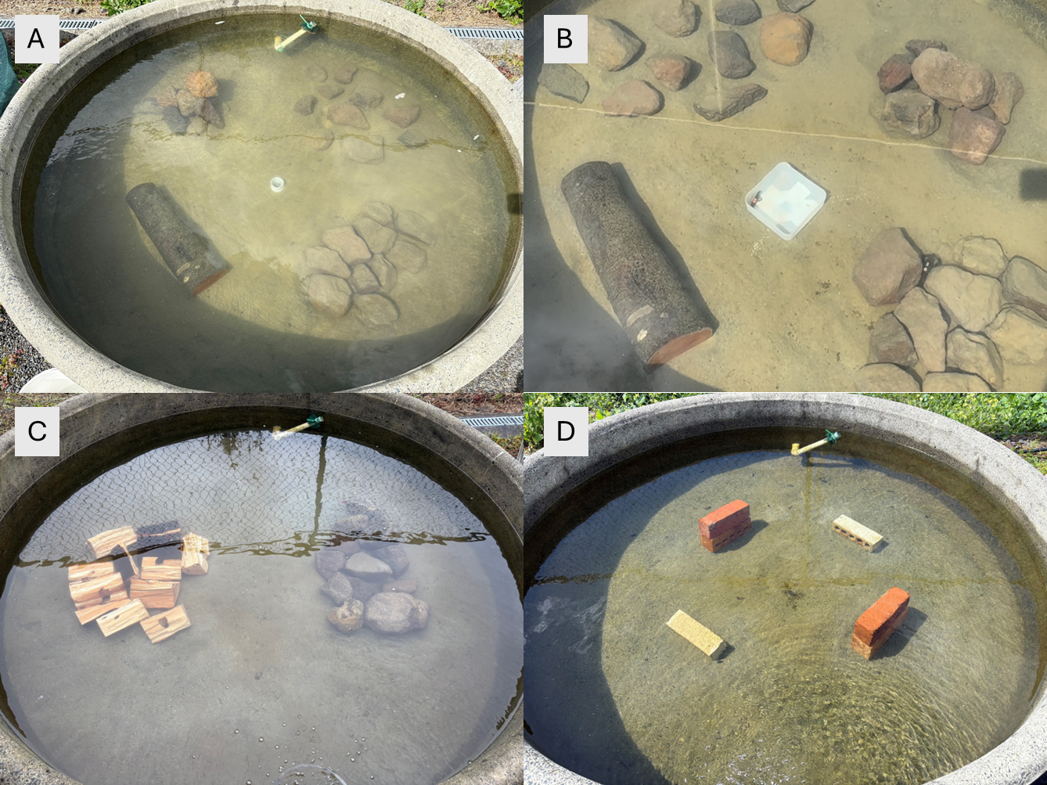
Fig. 1 Experiment tank setup for the four experiments. A) Experiment 1: single kōura with the four different reef types StonePile (top left), SingleStone (top right), WoodLog (bottom left), and FlatStone (bottom right). B) Experiment 2: group kōura with the same reef types as in A. C) Experiment 3: wood vs stone with the two reef types WoodSplit (left) and StoneFlat (left). D) Experiment 4: bricks with BrickWood (top left and bottom right) and BrickArtificial (top right and bottom left).
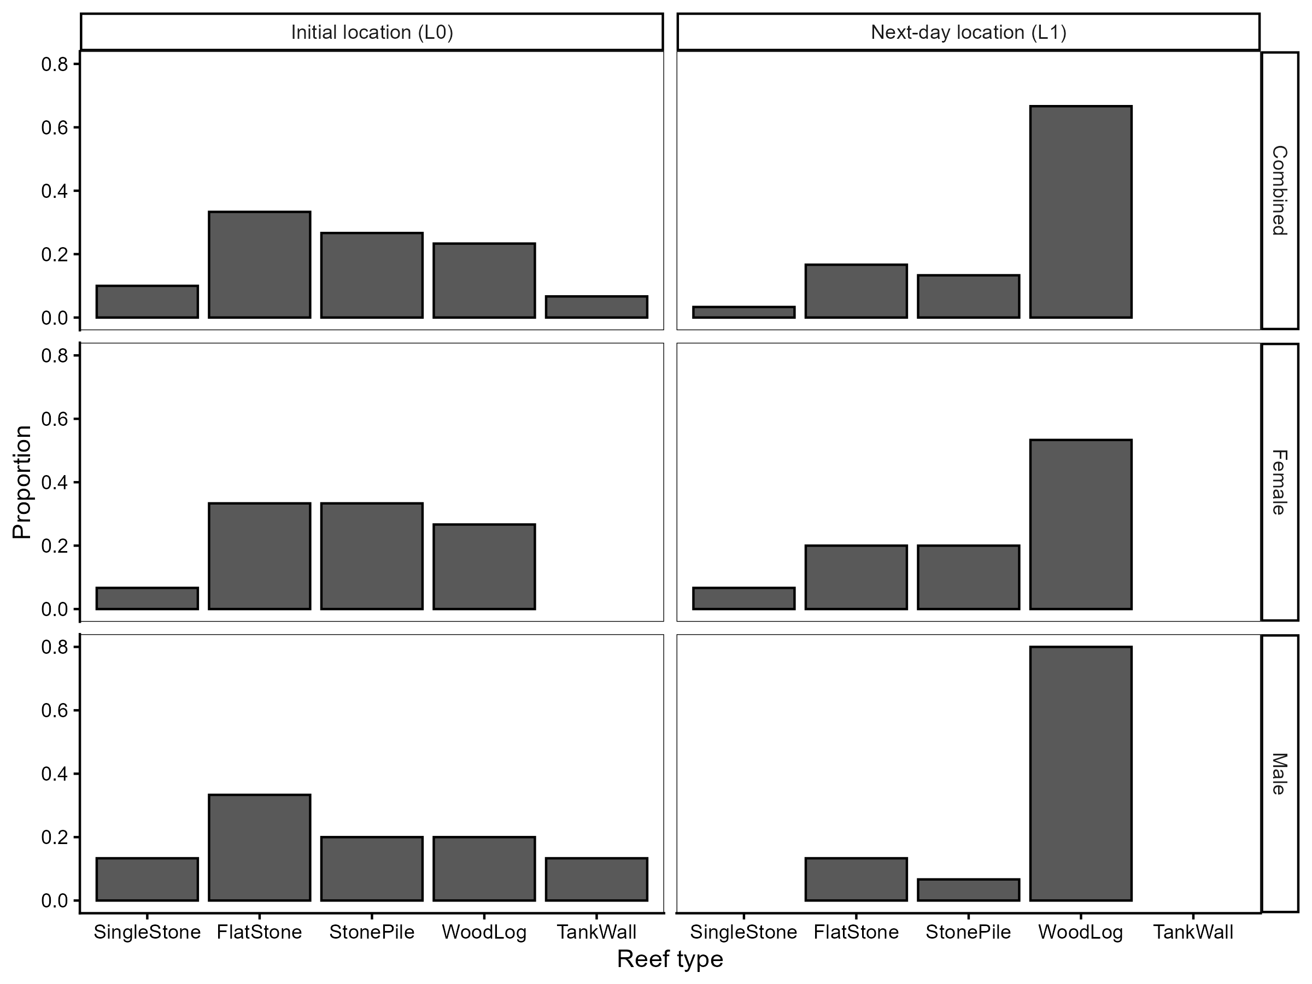
Fig 2 Experiment 1.
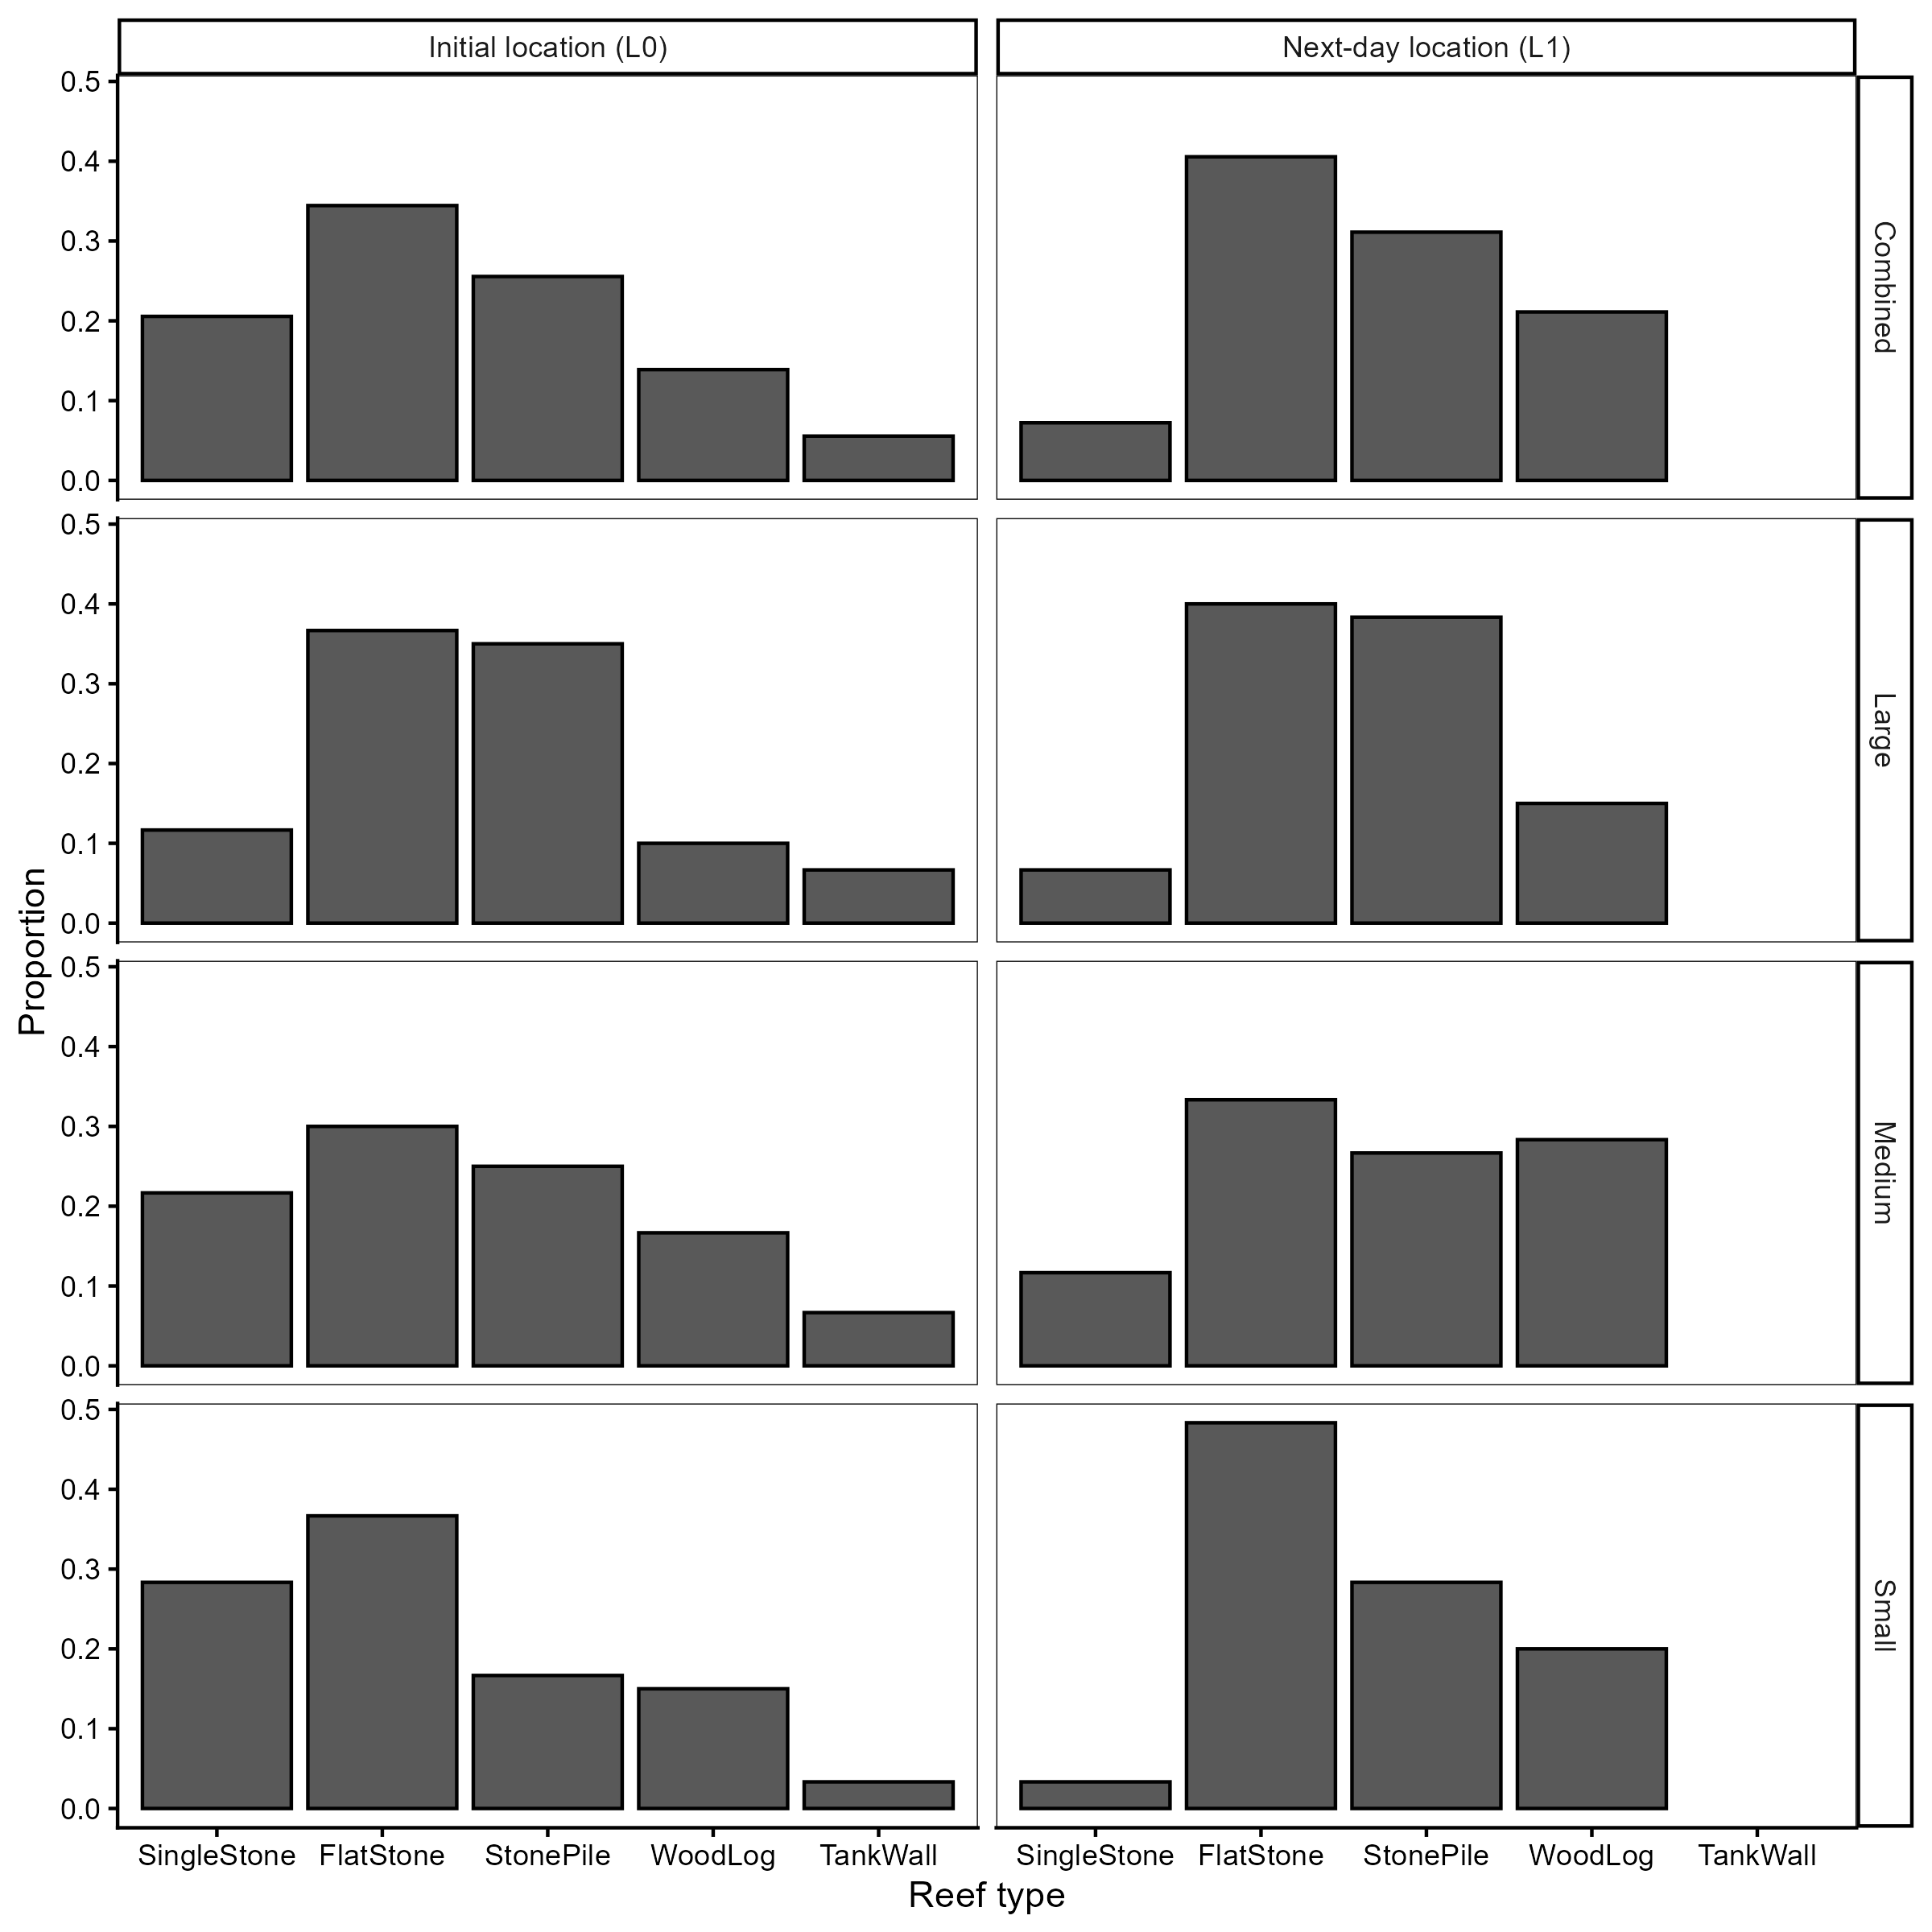
Fig 3 Experiment 2.
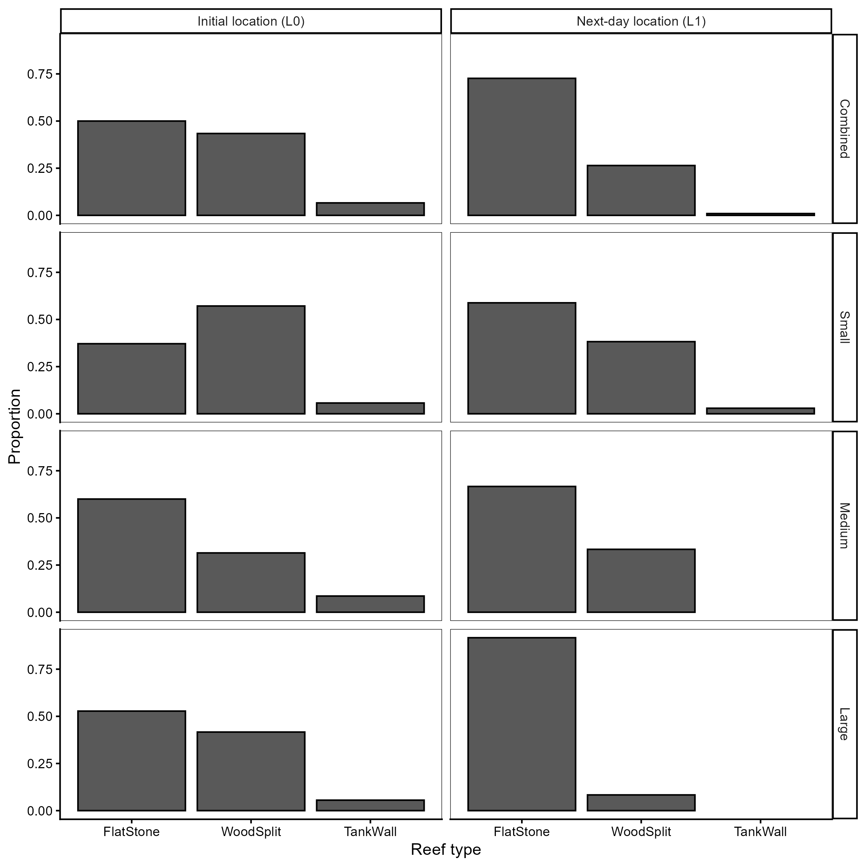
Fig 4 Experiment 3.

Fig 5 Experiment 4.

Supplementary

