The Importance of Structure
  - The importance of structure: mesocosm evidence for shelter design in freshwater crayfish restoration
Olivier V. Raven^{1*}, 0009-0008-6184-6831
Robin Holmes², 0000-0002-8737-2717
Ian A. K. Kusabs³, 0000-0002-1473-7447
Francis J. Burdon¹, 0000-0002-5398-4993
Deniz Özkundakci¹, 0000-0002-5442-4576
¹ Te Aka Mātuatua – School of Science, University of Waikato, Private Bag 3105, Hamilton 3240, New Zealand
² The Cawthron Institute, 98 Halifax Street East, Nelson 7010, Private Bag 2, Nelson 7042, New Zealand
³ Ian Kusabs and Associates Limited, 21 Summit Road, Rotorua 3076, New Zealand
*Corresponding author: olivier.raven@icloud.com; or81@students.waikato.ac.nz
Key words: Paranephrops planifrons; Artificial reef; Behaviour; Habitat preference; Aotearoa New Zealand
Chapter 4 The Importance of Structure The importance of structure: mesocosm evidence for shelter design in freshwater crayfish restoration
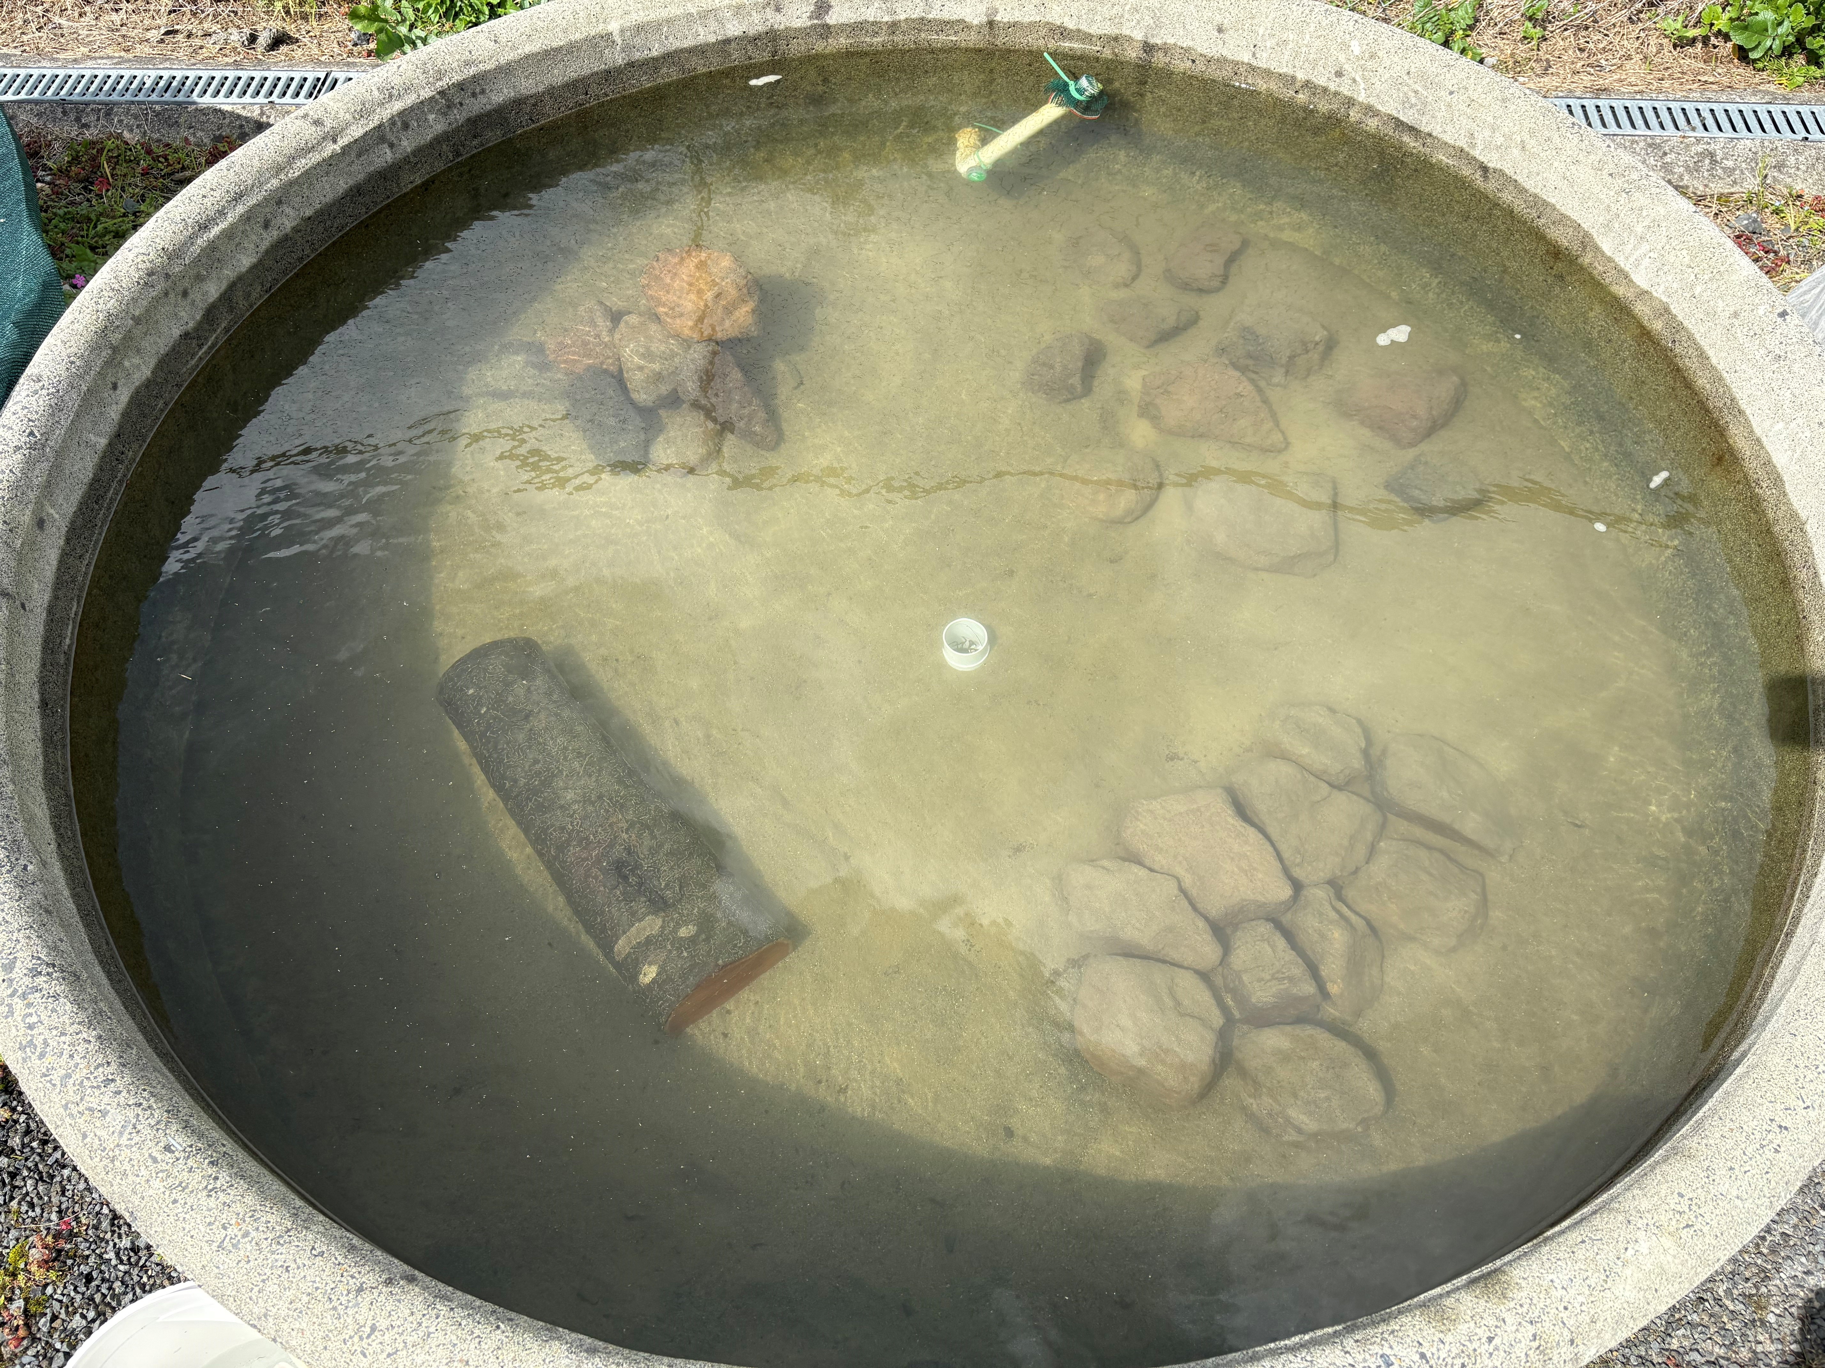
Olivier V. Raven, Robin Holmes, Ian A. K. Kusabs, Francis J. Burdon & Deniz Özkundakci
Aquatic Conservation: Marine and Freshwater Ecosystems — Under review

Abstract
Freshwater crayfish are keystone species that rank among the most threatened invertebrate groups globally. While habitat loss and predation by non-native predators feature prominently as drivers of crayfish population declines, the optimal design of habitat enhancement structures for their restoration remains largely unknown. To better understand freshwater crayfish habitat preferences, our study focussed on the endemic kōura (Paranephrops planifrons) found in Aotearoa New Zealand. We used four mesocosm experiments to examine how shelter structure, material composition, individual body size, and group dynamics influence refuge selection in kōura. Individual kōura strongly preferred a wooden log with enclosed drilled holes, but when housed in mixed-size groups, their preference shifted to flat and piled stone configurations that provided more complex refugia for individuals of different sizes. Flat stone structures were preferred over split wood pieces of similar dimensions, and this was strongest for large individuals. When structural dimensions were held constant, no significant preference was detected between concrete and wooden structures, indicating that material composition alone does not drive refuge selection. The findings of these mesocosm experiments suggest that stone pile configurations warrant field evaluations as habitat enhancement structures for kōura restoration. The stone piles create structural complexity that can provide habitat for different size classes and thus may add critical refuge from non-native predators for kōura populations.

Introduction
Freshwater biodiversity is declining faster than in any other ecosystem globally, driven by habitat loss, pollution, and invasive species (Dudgeon et al., 2006). Crayfish are among the most threatened freshwater invertebrates, with 32% of species assessed as threatened with extinction due to these same pressures (Richman et al., 2015). As keystone species and ecosystem engineers, crayfish play crucial roles in freshwater food webs through shredding of leaf litter, bioturbation of sediments, and nutrient cycling, and their loss can have profound cascading effects on freshwater ecosystems (Momot, 1995; Collier et al., 1997; Parkyn et al., 2001). The increasing degradation of freshwater habitats therefore not only threatens crayfish populations but also risks disrupting the ecosystem processes crayfish sustain.
Habitat complexity is a key driver of crayfish population persistence, as structurally diverse habitats provide physical refugia from predators, foraging opportunities, and shelter during moulting when individuals are particularly vulnerable (Hammond et al., 2006). Shelter availability directly increases crayfish survival and growth under predation pressure (Adams, 2007), making refuge quality a critical consideration for both natural habitat persistence and restoration design. Crayfish use a wide variety of natural and artificial structures as shelter, including rocks, woody debris, and even anthropogenic objects such as bottles and discarded appliances (Parkyn et al., 2009; Adams, 2014), demonstrating considerable flexibility in habitat use. While this diversity of potential refugia is well documented, preferences among different structure types remain poorly understood, even though knowledge of habitat preferences is fundamental to designing effective enhancement structures for restoration. In the context of freshwater restoration, increasing structural complexity through providing shelters has improved crayfish abundance and restocking success in degraded streams and lakes (Huolila et al., 1997; Johnsen and Taugbøl, 2008), and the availability of coarser substrate has also been shown to improve juvenile survival rates (Mazlum et al., 2017). These findings indicate that enhancing habitat complexity can be a useful management tool for threatened crayfish populations, yet systematic comparisons of shelter configurations for freshwater crayfish restoration remain largely absent from the literature.
Shelter selection in crayfish is strongly influenced by body size, as individuals actively select refugia proportional to their dimensions. Crayfish individuals tend to select stones more than 3 times longer and 1.25 times wider than their carapace length, with larger males consistently selecting larger stones (Streissl and Hödl, 2002). Social dynamics further complicate shelter use when refuge availability is limited, as competitive interactions among conspecifics determine which individuals gain access to preferred shelters. Dominance hierarchies based on body size and reproductive status show that males and maternal females often are able to take over shelters from non-maternal females, while adults consistently outcompete juveniles for shelter access (Figler et al., 2005). Body size and shelter dimensions have direct competitive consequences as crayfish in undersized shelters initiated and won more fights than those in appropriately sized shelters, suggesting that shelter fit influences an individual’s assessment of its own fighting ability (Percival and Moore, 2010). Body size ratios between contestants are a strong predictor of shelter takeover success, although prior ownership can offset size disadvantages (Ranta and Lindström, 1993), particularly when both individuals hold high-quality shelters (Takahashi et al., 2019). At the population level, habitat complexity buffers these competitive effects, with juveniles in structurally complex habitats showing higher survival, faster growth, and greater moulting rates as more shelter availability reduces agonistic interactions (Olsson and Nyström, 2009). Together, shelter use in crayfish reflects an interaction between individual body size and social competitive dynamics, suggesting that effective habitat enhancement structures must provide a range of shelter sizes to support different life stages and size classes simultaneously.
The material and structural properties of shelters can influence their value as refugia. In a study comparing shelter configurations on reef fish assemblages, the availability and size of enclosed spaces mattered more than total structure volume (Hylkema et al., 2020). Additionally, enclosed structures such as PVC pipes provide greater protection against predatory fish than stone or vegetation structures, likely due to their consistent hole dimensions (Zhao et al., 2024). However, the use of synthetic materials like PVC pipes in restoration ecology brings ecological concerns, particularly in contexts where introducing non-native materials may conflict with conservation values or indigenous cultural frameworks (Wehi and Lord, 2017; Cooke et al., 2023). Natural materials such as stones and wood offer ecologically compatible alternatives, yet the importance of structural configuration versus material composition for crayfish shelter preference is poorly understood.
In Aotearoa-New Zealand (hereafter Aotearoa), the endemic freshwater crayfish kōura (Paranephrops planifrons White, 1842) faces conservation pressure from habitat loss, water quality degradation, and predation by invasive species (Lee et al., 2025; Kusabs et al., 2026). Kōura are a taonga (culturally treasured) species for Māori, the indigenous people of Aotearoa, and hold significant ecological and cultural value in freshwater ecosystems (Kusabs et al., 2015a; Kusabs and Quinn, 2009). In their natural habitat, kōura are positively associated with overhanging banks, coarse substrates, and woody debris (Raven et al., 2026a; Usio and Townsend, 2000; Jowett et al., 2008; Parkyn et al., 2009). Kōura have been shown to significantly increase refuge use in the presence of predators (Raven et al., 2026b; Shave et al., 1994). Habitat restoration by increasing shelter availability represents a promising management tool for kōura recovery, and the use of natural materials aligns with ecological and cultural values.
In this study, four mesocosm experiments were conducted to identify kōura habitat preferences. We assessed how different structures varying in material and configuration influence refuge selection, accounting for individual behaviour, body size, and group interactions. We predicted that 1) Structurally complex structures providing enclosed crevices would be preferred over isolated or open structures, as enclosed spaces reduce predation risk; 2) structure preference would be size-dependent, with larger kōura selecting structures with larger refuge spaces (Streissl and Hödl, 2002; Percival and Moore, 2010); 3) stone-based structures would be preferred over wood due to greater structural stability, and 4) material type alone would not influence refuge preference between concrete and wooden bricks. The results provide practical guidance for designing cost-effective, ecologically appropriate habitat enhancement structures to enhance kōura abundance and support population recovery.

Materials and Methods

Animal collection and tank setup
In mid-August 2025, 72 kōura were sourced from Lakes Ōkāreka and Tikitapu, located within the Rotorua Te Arawa Lakes area in the North Island of Aotearoa. Collected animals were transported to the Aquatic Research Centre at the University of Waikato in Hamilton. Individuals were assigned to one of three size classes based on orbital carapace length (OCL): small (< 22 mm), medium (22–30 mm), and large (> 30 mm). Each animal was marked with a unique identification number written on the carapace using an orange oil-based paint marker (Sharpie, medium point) (Ramalho et al., 2010).
Kōura were acclimatised for 12 days in outdoor concrete holding tanks (Ø 1.4 m), each filled to 0.4 m with dechlorinated tap water conditioned for three months, paving sand as substrate, shelters, and were covered with a single layer of shade cloth. Each holding tank housed 10–12 individuals. Kōura were fed every second day with commercial carnivore pellets (Hikari Tropical, Kyorin Food Industries Ltd., Japan; animal protein 47%). Water temperature and dissolved oxygen remained stable throughout the experimental period (temperature: 12 ± 1.2 °C; dissolved oxygen: 99.9 ± 1.7%).
Experiments were conducted in six larger outdoor concrete tanks (1425 L; Ø 1.85 m) with the same substrate and water conditions, covered with a double layer of shade cloth to prevent escape and minimise solar heating. Fresh dechlorinated tap water and an air stone were added between rounds. To limit thermal stress, experiments were conducted during the Australasian spring (September to October). Because kōura are a taonga (treasured) species, permission to conduct the experiments was obtained from Te Arawa Lakes Trust and Te Komiti Whakahaere. All experimental procedures were conducted under University of Waikato animal ethics committee approval (protocol number: 1207; see Ethical Approval section).

Experiment 1: Individual preference
This experiment assessed individual kōura structure preference by offering single animals a choice among four structures (Figure 1). The structure-types were: SingleStone (ten quarried stones (150–250 mm) placed individually across the quadrant with sufficient spacing between stones that no crevices formed between them), FlatStone (ten quarried stones arranged tightly without stacking), StonePile (ten quarried stones stacked to form a pile), and WoodLog (a tānekaha (Phyllocladus trichomanoides) log (500 mm long, 150 mm diameter) containing six drilled holes (70 mm deep, 32 mm diameter)). If a kōura was not using a structure, TankWall was noted as its location which represents the wall of the tank or when the kōura was in the open. TankWall functioned as an indicator of structure rejection rather than a preference. Six experimental tanks were used, each housing a single medium-sized kōura. Across five experimental replicates, a total of 30 kōura were tested, consisting of 15 females with mean OCL and weight ± SD: 26.9 ± 2 mm, range: 23.2–29.8 mm, 12.5 ± 3.3 g and 15 males: 26.1 ± 2.2 mm, range: 22.6–30 mm, 11.9 ± 3.1 g. Each replicate lasted 22 hours, beginning at noon (12:00) and ending at 10:00 the following morning.
Each experimental tank was divided into four quadrants, with one structure type placed at random (randomizer.org) in each quadrant. For each trial, a single kōura was placed inside a vertically oriented plastic tube (50 mm long, open at one end and sealed at the other) positioned at the centre of the tank, with the sealed end resting on the substrate. This ensured a standardised starting position from which the kōura could exit in any direction (MacNeil et al., 2025). The time taken for the kōura to locate its initial refuge location was recorded. On the following day, the final location of the kōura was noted after which it was removed from the tank. Tanks were reset and structure placements re-randomised prior to the next trial. Each individual kōura was used once in a single trial and not reused across temporal replicate blocks. To confirm nocturnal activity, three digital cameras (GoPro Hero 3) were placed in one tank and recorded for five hours at the end of each of the five days.

Experiment 2: Group dynamics
Building on Experiment 1, this experiment examined how group dynamics and body size influenced structure preference when kōura were housed together. The same six experimental tanks were used and configured with the identical structure types and randomisation procedure as in Experiment 1 (Figure 1). In contrast to the single-animal trials, each tank housed a group of six male kōura, as male-only groups simplified competitive dynamics and size class assignment given limited female availability. Groups were comprised of two small, two medium, and two large individuals. Size classes were defined by OCL: small (mean OCL and weight ± SD: 19.2 ± 2 mm, range: 15.8–21.6 mm, 3.9 ± 2.1 g), medium (26.4 ± 1.6 mm, 23.5–29.5 mm, 11.6 ± 2.4 g), and large (36.3 ± 4.2 mm, 30.7–43.3 mm, 31.8 ± 11.2 g). Each group was introduced to the centre of the tank within an open-top plastic container (150 × 150 × 85 mm). The container was removed, and the initial location of each individual was recorded. On the following day, the final location of each kōura was documented, before all individuals were removed from the tank. This procedure was repeated across five experimental replicate blocks, resulting in 30 group-trials in total (six groups × five blocks). Structure placements and tank assignments were re-randomised between blocks, such that each group was housed in a different tank in each successive round. The same six groups were reused across all five blocks, with individuals staying with their assigned group between replicates. No mortality occurred during the experiment.

Experiment 3: Wood vs Stone
Using the same male kōura groups from Experiment 2, this experiment narrowed the choice to two structure types, stone and wood, to directly compare preference between these materials. The structure types were: (1) a flat stone structure (FlatStone) constructed from twelve stones placed tightly together, and (2) a wood structure consisting of twelve wood splits (WoodSplit) made from the tānekaha logs (Figure 1). Each group was released at the centre of the tank, and the initial structure selected by each kōura was recorded. The following day, the final location of each kōura was documented. This procedure was repeated across three experimental replicate blocks, resulting in 18 group-trials in total (six groups × three blocks). Structure placements and tank assignments were re-randomised between blocks, such that each group was housed in a different tank in each successive round. One small individual died in the first block and was replaced with a size-matched individual to maintain group composition. One individual could not be located at the end of the final block and was assumed to have escaped the tank.

Experiment 4: Material comparison
This experiment tested whether kōura showed a preference between perforated concrete bricks and perforated wooden blocks to further identify the effect of material on structure preference. Two perforated building bricks (ConcreteBrick) of 80 × 80 × 225 mm with five holes (Ø 30 mm) were tested against two wooden blocks (WoodBlock) with drilled holes made from Western red cedar (Thuja plicata), constructed to match the building bricks in external dimensions and hole size. To prevent floating, a solid clay brick of identical dimensions was placed on top of each WoodBlock. ConcreteBrick did not require additional weight (Figure 1). New groups of ten kōura and four experiment tanks were used for this experiment, comprising a total of 40 individuals consisting of 18 females with mean OCL and weight ± SD: 26.2 ± 3.1 mm, range: 20.2–30.8 mm, 12.2 ± 4.2 g and 22 males: 26 ± 2.1 mm, range: 20.9–29.5 mm, 11.6 ± 3.2 g. Due to reduced animal availability, individuals were drawn from a slightly broader size range than medium-size individuals, resulting in unbalanced size class representation (small: n = 4, medium: n = 35, large: n = 1). In each of the four experimental tank quadrants one structure was placed, with similar structure types positioned opposite to one another. Each group of kōura was released at the centre of the tank and the following day, the final location of each kōura was documented. This experiment was repeated across four temporal blocks using the same four groups of ten kōura, resulting in 16 group-trials in total (four groups × four blocks). Structure placements and tank assignments were re-randomised between blocks, such that each group was housed in a different tank in each successive round.
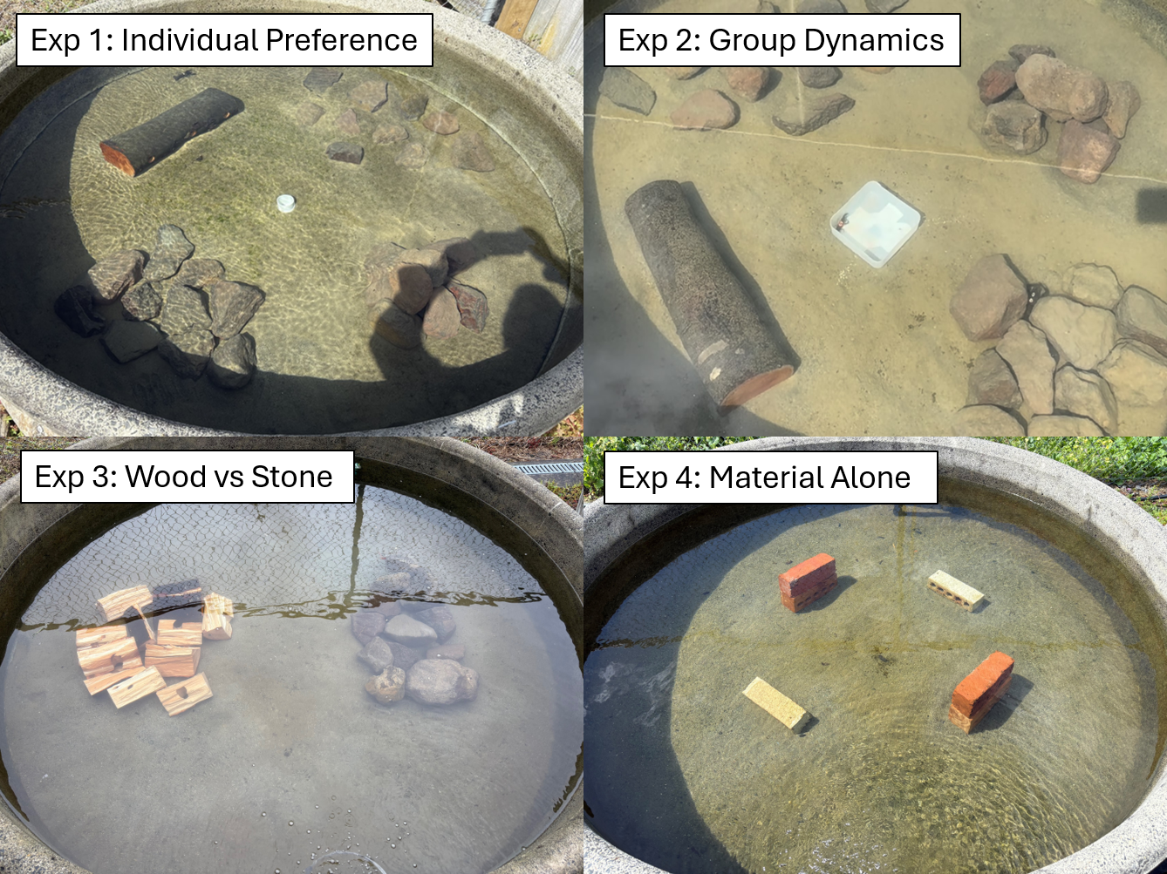
Figure 1: Overhead photographs of experimental tank configurations for each of the four mesocosm experiments. Experiment 1 (Individual preference) and Experiment 2 (Group dynamics): four shelter types, WoodLog (tānekaha log with drilled holes), FlatStone (stones arranged flat), StonePile (stones stacked), and SingleStone (individual stones placed separately). Experiment 3 (Wood vs Stone): WoodSplit shelter (tānekaha wood splits) and FlatStone shelter placed in opposing halves of the tank. Experiment 4 (Material comparison): ConcreteBrick (perforated concrete bricks) and WoodBlock (perforated wooden blocks of identical dimensions) placed in opposing quadrants of the tank.

Data analysis
Experiment 1: To test the difference between the four structure types selected by the single kōura, a multinomial goodness-of-fit test was performed using the XNomial package (Engels, 2014). TankWall was excluded from preference tests as it represents the absence of structure choice rather than a structure type preference. Additionally, pairwise likelihood-ratio G-tests with Bonferroni correction were used to identify which structure types differed significantly from each other. Bayesian categorical mixed-effects models were used to test whether body size or sex affected structure preference across all experiments, fitted using the brms package (Bürkner, 2017, 2018). For Experiments 1 and 2, where kōura chose among four structure types, a categorical family was used. For Experiments 3 and 4, where only two structure types were directly compared, a Bernoulli family was used. Model convergence was assessed using the Gelman-Rubin diagnostic (all $\hat{R}$ = 1.00) and divergent transition counts (all experiments: 0 divergences), confirming reliable posterior sampling (Gelman and Rubin, 1992). To test whether structure type use differed between sexes, the Bayesian categorical mixed-effects model was fitted with structure type as the outcome, sex as a fixed effect and tank and experimental round as random intercepts. A permutation-based symmetry test was applied to assess whether structure type transitions between initial location and next-day location were directional rather than random.
Experiment 2: To test whether overall structure preference existed at the group level, one-sample Wilcoxon signed-rank tests were applied to group-round proportions for each structure type, testing against a null expectation of 0.25 (equal distribution among four structure types). P-values were Bonferroni adjusted for multiple comparisons. Normal approximation was used due to ties arising from discrete group counts. To test whether size classes affected structure preference while accounting for repeated measurement of individuals and groups, the Bayesian categorical mixed-effects model was fitted with structure type as the outcome, size class as a fixed effect, and group identity, individual identity nested within group, and tank and experimental round as random intercepts. The Stuart-Maxwell test was used to test for statistical differences between initial and next-day location.
Experiment 3: To test the difference between FlatStone and WoodSplit the Wilcoxon signed-rank test was applied to group-round proportions for each structure type, testing against a null expectation of 0.5. P-values were Bonferroni adjusted. To test whether size classes affected structure preference while accounting for repeated measurement of individuals and groups, the Bayesian Bernoulli mixed-effects model was fitted with size class as a fixed effect, following the same random effects structure as described for Experiment 2. The Stuart-Maxwell test was used to test for statistical differences between initial and next-day location.
Experiment 4: To test whether kōura showed a preference between ConcreteBrick and WoodBlock, the Wilcoxon signed-rank test was applied to group-round proportions for each structure type, testing against a null expectation of 0.5 and p-values were Bonferroni adjusted. A paired Wilcoxon signed-rank test was used to directly compare group-round proportions between ConcreteBrick and WoodBlock. As size class was unbalanced, the effect of sex on structure preference was tested using the Bayesian Bernoulli mixed-effects model with sex as a fixed effect, following the same random effects structure as described for Experiment 2. Finally, as only next-day locations were recorded in this experiment, no directional shift analysis was performed.

Results

Experiment 1: Individual preference
Individual kōura showed a strong preference for WoodLog, selecting it significantly more often than SingleStone, FlatStone, and StonePile (pairwise G-test, Bonferroni adjusted: p < 0.001, 0.011, 0.004, respectively; overall multinomial test: p < 0.001; Figure 2). No significant differences were found among the stone structure types. Overall, WoodLog was selected by 67% of kōura at refuge (males: 80%; females: 53%), and no kōura were found at TankWall. Sex had no credible effect on structure preference ($β$ = 3.32, 95% CI: -1.09 to 9.3; posterior probability = 0.92) with credible intervals spanning zero for all structure types. The symmetry test indicated that structure type use shifted between initial and next-day location (p = 0.001), suggesting kōura actively relocated to preferred structure types overnight rather than remaining at their initial location. The video footage showed kōura emerging, walking and climbing on the structures after sunset.
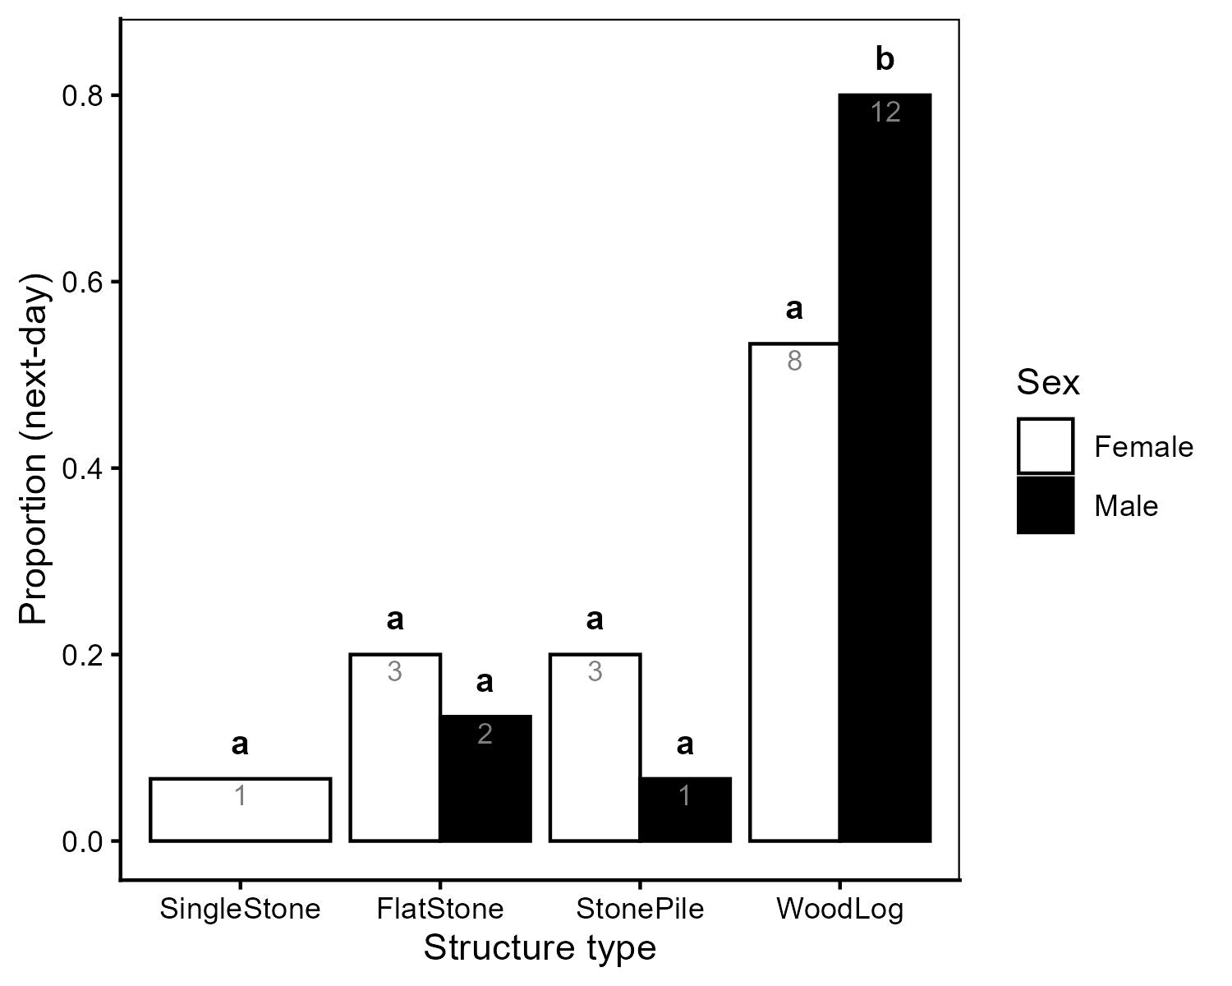
Figure 2: Proportion of individual kōura (Experiment 1) found at each structure type the next day, shown separately for female (white bars) and male (black bars) kōura. Bars show observed proportions with sample sizes (n) shown on bars. Letters above bars indicate results of pairwise G-tests with Bonferroni correction within each sex group, structure types sharing the same letter within a panel do not differ significantly from each other, while structure types with different letters differ significantly in use. No significant difference in overall structure preference was detected between sexes (see results).

Experiment 2: Group dynamics
When housed in mixed-size groups, kōura showed a significant overall preference for stone-based structures (Figure 3). FlatStone was used significantly more (p = 0.004), while SingleStone (p < 0.001) and WoodLog (p = 0.039) were significantly avoided. StonePile did not differ from random expectation (p = 1.000) and did not differ significantly from FlatStone (p = 0.117). No kōura were found at TankWall, indicating active structure selection across the group. Size classes had limited but credible effect on structure preference. Medium-sized kōura showed a weaker preference for FlatStone over SingleStone compared to small kōura ($β$ = -1.77, 95% CI: -3.7 to -0.14; posterior probability = 0.99), while no other size class effect was credible. Overall, FlatStone remained the most selected structure type across all size classes, but its strength of preference declined from small (posterior probability of top choice = 82%) to medium (53%), and with large kōura showing similar preference between FlatStone and StonePile (42% vs 38%). Structure type use shifted directionally between initial and next-day location (Stuart-Maxwell test: p = 0.001), indicating that kōura actively relocated to preferred structure types overnight.
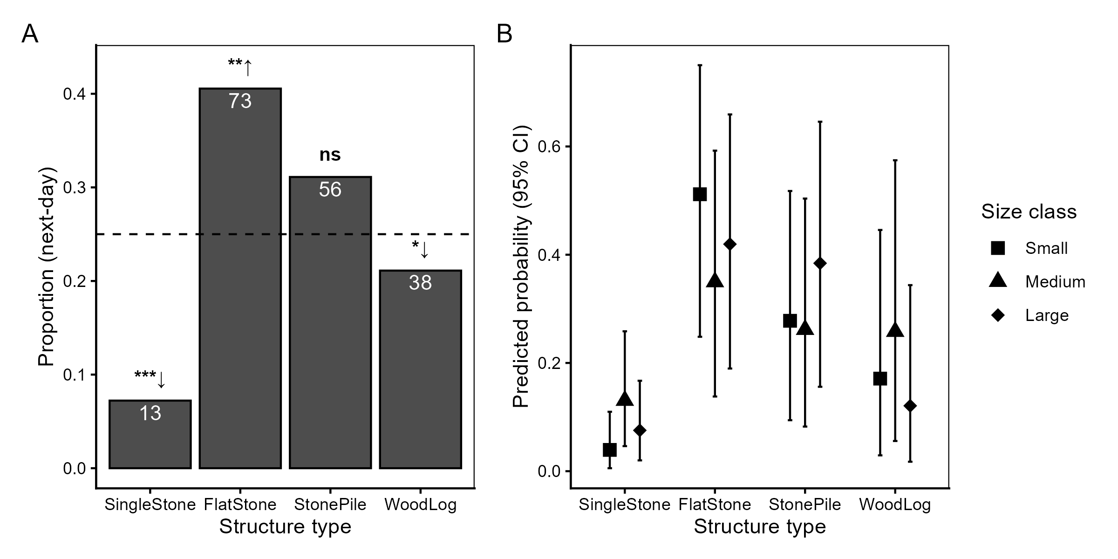
Figure 3: Structure type preference of group kōura (Experiment 2). (A) Proportion of kōura found at each structure type at L1 across all groups and rounds. The dashed line indicates the null expectation of equal distribution (0.25). Significance symbols indicate deviation from null expectation (Wilcoxon signed-rank test, Bonferroni adjusted): $↑$ used more than expected, $↓$ used less than expected. Sample sizes shown in white. (B) Posterior predicted probability of structure type use by size class from Bayesian categorical mixed model, with 95% credible intervals.

Experiment 3: Wood vs Stone
Kōura consistently selected FlatStone over WoodSplit, with the preference growing with body size (Figure 4). At the group level, FlatStone was used significantly more than expected (p = 0.001), while WoodSplit was significantly avoided (p = 0.004). Only one kōura was found at TankWall. The Bayesian model indicated that preference for FlatStone strengthened with body size, with the posterior probability of FlatStone being the top-ranked structure increasing from small (66%) to medium (79%), to large kōura (99%). Large kōura showed a particularly strong and credible preference for FlatStone over WoodSplit ($β$ = -2.55, 95% CI: -4.7 to -0.9; posterior probability = > 0.99), while medium kōura did not differ from small kōura. Structure type use shifted directionally between initial and next-day location (Stuart-Maxwell test: p = 0.003), with kōura relocating toward FlatStone overnight.
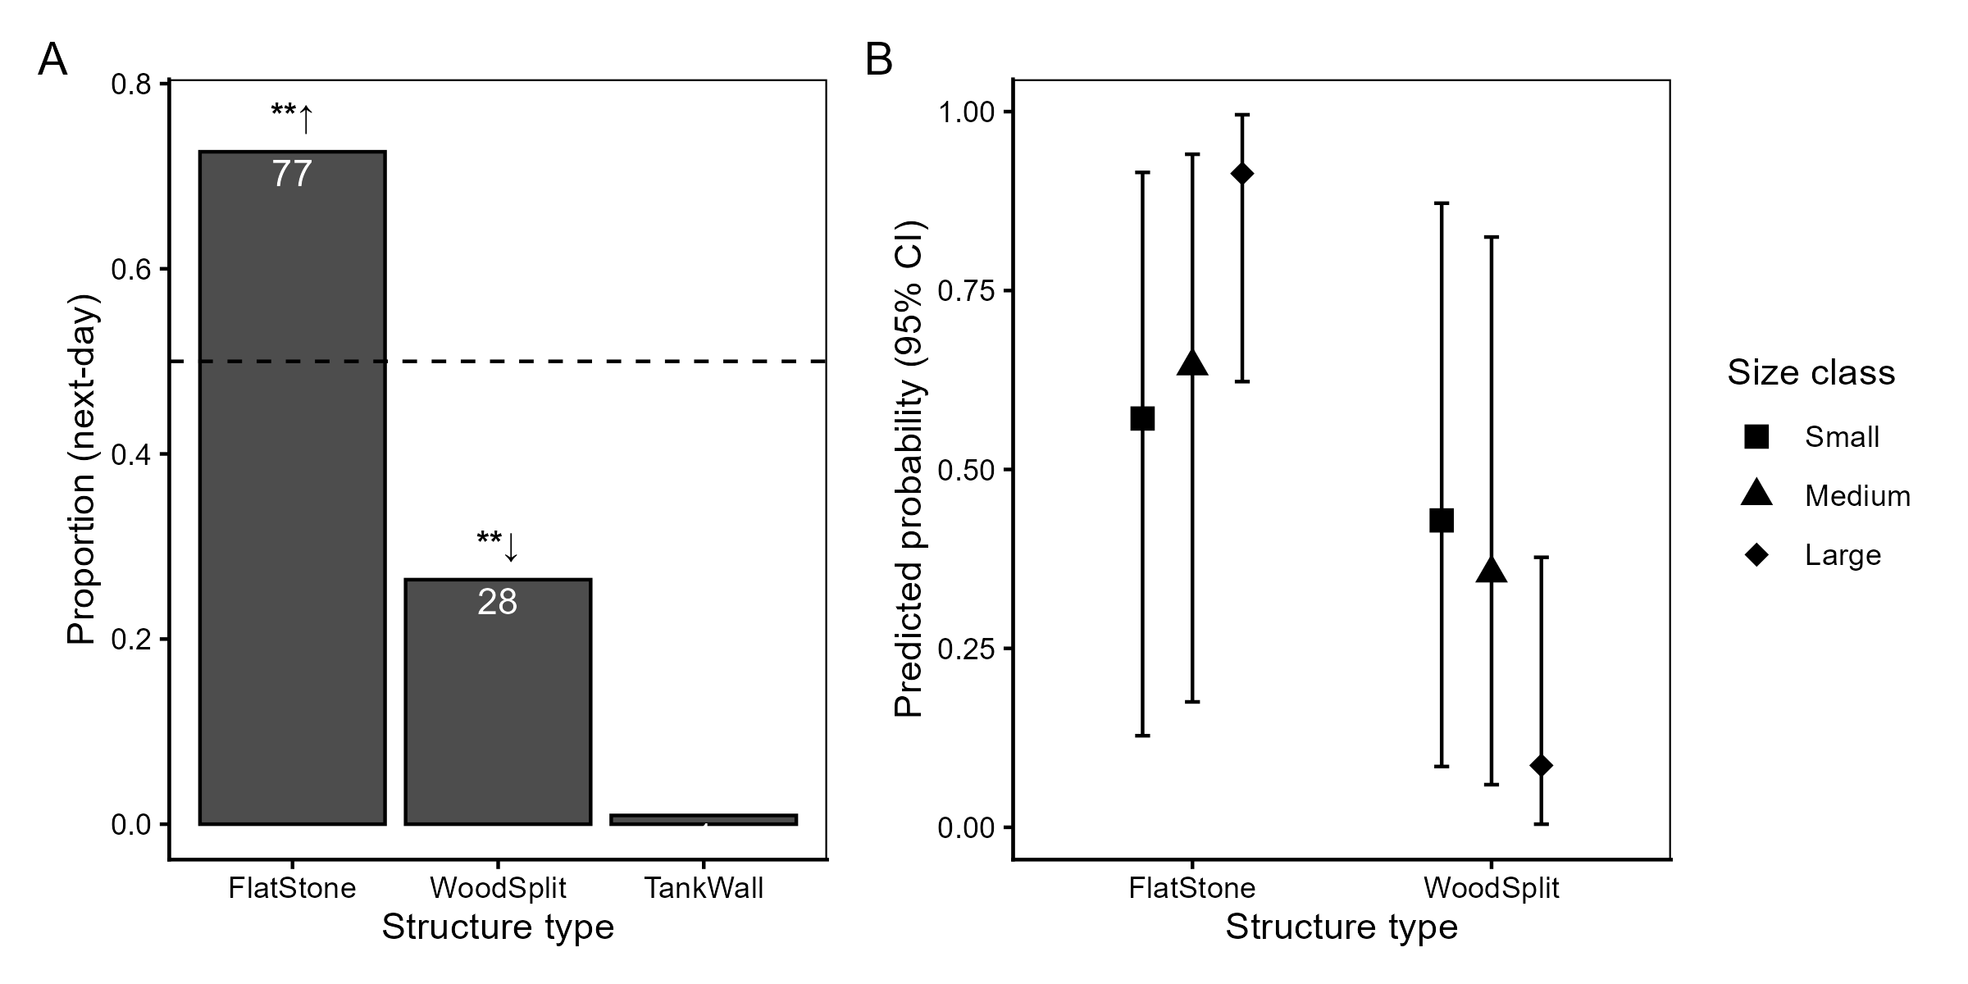
Figure 4: Structure type preference in stone versus wood comparison (Experiment 3). (A) Proportion of kōura found at each structure type at next-day location across all groups and rounds. The dashed line indicates the null expectation of equal distribution (0.5). Significance symbols as in Figure 3. (B) Posterior predicted probability of structure type use by size class from Bayesian categorical mixed model, with 95% credible intervals. $↑$ used more than expected, $↓$ used less than expected. TankWall excluded from model predictions.

Experiment 4: Material comparison
Kōura used both structure types, showing no significant preference between ConcreteBrick and WoodBlock (p = 0.137; Figure 5), with mean group proportions of 47% and 53% respectively. Neither structure type differed significantly from equal distribution (p = 0.273). 9% of kōura were found at TankWall, which is higher than in any previous experiment, likely reflecting the smaller total structure size in this experiment rather than active structure avoidance. Sex had no credible effect on preference between structure types ($β$ = -0.18, 95% CI: -1.24 to 0.84; posterior probability = 0.65), indicating that both structures were equally suitable refuge for male and female kōura.
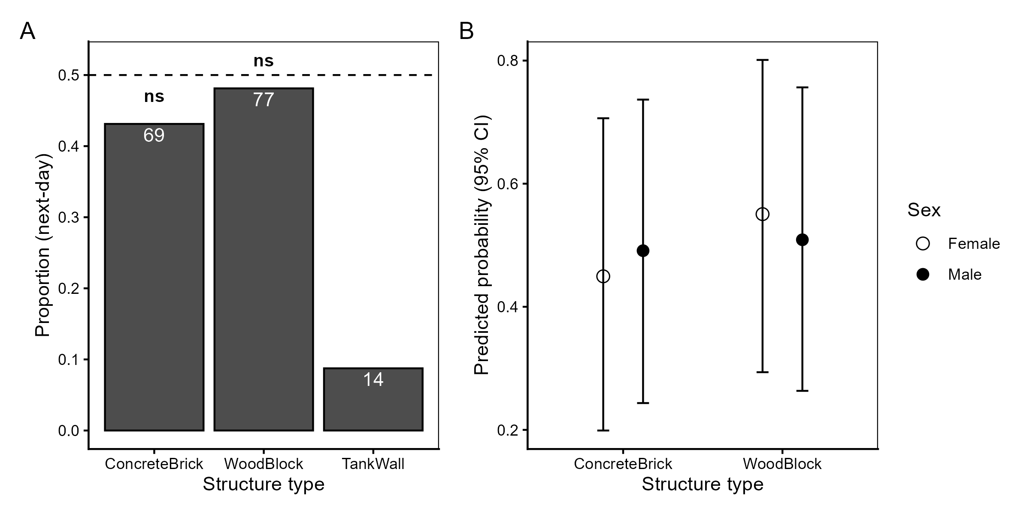
Figure 5: Material preference (Experiment 4). (A) Proportion of kōura found at each structure type at next-day location across all groups and rounds. The dashed line indicates the null expectation of equal distribution (0.5). (B) Posterior predicted probability of structure type use by sex from Bayesian categorical mixed model, with 95% credible intervals. TankWall excluded from model predictions.

Discussion

Structure matters more than material
The consistent finding across all experiments that structural stability and cavity complexity determined preference, regardless of whether the comparison involved material type, configuration or group size, suggests that kōura, like many refuge-dependent crustaceans (Zimmer-Faust and Spanier, 1987; Beck, 1995; Streissl and Hödl, 2002; Pirtle et al., 2012), are primarily selecting for physical shelter quality rather than material familiarity. When hole dimensions were held constant between concrete and wooden perforated structures, no preference for either material was detected, demonstrating that material composition alone may not drive refuge selection when structure is equivalent. Neither structure type was conditioned prior to experiments, meaning biofilm colonisation that occurs in natural lake environments was absent. As stone and wood develop different biofilm communities (Tank and Winterbourn, 1996), material preference in field settings could change. The wooden structures required a clay brick placed on top to prevent floating, creating a difference with the concrete structures, though the absence of any preference suggests this did not meaningfully influence the result. This material-independence broke down when material affected structural properties: when flat-laid stones were compared against similarly sized split wood pieces, kōura showed a clear preference for stone. The wood splits, being less dense than stone, sank but created less structurally stable refuge places in the sandy substrate than the stones, as larger kōura were able to move them [O.V. Raven, pers. obs.].
In group settings, structures providing the most crevice complexity were strongly preferred, with flat-laid stones accommodating the most kōura, followed by stone piles. Individual kōura showed a different preference, consistently choosing the perforated wooden log over all stone options, which is consistent with our first prediction that structurally complex and enclosed refugia would be preferred as enclosed spaces reduce predation risk (Jurcak et al., 2016). The individual drilled holes in the wooden log offered protection similar to what has been found for perforated brick and PVC tube shelters in response to the threat of catfish predation (Adams, 2007; Zhao et al., 2024). The directional shift in structure type use, between initial locations shortly after release and their location following a night within the tank, confirmed across all experiments that kōura actively relocated overnight, supporting the interpretation that next-day locations reflect genuine refuge preference rather than chance displacement.
The shift from the perforated wooden log in individual trials to stone structures in group trials was unexpected. The wooden log contained six individual drilled holes, so capacity was not limiting for the group of six kōura. The preference shift may partly reflect size mismatch between fixed hole dimensions, and the range of body sizes present in each group, with only medium-sized individual finding the holes well-suited, while small and large individuals were better served by the range of crevices created by the stone structures (Streissl and Hödl, 2002). However, a more fundamental explanation may relate to social behaviour. The wooden log was the most selected structure in round 1 of Experiment 2 (17 out of 36 times), similar to Experiment 1, but this preference did not persist in subsequent rounds. This shift suggests that once kōura had experienced sharing the tank, they adjusted their shelter use toward structures allowing closer conspecific proximity. Gregarious shelter behaviour has been documented in juvenile burrowing crayfish (Hazlett et al., 2007; Reynolds et al., 2013; Clay et al., 2017) and is well established in lobsters including the New Zealand rock lobster (Jasus edwardsii Hutton, 1875) (Butler et al., 1999), where conspecific chemical cues attract individuals to share refugia and find refugia significantly faster, reducing predation exposure (Zimmer-Faust and Spanier, 1987; Childress and Herrnkind, 2001). Whether kōura exhibit similar gregarious tendencies remains understudied, but the preference shift observed in this study might suggest that social context alters shelter preferences.

Body size and competitive dynamics
Size class consistently influenced refuge preference across experiments, but the pattern differed by context. In Experiment 3, larger kōura showed a stronger preference for flat stones over wooden splits than smaller individuals, consistent with size dependent shelter selection documented in crayfish (Streissl and Hödl, 2002; Percival and Moore, 2010). This may reflect larger kōura being more capable of asserting dominance over preferred stable refugia through competitive displacement, which is consistent with the size-based dominance hierarchy documented in kōura populations (Ranta and Lindström, 1993; Figler et al., 2005; Stewart and Tabak, 2011). In Experiment 2, where four structure types were available, small kōura showed the strongest preference for flat stones while large kōura distributed more evenly between flat stones and stone piles, suggesting that the large continuous surface area of the flat stones provides refuge spaces proportional to smaller body dimensions (Streissl and Hödl, 2002), while larger individuals find adequate crevice space in either stone configuration. The absence of sex effects in Experiments 1 and 4 suggests that refuge preference in kōura is driven primarily by body size and competitive dominance rather than sex (Figler et al., 1999). When refuge availability is limited, competitive hierarchies displace smaller and recently moulted individuals from preferred refugia, leaving them exposed (Ranta and Lindström, 1993; Figler et al., 2005). Providing sufficient refuge spaces with a range of crevice size can reduce agonistic interactions and benefit the whole population (Olsson and Nyström, 2009), supporting complex structure configurations over structures with fixed hole dimensions.

Restoration implications
With the threat from invasive predatory fish, such as catfish preying on kōura (Kusabs et al., 2026), enhancing habitat complexity may reduce top-down control on kōura populations. Additional habitat as used here can provide shelter spaces and offers a promising management tool, as refuge availability directly influences predation survival (Adams, 2007; Zhao et al., 2024). The present study demonstrates that structural configuration and stability drive refuge preference more strongly than material composition, with stone-based configurations preferred by groups and no preference detected between materials when dimensions were equal, suggesting that stone-based habitat enhancement structures warrant field evaluation in lake environments.
The broader restoration literature supports both the structural principle and the choice of natural materials. Structurally stable crevices are important for freshwater species like crayfish (Huolila et al., 1997; Streissl and Hödl, 2002), but also for marine environments, as reef fish, marine shrimp, and lobsters have all been shown to benefit from habitat enhancement structures such as artificial reefs (Spanier, 1994; Magnelia et al., 2008; Hylkema et al., 2020; Dickson et al., 2023). Structures made from stone and wood have been shown to outperform synthetic alternatives and bare substrates (Huolila et al., 1997; Magnelia et al., 2008; Cooke et al., 2023; Dickson et al., 2023), and do not contribute to plastic pollution in the environment (Cooke et al., 2023). Locally sourced natural materials also align with kaitiakitanga, which is the Māori principle of environmental guardianship and preserves the natural character of culturally significant lake environments (Clapcott et al., 2018). Furthermore, existing habitat surveys suggest that kōura are associated with coarser substrates (Kusabs et al., 2015b; Olsson et al., 2006; Jowett et al., 2008), and cobbles have previously been used in stream and lake restoration (Huolila et al., 1997; Johnsen and Taugbøl, 2008). For in-lake deployment, stone pile structures are likely to be the most practical configuration, due to their elevated structure, stone piles are less likely to be buried into soft substrates than flat individual rocks (Garron et al., 2024). Field validation in lake environments remains an essential next step, as in-lake conditions including water movement, natural substrate, and predator pressure may modify kōura preferences in ways not captured under controlled conditions.

Conclusion
Across four mesocosm experiments, structural configuration and crevice complexity consistently predicted kōura shelter preference more strongly than material composition. The shift from individual preference for enclosed wooden log shelters to group preference for stone configurations shows that social context plays a key role in determining shelter value for kōura. Size-dependent preferences further suggest that structures accommodating multiple body sizes simultaneously benefit whole populations rather than only dominant individuals. Stone-based structures using locally sourced materials are promising candidates for field evaluation, aligning with ecological and cultural values associated with restoring this taonga species. Field validation remains the essential next step for translating these findings into effective kōura habitat restoration practice.

Acknowledgements
We thank Te Arawa Lakes Trust and Te Komiti Whakahaere for the opportunity to collect and study the treasured kōura. We are grateful to Soweeta Fort-D’ath and William Anaru (Te Arawa Lakes Trust), and Tihini Grant (Ngāti Pikiao).

Funding statement
This research was supported by the Fish Futures programme funded through a Ministry of Business, Innovation and Employment grant (CAWX2101) with additional funding provided by the Bay of Plenty Regional Council under the Toihuarewa Waimāori - Bay of Plenty Regional Council Chair in Lake and Freshwater Science programme.

Authors’ contributions
Study conception and design were undertaken by O.V.R., R.H. and F.J.B. Experiments were conducted by O.V.R. Data analysis was performed by O.V.R. I.A.K.K. obtained iwi consent, provided local ecological knowledge and kōura specimens. Manuscript drafting was led by O.V.R. All authors contributed to manuscript revision, approved the results, and the final manuscript.

Ethical approval
This study received ethical approval by University of Waikato animal ethics committee, protocol number: 1207. Additional permission to conduct experiments with kōura was granted by Te Arawa Lakes Trust and Te Komiti Whakahaere.

Declarations
The corresponding author has declared that none of the authors has any competing interests.

Data availability statement
The code and derived data supporting the findings of this study are openly available on GitHub (https://github.com/OlivierRaven/Koura_Mesocosm) and a rendered version of the analysis is hosted at https://olivierraven.github.io/Koura_Mesocosm/. The primary raw dataset is archived on Zenodo (https://doi.org/…). Peer review documents, including the cover letter and reviewer responses, are available in the manuscript repository in the interest of open and transparent science.
Adams SB. 2007. Direct and indirect effects of channel catfish (Ictalurus punctatus) on native crayfishes (Cambaridae) in experimental tanks. The American Midland Naturalist 158: 85–96. https://doi.org/10.1674/0003-0031(2007)158[85:daieoc]2.0.co;2
Adams SB. 2014. Crayfish use of trash versus natural cover in incised, sand-bed streams. Environmental Management 53: 382–392. https://doi.org/10.1007/s00267-013-0197-3
Beck MW. 1995. Size-specific shelter limitation in stone crabs: A test of the demographic bottleneck hypothesis. Ecology 76: 968–980. https://doi.org/10.2307/1939360
Bürkner P-C. 2017. <B>brms</b> : An <i>r</i> package for bayesian multilevel models using <i>stan</i>. Journal of Statistical Software 80. https://doi.org/10.18637/jss.v080.i01
Bürkner P-C. 2018. Advanced bayesian multilevel modeling with the r package brms. The R Journal 10: 395. https://doi.org/10.32614/rj-2018-017
Butler M, MacDiarmid A, Booth J. 1999. The cause and consequence of ontogenetic changes in social aggregation in New Zealand spiny lobsters. Marine Ecology Progress Series 188: 179–191. https://doi.org/10.3354/meps188179
Childress MJ, Herrnkind WF. 2001. The guide effect influence on the gregariousness of juvenile caribbean spiny lobsters. Animal Behaviour 62: 465–472. https://doi.org/10.1006/anbe.2001.1760
Clapcott J, Ataria J, Hepburn C, Hikuroa D, Jackson A, Kirikiri R, Williams E. 2018. Mātauranga Māori: Shaping marine and freshwater futures. New Zealand Journal of Marine and Freshwater Research 52: 457–466. https://doi.org/10.1080/00288330.2018.1539404
Clay M, Stoeckel J, Helms B. 2017. The role of abiotic and biotic cues in burrow habitat selection by juvenile crayfish. Behaviour 154: 1177–1196. https://doi.org/10.1163/1568539x-00003463
Collier KJ, Parkyn SM, Rabeni CF. 1997. Koura: A keystone species. Water and Atmosphere 5: 18–20.
Cooke SJ, Piczak ML, Vermaire JC, Kirkwood AE. 2023. On the troubling use of plastic ‘habitat’ structures for fish in freshwater ecosystems – or – when restoration is just littering (D Lesbarrères, Ed). FACETS 8: 1–19. https://doi.org/10.1139/facets-2022-0210
Dickson J, Franken O, Watson MS, Monnich B, Holthuijsen S, Eriksson BK, Govers LL, Heide T van der, Bouma TJ. 2023. Who lives in a pear tree under the sea? A first look at tree reefs as a complex natural biodegradable structure to enhance biodiversity in marine systems. Frontiers in Marine Science 10: 1213790. https://doi.org/10.3389/fmars.2023.1213790
Dudgeon D, Arthington AH, Gessner MO, Kawabata Z, Knowler DJ, Lévêque C, Naiman RJ, Prieur‐Richard A, Soto D, Stiassny MLJ, et al. 2006. Freshwater biodiversity: Importance, threats, status and conservation challenges. Biological Reviews 81: 163–182. https://doi.org/10.1017/s1464793105006950
Engels B. 2014. XNomial: Exact goodness-of-fit test for multinomial data with fixed probabilities. CRAN: Contributed Packages. https://doi.org/10.32614/cran.package.xnomial
Figler MH, Blank GS, Peeke HVS. 2005. Shelter competition between resident male red swamp crayfish Procambarus clarkii (girard) and conspecific intruders varying by sex and reproductive status. Marine and Freshwater Behaviour and Physiology 38: 237–248. https://doi.org/10.1080/10236240500376477
Figler MH, Cheverton HM, Blank GS. 1999. Shelter competition in juvenile red swamp crayfish (Procambarus clarkii): The influences of sex differences, relative size, and prior residence. Aquaculture 178: 63–75. https://doi.org/10.1016/s0044-8486(99)00114-3
Garron C, Pangaud A, Taubaty M, Rolan‐Meynard M, Argillier C, Raymond J, Dublon J, Westrelin S. 2024. Towards the development of a standardized method to monitor lakeshore hydromorphological restoration measures. Aquatic Conservation: Marine and Freshwater Ecosystems 34. https://doi.org/10.1002/aqc.4152
Gelman A, Rubin DB. 1992. Inference from iterative simulation using multiple sequences. Statistical Science 7: 457–472. https://doi.org/10.1214/ss/1177011136
Hammond KS, Hollows JW, Townsend CR, Lokman PM. 2006. Effects of temperature and water calcium concentration on growth, survival and moulting of freshwater crayfish, Paranephrops zealandicus. Aquaculture 251: 271–279. https://doi.org/10.1016/j.aquaculture.2005.05.032
Hazlett BA, Lawler S, Edney G. 2007. Agonistic behavior of the crayfish Euastacus armatus and Cherax destructor. Marine and Freshwater Behaviour and Physiology 40: 257–266. https://doi.org/10.1080/10236240701562412
Huolila M, Marjomäki TJ, Laukkanen E. 1997. The success of crayfish stocking in a dredged river with and without artificial shelter increase. Fisheries Research 32: 185–189. https://doi.org/10.1016/s0165-7836(97)00046-5
Hylkema A, Debrot AO, Osinga R, Bron PS, Heesink DB, Izioka AK, Reid CB, Rippen JC, Treibitz T, Yuval M, et al. 2020. Fish assemblages of three common artificial reef designs during early colonization. Ecological Engineering 157: 105994. https://doi.org/10.1016/j.ecoleng.2020.105994
Johnsen SI, Taugbøl T. 2008. Add stones, get crayfish – is it that simple? Freshwater Crayfish 16: 47–50.
Jowett IG, Parkyn SM, Richardson J. 2008. Habitat characteristics of crayfish (Paranephrops planifrons) in New Zealand streams using generalised additive models (GAMs). Hydrobiologia 596: 353–365. https://doi.org/10.1007/s10750-007-9108-z
Jurcak AM, Lahman SE, Wofford SJ, Moore PA. 2016. Behavior of crayfish. In Biology and ecology of crayfish CRC Press;
Kusabs IAK, Duggan IC, Bruere AC, Scholes P, Te Kurapa TW, Grant TM, Burdon FJ. 2026. Invasive catfish linked to the decline of freshwater crayfish in two Aotearoa New Zealand lakes. Biological Invasions 28. https://doi.org/10.1007/s10530-026-03852-0
Kusabs IAK, Hicks BJ, Quinn JM, Hamilton DP. 2015a. Sustainable management of freshwater crayfish (kōura, Paranephrops planifrons) in Te Arawa (Rotorua) lakes, North Island, New Zealand. Fisheries Research 168: 35–46. https://doi.org/10.1016/j.fishres.2015.03.015
Kusabs IAK, Quinn JM. 2009. Use of a traditional Maori harvesting method, the tau kōura, for monitoring kōura (freshwater crayfish, Paranephrops planifrons) in Lake Rotoiti, North Island, New Zealand. New Zealand Journal of Marine and Freshwater Research 43: 713–722. https://doi.org/10.1080/00288330909510036
Kusabs IAK, Quinn JM, Hamilton DP. 2015b. Effects of benthic substrate, nutrient enrichment and predatory fish on freshwater crayfish (kōura, Paranephrops planifrons) population characteristics in seven Te Arawa (Rotorua) lakes, North Island, New Zealand. Marine and Freshwater Research 66: 631–643. https://doi.org/10.1071/MF14148
Lee F, Kusabs IAK, Perry GLW, MacNeil C. 2025. Identifying refugia from the synergistic threats of climate change and invasive species. Web Ecology 25: 221–239. https://doi.org/10.5194/we-25-221-2025
MacNeil C, Lee F, Kusabs IAK, Holmes R. 2025. The biter bit; scavenging behaviour of native freshwater crayfish on the carrion of native and introduced fish predators in Aotearoa-New Zealand. Knowledge & Management of Aquatic Ecosystems: 29. https://doi.org/10.1051/kmae/2025022
Magnelia SJ, Jesus MJD, Schlechte JW, Cummings GC, Duty JL. 2008. Comparison of plastic pipe and juniper tree fish attractors in a central texas reservoir. 62: 183–188.
Mazlum Y, Guner Gurlek O, Sirin S. 2017. Effect of different substrates on survival and growth of juveniles of the freshwater narrow-clawed crayfish Astacus leptodactylus eschscholtz, 1823 (Decapoda, Astacidae). Crustaceana 90: 1289–1302. https://doi.org/10.1163/15685403-00003724
Momot WT. 1995. Redefining the role of crayfish in aquatic ecosystems. Reviews in Fisheries Science 3: 33–63. https://doi.org/10.1080/10641269509388566
Olsson K, Nyström P. 2009. Non-interactive effects of habitat complexity and adult crayfish on survival and growth of juvenile crayfish (Pacifastacus leniusculus). Freshwater Biology 54: 35–46. https://doi.org/10.1111/j.1365-2427.2008.02089.x
Olsson K, Stenroth P, Nyström P, Holmqvist N, McIntosh AR, Winterbourn MJ. 2006. Does natural acidity mediate interactions between introduced brown trout, native fish, crayfish and other invertebrates in West Coast New Zealand streams? Biological Conservation 130: 255–267. https://doi.org/10.1016/j.biocon.2005.12.019
Parkyn SM, Collier KJ, Hicks BJ. 2001. New Zealand stream crayfish: Functional omnivores but trophic predators? Freshwater Biology 46: 641–652. https://doi.org/10.1046/j.1365-2427.2001.00702.x
Parkyn SM, Meleason MA, Davies‐Colley RJ. 2009. Wood enhances crayfish (Paranephrops planifrons) habitat in a forested stream. New Zealand Journal of Marine and Freshwater Research 43: 689–700. https://doi.org/10.1080/00288330909510034
Percival D, Moore P. 2010. Shelter size influences self-assessment of size in crayfish, Orconectes rusticus: Consequences for agonistic fights. Behaviour 147: 103–119. https://doi.org/10.1163/000579509x12512685881053
Pirtle JL, Eckert GL, Stoner AW. 2012. Habitat structure influences the survival and predator-prey interactions of early juvenile red king crab Paralithodes camtschaticus. Marine Ecology Progress Series 465: 169–184. https://doi.org/10.3354/meps09883
Ramalho RO, McClain WR, Anastacio PM. 2010. An effective and simple method of temporarily marking crayfish. Freshwater Crayfish 17: 57–60.
Ranta E, Lindström K. 1993. Body size and shelter possession in mature signal crayfish, Pacifastacus leniusculus. Annales Zoologici Fennici 30: 125–132.
Raven OV, Burdon FJ, Kusabs IAK, Holmes R, Özkundakci D. 2026b. Littoral habitat structure influences freshwater crayfish populations in five volcanic lakes of aotearoa new zealand. Hydrobiologia. https://doi.org/10.1007/s10750-026-06302-z
Raven OV, MacNeil C, Lee F, Holmes R, Kusabs IAK, Burdon FJ, Özkundakci D. 2026a. Fear of the new: A predatory invader provokes stronger non-consumptive effects on a keystone native prey than a native predator. https://doi.org/10.21203/rs.3.rs-9891519/v1
Reynolds J, Souty-Grosset C, Alastair A. 2013. Ecological roles of crayfish in freshwater and terrestrial habitats. Freshwater Crayfish 19: 197–218. https://doi.org/2010.5869/fc.2013.v19-2.197
Richman NI, Böhm M, Adams SB, Alvarez F, Bergey EA, Bunn JJS, Burnham Q, Cordeiro J, Coughran J, Crandall KA, et al. 2015. Multiple drivers of decline in the global status of freshwater crayfish (decapoda: astacidea). Philosophical Transactions of the Royal Society B: Biological Sciences 370: 20140060. https://doi.org/10.1098/rstb.2014.0060
Shave CR, Townsend CR, Crowl TA. 1994. Anti-predator behaviours of a freshwater crayfish (Paranephrops zealandicus) to a native and an introduced predator. New Zealand Journal of Ecology 18: 1–10.
Spanier E. 1994. What are the characteristics of a good artificial reef for lobsters? Crustaceana 67: 173–186.
Stewart C, Tabak J. 2011. Size‐based dominance hierarchies in the New Zealand freshwater crayfish (koura) Paranephrops zealandicus. New Zealand Journal of Marine and Freshwater Research 45: 281–285. https://doi.org/10.1080/00288330.2011.559661
Streissl F, Hödl W. 2002. Habitat and shelter requirements of the stone crayfish, Austropotamobius torrentium schrank. Hydrobiologia 477: 195–199. https://doi.org/10.1023/A:1021094309738
Takahashi K, Yamaguchi E, Fujiyama N, Nagayama T. 2019. The effects of quality of shelters and prior residence on marmorkrebs (marbled crayfish). Journal of Experimental Biology. https://doi.org/10.1242/jeb.197301
Tank JL, Winterbourn MJ. 1996. Microbial activity and invertebrate colonisation of wood in a New Zealand forest stream. New Zealand Journal of Marine and Freshwater Research 30: 271–280. https://doi.org/10.1080/00288330.1996.9516714
Usio N, Townsend CR. 2000. Distribution of the New Zealand crayfish Paranephrops zealandicus in relation to stream physico‐chemistry, predatory fish, and invertebrate prey. New Zealand Journal of Marine and Freshwater Research 34: 557–567. https://doi.org/10.1080/00288330.2000.9516957
Wehi PM, Lord JM. 2017. Importance of including cultural practices in ecological restoration. Conservation Biology 31: 1109–1118. https://doi.org/10.1111/cobi.12915
Zhao M, Feng G, Wang H, Shen C, Fu Y, Zhang Y, Zhang H, Yao Y, Chen J, Xu W. 2024. The influence of shelter type and coverage on crayfish (Procambarus clarkii) predation by catfish (Silurus asotus): A controlled environment study. Animals 14: 1147. https://doi.org/10.3390/ani14081147
Zimmer-Faust RK, Spanier E. 1987. Gregariousness and sociality in spiny lobsters: Implications for den habitation. Journal of Experimental Marine Biology and Ecology 105: 57–71. https://doi.org/10.1016/s0022-0981(87)80029-1

