FILL IN — manuscript title
FILL IN — Your Name
2026-07-24

Abstract
FILL IN — 150–250 words summarising the question, approach, and key finding.

Introduction
FILL IN. Cite sources with the [@key] syntax once you’ve added entries to references/references.bib, e.g. (Author and Other 2024).

Methods

Study design
FILL IN.

Statistical analysis
FILL IN — describe the model(s) from analysis.qmd in prose here.

Results
── Attaching core tidyverse packages ──────────────────────── tidyverse 2.0.0 ──
✔ dplyr 1.1.4 ✔ readr 2.1.5
✔ forcats 1.0.0 ✔ stringr 1.5.2
✔ ggplot2 4.0.0 ✔ tibble 3.3.0
✔ lubridate 1.9.4 ✔ tidyr 1.3.1
✔ purrr 1.1.0
── Conflicts ────────────────────────────────────────── tidyverse_conflicts() ──
✖ dplyr::filter() masks stats::filter()
✖ dplyr::lag() masks stats::lag()
ℹ Use the conflicted package (<http://conflicted.r-lib.org/>) to force all conflicts to become errors
Rows: 2 Columns: 4
── Column specification ────────────────────────────────────────────────────────
Delimiter: ","
chr (1): treatment
dbl (3): n, mean, sd
ℹ Use `spec()` to retrieve the full column specification for this data.
ℹ Specify the column types or set `show_col_types = FALSE` to quiet this message.
FILL IN — describe the result in prose, referencing the figure and table produced by analysis.qmd:
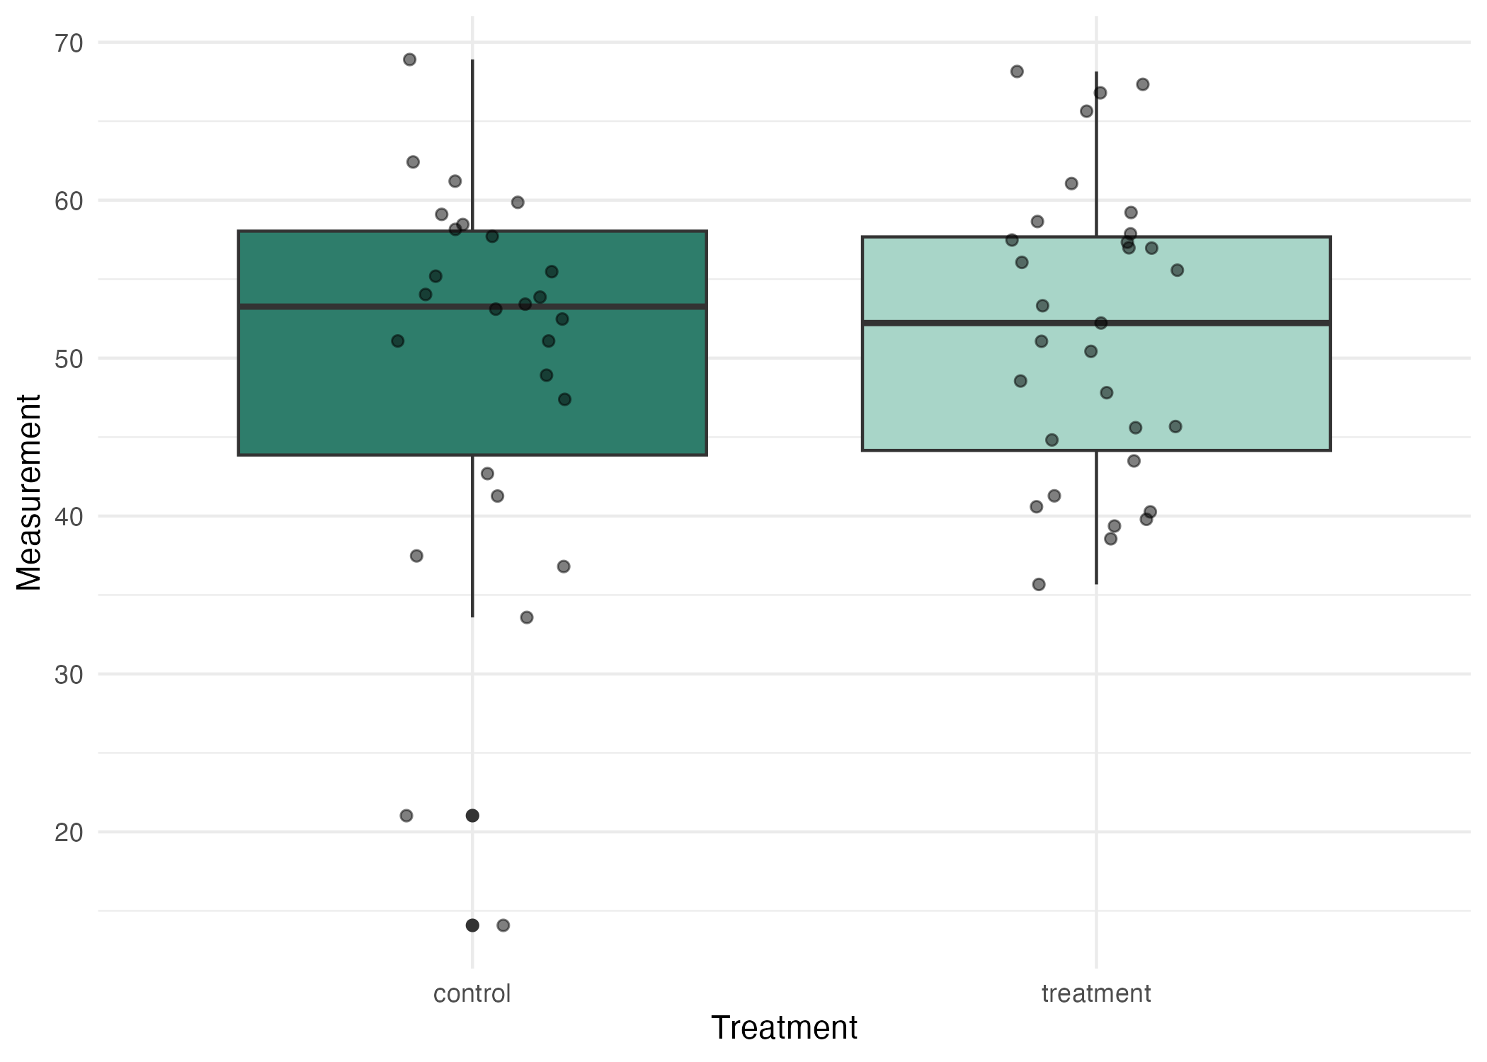
Figure 1: FILL IN — figure caption matching the one in analysis.qmd
See Figure 1 and Table 1.
Table 1: FILL IN — table caption
treatment | n | mean | sd
control | 26 | 49.56731 | 12.64178
treatment | 31 | 51.72839 | 9.35755

Discussion
FILL IN.

Data availability

References
Author, A. N., and B. Other. 2024. “An Example Reference to Show the Citation Syntax.” Journal of Examples 1: 1–10. https://doi.org/10.0000/example.

