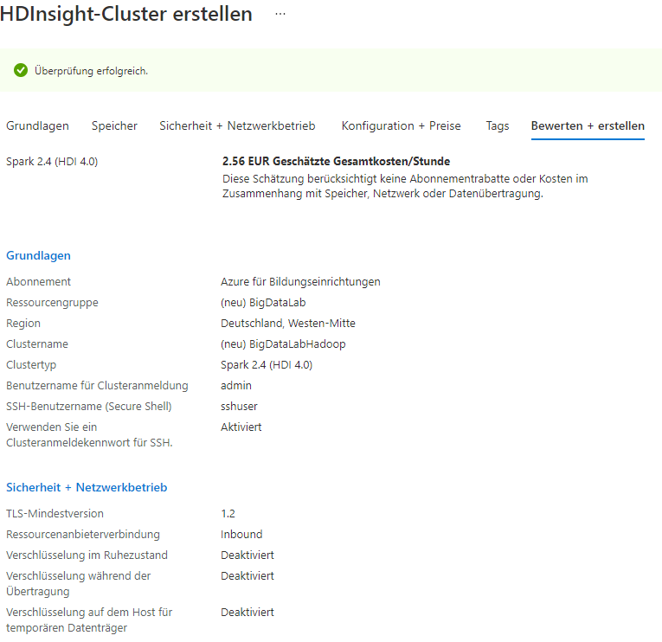

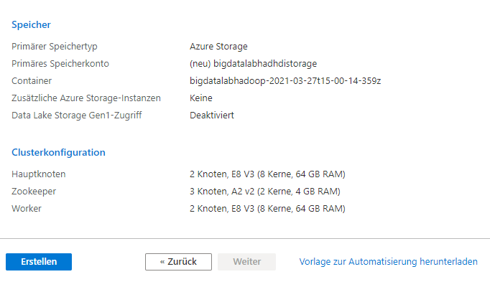

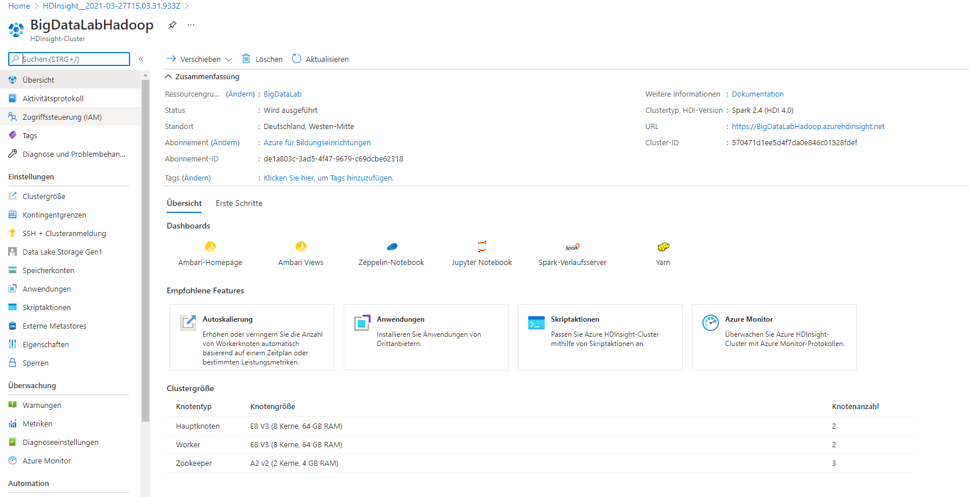

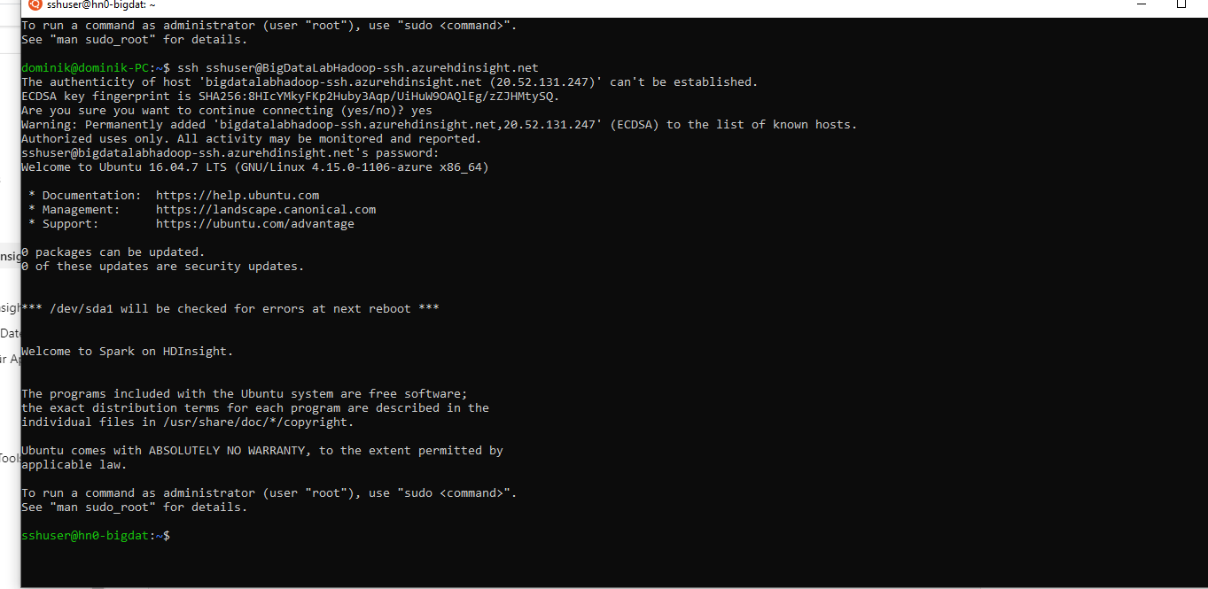

HDFS

1. Login

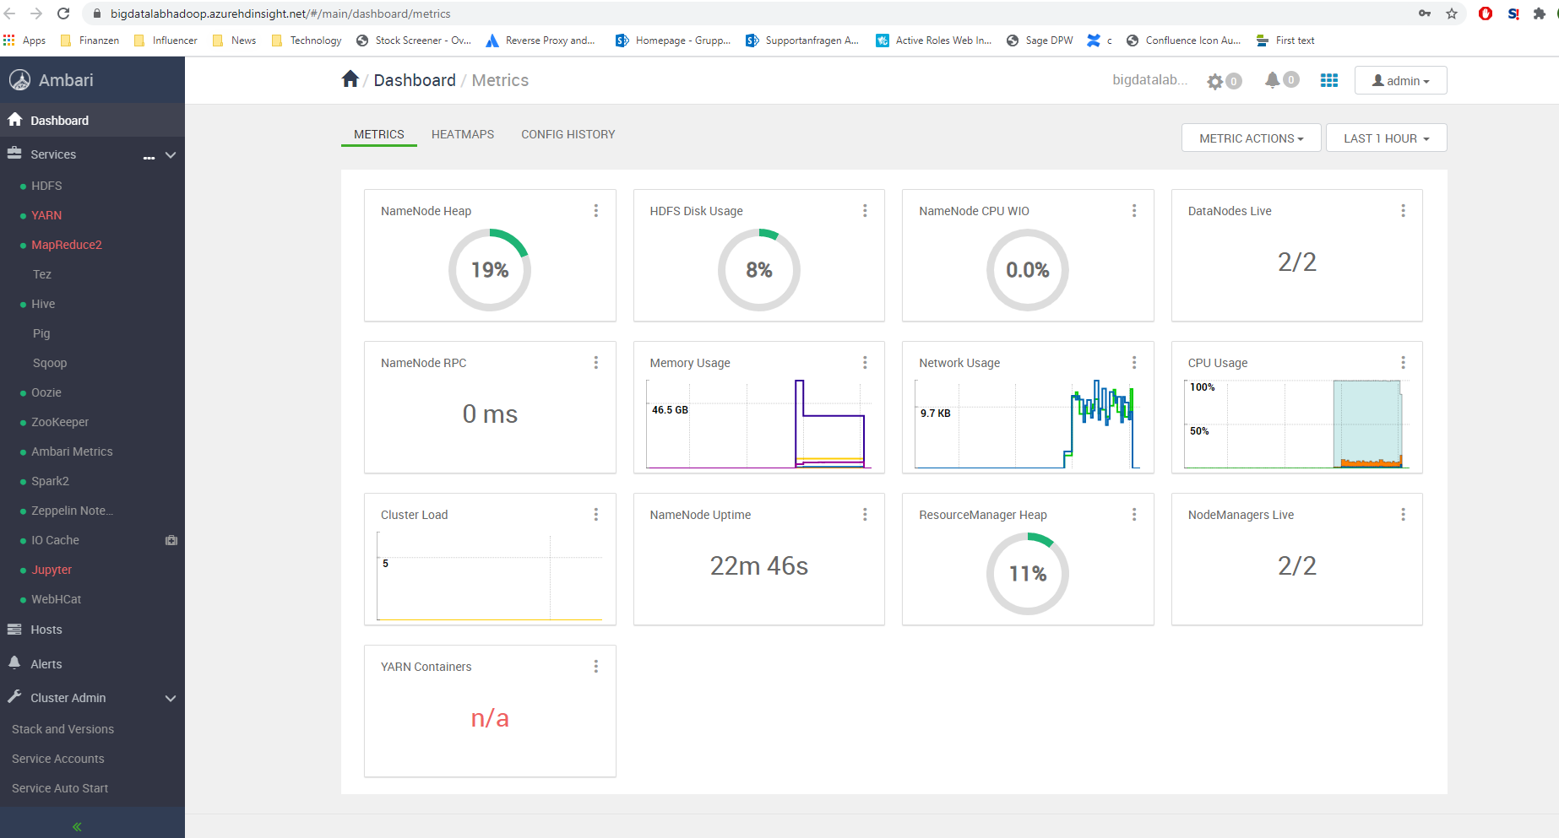

1. Explore

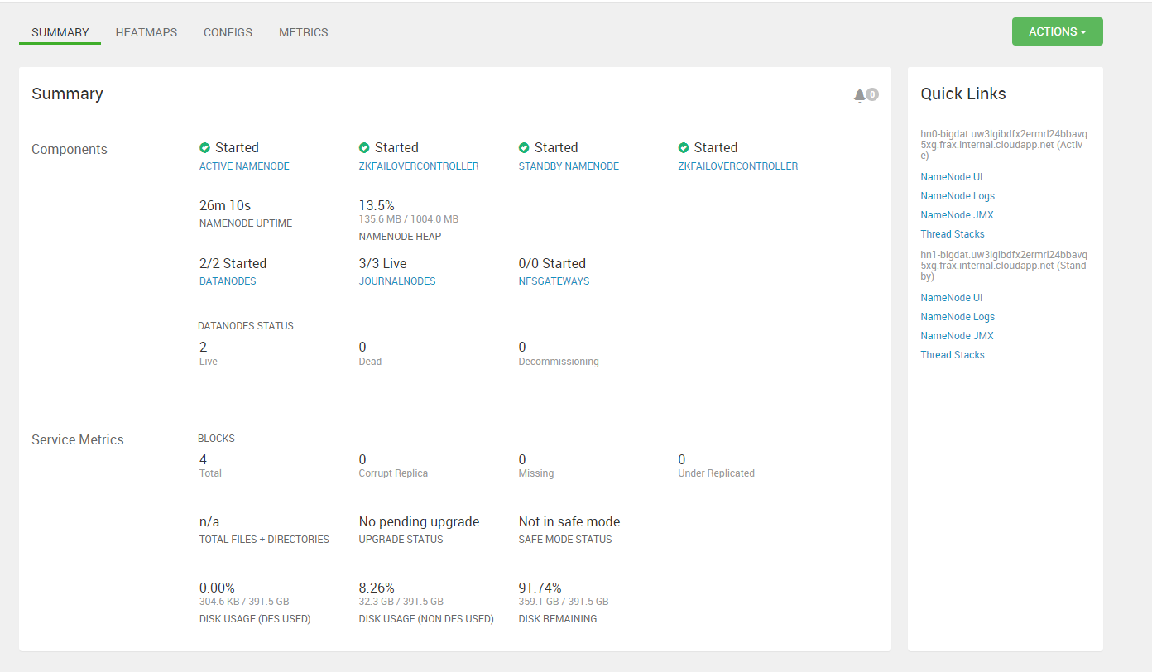

Hostname of the HDFS NameNodes:

hn0-bigdat.uw3lgibdfx2ermrl24bbavq5xg.frax.internal.cloudapp.net (Active)

hn1-bigdat.uw3lgibdfx2ermrl24bbavq5xg.frax.internal.cloudapp.net (Standby)

1. Connect

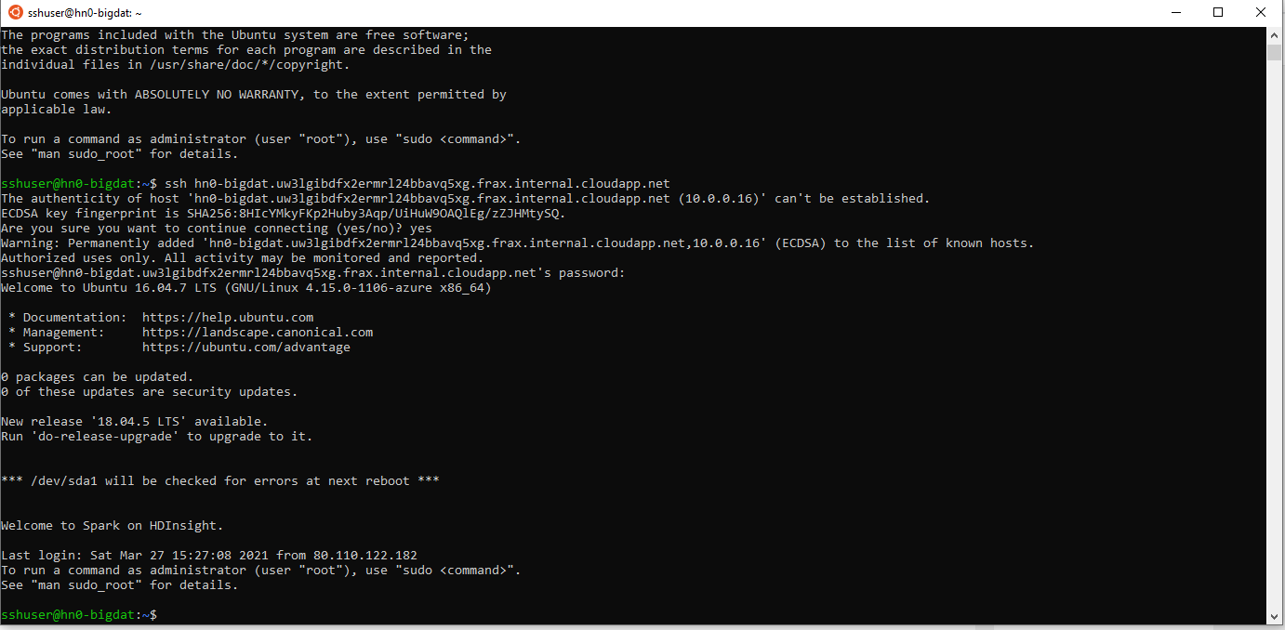

1. HDFS NameNode



1. HDFS MKDIR



1. Download Files

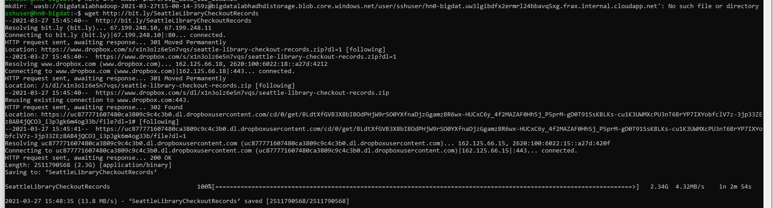

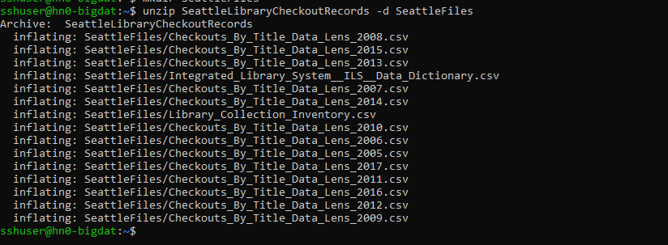

1. HDFS PUT



1. HDFS FSCK

