Bid Data / Lab04

Team kappa

Weidele, prüll, tomondy, bauer

2021

# HDInsight cluster

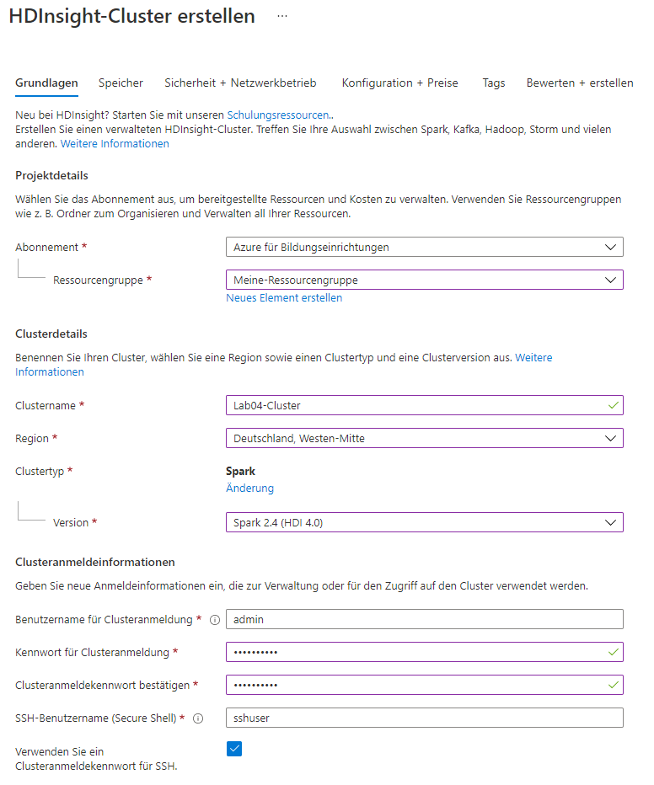

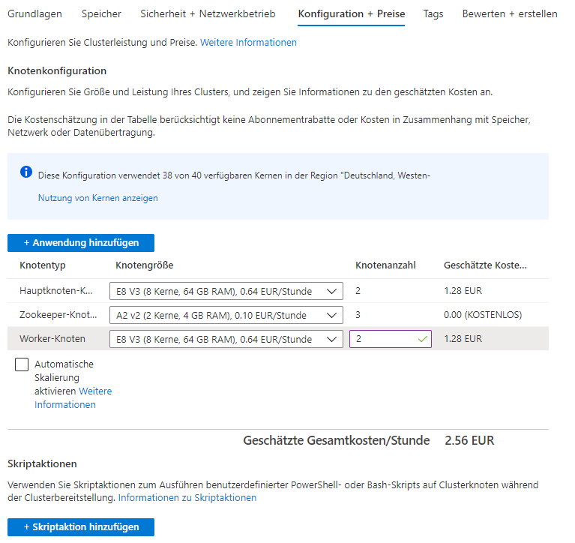

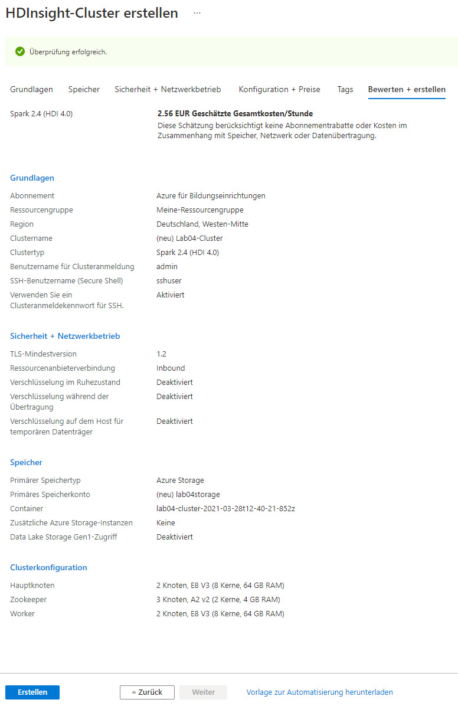

4. Explore the cluster

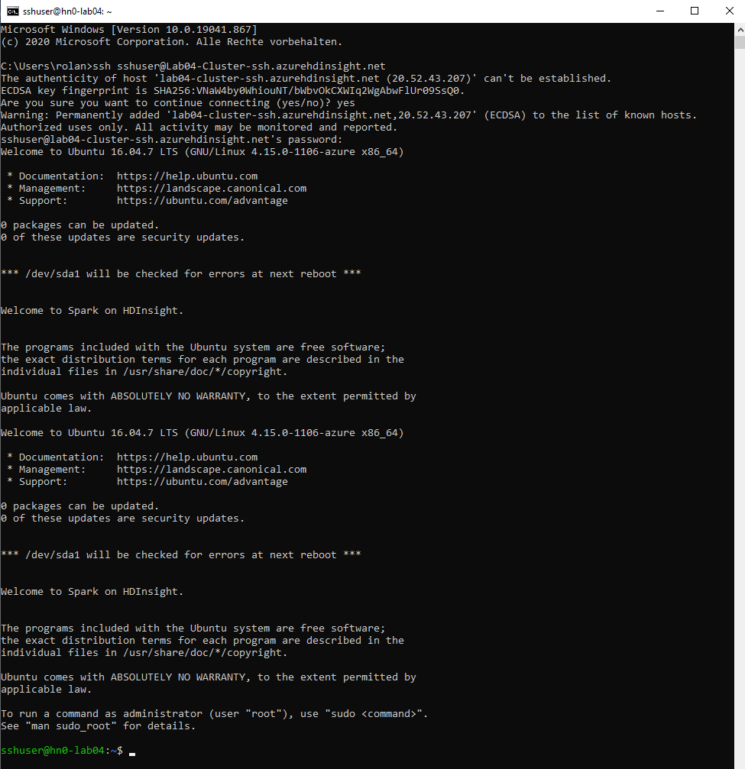

# HDFS

1. Login

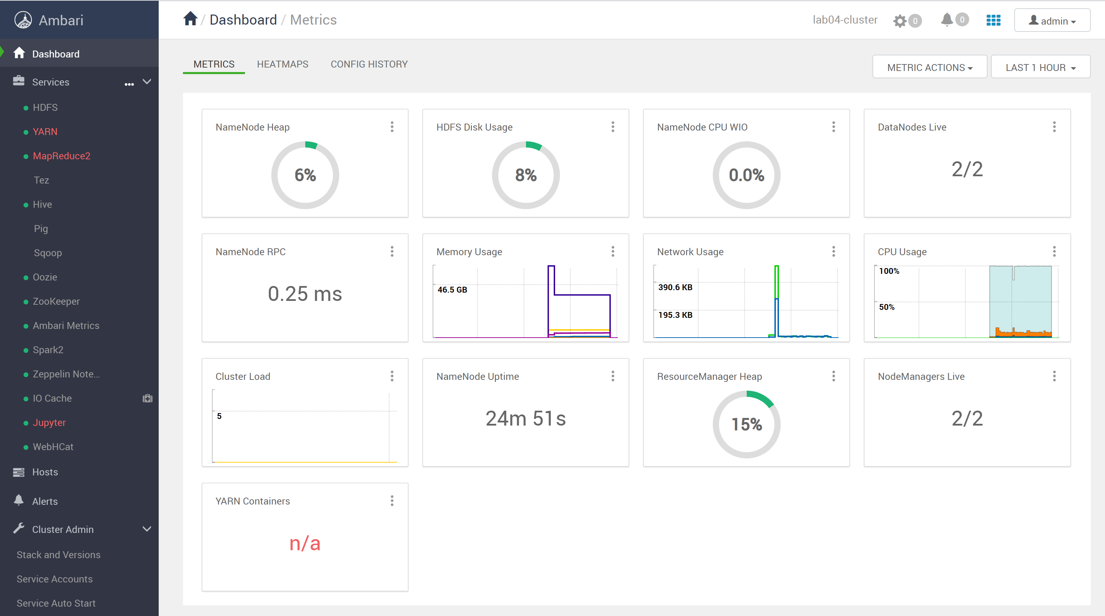

1. Explore

hn0-lab04.5lhzqh2ujh0uxmecbuowphwhib.frax.internal.cloudapp.net

hn1-lab04.5lhzqh2ujh0uxmecbuowphwhib.frax.internal.cloudapp.net

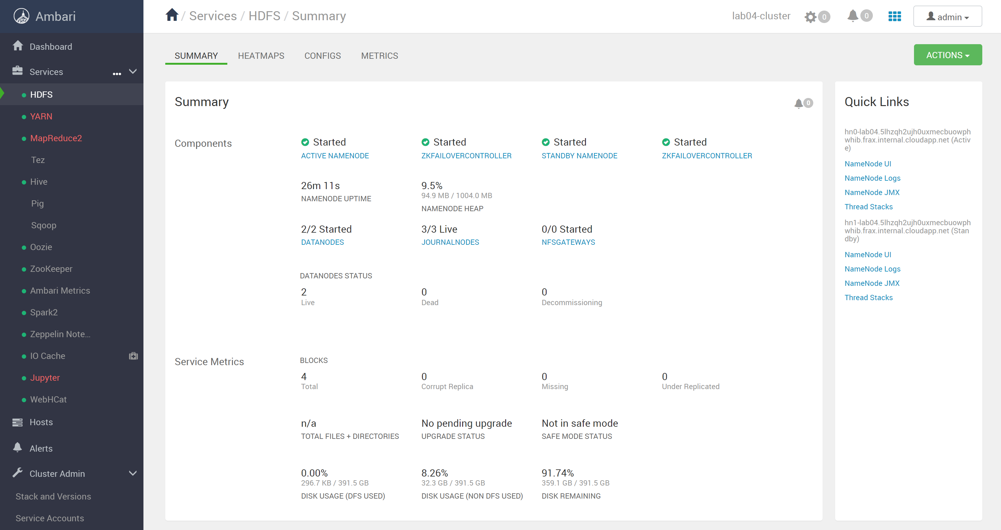

1. Connect

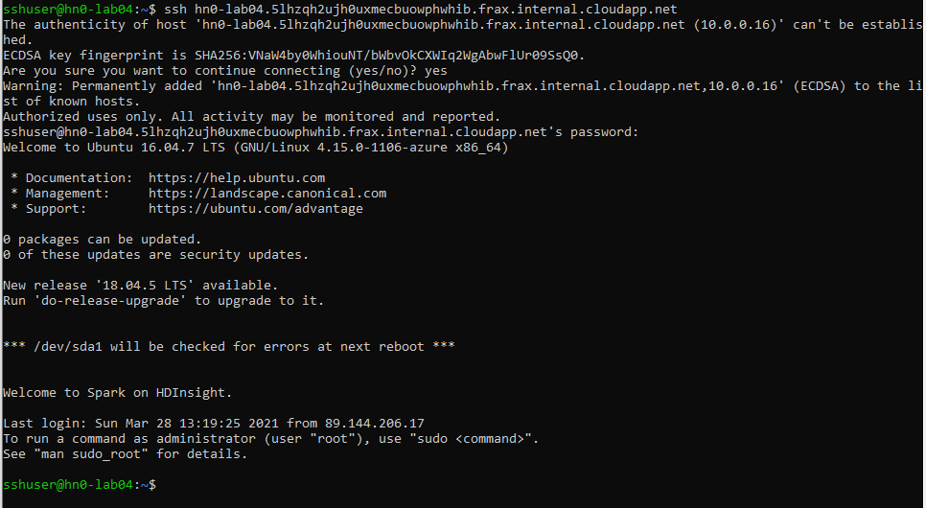

1. HDFS NameNode



1. HDFS MKDIR



1. DOWNLOAD FILES

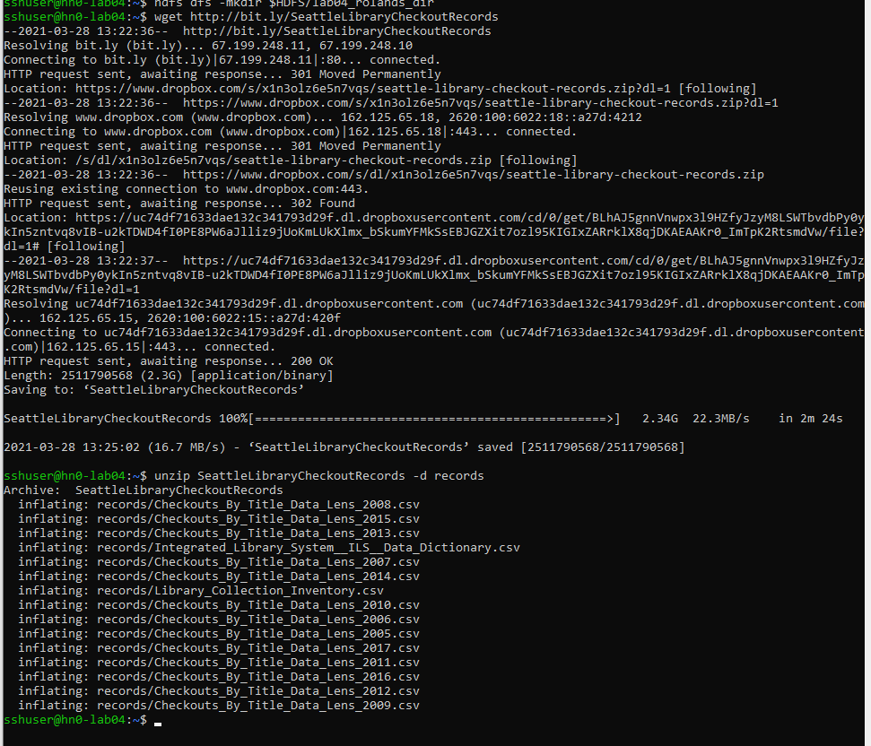

1. HDFS PUT



1. HDFS FSCK
   1. 4
   2. 1
   3. average block size: 115556230 Byte
      1. Block 1: 10.0.0.6:30010,DS-df4e88cb-8382-4aca-8a4a-ce4d68c3e26c
      2. Block 2: 10.0.0.6:30010,DS-df4e88cb-8382-4aca-8a4a-ce4d68c3e26c
      3. Block 3: 10.0.0.4:30010,DS-af7231e1-c0fc-4d70-aee1-276805a82901
      4. Block 4: 10.0.0.6:30010,DS-df4e88cb-8382-4aca-8a4a-ce4d68c3e26c

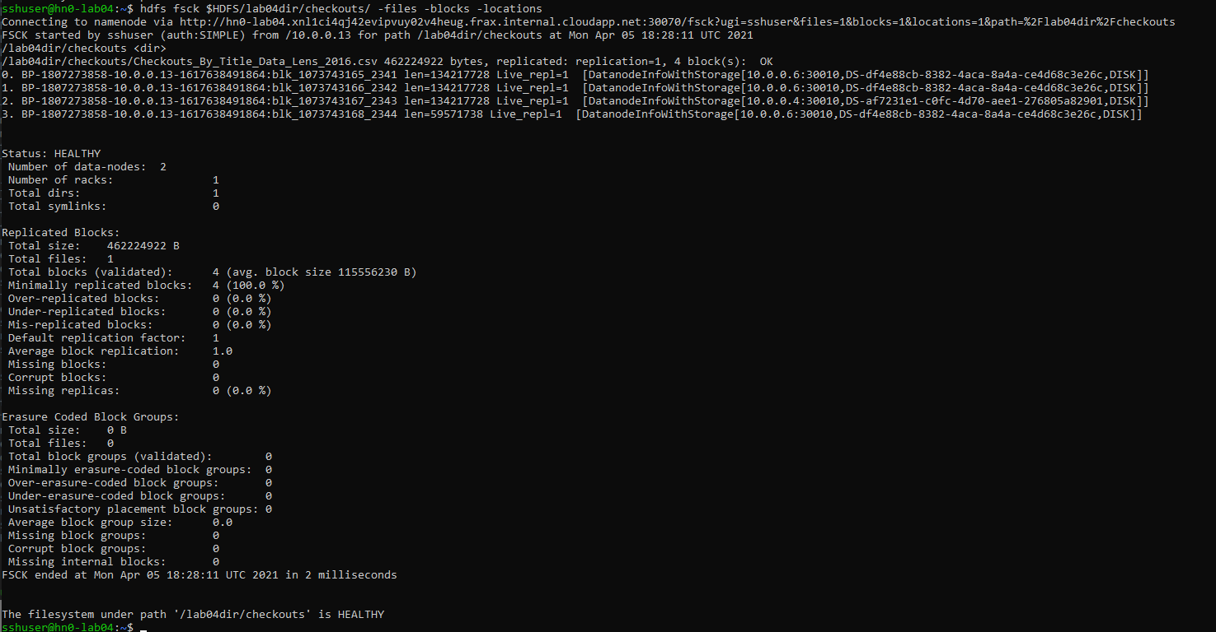

1. PLAY AROUND WITH HDFS / query data with HIVE

