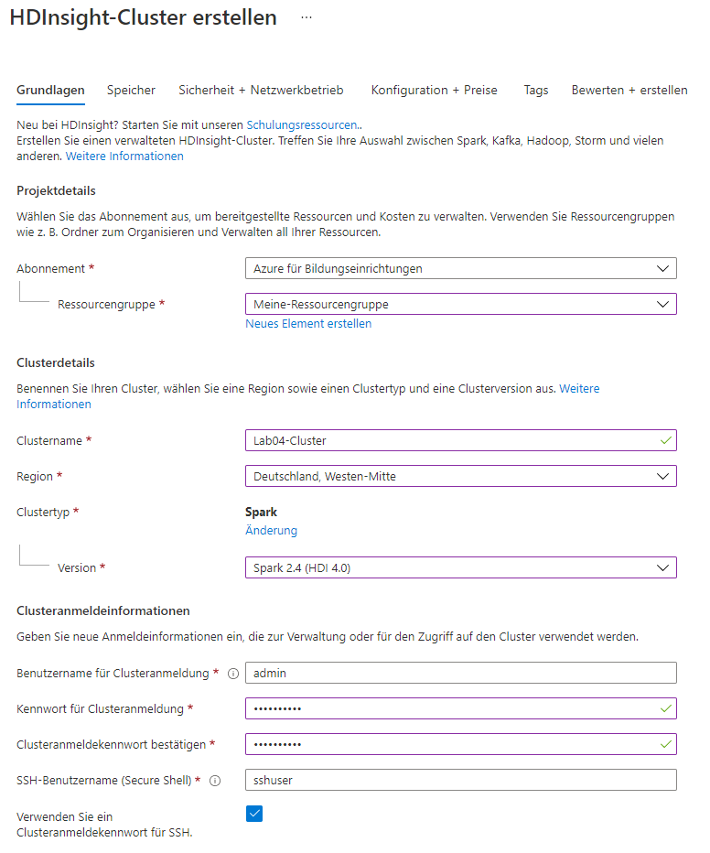

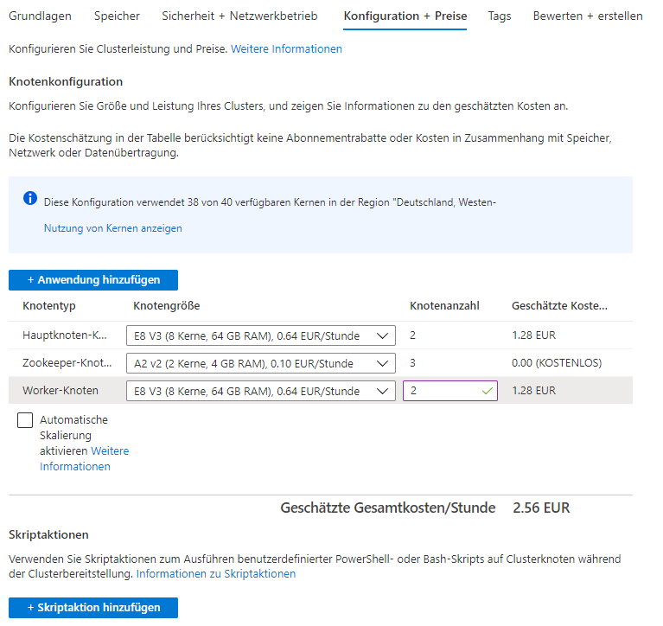

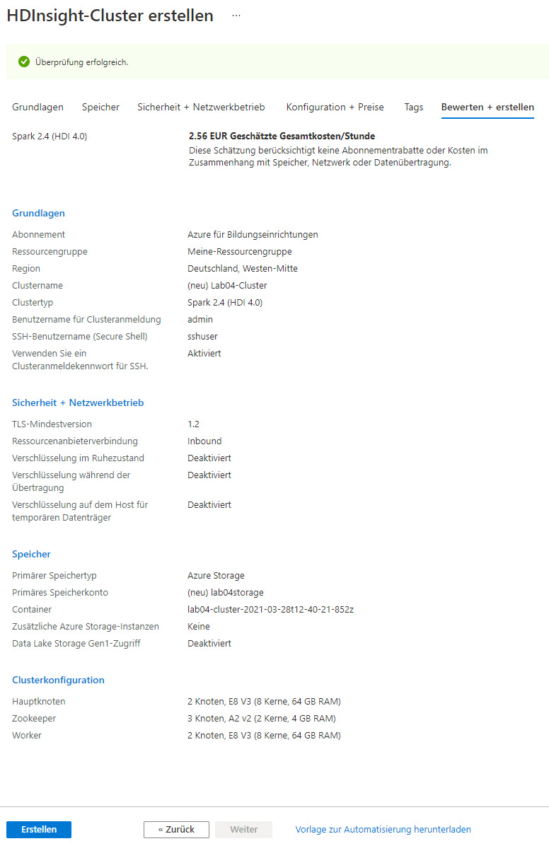

4. Explore the cluster

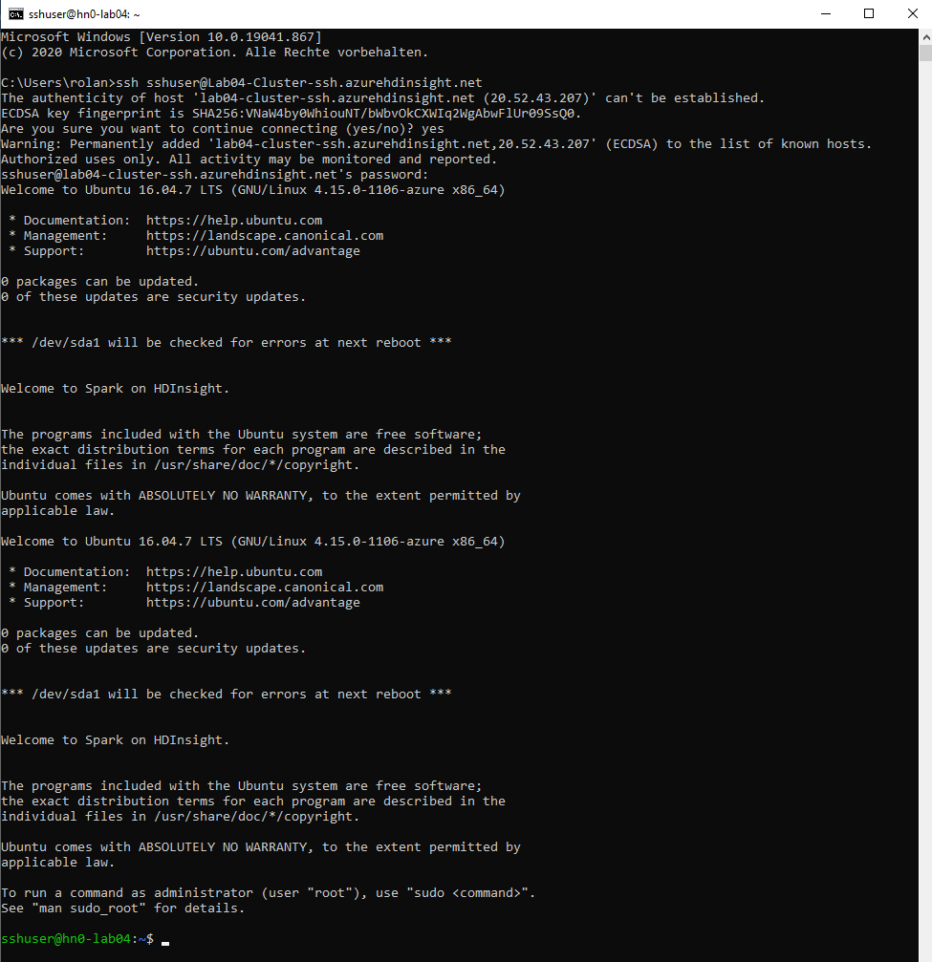

HDFS

1. Login

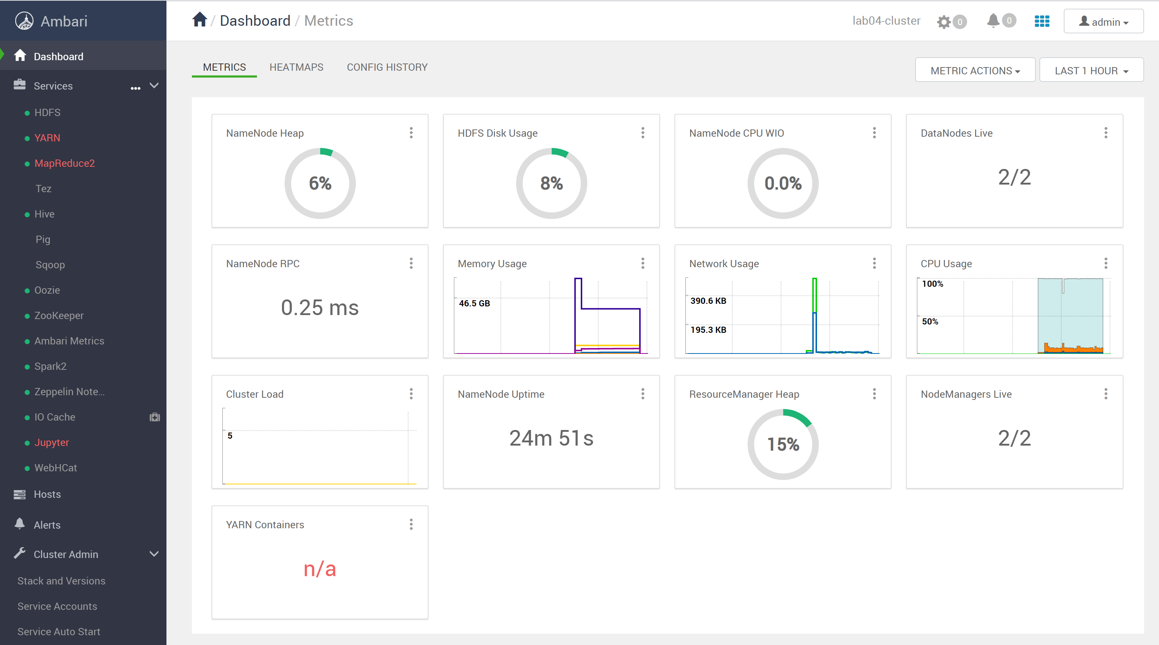

1. Explore

hn0-lab04.5lhzqh2ujh0uxmecbuowphwhib.frax.internal.cloudapp.net

hn1-lab04.5lhzqh2ujh0uxmecbuowphwhib.frax.internal.cloudapp.net

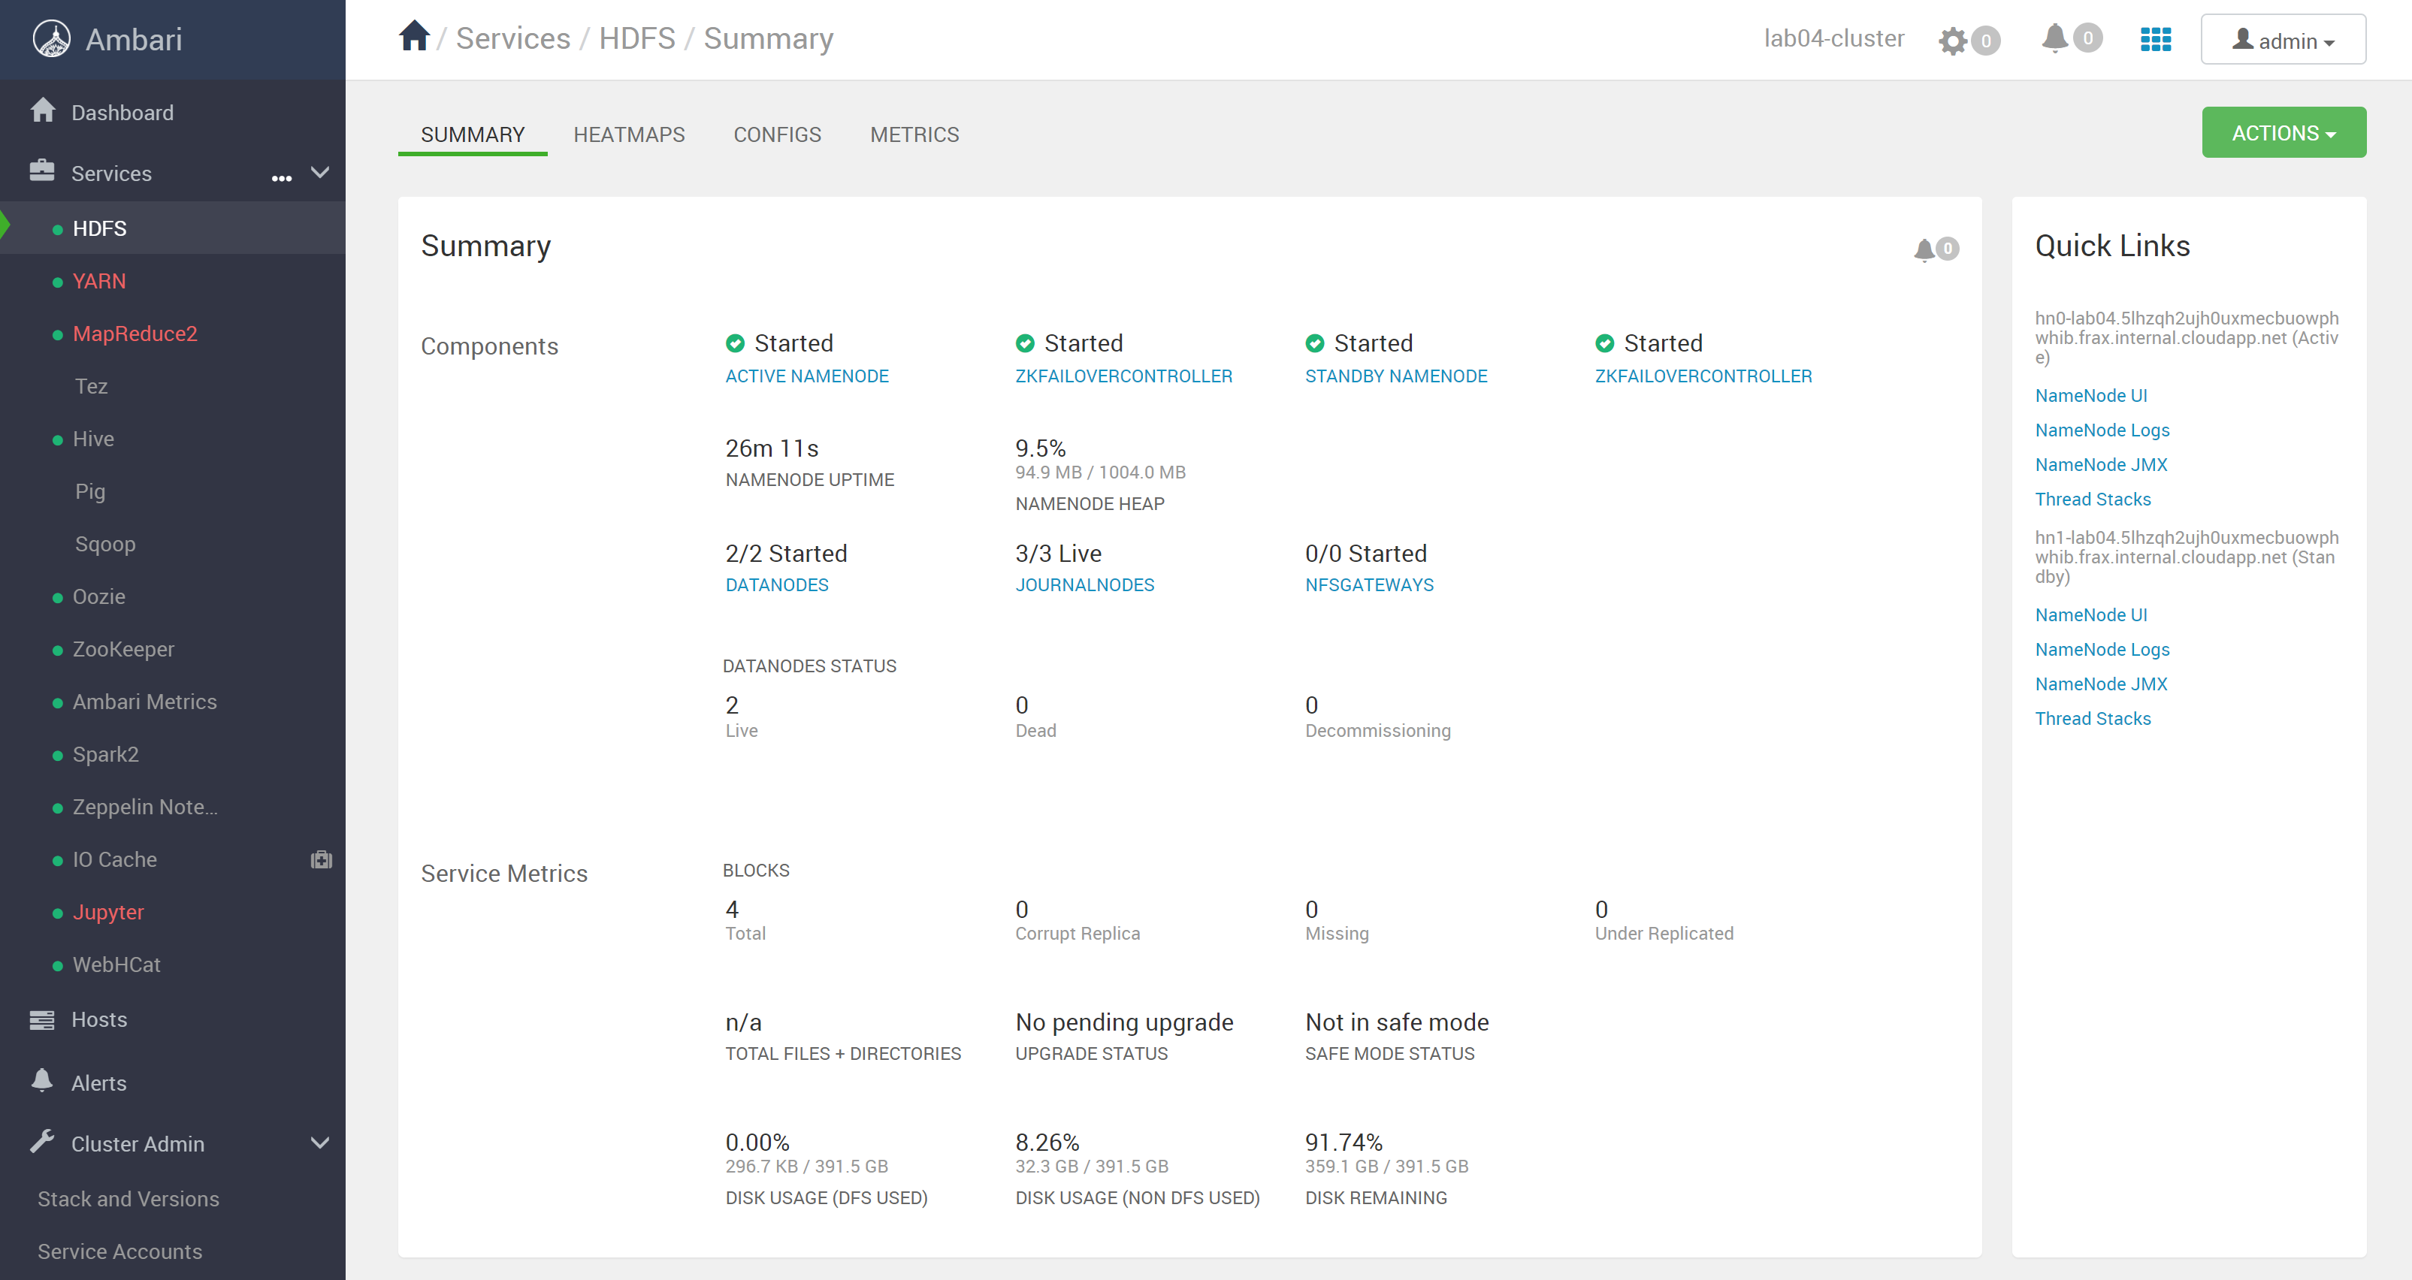

1. Connect

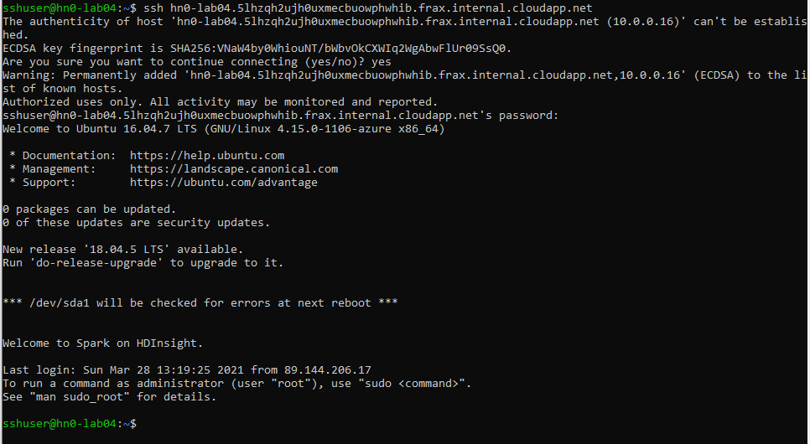

1. HDFS NameNode



1. HDFS MKDIR



1. DOWNLOAD FILES

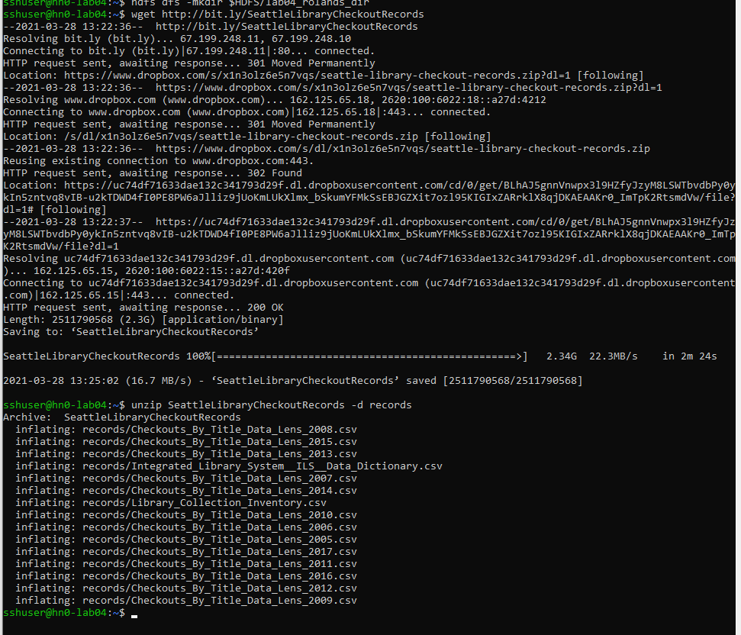

1. HDFS PUT



1. HDFS FSCK
   1. 4
   2. 1
   3. average block size: 115556230 Byte
      1. Block 1: 10.0.0.9:30010,DS-6dc6e701-72c9-4165-b559-f6a51554fcf7
      2. Block 2: 10.0.0.9:30010,DS-6dc6e701-72c9-4165-b559-f6a51554fcf7
      3. Block 3: 10.0.0.6:30010,DS-7f8e2e57-8954-4732-8cb4-58644fb44915
      4. Block 4: 10.0.0.9:30010,DS-6dc6e701-72c9-4165-b559-f6a51554fcf7

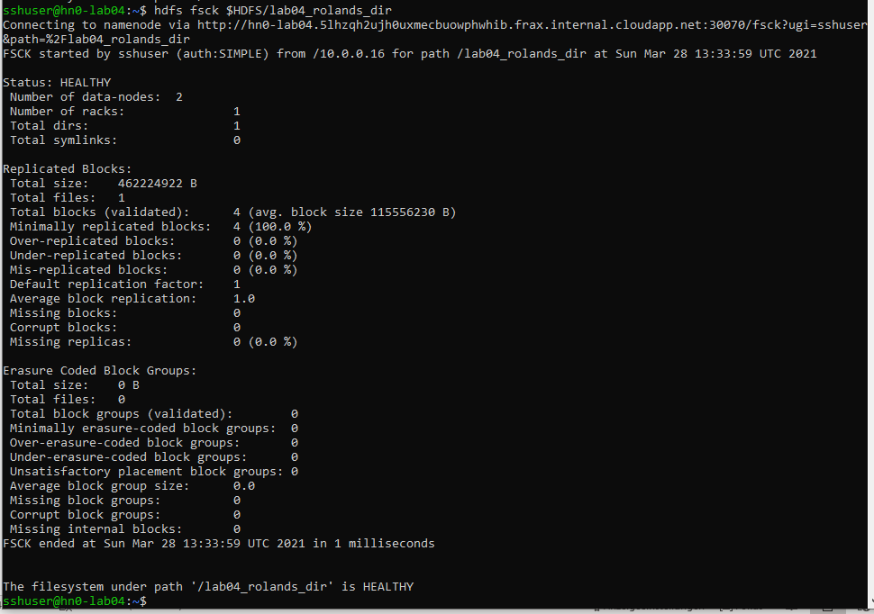

1. PLAY AROUND WITH HDFS