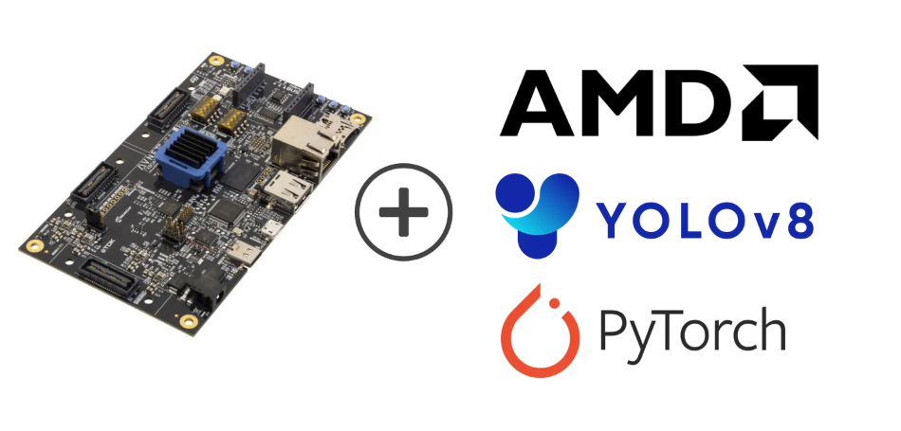
PYNQ-Z2 Embedded graphics
Oliwier Jaworski
PXL hogeschool
Elektronica ICT
oliwier.jaworski@student.pxl.be

ABSTRACT
quick intro explain what this whole thing is about

Keywords: Zuboard-1CG, Petalinux, DPU, AXI-interfaces, embedded linux, onnx, model quantization

Table of Contents
1. INTRODUCTION 3
2. HARDWARE REQUIREMENTS 3
3. HARDWARE SETUP 3
3.1 INSTALLATION PREREQUISITS 3
3.2 VIVADO PROJECT 3
3.2.1 TCL CANT FIND BOARDFILES 3
4. CREATING THE LINUX IMAGE 4
4.1 PACKAGING CUSTOM LINUX 5
5. IMAGE FLASHING 5
REFERENCES 6

1. INTRODUCTION
Intro here!

2. HARDWARE REQUIREMENTS
The list below describes the minimum hardware and software requirements.
- Host machine using a compatible linux distribution(ubuntu 20.04)
- Vivado (2024.1)
- Vitis (2024.1)
- Petalinux (2024.1, codename: nanbield)
- PYNQ-Z2
- Ethernet and USB-C data cable
- SD-card(>8GB)

3. HARDWARE SETUP
In this chapter the user will recreate the Zynq +VDMA block-design using the tcl-script and tcl utility, after which the XSA(Xilinx Support Archive) will then be used for hardware development.

3.1 INSTALLATION PREREQUISITS
- Start by downloading the bdf-files(board definition files) for the PYNQ-Z2. After which copy the folder over to the following directory:
<PATH>Vivado/2024.1/data/xhub/boards/XilinxBoardStore/boards/Xilinx/
- prefix <PATH> will depend on where vivado is installed.
- Download the Digilent vivado ip zip-file from the github release page.
- Inside the folder take note of the path to the “ip” folder:

3.2 VIVADO PROJECT
- Launch the vivado environment.
- On windows open a vivado tcl command window(2024.2)
- On Linux source the vivado settings64.sh script using the following command:
source <PATH-TO-VIVADO-INSTALL>/settings64.sh
- Build the vivado project using the following command:
vivado -mode batch -source script.tcl
- This command will generate the project automatically.
!Note: section 3.2.1 TCL CANT FIND BOARDFILES explains the following; If errors occur during initialization (e.g., Vivado cannot find the correct BDF files), this is likely due to a version mismatch between the Tcl script and your installed board files.
- Open the project inside Vivado and add the
Digilent IP repository.
- This step is required; otherwise, errors will occur when creating the HDL wrapper.
- Finalize the design
- Open the block design in Vivado.
- Create the HDL wrapper.
- Generate the bitstream.
- Export the hardware design including the bitstream.
- Save the XSA-file
- During export, Vivado will generate an .xsa file. Make sure to note the location where this file is saved, as it will be required in later steps.

3.2.1 TCL CANT FIND BOARDFILES
Open the board.xml file located at:
<PATH>Vivado/2024.1/data/xhub/boards/XilinxBoardStore/boards/Xilinx/zub1cg/1.2/board.xml
From this file, note:
- file_version
- vendor
- name
Then, in the Tcl script, locate the “Set project properties” section and update the hardcoded board parameters to match these values.

4. CREATING THE LINUX IMAGE
The following steps outline the process of creating a embedded-linux image for the compatible platform of choice. This image will contain the user generated .xsa hardware logic. It also contains device drivers and interfaces for the user to be able to interact with the hardware.
To complete this process, the user must have access to an SD card and a method to flash the generated image onto it.
!Note: Most troubleshooting tends to occur in this section due to the frequent changes, patches, and updates within the toolchain and ecosystem. If your results do not exactly match what is shown in this guide, it may not necessarily mean the steps were followed incorrectly. However, identifying the issue may require additional investigation and effort. Some of the most common pitfalls are outlined later in this section.
- Source both the petalinux and vivado environment
- Deactivate any environment which may influence linux paths such as conda, python venv, etc...
- Problem might occur if vivado is not sourced
- this environment is only local to that console instance.
- Use the following command to create your petalinux project.
petalinux-create -t project -n my_project --template zynq --silentconfig
- Add the hardware design(XSA) to the project
petalinux-config –get-hw-description=/home/<path>/custom/file.xsa
- Changing OE terminal
This prevents the next step from hanging up on 99% during package building on some systems.
- location:
<petalinux-project>/project-spec/meta-user/conf/petalinuxbsp.conf
- replace the commented out line with:
OE_TERMINAL = "xterm"
- Configuring the kernel
- Command:
petalinux-config -c kernel
The bullet points below outline the paths and features that must be enabled (<*>) or disabled (< >).
- Device Drivers → Graphics support
- <*>Enable Legacy fbdev support for your modesetting driver
- <*>Simple framebuffer driver
- Device Drivers → Graphics support → Frame buffer Devices
- <*>support for frame buffer device drivers
- <*>Provide legacy /dev/fb* device
- Device Drivers → USB support
- <*>USB announce new devices
- < > USB Gadget Support
- Petalinux System Configuration
- Command:
petalinux-config
- Image Packaging Configuration
- Root filesystem type(EXT4 (SD/eMMC/SATA/USB)
- Adding user packages
by adding packages before the linux image is created the user can expand functionality that’s provided with the image.
The Openembedded ecosystem provides the packages the user can import into the linux image, by either using the bitbake recipe or a full layer. For full layers the procedure is not explained in this guide.
the collection of packages can be found in the references section. By going to the “Openembedded layer index” link.
For this project only the following recipes were added:
- xf86-video-fbdev 0.5.0
This package provides a driver for framebuffer devices
- libsdl2 2.32.10
This package is optional
Note: Some packages will cause the petalinux build process to fail. Each package has a “patches” section which will contain possible fixes. Which may or may not fix the issue.
In some cases one version will work while an other will fail. The only way to go about it is through trail and error.

The following steps explain the user how to add a recipe to the petalinux project.
- Visit the “openembedded layer index” webpage”(found in references) or visit one of the reference links which will directly point you to the recipe used in this guide.
- Find a section called “recipe file” and open it. This contains the files and layout which will be used.
- Take note of the “path” string in the tree section which will look something like the following for a “one file recipe”:
path: root/meta/recipes-graphics/libsdl2_2.32.10.bb
- Inside the petalinux project navigate to:
<project>/project-spec/meta-user/
- from the found path only create the path after meta, because we will be staying in the meta-user layer. Which will look as following:
<project>/project-spec/meta-user/recipes-graphics/libsdl2
- inside the libsdl2 folder create the bitbake(.bb) file and copy the content from the served <recipe>.bb into that file.
Note: in a multi-folder recipe make sure to copy all the files and paths. And add the patches with the same method provided.
The following is a directory tree of the added recipes:
project-spec/meta-user/recipes-graphics/
├── libsdl2
│ └── libsdl2_2.32.10.bb
└── xorg-driver
├── xf86-video-fbdev_0.5.0.bb
├── xorg-driver-common.inc
└── xorg-driver-video.inc
Note: The used recipes can be found in the github repository in the following path:
<repo>/petalinux-yocto/linux-images/guide_VDMA_HDMI
- The .bb files provide the name by which the recipe will be included in the petalinux project. By taking note of the filename for example libsdl2_2.32.10.10.bb is found as “libsdl2” by petalinux.
- Include the recipes names in the following file, for petalinux-rootfs to recognise them:
<project>/project-spec/meta-user/conf/user-rootfsconfig
They should be included with a “CONFIG_” prefix as following:
CONFIG_libsdl2
CONFIG_xf86-video-fbdev
- Configuring the root file system
- Command:
petalinux-config -c rootfs
The bullet points below outline the paths and features that must be enabled ([*]) or disabled ([ ]).
- User Packages
- [*]libsdl2
- [*]xf86-video-fbdev
- Image Features
- [*]debug-tweaks
- Petalinux Package Groups → matchbox
- [*] packagegroup-petalinux-matchbox
- Petalinux Package Groups → packagegroup-petalinux-x11
- [*] packagegroup-petalinux-x11
- Petalinux Package Groups → packagegroup-petalinux-qt
- [*] packagegroup-petalinux-qt
- [*] populate_sdk_qt5
- Filesystem Packages → x11 → base → xserver-xorg
- [*] xserver-xorg
- Filesystem Packages → x11 → base → xserver-xf86-config
- [*] xserver-xf86-config
- Filesystem Packages → x11 → base → libs → libmatchbox
- [*] libmatchbox
- Filesystem Packages → x11 → base → libs → xkeyboard-config
- [*] xkeyboard-config
- Filesystem Packages → x11 → matchbox-keyboard
- [*] matchbox-keyboard
- Filesystem Packages → x11 → matchbox-session
- [*] matchbox-session
- Filesystem Packages → x11 → mini-x-session
- [*] mini-x-session
- Filesystem Packages → x11 → pcmanfm
- [*] pcmanfm
- Filesystem Packages → x11 → utils → matchbox-terminal
- [*] matchbox-terminal
- Filesystem Packages → x11 → wm → matchbox-wm
- [*] matchbox-wm
- Filesystem Packages → x11 → xserver-nodm-init
- [*] xserver-nodm-init
- Adding and adjusting device tree entries
The device tree is currently missing the reserved memory for vdma read/write(frame-buffer), usb and vdma kernel driver entries to add these edit the following file located in:
project-spec/meta-user/recipes-bsp/device-tree/files/system-user.dtsi
The used device-tree.bbappend can be found in the github repository under the following prefix:
petalinux-yocto/linux-images/guide_VDMA_HDMI
followed by the path already mentioned earlier.

petalinux-build
- if changes are made which need full rebuild use the following command and then build the project again.
petalinux-build -x mrproper

4.1 PACKAGING CUSTOM LINUX
After the build completes, a new directory is created inside the PetaLinux project at /images/linux/. This directory contains all files required to create the boot image and package the Linux distribution into a .wic file. The resulting .wic file can then be written to the SD card using a tool such as Balena Etcher, or alternatively by manually copying the relevant files to the appropriate SD card partitions.
- Generation of boot image(BOOT.BIN)
- The boot image (BOOT.BIN) typically contains the First Stage Boot Loader (FSBL), which initializes the processing system (DDR, clocks, and I/O) and then loads the Second Stage Boot Loader (U-Boot). U-Boot provides the environment to load and start the Linux kernel.
- Optionally, the boot image can also include the FPGA bitstream to configure the programmable logic. In this tutorial, the bitstream (system.bit) is included.
- The BOOT.BIN file is generated inside the images/linux/ directory, as the command structure and available arguments make this the most convenient working location.
- The following command must be executed from the base directory of the PetaLinux project; otherwise, the files will not be found.
petalinux-package boot --fpga images/linux/system.bit --u-boot images/linux/u-boot.elf --force
- The following command creates a .wic image
petalinux-package wic

Together, these steps form the minimal setup required for booting the custom Linux system from the SD card.

5. IMAGE FLASHING
To flash the image onto the SD card, Balena Etcher was used. Simply select the generated .wic file from /images/linux/, choose the target SD card, and click Flash. Wait for the process to complete before removing the card.
Note: Ensure the boot mode jumper is set to SD rather than JTAG; otherwise, the board will not boot from the SD card.

REFERENCES
- article-name/company, date,person who worked on it
2.0: HARDWARE REQUIREMENTS
- Petalinux install requirements
3.1: HARDWARE DESIGN
- PYNQ-Z2 bdf-files
- Digilent vivado library(IP’s)
- petalinux commands
- master XDC(constraints file:line-180:187)
X.X: LINUX IMAGE
- OpenEmbedded Layer Index
- xf86-video-fbdev 0.5.0
- libsdl2 2.32.10
- don’t use any env that influences the paths such as conda etc…
- starting a x-session script
- pas da ding aan waardoor da soms petalinux-c kernel niet wil opstarten met “xterm” ipv ander
- usb-guide
- used framebuffer driver fbdev
- sdl2 used
- For building linux kernel modules
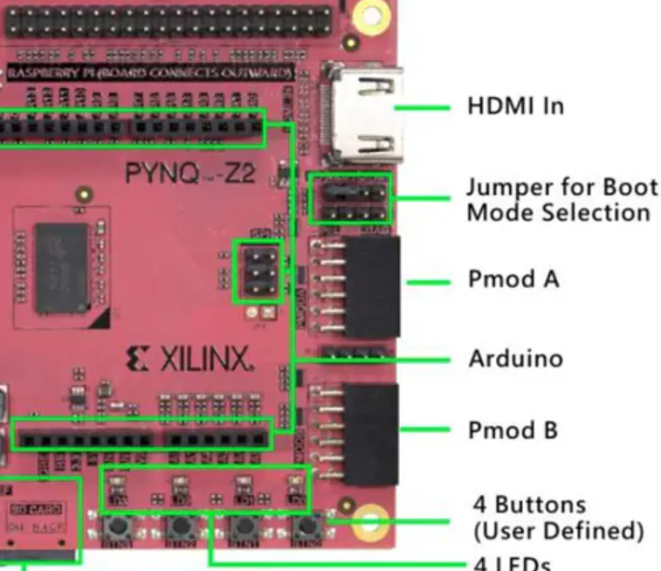
source <sdk>/environment-setup-*
cd <kernel-source>
make ARCH=arm olddefconfig
scripts/config --disable GCC_PLUGINS
make ARCH=arm olddefconfig
make ARCH=arm modules_prepare
make ARCH=arm modules # if Module.symvers missing
export KERNEL_SRC=$(pwd)

