Computer Science NEA 2024  
Life Organiser

short line

Full name: Oliver Wyatt  
School name: St-Martins

# 

# 

**Analysis** **3**

**Project Overview** **3**

**Current Solutions** **3**

**End User And Target Audience** **3**

**Proposed Solution** **3**

**Modelling** **3**

**Research** **3**

**Objectives** **3**

**Design** **4**

**High Level Overview** **4**

**GUI Sketches** **4**

**Pseudocode** **4**

**Modules** **4**

**Technical Solution** **5**

**System Overview** **5**

**Key Code** **5**

**References** **5**

**Complex Programming Techniques** **5**

**Coding Styles** **5**

**Testing** **6**

**Frontend Testing** **6**

**Backend Testing** **6**

**Evaluation** **7**

**Objectives** **7**

**End User And Target Audience** **7**

**Areas For Improvement** **7**

**Conclusion** **7**

**Appendices** **8**

# Analysis

# Project Overview

My project is a life organiser that will have a calendar that is filterable by personal and work, as well as having a relaxation area which the user can access which will have their preferred method of relaxation (for example playing video games) all organised and give suggestions on what to do to relax so the user doesn’t have to spend a lot of time thinking about it. I decided to do this project because of my clients request and that I would be able to use my knowledge of SQL tables and data handling to do this.

# Current Solutions

* Research the various things out there for you
* Compare the similarities and differences
* What makes your project / solution stand out?
* What problem are you solving?

There are some other solutions to this problem such as the website ClickUp which uses a drag and drop system to organise your day and set projects for when they need done. However, my project will give unlimited access without having to pay any money and with no user limit/minimum. My problem that I am solving is a common one which everyone faces in their lives hopefully my filterable calendar and show organiser can give people some stability in their chaotic lives.

# End User And Target Audience

* Can tailor for a target audience but having 1 specific end user makes it 100x easier
* Alternate discord chat, ask and answer questions
* Make it seem like your solution fixes a problem that your end user has and NOT creating a problem that the end user may have

I have asked my main client some questions but my main target end users are people who struggle to organise their daily life and would like something easy and filterable to have a structure of what they will do for that day or week etc.

Q) How would you like your data for the day to be formatted?

A) A table could work for that but equally a diagram that has blocks for each task with length could be nice.

Q) How would you like your calendar to be presented?

A) I would like to be able to have things as work or personal and see what I have for each and or both. Also maybe I could add one of my own category to organise further.

Q) What would you like in your relaxation area?

A) I generally like to relax by watching Tv shows so maybe having my top ones organised and displayed to me to stop me from searching all the different services would be quite nice.

Q) What do you use to organise yourself at the moment?

A) I just use a paper calendar which is ok, but I would like to be able to find things quicker, find specific appointments and the calendar come up a lot quicker.

Q) Any other requests for this system?

A) If I was being really picky being able to be sent notifications on what I have coming up on my day soon would be helpful, but the rest would be good enough.

From this I have found that I will need the calendar to be able to be filtered by work, personal and custom, have the relaxation are be a tv show organiser and recommender and have, as an extra, either be displayed as coloured blocks or have notifications.

# Proposed Solution

* What technologies could you use for your project and why are you using the ones that you are using?
* E.g. Unity vs Unreal engine and gave advantages and disadvantages of both and gave a conclusion as to why I picked Unity

I will be creating the code for this project in python and the data storage in SQL. Python would be good over a language like C because I already know a lot of python and C cannot support OOP. I will be using SQL because it has a installed library in python which allows the code to interact with it well and I can create normalised databases in SQL whereas other systems might not have as much freedom. For the UI I will use FLASK to create a client-server model for my project this would be good because it would allow me to be able to accommodate for multiple users using the project at the same time. While this could equally work as an app a website allows more access from other people that are not the client. However this will remove the possibility of notifications as one of the extra requests from the client so I will try to find an alternative to this in my website.

# Modelling

* Make your models detailed enough to be actually useful for your completed project
* Ask for feedback from your end user (create algorithm without UI and ask user if they liked the songs it recommended)
* Don’t make it identical to your final product, you want to show the marker that you have improved from this the base models

This is a quick menu of how the website will be formatted which I have showed my client and they have come back with a positive response “”.

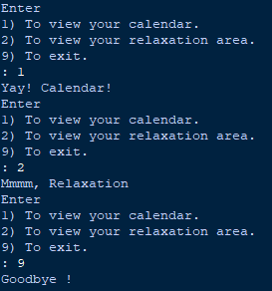

I have also drawn a mock up version of my SQL database as a relationship diagram which will serve also as a prototype for my database going forward.

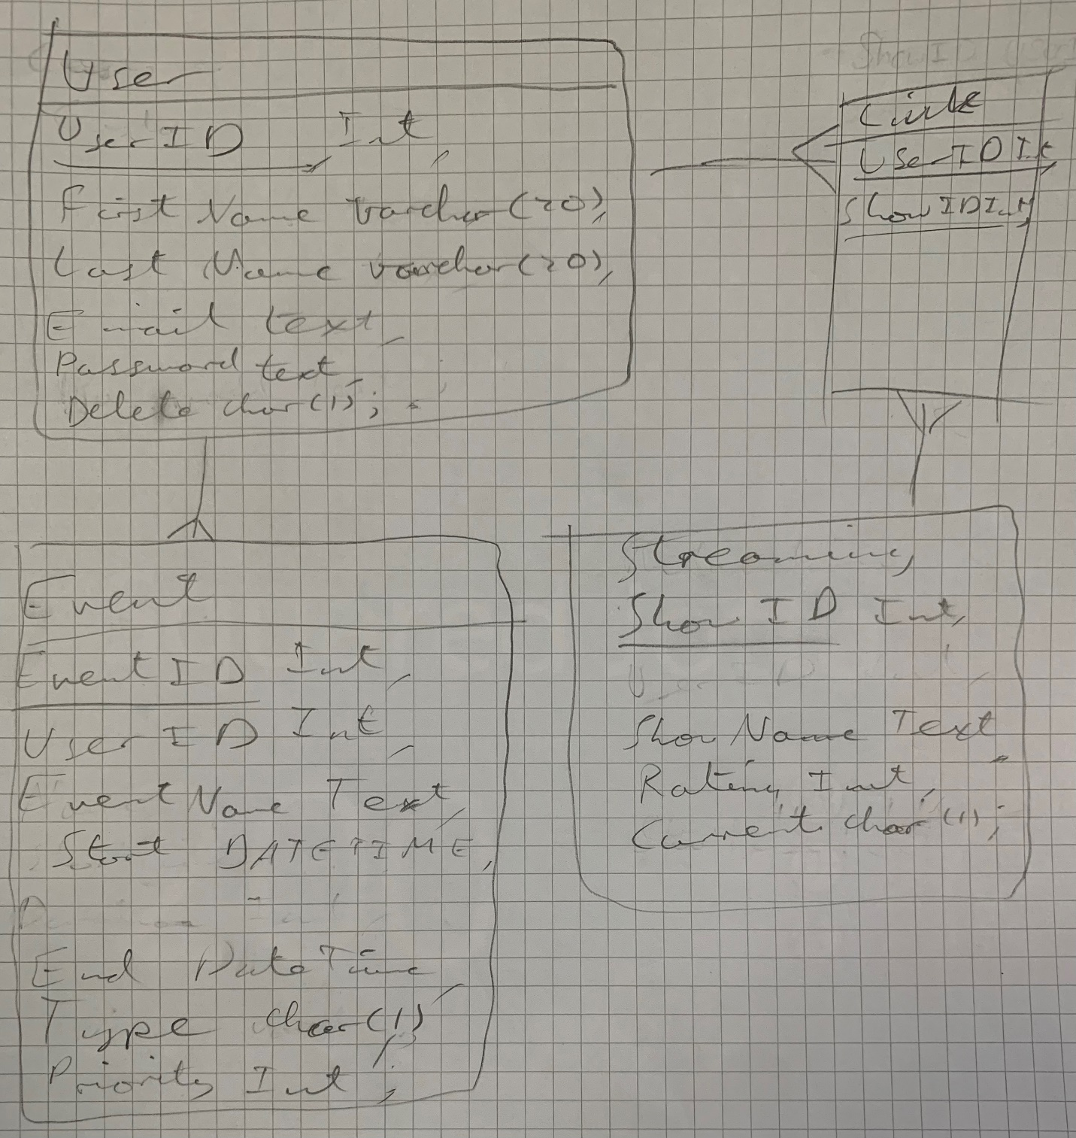

This is a flow chart of what my idea for the project will be while this is still a prototype model a lot of the features that I think I will be including are there. Using lucidchart.

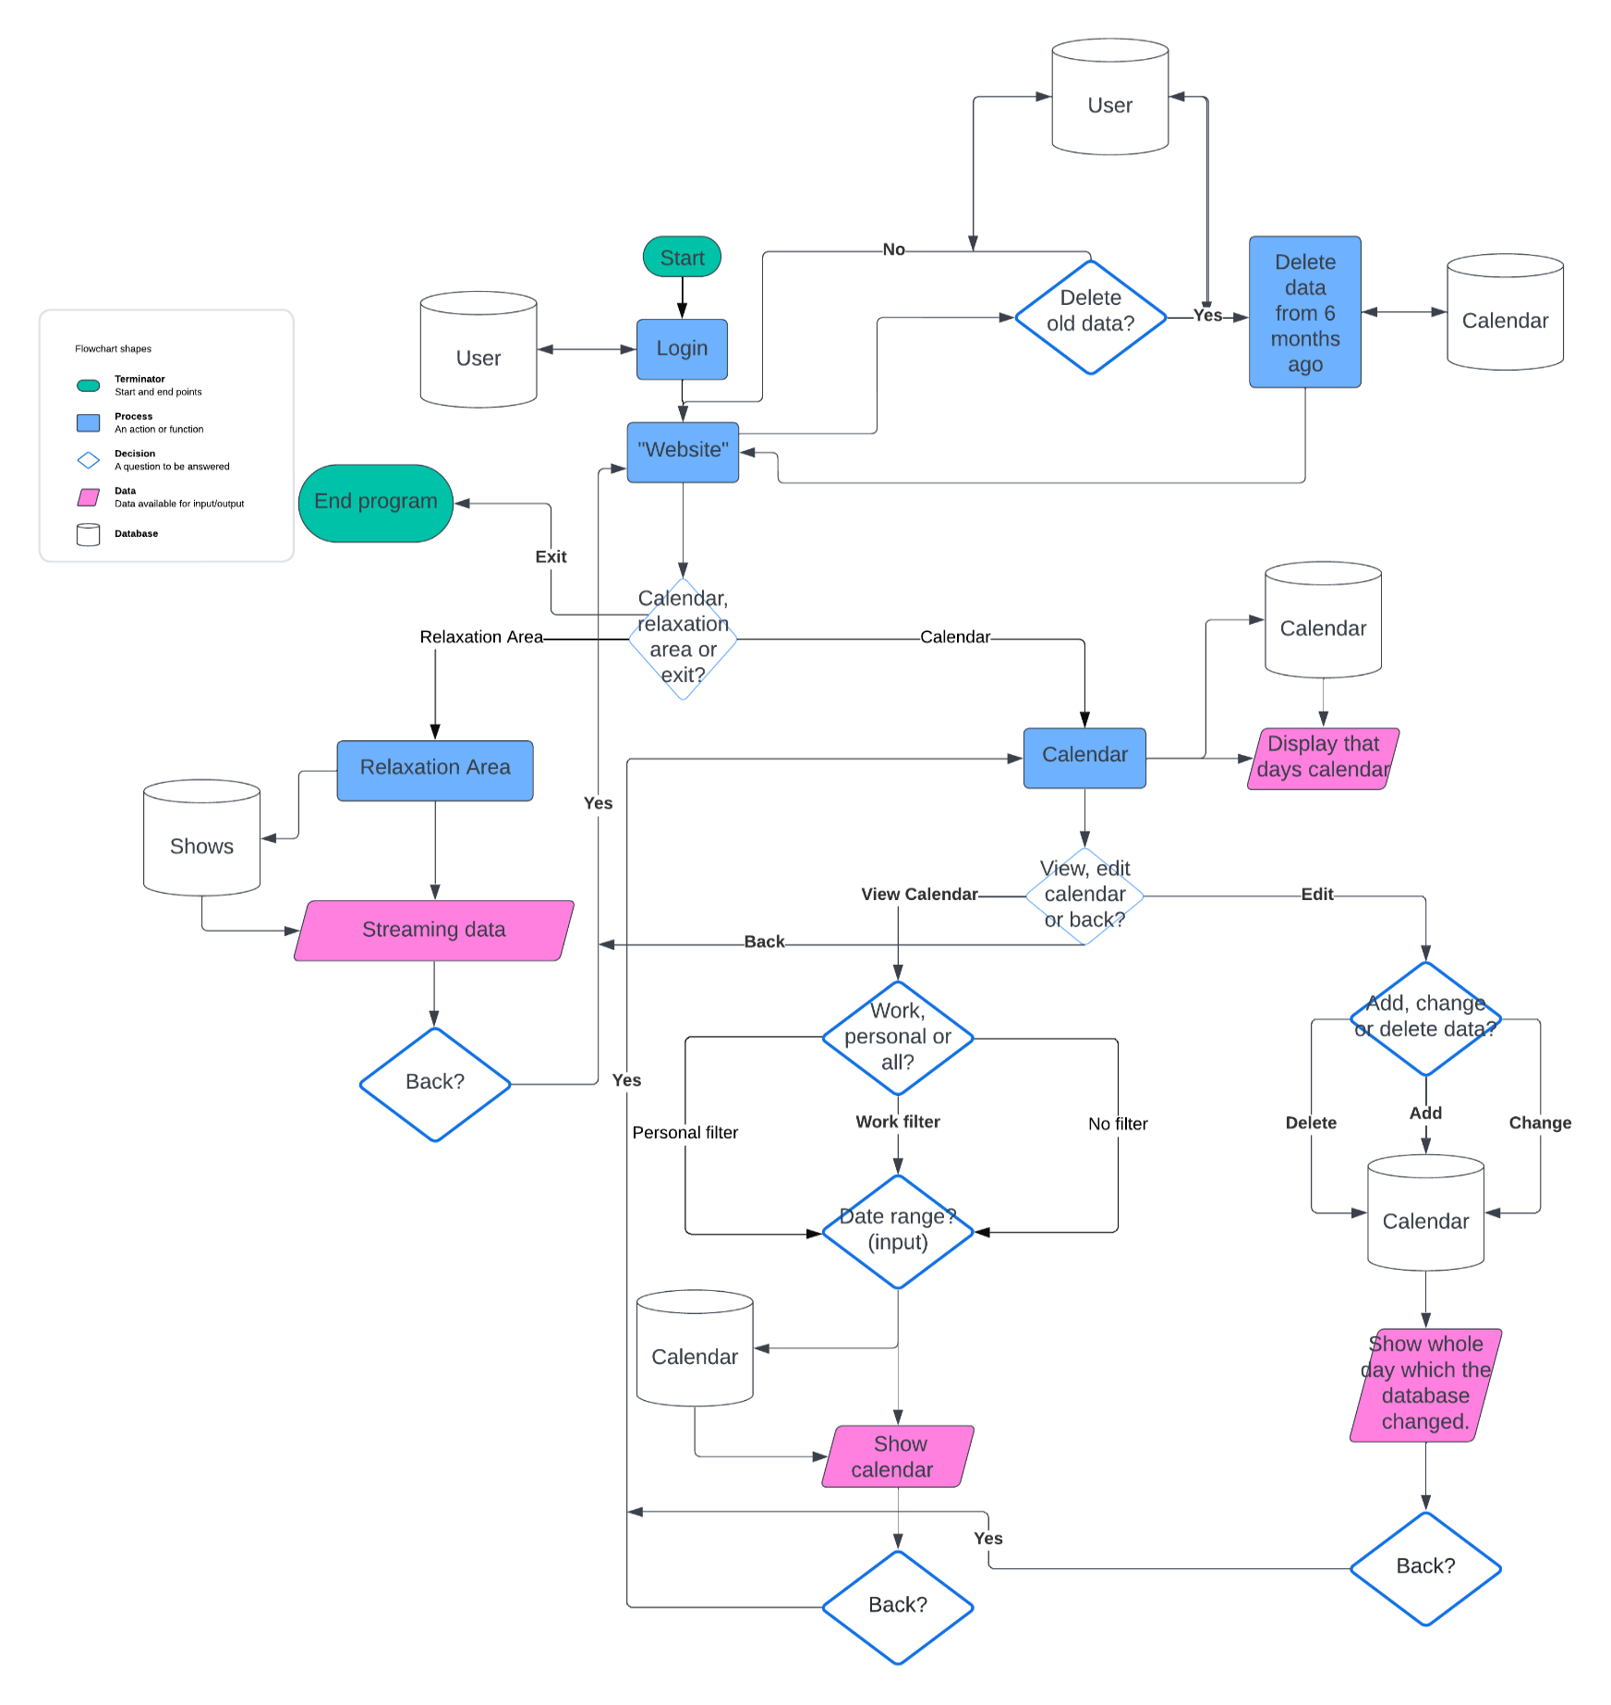

# Research

* Easier to complete the project, find the main “components” that you use and then break them down into how they work
* What things did you use which you did not know beforehand? Explain a bit about them.
* Where you used those different things?
* Compared to libraries section:
  + Mention libraries here but explain that you needed to analyse the metadata of various mp3 files and you could’ve used the tinyTags library or x solution but you chose tinyTags because xyz
  + e.g. tinyTags   
    ieyed3

# Objectives

* “Based on the research I have carried out and the conclusions I have drawn from my player base feedback, I have created a list of objectives that aim to fulfil the necessary requirements of my game.”
* To be very very specific
* For every objective you have -> stretch it as far as possible, leave no room for interpretation
* The more the better

# Design

# High Level Overview

* Flowcharts demonstrating the logic of your project (Lucid chart)
* Hierarchy diagram (Demonstrates the UX - every single thing a user can click on/interact with)

# GUI Sketches

* Doing them by hand is a decent option
* Everything single thing you can see, draw it and label everything e.g. button: pressing it does x and takes you to y

# Pseudocode

* Talk about different operations in your project and map out the logic for it using pseudcode e.g. if you have a login system, write some pseudocode for a very basic login system
* Don’t make it identical to your final piece of code, the examiner wants to see progression

# Libraries

* I used the tinyTags library extra metadata from the files. This is how tinyTags works… (e.g. screenshot code and give examples of functions within the library that you use)

# Technical Solution

# System Overview

* UML diagram
* Classes and functions used as well as the inputs for them

# Key Code

* All of the code used in CPT, just copy and paste here for reference

# References

* Reference things (e.g. youtube videos, stack overflow (major bits), APIs, Github Repos) that you could get caught for plagiarism

# Complex Programming Techniques

* Explain the bits of your code that give you marks (level 3 in the techniques used table on the mark scheme)
* For each thing in the table that you hit, use it as a different subheading

# Coding Styles

* Make sure code you have is appropriately named (people who dont know the programming language can read it and understand it e.g. no Xz or Is)
* Copy and paste code that demonstrates it, briefly explain it if needed
* Online formatter
* Add your own subheadings if you need to

# Testing

* Create table:  
  Test #, Purpose, Test Data, Expected Outcome, Actual Outcome, Timestamp
* Create short videos that demo each thing that you are testing
* In the video, make sure you demonstrate what the purpose of each thing is
* Can also just use screenshots when you need to

# Frontend Testing

# Backend Testing

# Evaluation

# Objectives

* Take your original objects (copy and paste) and then underneath each one write about it e.g. have you reached it and how

# End User And Target Audience

* Create another ss / fake conversation with your end user and show that they enjoyed it and matches up to their expectations

# Areas For Improvement

* What things would you have liked to have added that you didn’t

# Conclusion

* To conclude, my game has met the requirements and objectives I set at the beginning of th development process. Not only has it has a glowing review from my end user, but from the people the game has been shared with as well. “

# Appendices

* All of your code goes here