db.listingsAndReviews.aggregate([
{$match: {
"address.country": "Portugal",
"beds": {$gte: 4},
"price": {$lte: 75}
}}
])

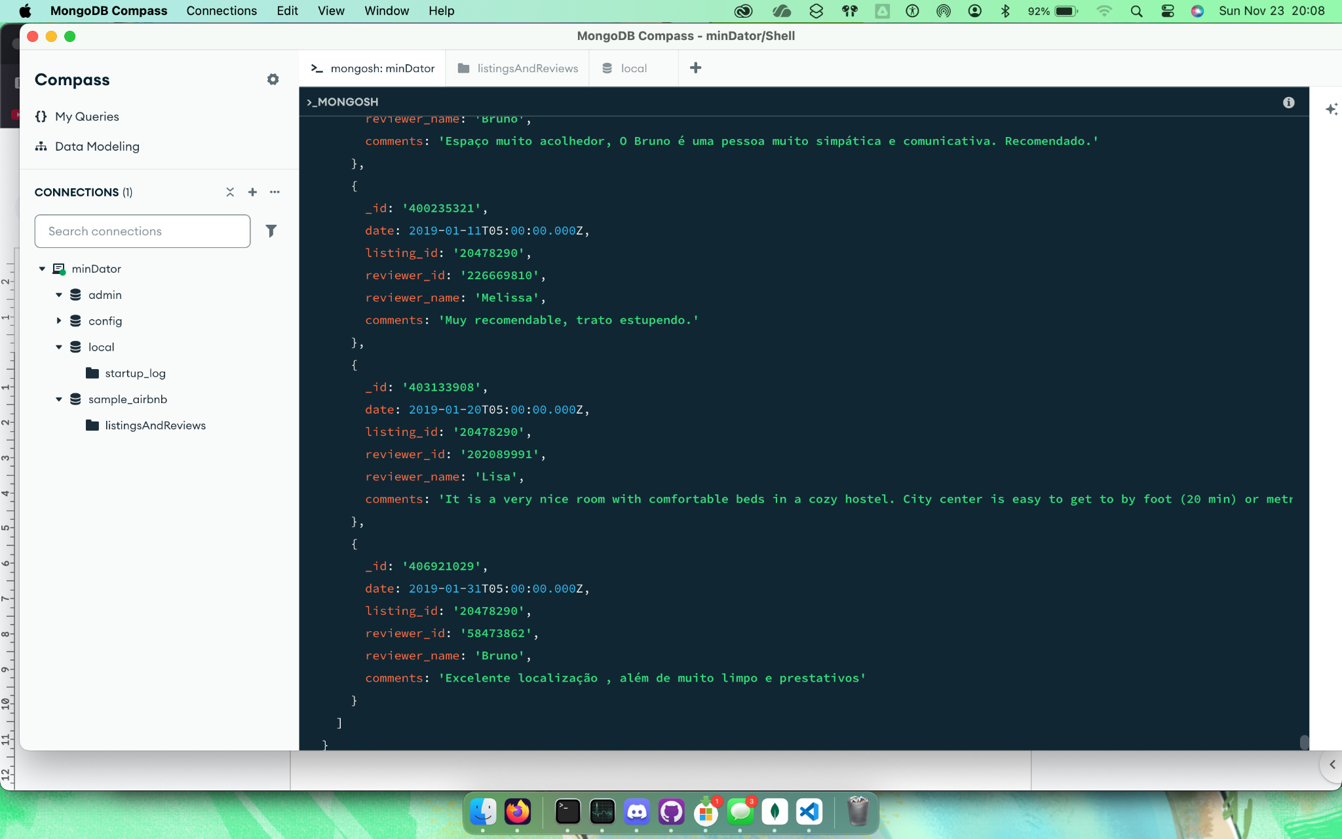

db.listingsAndReviews.aggregate([
{$match:{
"review_scores.review_scores_cleanliness": {$gte: 9}
}},
{$project: {
"name": 1,
"summary": 1,
"address.country": 1,
"price": 1
}},
{$sort: {
"price": 1
}}
])
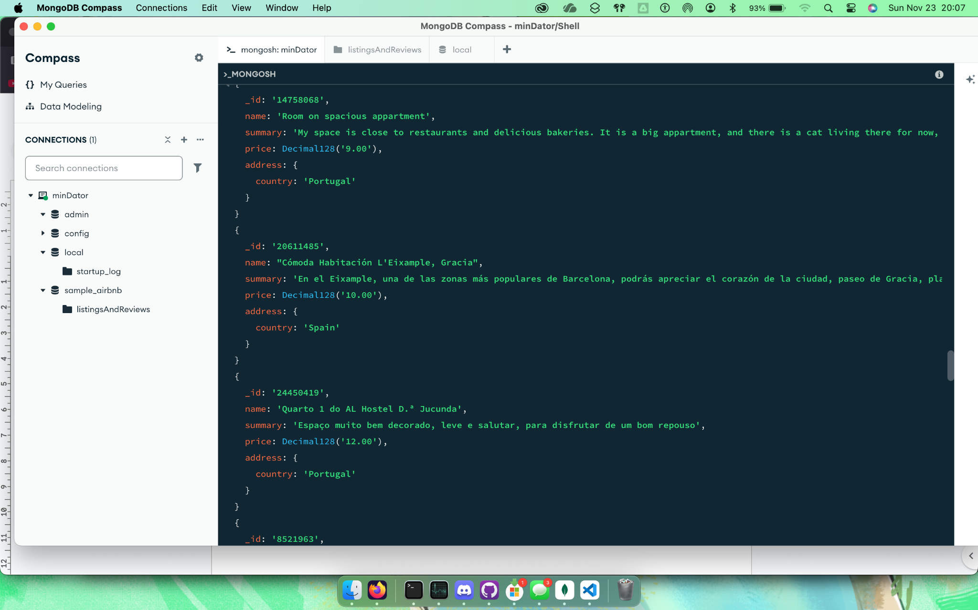

db.listingsAndReviews.updateOne(
{"description": /.* mountain view */},
{$set: {"price": Decimal128('90.00')}}
)
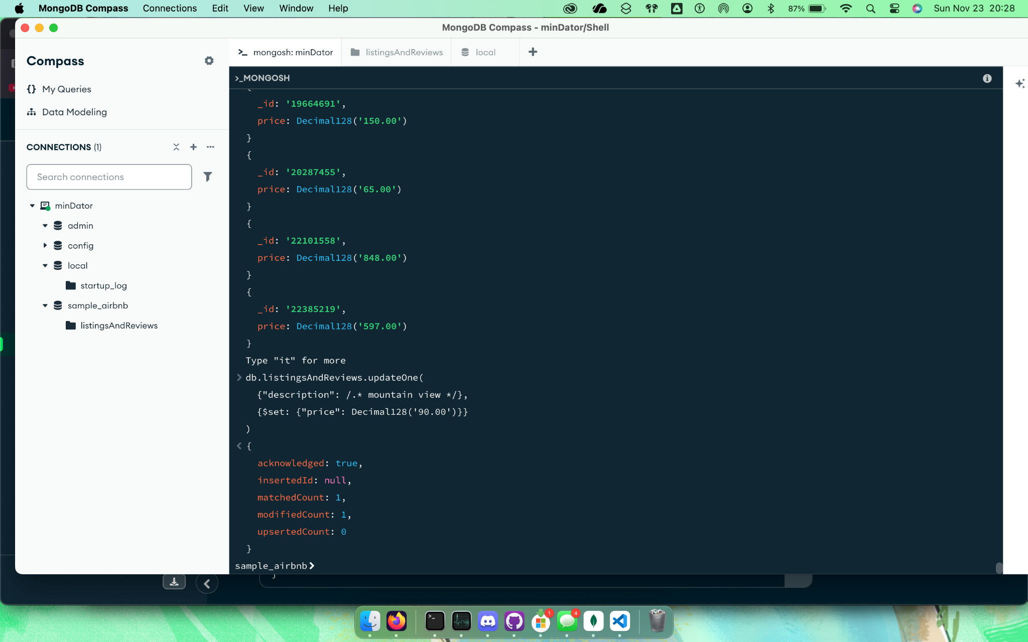

db.listingsAndReviews.updateMany(
{"address.country": "Turkey"},
{$set: {"isactive": false}})

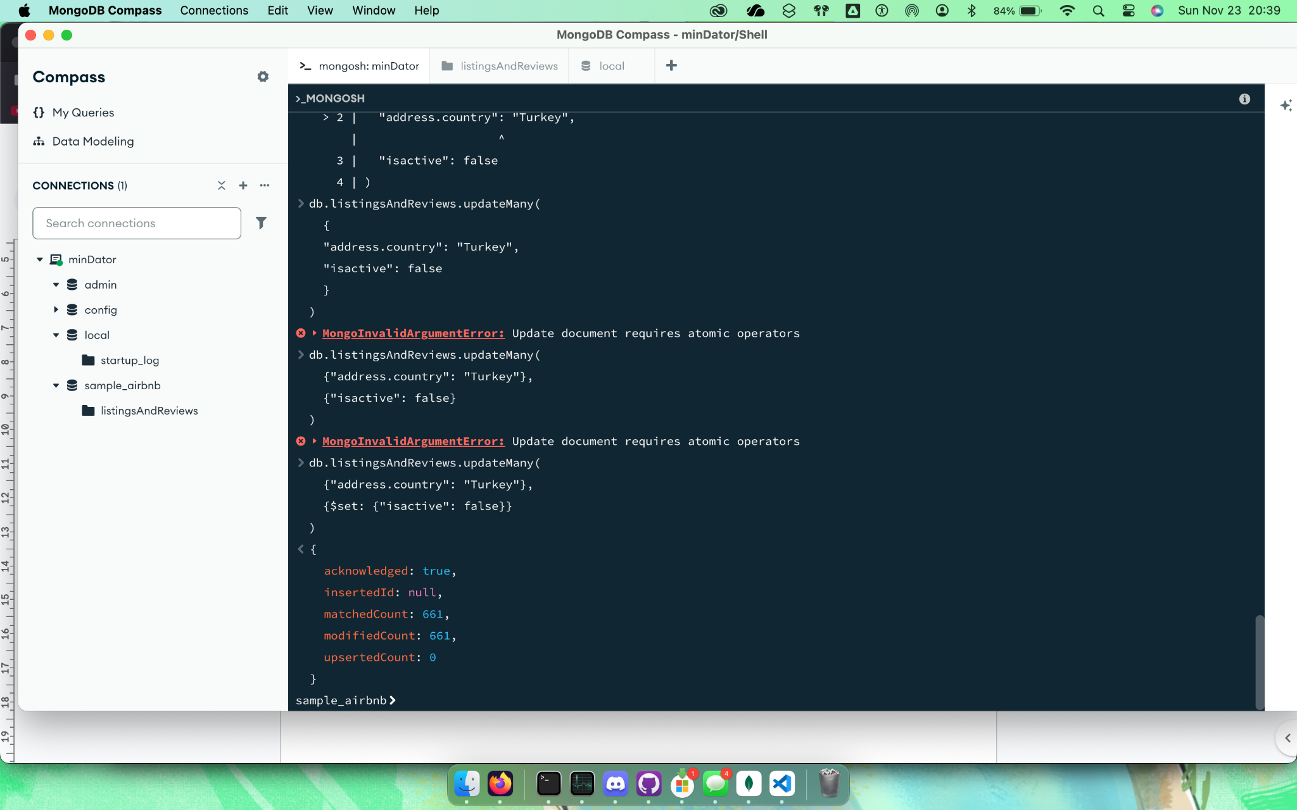

db["listingsAndReviews"].deleteMany({
"review_scores.review_scores_rating": {$lt: 21}
})

