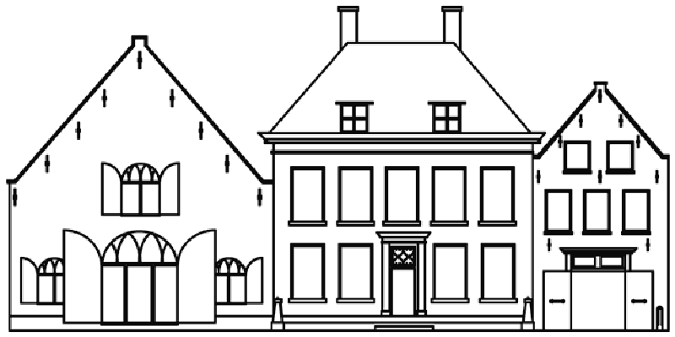

PRESS RELEASE Priveekollektie presents Power Pixels, April 10 – May 7 2011

HEUSDEN AAN DE MAAS – From the 10th of April till the 7th of May 2011 Priveekollektie presents ‘Power Pixels’, a solo exhibition with recent work by Miguel Chevalier (Mexico City, Mexico 1959). This internationally renowned artist is known for his technological yet very esthetic work, such as his ‘Fractal Flowers’. These growing and moving generative flowers form a very dynamic and fascinating subject. During the exhibition his most recent objects and unique installations, made site-specifically for the gallery space, will be presented.

While studying at the École des Beaux Arts in Paris in the late seventies, a decade in which minimalistic art flourished, Miguel Chevalier realized how hard it would be to be inventive and avant-garde as a painter. With the development of computers in the early eighties, Chevalier knew right away that this technology would be of great importance in the future. After requiring programming skills and exploring the possibilities of this ever renewing medium, the result was a very innovative form of art, in which technology plays a major part. Recently Chevalier has shown his work in exhibitions all over the world, such as a greenhouse with projections of fractal flowers on all sides in Rio de Janeiro (Brazil) and a modern take on the nineteenth century art of Odilon Redon and Maurice Denis by projections in Musée Maurice Denis in St-Germaine-en-Laye (France). Also his interactive installation in Lisboa Lisbon (Portugal) was astonishing, as the moving and growing virtual plants reacted on the presence of a visitor.
Chevalier explains how his art is related to the present-time: ‘We live in a world in which almost everything surrounding us is artificial: there is artificial light everywhere and we cultivate vegetables in greenhouses for example. Even nature is not free from culture.’ This vision of contemporary society is shown in his art, created by a medium that represents this artificiality like no other: the computer. Chevalier dictates his criteria to the computer, making use of software by Cyrille Henry: ‘For example I decide that a flower can have between a hundred and a thousand leaves and is allowed to grow a maximum length of three meters. The computer then randomly creates a plant within my boundaries. This way the outcome is always unique and surprising, even to me. Creating a virtual life is very exciting.’
On the other hand the practice of the artist shows a tendency to focus on nature (before interference of humanity), as Chevalier studies the natural growth of plants like a botanist. This is also shown in his ‘Herbarius 2059’, a highly innovative Generative Virtual Reality creation with growing fractal flowers and corresponding generative texts by author Jean-Pierre Balpe. The flowers in this book look different from flowers in nature, but behave in a similar way, sprouting from a seed, growing, blossoming, dying and leaving seed from which a new flower originates. Although the names of the flowers sound like scientific plant names, Chevalier also likes to honor influential persons from history: ‘I like to give the flowers names that refer to writers, poets or mathematicians. For example I created a ‘Fleur du mal’, suitable with its nature, after the book by the famous French writer Baudelaire.’ Also the texts are very similar to the content of a traditional herbarius, as they tell the reader about the appearance and capacity of the plant, such as medicinal abilities. Striking however is that these texts are also generated by the computer, resulting in a unique combination of text and plant each time.
During ‘Power Pixels’ Priveekollektie will present several objects and installations by Chevalier, such as a tapestry, a light object, prints and stereolithography sculptures of fractal flowers, the ‘Pixels Infini’ mirror with infinite depth and on top of all a unique, site-specific virtual garden.
We will be pleased to welcome you during the opening of the exhibition on April 10. Please RSVP to rsvp@priveekollektie.com.
KunstKoop regeling van toepassing.

Priveekollektie Contemporary Art | Design
Pelsestraat 13-15 (from April onwards) | 5256 AT Heusden The Netherlands
T: + 31 (0) 416 663234 | www.priveekollektie.com
Opening times Wed – Sun 13.00 – 17.00 and by appointment
For more information or images please contact janneke@priveekollektie.com
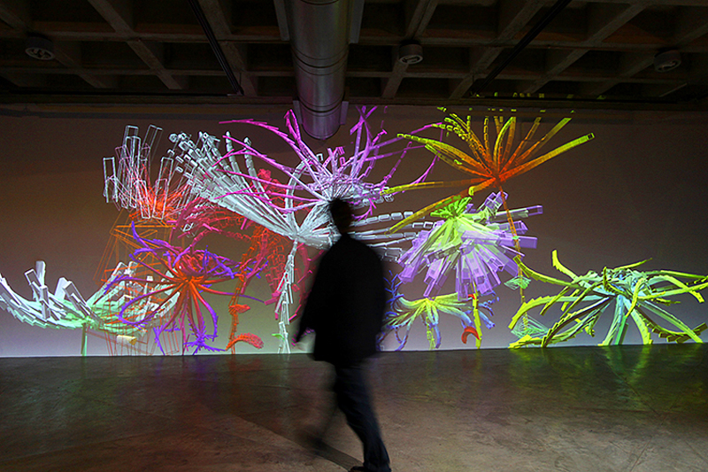
Miguel Chevalier, Fractal Flowers (installation)
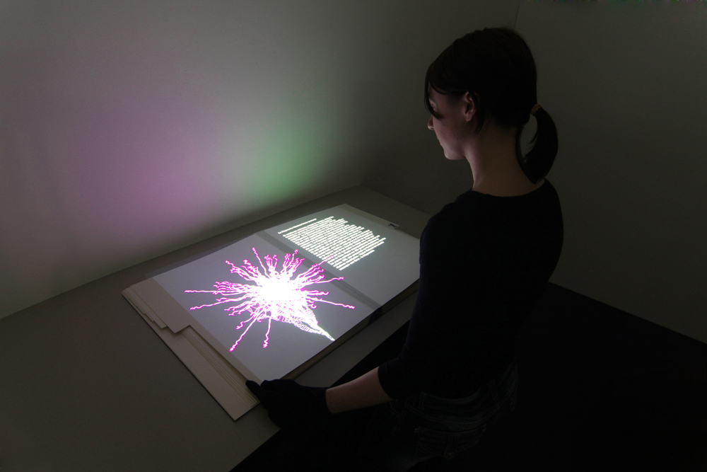Miguel Chevalier, Herbarius 2059

Herbarius 2059
Miguel Chevalier
and Jean-Pierre Balpe (Ecrivain)
Software Cyrille Henry

Herbarius 2059 is new GVR* creation of artist Miguel Chevalier, in collaboration with author Jean-Pierre Balpe, exposed for the first time on the occasion of the Salon International du Livre Ancien 2009 with the Librairie Serge Plantureux in june 2009.

This project is the virtual incarnation of an herbal, whose long tradition dates back to ancient Greece.** Herbarius 2059 retains the form of the codex but mixes the real with the virtual, using projection to present texts in french and images that are generated in real time: growing fractal flowers and corresponding generative texts are projected side by side onto the twelve-leaved album. Each flower’s seed corresponds to a zodiac sign. Drawing his inspiration from the historical Herbarius, Miguel has created a new herbal composed of “Fractal Flowers”, virtual and autonomous seeds that germinate randomly, grow, bloom and die, creating a new seed that will evolve in turn. This vegetal world, peopled by mineral-like flowers, is intriguing also for its reminder of the geological world of crystals. Facing each flower is its imaginary description proposed by Jean-Pierre Balpe’s automatic writing generator drawing on scientific texts dating from the 14th century to modern times. Here, fiction is omnipresent; the resulting descriptive texts are infinitely renewed for each reader. The prototype of the Herbarius 2059 is a hymn to hybridization and for us opens a door to timeless imagination.

Its roots link the Herbarius 2059 to tradition, but the technology that it uses reveals its nature as being radically modern. Herbarius 2059 points us towards what could be a twenty-first century bibliophily.

* Generative Virtual Reality. The program used by Miguel Chevalier was developed by Cyrille Henry.
** The Herbarius is an illustrated herbal of Greek origin, inspired by the 1st century A.D. medical text De materia medica by Dioscorides and composed in Latin in the 4th century by an author known as pseudo-Apuleius Platonicus.
This herbal explains the curative properties and virtues of 131 plants and how to use them. It was widely circulated in Europe and the Near East, where it was translated, copied and recopied by generations of scribes until 1481 when the first printed version was introduced.

