Meeting - 14/07/25

* 1. Coal Gasification and Methane Process
     1. Investigate why the region is rich in resources
     2. Validate if unknown minerals in the coal mine accelerate methane production
     3. Previous tests done but not robust; need to find suitable research partner for validation
     4. Plan to build a site in HK to commercialize fabrication/test equipment
     5. Paperwork to be shared and translated
  2. PASS
     1. Background
        1. Value-added manufacturing process due to high land cost in HK
        2. Micro-factories as a key characteristic of HK manufacturing
        3. Find HK manufacturing characteristics and provide relevant training
        4. Include Digital Twins, AI, ESG (carbon emission/footprint), CBAM for adaption
        5. Training needed on monitoring and standards like ISO 14064 and Eco-design
     2. Deadline End of July
        1. Agree/Draft proposal and budget
        2. Consider hiring someone for training
        3. Define class size, accommodation and budget
     3. Previous proposal rejected for being too long
     4. Need a new proposal targeting employees/frontline and higher-level staff
     5. Another meeting required to define scope and skillset
     6. Identify right people for training
  3. GSP Event
     1. Deadline 28th July
     2. Need communication plan, air tickets, hotel, attendance management
     3. Expected attendance: 300 onsite + 400 registrations
     4. Focus on main event
     5. University departments to contact: Energy, Chemistry and Hydrogen Research
     6. Free attendance program
     7. Key visual and key notes handled by event management
     8. Three technical seminars planned - but speakers not finalised
     9. Approaching speakers from China Hydrogen Company
  4. ITSP Proposal
     1. Submitted February - Deadline ??
     2. Review proposal and work plan
     3. Design of microfluidic chip in progress
     4. Focus on material, device design, CAD and simulation
     5. Proposal theme: Bridging bulk and microfluidic chips
     6. Stackable chip design, Tangential Flow Filtration, Harringbone/Y design to be validated
     7. Gasket issues and flexibility problem notes (Yang Mengsu = professor + collaborator)
     8. Need to improve volume adjustment flexibility
  5. CRD Hydrogen Tank Project
     1. Client project: Type 4 hydrogen tank for drone applications
     2. External R&D partner searched; clients wants own design contribution
        1. External partner provides tank and lists design difficulties (regulator, internal structure and pocket)
     3. Design/manufacture/testing phase planned
     4. Prototype expected in six months
     5. Design proposal needed
        1. O-ring tightening process and dimensions to be defined
        2. Standards involved: GB/T, HK + Mainland ISO (China standard)
     6. Manufacturing method: bowl molding liner, carbon composite wet winding, aluminum CNC, 3rd part valve bought
     7. Research Type 4 and 5 Hydrogen tanks
     8. China Visa/Visit planned for 5th August
  6. L&H Mcirofluidic Collaboration
     1. Select most profitable technology
     2. Test applicability to other proposals

* 1. 3D Printing Proposal (Future Project)
     1. Binder Jet machine for own formulation use
     2. Develop binder formulation for BJAM sand printing
     3. Parameters for printing need to be defined
     4. Half-year report due by December
     5. Manufacturing Difficulties
        1. Cryogenic and expansion technology notes as low uptake due to manufacturing challenges
        2. Desing of removable layup core
     6. Techniques: Winding, dissolvable core, balloon popping.
  2. K Meeting (After)
     1. Reviewed hydrogen tank design flaws
     2. Presented literature on JSEM + TEM/SEM techniques for atom cluster analysis
     3. Identified potential university research partners with SEM/JSEM expertise

Meeting - 27/07/25

GSP

* After sending universities, get 5 people
* Suggestion

Microfluidic

* Create better design

27/07/25 - Training Program

* To train the manufacturing engineers (supervisors)
* What manufacturing?
* No charter(ed) scheme for Manufacturing … Raymon head of IE
  + What is the knowledge a manufacturing engineer needs to know
  + What current chartered programmes around the world are there
* Method
  + Relatively generic overview … first
  + 1st: example technology, chartered/training program available around the world
    - Has to fit into the chosen sectors; Medical manufacturing, Chinese medicine, and communication …., Waste management and __??__
  + 2nd: Write the proposal
* End of this week == High level proposal
  + Needs lots of background search of what is currently available
  + Make sure to look at guide_e_May 2024 to ensure you cover everything and look at their website to see which project is successful to copy them (e.g. Hydrogen project)
* End of this month == Internal deadline --> 21st July give to GM
  + Filled proposal, budget, extra stuff

Meeting - 11/07/25

* + 14th July (Mon), 2-4pm, leave 1pm, HKU - Read document
    - Client = HK +?
    - What would you like our role to be in the meeting
    - Dress code fine

Meeting - 15/07/25

**Health and Teach (THURSDAY // NEED BY 4PM 15TH)**

* Latest development train & different initiatives
* Medical robots/drugs/pharma/digital
* What is relevant to HK and what academic background is needed
* What are can be further developed and *how can this improve global community health?*
* 5 mins
* Template
* FRIDAY TRAINING COURSE

**Microfluidics (LATE JULY/EARLY AUGUST? // MONDAY 21ST)**

* Ocean economy
* NID teaching presentation = layman terms
  + How the microscale changes physics
  + Application
  + R&D
  + Industrialisation
  + (N)LP
  + PCR, mRNA, diagnostic
  + Chemical/cellular sensing
  + Digital PCR
* 10-20 minutes, 20 slides

**Microfluidic Progress Report**

PASS Overview

**14/07/25 - PASS**

1. Background
   1. Value-added manufacturing process due to high land cost in HK
   2. Micro-factories as a key characteristic of HK manufacturing
   3. Find HK manufacturing characteristics and provide relevant training
   4. Include Digital Twins, AI, ESG (carbon emission/footprint), CBAM for adaption
   5. Training needed on monitoring and standards like ISO 14064 and Eco-design
2. Deadline End of July
   1. Agree/Draft proposal and budget
   2. Consider hiring someone for training
   3. Define class size, accommodation and budget
3. Previous proposal rejected for being too long
4. Need a new proposal targeting employees/frontline and higher-level staff
5. Another meeting required to define scope and skillset
6. Identify right people for training

*Scope = ??*

**27/07/25 - Training Program**

* To train the manufacturing engineers (supervisors)
* What manufacturing?
* No charter(ed) scheme for Manufacturing … Raymon head of IE
  + What is the knowledge a manufacturing engineer needs to know
  + What current chartered programmes around the world are there
* Method
  + Relatively generic overview … first
  + 1st: example technology, chartered/training program available around the world
    - Has to fit into the chosen sectors; Medical manufacturing, Chinese medicine, and communication …., Waste management and __??__
  + 2nd: Write the proposal
* End of this week == High level proposal
  + Needs lots of background search of what is currently available
  + Make sure to look at guide_e_May 2024 to ensure you cover everything and look at their website to see which project is successful to copy them (e.g. Hydrogen project)
* End of this month == Internal deadline --> 21st July give to GM
  + Filled proposal, budget, extra stuff

PASS Links

|  |  |  |  |
| --- | --- | --- | --- |
| HKPC | NPF + NID Introduction | <https://www.hkpc.org/en/about-us/media-centre/press-releases/2024/hkpc-welcomes-conclusion-of-two-sessions> |  |
| McKinsey & Compnay | Manufacturing & Supply Chain | <https://www.mckinsey.com/capabilities/operations/how-we-help-clients/manufacturing-supply-chain> |  |
| BCG | Manufacturing | <https://www.bcg.com/capabilities/manufacturing/overview> |  |
| BCG | Industry 4.0 | <https://www.bcg.com/capabilities/manufacturing/industry-4.0> |  |
| Bain & Company | Manufacturing | <https://www.bain.com/consulting-services/operations/manufacturing/> |  |
| Bain & Company | Building the Factory of the Future | <https://www.bain.com/insights/topics/factory-of-the-future/> |  |
| Bain & Company | Machinery & Equipment Report 2025 | <https://www.bain.com/insights/topics/global-machinery-equipment-report/> |  |
| Pwc & Invest HK | Crafting Tomorrow: A Fresh Look at Advanced Manufacturing in Hong Kong (pdf) | <https://www.investhk.gov.hk/media/tsrmudkm/crafting-tomorrow-a-fresh-look-at-advanced-manufacturing-in-hong-kong_en.pdf> |  |
|  | HK Standard Industrial Classification Version 2.0 | <https://www.censtatd.gov.hk/en/index_hsic2_code.html?keyword=&code=&exactCode=C&page=&innerSearch=&language=> |  |
|  | HK Industry Profiles - Manufacturing | <https://research.hktdc.com/en/data-and-profiles/hk-industry-profiles/manufacturing> |  |
| HKPC | HK Manufacturing Industries Development Study Report | <https://www.hkpc.org/sites/default/files/2024-10/hong_kong_manufacturing_industry_development_study_research_results_presentation_en.pdf> |  |
| Forbes | Why is the Manufacturing Industry Hesitant to Adopt New Technologies | <https://www.forbes.com/councils/forbestechcouncil/2023/11/09/why-is-the-manufacturing-industry-hesitant-to-adopt-new-technology/> |  |
| HKPC | New Productive Forces, Ifnite New Momentum in HK Manufacturing | <https://www.hkpc.org/sites/default/files/2025-02/hong_kong_manufacturing_industry_development_study_report_en.pdf> |  |
| HKPC | New Industrialisation Unveils … Info | <https://www.hkpc.org/en/about-us/media-centre/press-releases/2024/hong-kong-manufacturing-industries-development-study-report> |  |

ITSP

Intro

ML for Computational Fluid Dynamics

* Accelerate direct numerical simulation
* Accelerate approximate models for turbulence modelling (LES & RANS)
* Accelerate reduced-order models

Links

|  |  |  |
| --- | --- | --- |
| Phd "Modelling and simulation of microfluidic chips for analytical applications" |  | file:///C:/Users/oliverharper/Downloads/Tesis.pdf |
| Medium - Computational Fluid Dynamics using Python: Modelling Laminar Flow |  | <https://medium.com/data-science/computational-fluid-dynamics-using-python-modeling-laminar-flow-272dad1ebec> |
| Tangential Flow Filtration |  | <https://www.sciencedirect.com/science/article/abs/pii/S0003267023003811> |
|  |  |  |
| Cool mRNA Graphics |  | <https://en.vectorbuilder.com/products-services/service/IVT-RNA/LNP-encapsulation.html?utm_term=lipid%20nanoparticles&utm_campaign=Products+and+Services&utm_source=adwords&utm_medium=ppc&hsa_acc=7010094439&hsa_cam=21534035730&hsa_grp=166608587938&hsa_ad=708018509484&hsa_src=g&hsa_tgt=kwd-468390805617&hsa_kw=lipid%20nanoparticles&hsa_mt=b&hsa_net=adwords&hsa_ver=3&gad_source=1&gad_campaignid=21534035730&gclid=EAIaIQobChMIxumS1urAjgMVPG0PAh35iDZNEAAYAiAAEgJhYfD_BwE> |
| mRNA & LNP formulations |  | <https://formu-tech.com/?gad_source=1&gad_campaignid=21477567784&gclid=EAIaIQobChMIkO-WjvPAjgMVfdQWBR1eAgaNEAMYAiAAEgLJQPD_BwE> |
| COMSOL mRNA Vaccine simulation |  | <https://www.comsol.com/blogs/using-simulation-to-guide-mrna-vaccine-production> |
| Mass Production system for RNA-loaded lipid nanoparticles using piling up microfluidic devices |  | <https://www.sciencedirect.com/science/article/pii/S2352940723000240> |
| Inside Therapeutics - Microfluidic synthesis of lipid nanoparticles |  | <https://insidetx.com/review/microfluidic-synthesis-of-lipid-nanoparticles/> |
| Cool electronic microfluidics |  | <https://www.analog.com/en/solutions/healthcare/in-vitro-diagnostics/point-of-care-poc-diagnostics.html> |
| Pyhton Plotly |  | <https://plotly.com/python/sankey-diagram/> |
| Medium - Vision Transformers vs Convolutional Neural Networks |  | <https://medium.com/@faheemrustamy/vision-transformers-vs-convolutional-neural-networks-5fe8f9e18efc> |

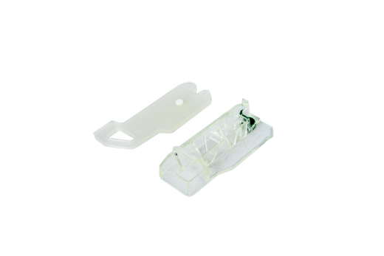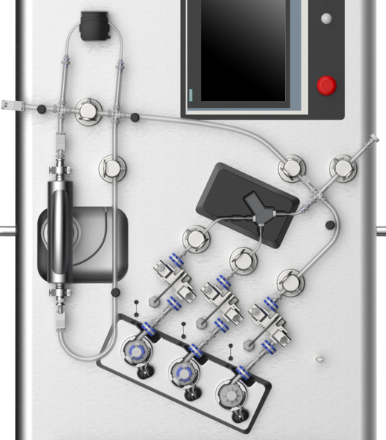

**Fluid Mechanics of a Crystallizer**

**Computational Fluid Dynamics using Python: Modeling Laminar Flow**

**Solve the 2D Navier-Stokes equations using the finite difference method for single-phase laminar flow and verify results using the benchmark lid cavity test**

Medium article

|  |  |
| --- | --- |
| Medium | <https://medium.com/swlh/create-your-own-lattice-boltzmann-simulation-with-python-8759e8b53b1c> |
| Git | <https://github.com/pmocz/latticeboltzmann-python> |
| YouTube | [Simple Lattice-Boltzmann Simulator in Python | Computational Fluid Dynamics for Beginners](https://www.youtube.com/watch?v=JFWqCQHg-Hs)     |
| Kaggle | <https://www.kaggle.com/code/oliverharper/notebookb04690d528/edit> |

IN Paper

<https://www.linkedin.com/feed/update/urn:li:activity:7351669576562098176/>

OpenFoam Docs

<https://www.reddit.com/r/CFD/comments/huwy1n/step_by_step_tutorial_openfoampyfoam/>

<https://doc.cfd.direct/openfoam/user-guide-v7/tutorials#x4-30002>

<https://github.com/UnnamedMoose/BasicOpenFOAMProgrammingTutorials>

<https://openfoamwiki.net/index.php/Contrib/PyFoam>

Coal Project Background

Single and Clumped Atom Catalyst

, Picture

* JEOL JEM-ARM200F
  + STEM = Scanning Transmission Electron Microscopy
  + A screenshot of a computer

    AI-generated content may be incorrect.
  + <https://www.jeol.com/products/scientific/tem/JEM-ARM200F_NEOARM.php>

Tests:

* IR Absorbency spectroscopy