**Figure 1: Ingredient landscape for alternative protein production and industry growth timeline.** (A) The word cloudvisualizes the prominence of various ingredient types for alternative proteins. The concentration of key terms highlights the central ingredients driving innovation and underscores the industry's focus on enhancing the efficiency and scalability of production processes. This serves as a tool to identify major ingredients in alternative protein production. (B) Emergence of alternative protein companies over the past decades. Original data obtained from the Good Food Institute company database: https://gfi.org/resource/alternative-protein-company-database/. Created with RStudio 2021.09.0.

**Figure 2: Distribution of key product types across alternative protein categories.** The detailed view of proportional distribution of key product types within alternative protein categories in the cellular agriculture sector. It highlights the relative prevalence of product types such as cultured meat and dairy alternatives across various alternative protein categories. This visualization demonstrates the alignment of different alternative protein categories with specific product types, showcasing the diversity arising from both traditional and innovative protein production approaches. The data underscores the broadening spectrum of food offerings and the transformative potential of various technologies in establishing a more resilient and diverse alternative protein ecosystem. Original data obtained from the Good Food Institute company database: https://gfi.org/resource/alternative-protein-company-database/. Created with RStudio 2021.09.0.

**Figure 3: Technology focuses across alternative protein categories.** The overview of the distribution of alternative protein categories with their technological focus. It highlights the number of companies engaged in specific alternative protein sectors and their corresponding emphasis on technological innovation. The visualization provides insights into the technological advancements driving cellular agriculture, revealing key areas of concentrated innovation within the alternative protein industry. Specifically, it underscores the critical role of scaling technologies, the integration of AI for optimizing biotechnological processes, and the necessity for sustained investment in scalable, high-throughput solutions to satisfy the escalating demand for sustainable protein production systems. Original data obtained from the Good Food Institute company database: https://gfi.org/resource/alternative-protein-company-database/. Created with RStudio 2021.09.0.

**Figure 4: Global landscape of technology focuses on alternative protein production and market readiness of products.** (A) Visualization of the global distribution of leading technology focus, emphasizing the widespread adoption of innovative technologies for alternative protein production. It showcases the geographic diversification of technological focuses, highlighting regions with established alternative protein industries and underscoring the global prioritization of these technology focuses. (B) The barplot identifies the top three technology focuses for alternative protein production in each headquarter country represented in the dataset, providing a comparative overview of national technological priorities. (C) Visualization of dominant technological approaches with consumer-facing products in cellular agriculture. It highlights the prevalence of innovative technologies in driving the development of high-quality, sustainable protein sources across various product types (e.g., cultured meat, dairy alternatives), underscoring the market readiness and the strategic importance of technology-product alignment in commercializing alternative proteins. Original data obtained from the Good Food Institute company database: https://gfi.org/resource/alternative-protein-company-database/. Created with RStudio 2021.09.0.

**Figure 1**

**(A)**

**(B)**

**Figure 2**

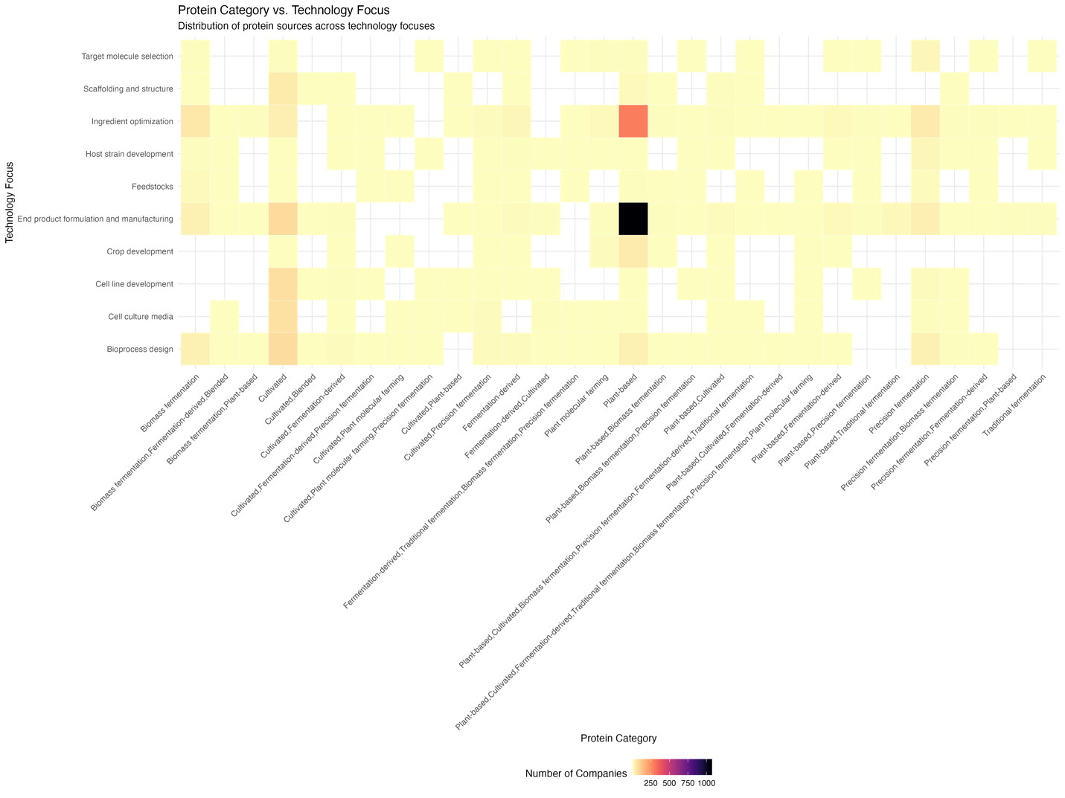**Figure 3**

**Figure 4**

**(A)**

**(C)**

