Revenue streams

Usage fees - this is income generated through the purchase of a service, where the more of the service a customer receives, the more they pay. So for example, broadband services, utilities such as gas or electricity, or piano lessons.

Pricing mechanisms – Dynamic or fixed

In developing your revenue model you will need to consider the following:

● How might your revenue streams or pricing mechanisms affect the value you deliver to your customers?

● How might your revenue streams or pricing mechanisms solve a customer problem?

● How might your revenue streams or pricing mechanisms differ for your different customer

segments?

● How might your revenue streams or pricing mechanisms impact on satisfying customer needs

By now, you should be able to start answering some of the following questions:

● What value are your customers really willing to pay for? Using our gardening service as an

example, your executive customers may be paying you to mow the lawn, but the value they are really paying for is the time they save not having to do it themselves.

● What do they currently pay? You will have established this during your secondary market

research phase.

● How are they currently paying? How would they prefer to pay? This information may help you to offer a different, more accessible way to pay, or it may just give you an idea of how payment schedules will impact on your cash flow forecast.

● How much does each revenue stream contribute to overall revenues? What is interesting to note here is that your largest revenue stream may not necessarily be your most profitable.

Fixed cost

Variable costs

Need to produce a Cash flow forecast document, tracking anticipated ingoing and outgoing costs to determine where money is needed

Revenues: For most businesses income is rarely steady month on month, and there will be some seasonal fluctuation.

Costs: Whilst variable costs will fluctuate according to revenues, fixed costs remain the same and will have to be met regardless of revenue

Timing: ​A fixed or variable cost may be consumed in an even and steady manner but may for practical reasons, for example economies of scale, need to be purchased in large blocks.

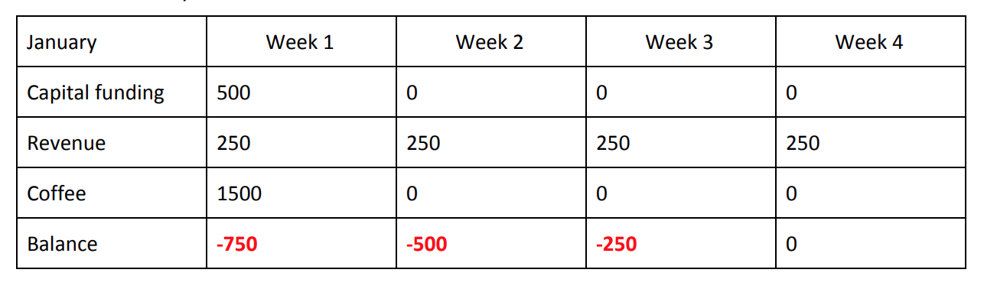

Where do we get the money for this from?

Loans – Can come from bank, but new businesses find it hard to get loans for more than 50% of capital required as new businesses don’t have a credit score.

Another way it to rely on personal loans to bootstrap the business.

Government also issue startup loans, through intermediaries which are personal loans, not business loans.

Also angel investors

Grants are few and far between, and are usually given for socially focused start-ups. Examples include Key Fund, Awards for All, and Esmee Fairbairn Foundation. This should be combined with a loan to make up total equity amount

Profit and loss statement

* Lets you see how much you make from sale of goods after accounting for fixed and variable costs.
* Only accounts for costs consumed in that sale and not for the costs you have actually incurred. Its prepared at the end of each financial year.

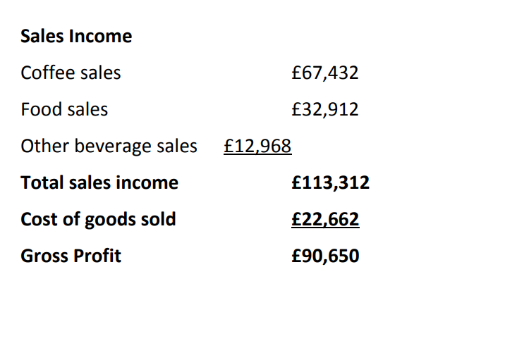

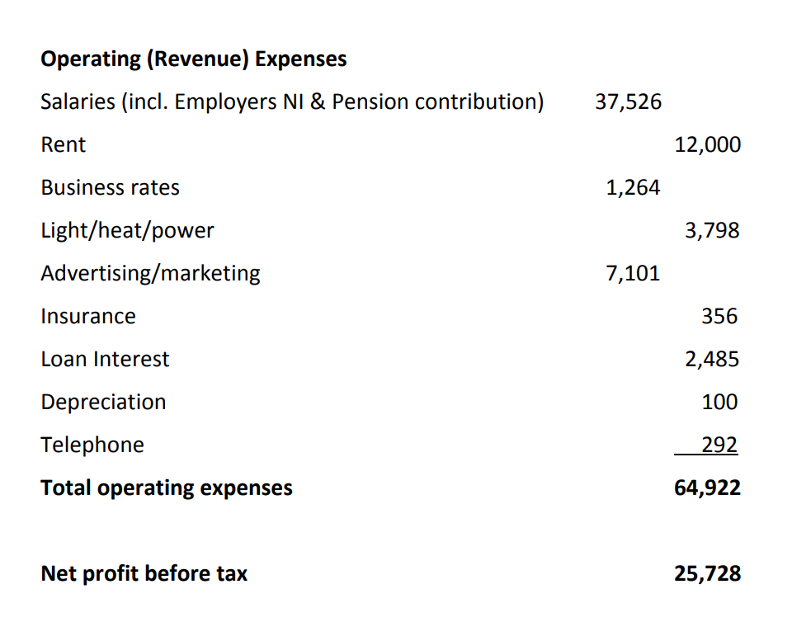

Revenue and capital

* Revenue expenses are anything consumed by the business and should be included in profit and loss
* Capital expenses are for anything that is an asset, something that is not consumed and would have value if the business went bust and they were sold. E.g plant and machinery and vehicles

Costs of goods sold

* Costs involved in the production of goods you’ve sold. E.g costs of materials, petrol etc. NOT include wages – this is an operating expense.

Operating expenses

* Think carefully about what goes into this section. Everything that is consumed. If 6 months into the year you take out 12 month insurance, only 6 months of it would go here. 6 months will be on balance sheet as ‘prepayment’
* Only account for profit and loss for loans. Capital element of loan is accounted for on balance sheet.
* Depreciation. However not put on profit and loss statement, but accounted for as a ‘written down allowance’ on balance sheet.

Balance sheet

* Snapchat of business’ financial position at a given moement in time, usually at year end. Rarely appears ona business plan

Financial risk

* Start-ups are more susceptible for financial risk.
* Need to do a sensitivity analysis. Creating duplicate pages in spreadsheet and playing with them is adequate. E.g What if sales aren’t as high as expected in December?
* In your copy worksheet – not in your original – play with your figures, see how they change, and then use these to decide how much capital your business needs. What is the degree of risk, how likely is the risk, is an increased loan cost warranted to mitigate against these risks? Every business should have a financial ‘cushion’ if possible.

Costs

Van hire – Getting a quote

Van insurance

Petrol – work out how many jobs first

How much do DIY people charge

Employers liability

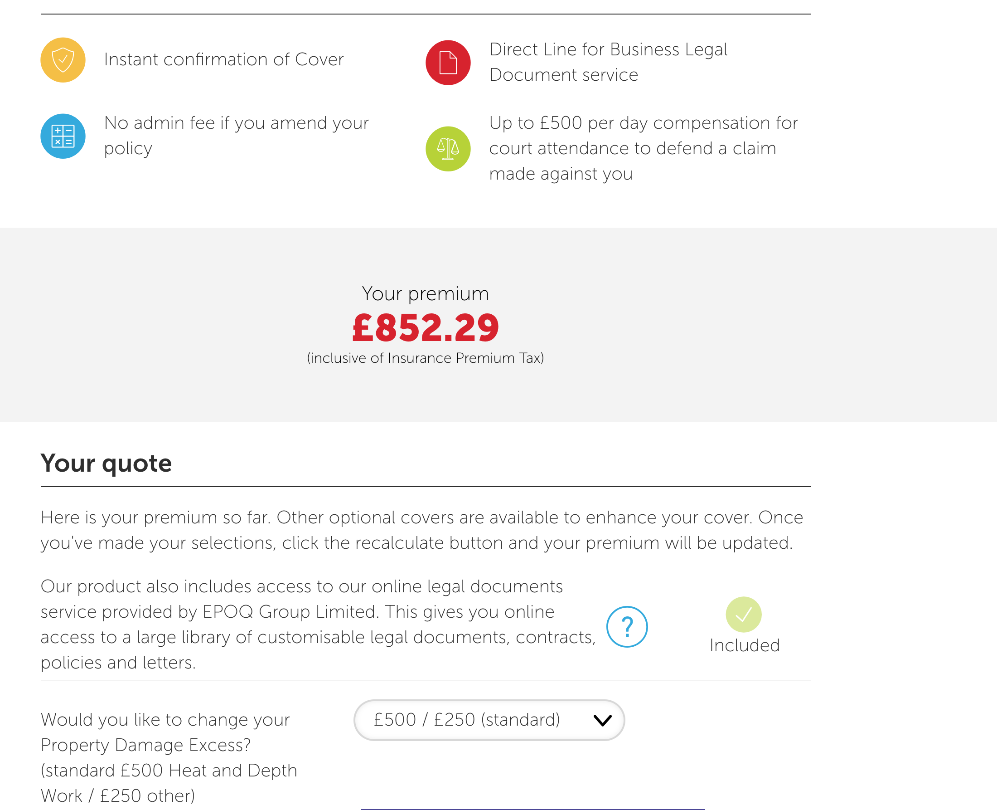

£852.29 including tools and business equipment cover up to £5000



£493.57 not including