DragonBoard™ 410c

Home Automation Sweepstakes Demo

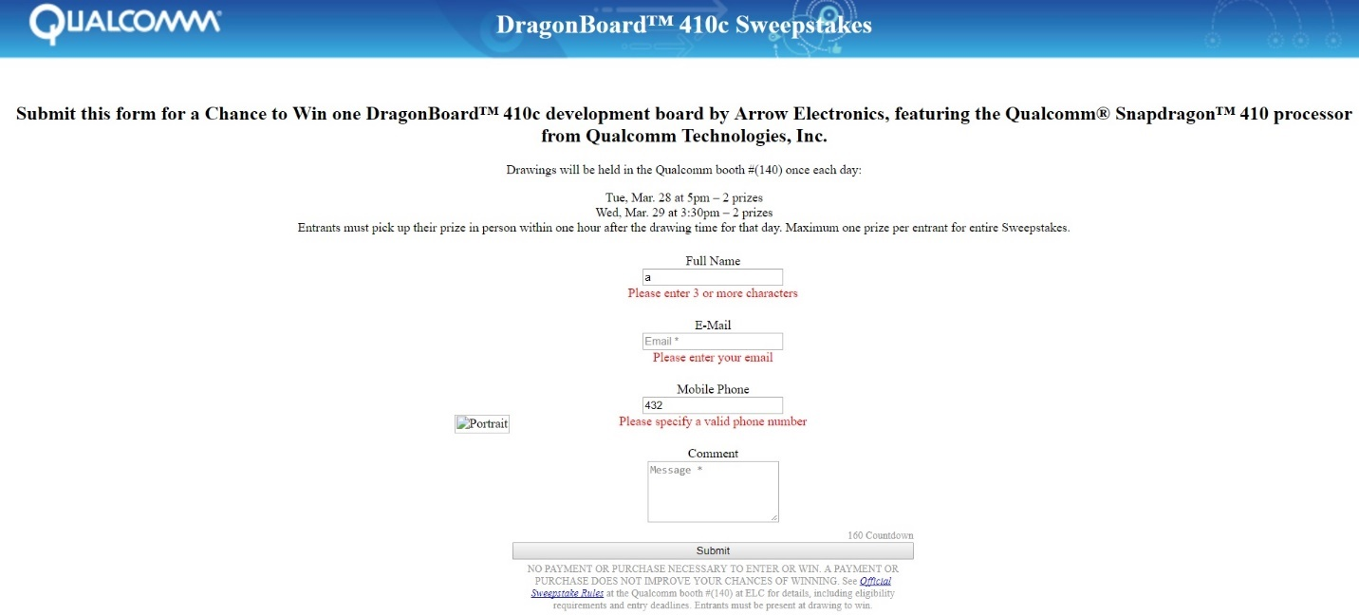

Table of Contents

Demo Background 2

Preparing the Demo 3

Running the Demo 5

Launch Face Detection python script 5

Opening the Web Browser registration page 6

Export the list of sweepstake entries 6

Run the sweepstakes 7

# Demo Background

Face detection uses OpenCV library to detect and track faces within the image. If the Red button or the spacebar on the keyboard is pressed, the program launches a web browser with a registration page. User can enter relevant information like name, phone number and email to register for the sweepstakes.

Only a few items are required:

* DragonBoard 410c (QC provided)
* Sensor Mezzanine Board (QC provided)
* 12V power supply (Arrow provided)
* USB Camera (QC provided)
* USB Hub- 4 port extender (QC provided)
* USB keyboard/mouse touchpad wireless combo (QC provided)
* HDMI monitor & cable (Arrow provided)
* Big Red Button (QC provided)
* USB to Ethernet dongle (QC provided)-optional

# ****Preparing the Demo****

* Connect the USB webcam to the DragonBoard 410c. Use the USB port extender if needed.
* Mount the Sensor Mezzanine board on the DragonBoard 410.
* Connect the Big Red button to the Sensor Mezzanine board.
* Connect the DragonBoard 410c to a HDMI display.

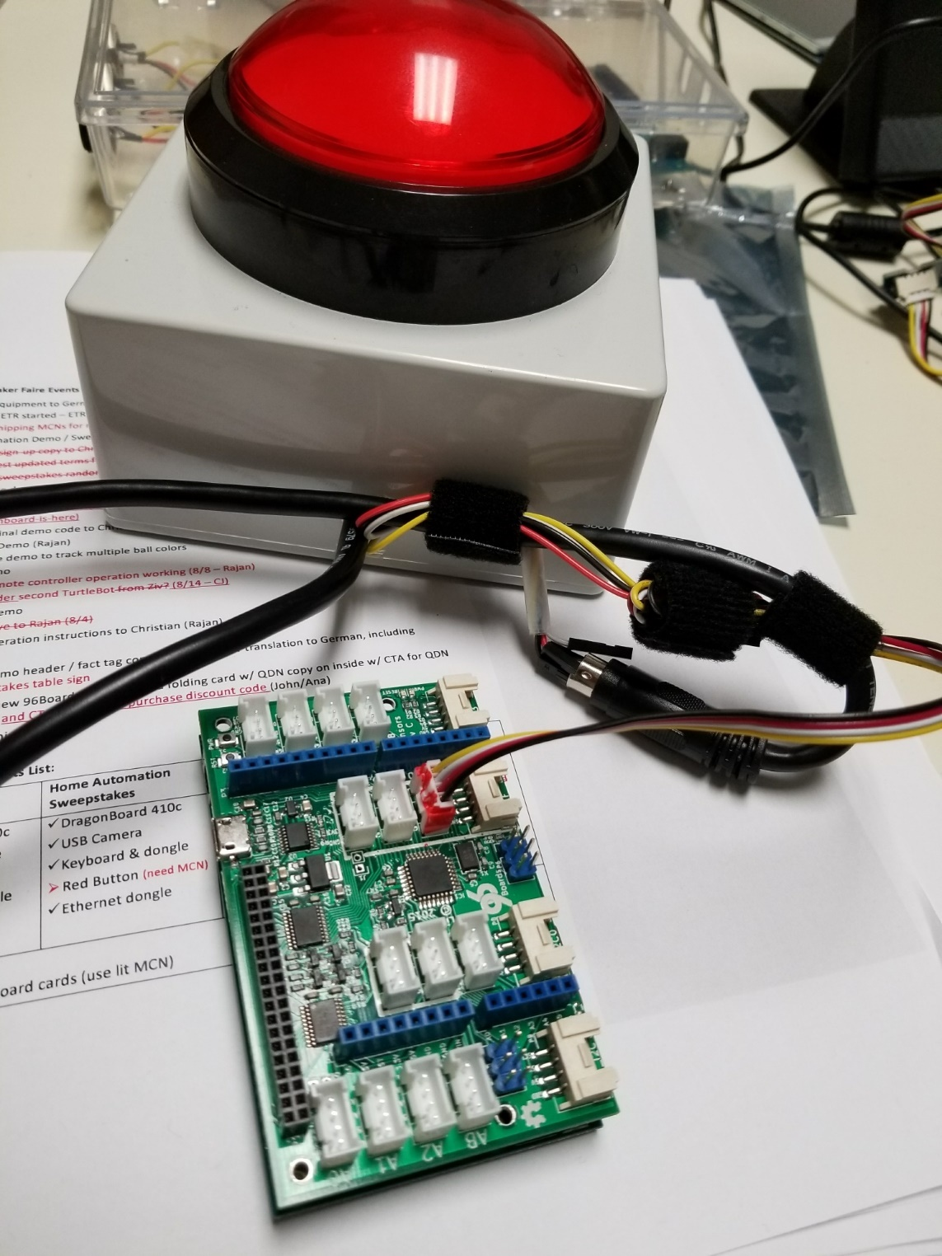

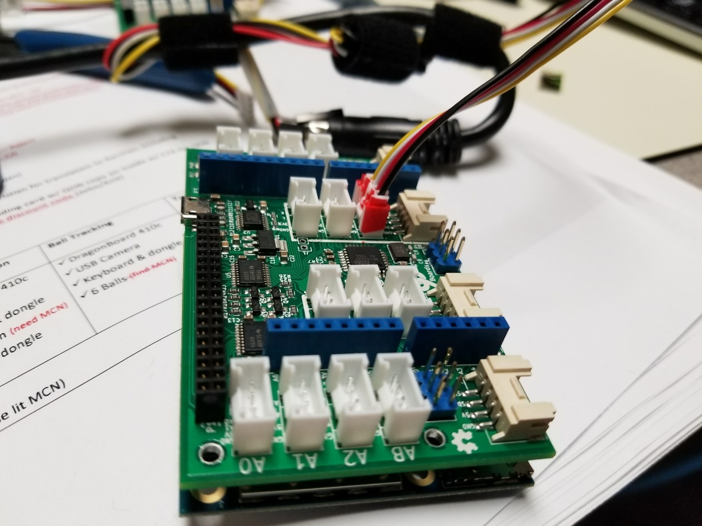

The DragonBoard 410c is already programmed with the demo code, so next steps are:

1. 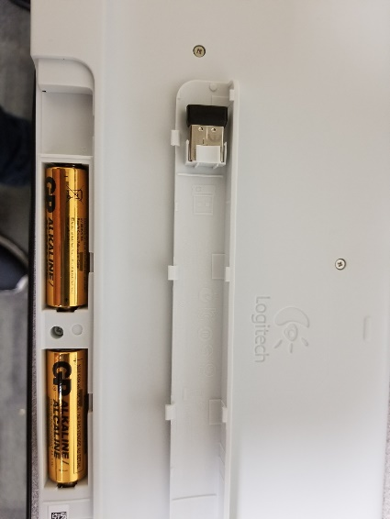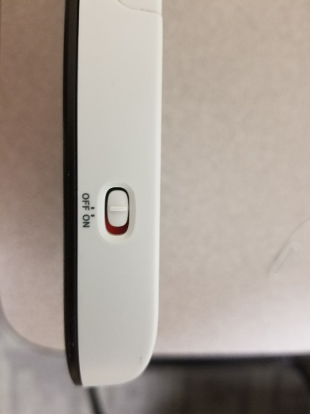Plug the USB Bluetooth Keyboard dongle (found in the back of the keyboard), and slide the keyboard power switch to on
2. Connect the power supply
3. Mount the Web Camera on the HDMI monitor
4. Place the Big Red Button on the table in front of the HDMI monitor where it is easy to reach and press by anyone walking by the booth.

# Running the Demo

The demo has two components,

* Python script that does the face detection using OpenCV. This script also takes input from the Big Red Button and launches the web browser if the button is pressed.
* Web browser registration form. This is where the user will enter their information to take part in the sweepstakes.

After the DragonBoard 410c boots up Debian Linux,

## Launch Face Detection python script

Launch QTerminal from the Desktop as seen in the image below.

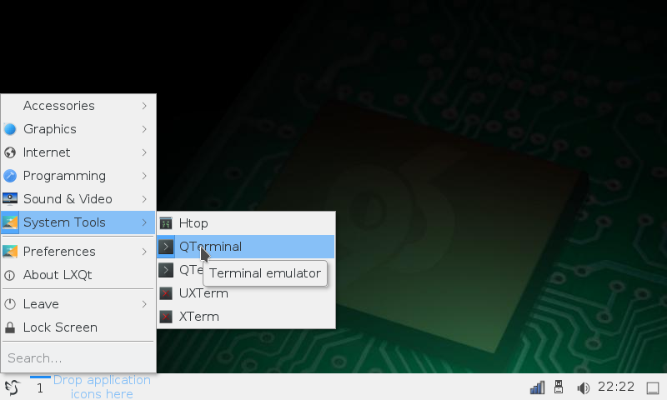

You will see Terminal Window as seen below:

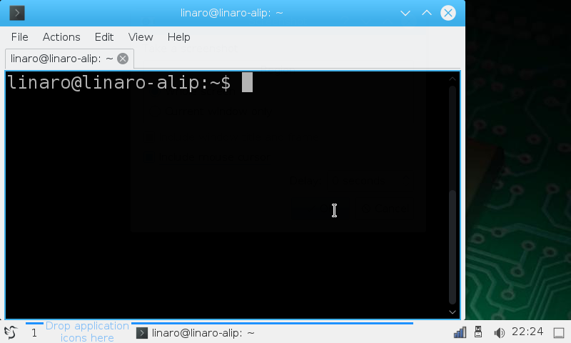

Launch the demo with

cd Home-Automation-Sweepstakes/

sudo python register.py cascades/lbpcascade_frontalface.xml

## Opening the Web Browser registration page

Once the python script runs face detection, the script will constantly look for a button Press (>2 seconds) from Big Red Button or the Spacebar press from the keyboard. If either is pressed, the script will launch the web registration form.

Important Notes regarding web browser use in this demo:

* For the first run, launch the web browser by pressing the Red button and minimize the browser window.
* On web registration page, once the user submits the form, the script tries to auto-close the web browser.
* Auto closing the web browser only works if there is one web browser window always open and minimized in the taskbar.
* Always keep a browser window minimized in the taskbar.

## Export the list of sweepstake entries

Every time the user hits submit button on registration page, the information is saved in a CSV file. Location of the CSV file on the DragonBoard is:

/home/linaro/Desktop/registration_list.csv

## Run the sweepstakes

Digitally select the winner for the QC DragonBoard Sweepstakes:

1. List of raffle entrants is on the Desktop.
2. Open the csv file, it will open in LibreOffice.
3. This supports all Excel type commands.
4. DO NOT SAVE this file after making changes.
5. Insert a column call “RAND”
6. For each row (entrant), enter the formula **RAND()** *(just enter it for one row and copy and paste to the rest)*
7. Select the entire contents of the RAND column, copy it, and paste as just Values only
8. Sort the rows by the RAND column, and pick the top 5 as your winners

Once you have your top 5 Winners, make sure to note down a few backups. In case a winner cannot collect their DragonBoard in time, you can contact the backup alternatives for the prize.

If for any reason you cannot open the registration_list.csv locally on the Dragonboard:

You will need to connect the DragonBoard to internet using WiFi or USB to ethernet dongle.

Once the DragonBoard has internet Connection, SSH into the DragonBoard 410c using tool like [WinSCP](https://winscp.net/eng/index.php), and copy the CSV file to your PC.

Alternatively, you use the web browser to log into your favourite email client (gmail, yahoo!?!, outlook) and email the file to yourself.