MILESTONE 1 - CLIENT DESIGN REVIEW
CMPG325 - Computer Networks
Network Plan Document
Completed By:
OTM MOKOBANE
31120997
For:
Mokone Legal Chambers(Klerksdorp)

1. Client Requirements and Brief

- Client Details:
  - Client ID: CLI-079
  - Organization Name: Mokone Legal Chambers (Klerksdorp)
  - Industry: Legal services
- Core Requirements :
  - Build a reliable network structure to support business operations between two departments (legal and admin) as well as a shared printer zone(CR8)
- Design Constraints:
  - Network must utilize Basic OSPF(single-area dynamic routing)
  - Network must allow for printer sharing between departments.
  - Inter-department file sharing must be blocked.
- Addressing Block:
  - Base network 172.30.50.0/23( subnetted to provide addressing to other departments, printer zones and wan/router links)

- Technical implementation:
  - Implement ACL’s(Access-control lists) on routers to prevent interdepartmental data-packet transfer.

- Delivarables:
  - Functional Cisco Packet Tracer file (.pkt) demonstrating connectivity and policy enforcement via a working simulation
  - Comprehensive documentation showing the physical/logical network topologies, IP addressing scheme and routing configuration

2. Physical Topology

Hardware, design and Justification

The physical topology design uses a centralized routing architecture to manage traffic flow and enforce security protocols between the two departments and shared printer zone . Category 6 (Cat6) Unshielded Twisted Pair (UTP) copper straight-through cabling was chosen to connect end devices, including workstations and dedicated network printers, to their respective access-layer switches. The cables then terminate at the default gateway router via high-speed Ethernet uplinks.

The hardware is detailed below:
- Cisco 2911 Router (Gateway): Chosen because it already has three native Gigabit Ethernet interfaces (Gig0/0/0 – Gig0/0/2) for each department’s switch, hence avoiding the need for expansion modules. This allows each department's switch to its own dedicated physical gateway establishing a central point for OSPF routing and Access Control List (ACL) enforcement.
- Cisco 2960 Layer 2 Switches: Three switches used for each individual department( Legal, Admin, and Printer zones). Three physical switches were chosen to provide broadcast domain separation at the physical hardware level as opposed to using a single-switch VLAN configuration, in order to simplify physical port mapping for the client.
- Fast Ethernet Access Ports (FastEth0/1 – FastEth0/3): Workstations and network printers connect to Fast Ethernet ports for their cost-effectiveness and 100 Mbps throughput which should be enough for printing and file handling.
- (Cat 6 UTP): Category 6 Unshielded Twisted Pair straight-through cabling is used for all device connections. They were chosen to avoid the grounding requirements required for shielded twisted-pair cables(STP), flexibility advantage. and to reduce unnecessary overhead as standard indoor offices do not have components that generate intense electromagnetic or radio interference that might warrant the metallic foil shield around the cable pairs.

Physical Diagram

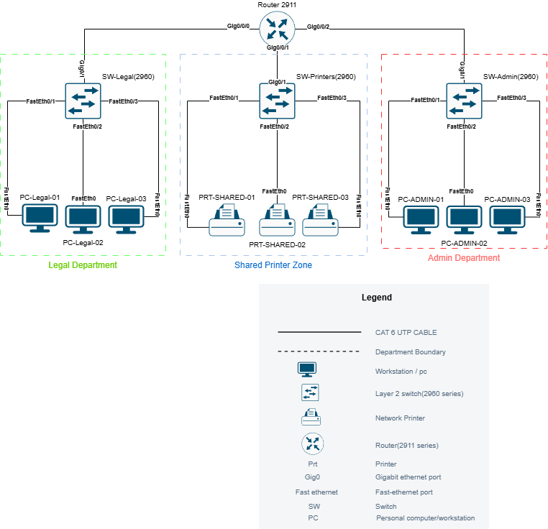
Figure 1: Physical Topology

3. Logical Topology

Data Flow & Logical Layout

The base network of 172.30.50.0/23 is divided using Variable Length Subnet Masking (VLSM) into three distinct broadcast domains representing the Legal Department, the Admin Department, and the Shared Printer Zone.
Traffic routing between these isolated subnets is managed centrally by the gateway router utilizing single-area OSPF. To enforce the client's security requirements, an Access Control List (ACL) is configured on the router. This ACL explicitly permits traffic directed toward the Shared Printer Zone (allowing both departments to utilize the printers) while explicitly denying any inter-departmental data packets from crossing between the Legal and Admin subnets, effectively blocking unauthorized file sharing
The design choices are justified below:
- Variable Length Subnet Masking (VLSM): VLSM was chosen over fixed-length subnet masking so that each subnet can have a custom size based on the number of actual hosts in it, preserving addresses in case the client may want to expand with future WANS, departments or links.
- Single-Area OSPF: Chosen to satisfy client requirements and fulfill the design brief
- Centralized Router ACLs: Chosen over host-based firewalls to block inter-department data transfer. Using an Access Control List (ACL) on the default gateway creates a strict, unpassable network boundary. Firewall software on individual PCs on the other hand is vulnerable to accidental or malicious tempering/deactivation by the user.
- Segmented Subnets: Dividing the 172.30.50.0/23 block into three distinct subnets forces all inter-departmental traffic to pass through the router, and thus allow the ACL to block interdepartmental data transfer. A single, flat, subnet would have not been feasible as, then, traffic would just switch locally and bypass the router’s ACL protocol

Logical Diagram

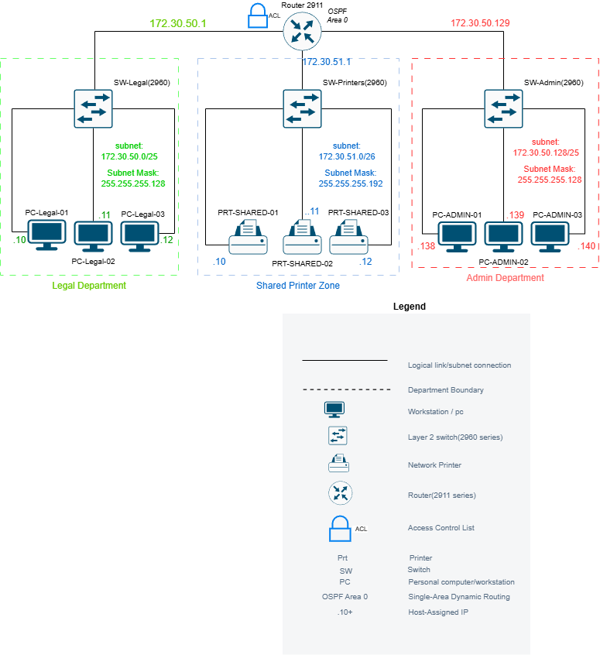
Figure 2: Logical Topology

4. IP Addressing Plan

Table 1: IP Addressing Plan
Subnet Name | Network Address | Subnet Mask (CIDR) | Default Gateway | Usable IP Range | Broadcast Address
Legal Department | 172.30.50.0 | 255.255.255.128 (/25) | 172.30.50.1 | 172.30.50.2 – 172.30.50.126 | 172.30.50.127
Admin Department | 172.30.50.128 | 255.255.255.128 (/25) | 172.30.50.129 | 172.30.50.130 – 172.30.50.254 | 172.30.50.255
Shared Printer Zone (CR8) | 172.30.51.0 | 255.255.255.192 (/26) | 172.30.51.1 | 172.30.51.2 – 172.30.51.62 | 172.30.51.63
Spare / Future Expansion 1 | 172.30.51.64 | 255.255.255.192 (/26) | Unassigned | 172.30.51.65 – 172.30.51.126 | 172.30.51.127
Spare / Future Expansion 2 | 172.30.51.128 | 255.255.255.128 (/25) | Unassigned | 172.30.51.129 – 172.30.51.254 | 172.30.51.255
Scheme & Subnet Description:
The allocated base block 172.30.50.0/23 contains 512 total IPv4 addresses (spanning 172.30.50.0 to 172.30.51.255). Variable Length Subnet Masking (VLSM) was implemented to size subnets based on operational requirements and department separation.
• Legal Department (172.30.50.0/25): A /25 subnet providing 126 usable host addresses (.1 to .126). Gateway 172.30.50.1 is configured on router interface Gig0/0/0, with workstations starting at .10 (leaving .2 to .9 open)
• Admin Department (172.30.50.128/25): A /25 subnet providing 126 usable host addresses (.130 to .254). Gateway 172.30.50.129 is configured on router interface Gig0/0/2, with workstations starting at .138 (leaving .130 to 137 open)
• Shared Printer Zone CR8 (172.30.51.0/26): Sized via /26 to support up to 62 network printers (.1 to .62). Gateway 172.30.51.1 is configured on router interface Gig0/0/1, with static printer IPs mapped to .10, .11, and .12 (leaving .2 to .9 open)

5. Initial GitHub Repository

Repository Link:

https://github.com/OllyMoko/CMPG325-Mokone-Network-Project-31120997.git

Repository Structure:

CMPG325-Mokone-Network-Project-31120997/
|-- README.md
|-- documentation/ (storing relevant network documentation)
|-- diagrams/ (packet tracer screenshots, topology diagrams etc)
|-- packet tracer/ (.pkt simulation + ACL configuration)
|-- configs/ (router and switch running-config text outputs)

6. Technical Implementation and Testing

6.1 Setup and Device Configuration
The network for Mokone Legal Chambers was built in Cisco Packet Tracer. Cat6 straight-through cables were used to connect the three Cisco 2960 switches to the main Cisco 2911 router (R1-MOKONE-GW).

The router's Gigabit ports were set up as the default gateways for each subnet:

- GigabitEthernet0/0/0: 172.30.50.1/25 (Legal Department)
- GigabitEthernet0/0/1: 172.30.51.1/26 (Shared Printers)
- GigabitEthernet0/0/2: 172.30.50.129/25 (Admin Department)

All PCs and printers were assigned static IP addresses based on the addressing plan in Section 4.

6.2 OSPF Routing Configuration
To meet the client's routing requirements, single-area OSPF was set up on the router (Area 0). Even though the subnets are directly connected, OSPF was included so the network can easily be expanded later (like adding a WAN link) without having to redesign everything.

Passive interfaces were configured on the router ports connected to the switches. This stops the router from sending unnecessary routing updates to the PCs and printers, saving bandwidth.

6.3 Security and ACL Configuration
Extended Access Control Lists (ACLs) were created to enforce the rule that both departments must be able to print, but they cannot communicate or share files with each other.

Extended ACLs were chosen because they can filter traffic based on both the source and destination IP addresses right as the traffic enters the router. The ACLs were applied inbound on the Legal and Admin gateway interfaces. The rules were ordered to first permit printer access, then deny access to the other department, and finally permit any other traffic so normal network functions aren't blocked.

6.4 Test Results
Testing was done using one PC from the Legal department and one from the Admin department. Because the ACLs block traffic based on the entire subnet, only one pc per department was tested to show that the whole department is restricted correctly.

Table 2: Test Case Table
Test ID | Scenario Description | Source Node (IP) | Destination Node (IP) | Expected Behavior | Observed Result | Outcome
TC-01 | Legal to Printer Zone | PC-legal-02 (172.30.50.11) | PRT-SHARED-01 (172.30.51.10) | ICMP Echo Reply Received (Permitted) | 4/4 replies received | PASS
TC-02 | Legal to Admin Sharing | PC-legal-02 (172.30.50.11) | PC-admin-01 (172.30.50.138) | Filtered by Gateway ACL (Denied) | Destination host unreachable | PASS
TC-03 | Admin to Printer Zone | PC-admin-01 (172.30.50.138) | PRT-SHARED-01 (172.30.51.10) | ICMP Echo Reply Received (Permitted) | 4/4 replies received | PASS
TC-04 | Admin to Legal Sharing | PC-admin-01 (172.30.50.138) | PC-legal-01 (172.30.50.10) | Filtered by Gateway ACL (Denied) | Destination host unreachable | PASS
TC-05 | Legal Intra-Subnet Traffic | PC-legal-02 (172.30.50.11) | PC-legal-01 (172.30.50.10) | Local Layer 2 Forwarding (Permitted) | 4/4 replies received | PASS
TC-06 | Admin Intra-Subnet Traffic | PC-admin-01 (172.30.50.138) | PC-admin-02 (172.30.50.139) | Local Layer 2 Forwarding (Permitted) | 4/4 replies received | PASS

6.5 Testing Evidence

6.5.1 Legal Department Tests (TC-01, TC-02, TC-05)
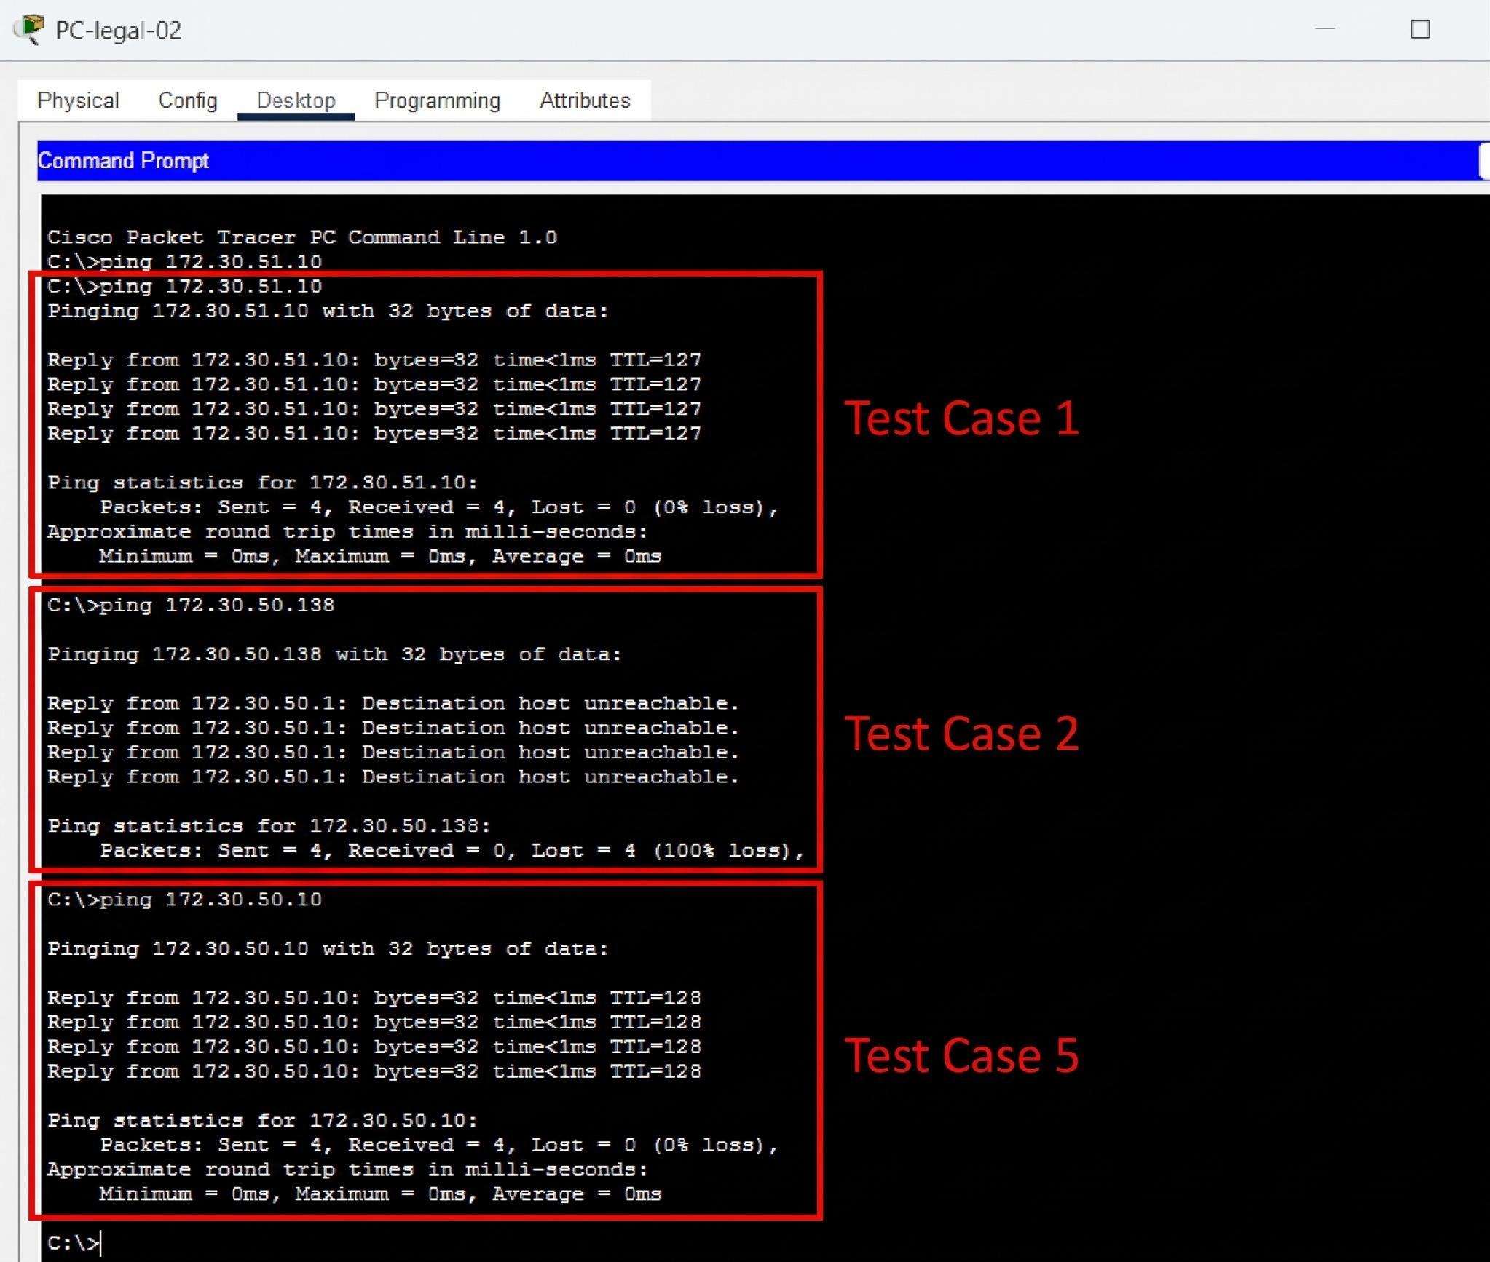
Figure 3: Ping tests from PC-legal-02 showing successful connection to the printer, blocked connection to the Admin subnet, and successful local connection to another Legal PC

6.5.2 Admin Department Tests (TC-03, TC-04, TC-06)
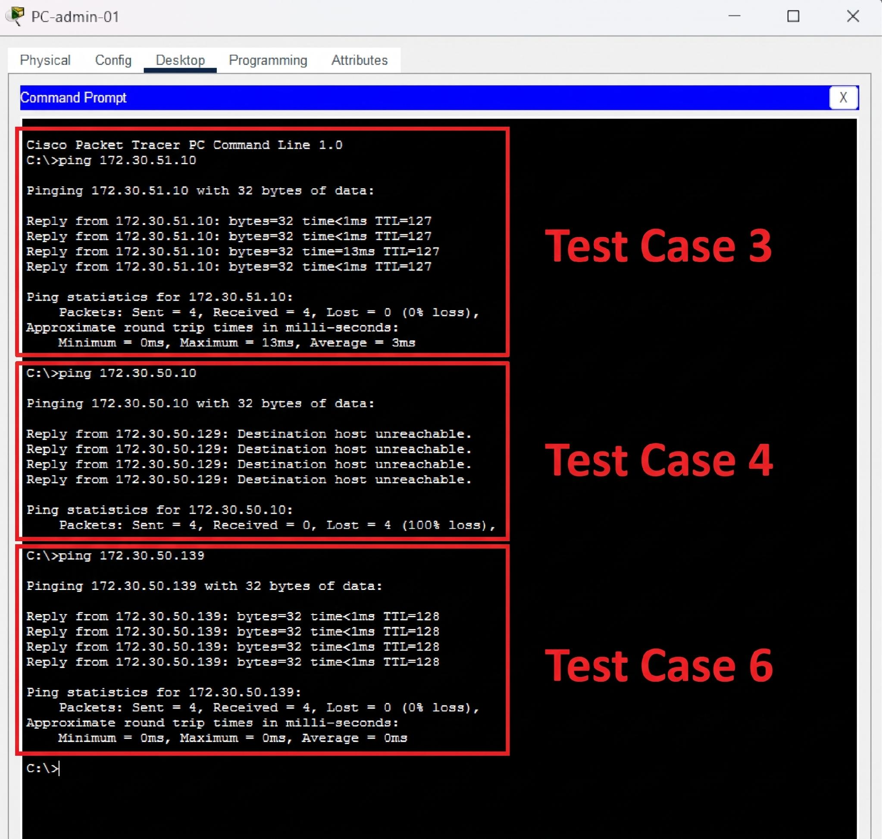
Figure 4: Ping tests from PC-admin-01 showing it can reach the printer but is blocked from reaching the Legal department. Local Admin connections still work fine.

6.5.3 Router ACL Matches

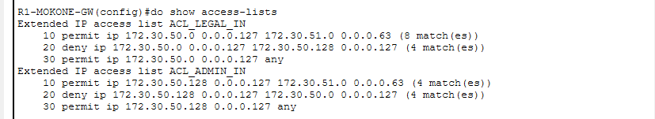
Figure 5: Output of 'show access-lists' on the router, showing that the ACL rules actively blocked/permitted the test packets.

