Programming Project - Codle
By Olly Poyntz
An attempt to create a faithful Wordle clone, as set by one of my Computer Science teachers as homework.

Project Summary
Some key statistics for the project are outlined below:
- Language: C++ (standard libraries only) (probably a mistake)
- Lines of code: ~250 (ignoring comments and empty lines)
- Painful: true
- Unique puzzles: 2309
- Supposed development cost, converted to GBP: £5300 (according to scc)

Algorithms + analysis
I decided to divide the project into the following algorithms:
- Random word selection from a file
- Guess validation
- Checking if a word is in a list (using binary search for optimisation).
- Main game loop

The guess checking algorithm is shown below, written in pseudocode:

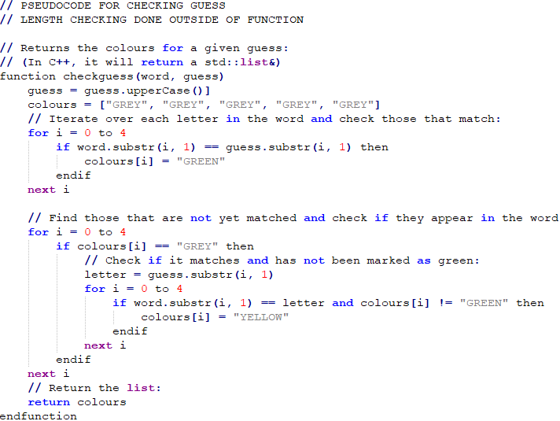
The main game loop is shown below, drawn as a flowchart. The red subprocess is equivalent to the function above, plus another function to output the actual feedback.
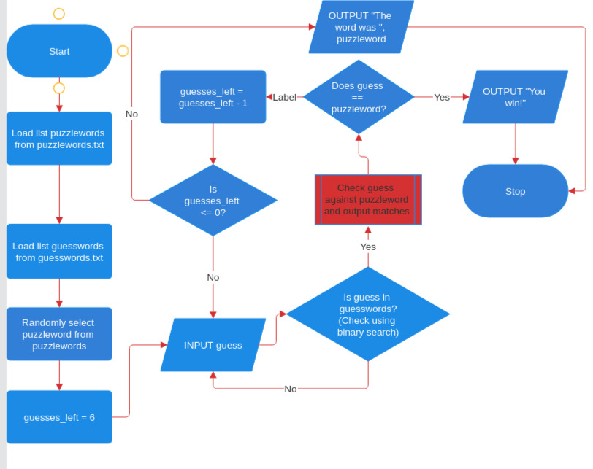

I also determined that two external text files were required; one containing a list of valid 5-letter words, and one containing a list of puzzles. I took both of these from GitHub ((https://gist.github.com/dracos/dd0668f281e685bad51479e5acaadb93) and (https://gist.github.com/cfreshman/a03ef2cba789d8cf00c08f767e0fad7b)), respectively), but I had to manually remove profanity, slurs, insults, etc. from the list, by feeding the list into a profanity detector (https://sapling.ai/utilities/profanity) and then removing the words from the text files.

Implementation
I first decided to write a header file, algo.hpp, containing general-purpose algorithms which would be useful in other project modules:
- Conversion of strings to uppercase
- Loading a list of words from a file (with automatic conversion to uppercase)
- Random selection from a list of words
- Binary search on a list of words.

Then, I wrote another header file, guess.hpp, to implement the guess validation and checking algorithms, as well as output feedback to the user using Unicode characters for a tick (✓), cross (❌), and the standard ASCII tilde (~).
The next file required was the main game loop, in a third header file, game.hpp. Finally, I wrote an entry point, codle.cpp, which is what the compiler will actually take in as input, along with a basic makefile to instruct compilation.
On that note, my development environment consisted of VS Code on Linux as an IDE, g++/MinGW (Minimalist GNU for Windows) to compile for Linux and Windows, respectively, and a bash terminal to execute the program.
The next phase was to produce a basic version ready for black box and white box testing. I ran into the unfortunate difficulty of being unable to print Unicode characters, so I settled for O, X, and ~, and found that my code was segmentation faulting when given input beginning with numbers, which turned out to be a bug in the binary search algorithm (found using the GNU debugger, which identified the function causing the segfaults with traceback).
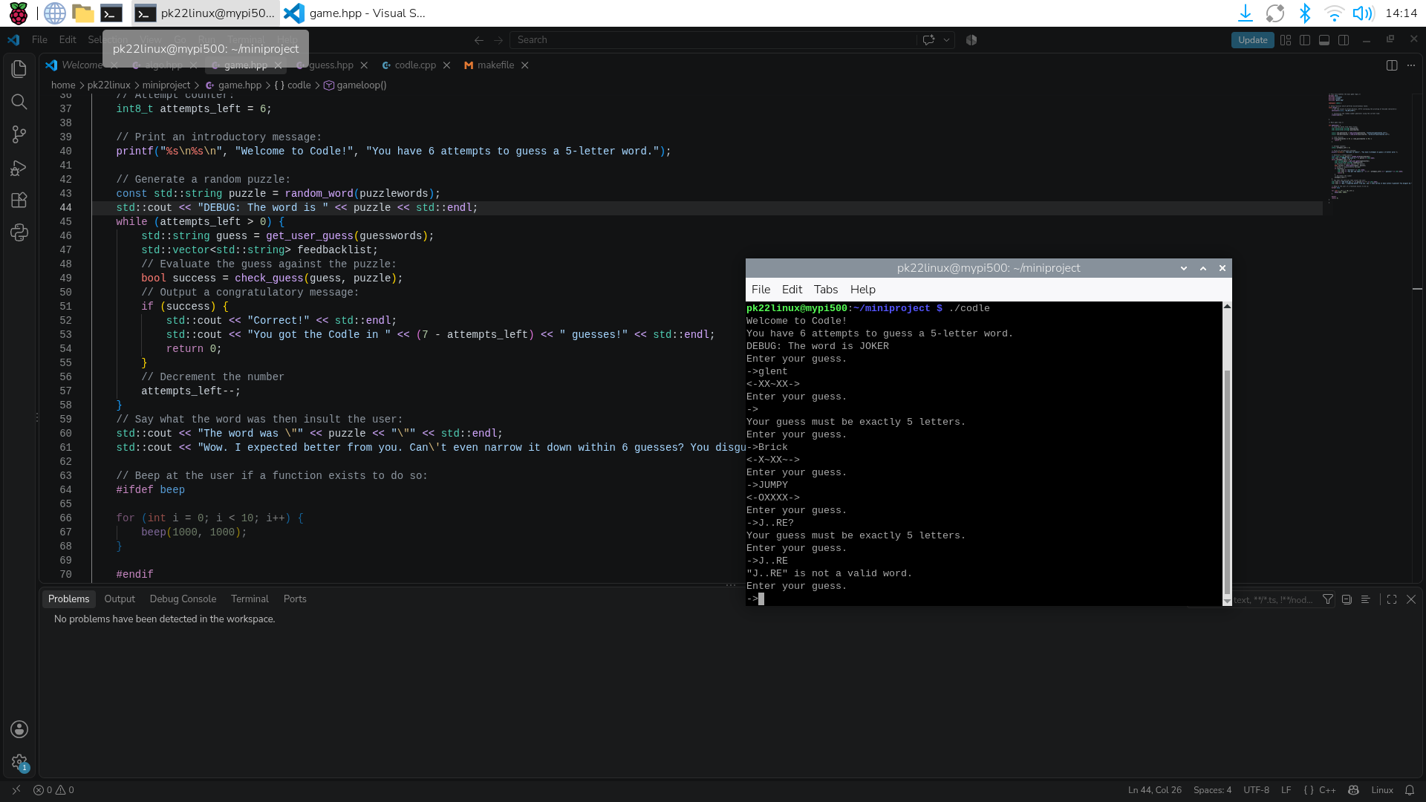Figure 1: A screenshot taken during basic, informal testing, showing the development environment used for implementation.

Testing (yay...)
I decided to start with white box testing. Below is a trace table for all routes through the main game loop algorithm, as defined in game.hpp:
Branch desc. | Branch condition | Variable quit (boolean) | Variable attempts_left (integer) | Variable puzzle (string) | Variable guess (string) | Variable success (boolean) | User input | Program output
Start of the while loop |  | false | 6 | “CRANE” (example; randomly generated in practice) |  |  |  | Welcome to Codle! You have 6 attempts to guess a 5-letter word.
Taking user input – incorrect word |  |  |  |  | “AUDIO” |  | AUDIO | ~XXXX  (One tilde for the matching A, otherwise all grey)
Checking guess with call to function. |  |  |  |  |  | false
Reduce attempt counter | Variable success = false |  | 5
Taking user input – correct word |  |  |  |  | “CRANE” |  | CRANE
Checking guess with call to function |  |  |  |  |  | true
Print win message and break loop | Variable  success = true |  |  |  |  |  |  | Correct! You got the Codle in 2 guesses!
Ask if the user wants to play again |  |  |  |  |  |  |  | Play again? (y/n)
Going back to the main loop | Variable play_again = ‘Y’ or play_again = ‘y’ | false |  |  |  |  | Y
Quitting Codle | Variable play_again != ‘Y’ or ‘y’ | true |  |  |  |  | n
Failure to guess the word | attempts_left = 0 |  | 0 |  |  |  |  | The word was “CRANE” (insults omitted)
Next, I did some black box testing, temporarily modifying the code if a specific word was required for the test case. The testing table is shown below:
Test name | Test objective | Word for test  (if relevant) | Input data | Expected output (paraphrased)  (with ANSI colourings) | Actual output  (with ANSI colourings) | Pass?
Word length | Ensure only 5-letter words are allowed. |  | (no input)  A  abc  ABCDEFG | Must be 5 letters  (repeated four times total) | “Your guess must be exactly 5 letters.” x 4
Word validity | Ensure that invalid and/or profane English words are not accepted. |  | AAAAA  GHENT  SH1TE  (slightly censored)  12345  >:))) | Word invalid x 5 | “AAAAA” is not a valid word.  “GHENT” is not a valid word.  “SH1TE” is not a valid word.  “12345” is not a valid word.  “>:)))” is not a valid word.  (There was actually a racial slur in the list of words I found on GitHub, so I had to remove that manually, along with all of the other profanity)
Basic letter matching | Ensure that the letter checking works correctly in normal cases, and ignores lower/uppercase. | “CRANE” | FOILS  audio  StInK | XXXXX  ~XXXX  XXXOX | XXXXX  ~XXXX  XXXOX
Victory | Review the victory message and checker | “CRANE” | CRANE | OOOOO  You won in 1 attempt! | OOOOO  Correct!  You got the Codle in 1 guesses! | Need to fix the error with the grammar...
Defeat | Review the defeat message and ensure it occurs after six failed guesses. | “CRANE” | LOSER x 6 | XXX~~ x 6  The word was “CRANE”  <insults> | XXX~~ x 6  The word was "CRANE"  Wow. I expected better from you… (further mockery)
Double letters | Ensure that the letter matching algorithm can handle double letters. | “BEGET” | WRENS  GULAG  EXUDE  UNGAG | XX~XX  ~XXX~  ~XXX~  XXOXX | XX~XX  ~XXX~  ~XXX~  XXOXX
Missing files | Ensure that a graceful error is displayed if the word lists cannot be located. |  | Moved directory “wordlists” to “wurdlists” | Unable to locate file(s)! | Unable to open file wordlists/guesswords.txt for reading!  Unable to open file wordlists/puzzlewords.txt for reading!

Deployment
After finishing the testing and making a correction to the code, I decided to take a few steps to simulate how the software would be deployed in practicality.

I decided to write a README in markdown, documenting how to use and compile the game, ready to upload it on GitHub under the permissive MIT license at https://github.com/OllyPoyntz/Codle
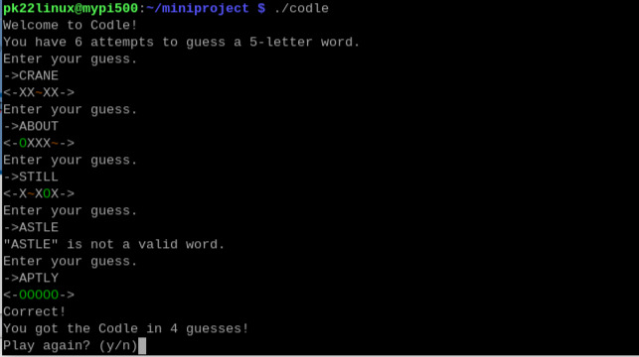
To conclude the project, here is an example of a full, unscripted game:
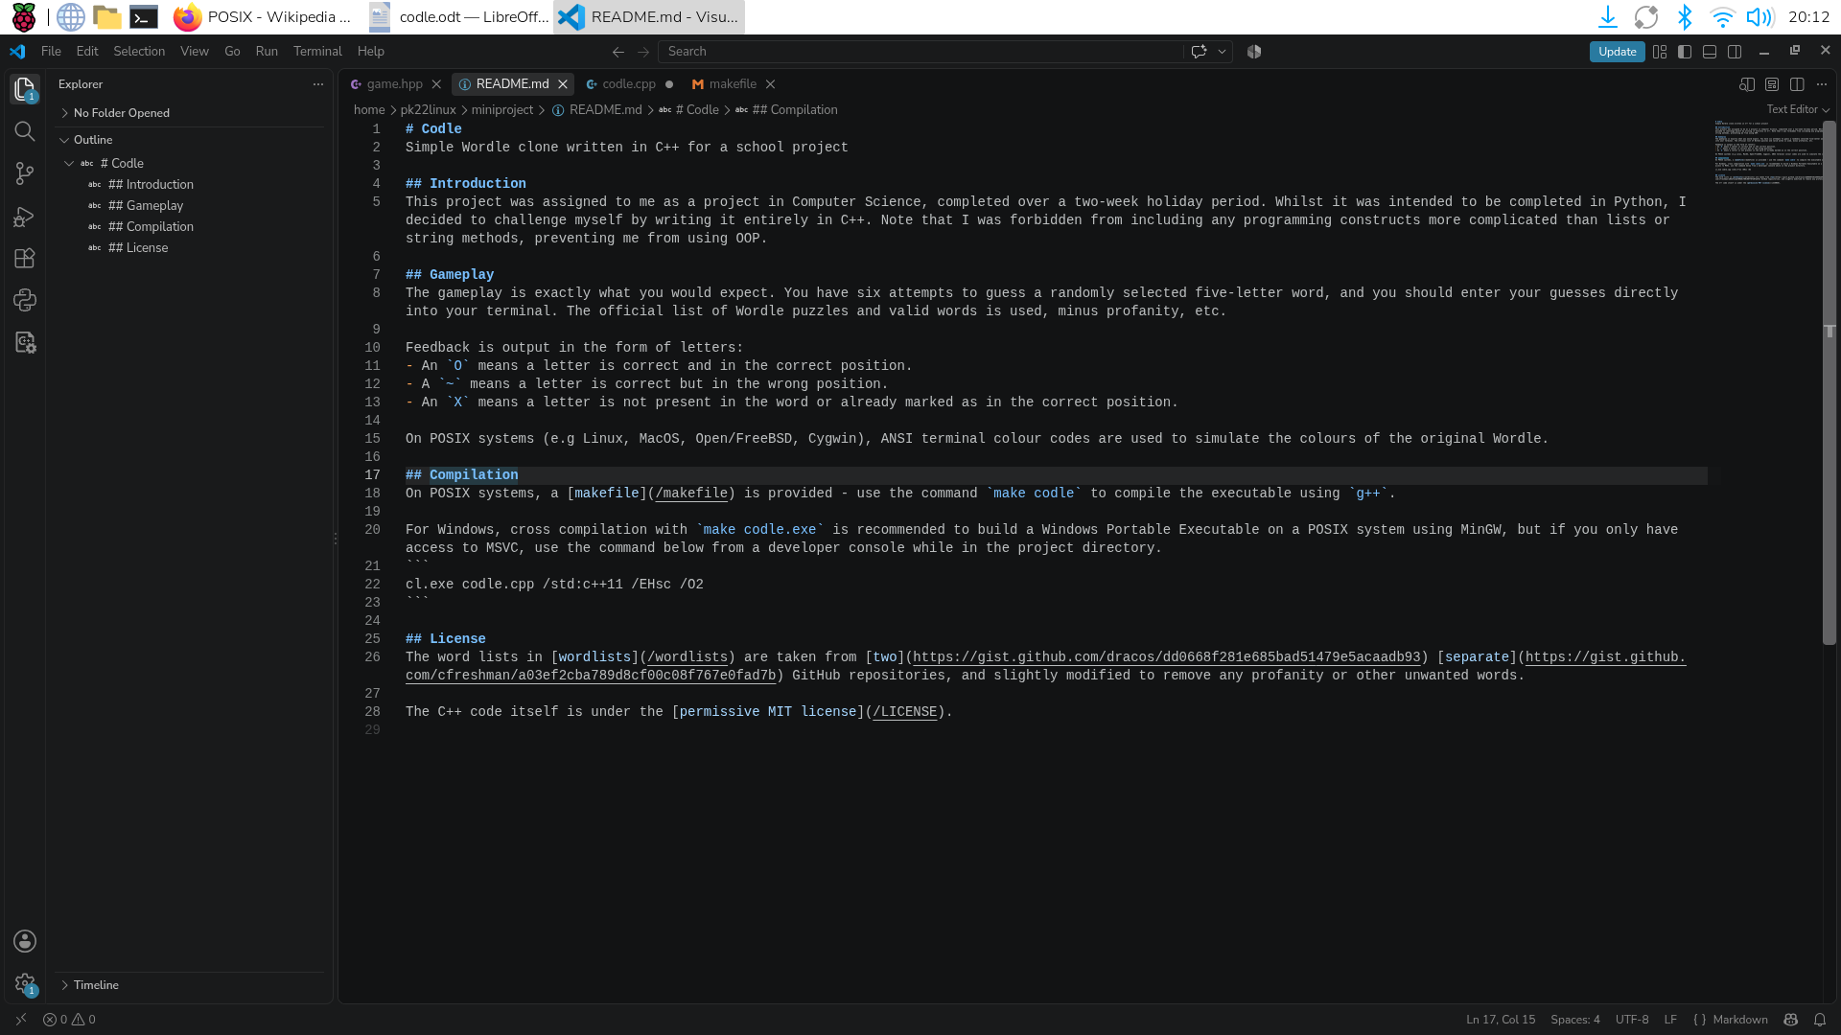Figure 2: Writing documentation for the project in markdown. I try and ensure that my projects work on both Windows and POSIX systems where possible.

