Log Analysis Basics
Network-Based Attack Detection Using UFW
Student | Abass Adam TEMITOPE
Course | Advanced Cybersecurity Class
Tutor | Mr. Oluwasola
Date | 21 October 2026
GitHub repository | https://github.com/Olor-netizen/log-analysis-ufw-assignment

1. Objective
The objective of this lab is to simulate a network-based port scan and show how it can be detected using UFW logs on a Linux system. An HTTP port scan was launched with Nmap from the attacker machine, and the scan attempts were blocked and recorded by UFW on the target machine.

2. Background
- Port scan: probes a system for open ports and active services. It is often a first step before an attack, because it shows an attacker which services (such as SSH, FTP or a web server) might be vulnerable.
- Nmap (Network Mapper) is an open-source tool that discovers hosts and services on a network. Common scan types are SYN (-sS), TCP connect (-sT), UDP (-sU) and ping (-sn).
- UFW (Uncomplicated Firewall) is a front end for managing Linux firewall rules. When logging is enabled, firewall events can be written to /var/log/ufw.log.

3. Lab Setup
Role | System | IP address | Tools
Attacker | Windows host (VMware VMnet8 adapter) | 192.168.159.1 | Nmap
Target | Kali Linux virtual machine (VMware) | 192.168.159.128 | UFW, rsyslog

Note on the setup: The lab handout suggests Kali as the attacker and Ubuntu as the target. I did not have an Ubuntu machine, so I used the Kali VM as the target (UFW works the same on Debian-based systems) and the Windows host as the attacker. Both machines belong to me, and no other system was scanned.
Log file: /var/log/ufw.log (the same events are also available with journalctl -k).

4. Procedure

Step 1: Install UFW, enable it and turn on logging (Kali target)
sudo apt update
sudo apt install ufw rsyslog -y
sudo systemctl enable --now rsyslog
sudo systemctl restart rsyslog
sudo ufw enable
sudo ufw logging on
sudo ufw logging high
rsyslog was installed so that UFW messages are written to /var/log/ufw.log.

Step 2: Deny HTTP traffic from the attacker (Kali target)
sudo ufw deny from 192.168.159.1 to any port 80 proto tcp
sudo ufw reload
sudo ufw status numbered

Step 3: Monitor the log (Kali target)
sudo tail -F /var/log/ufw.log | grep --line-buffered "UFW BLOCK" | grep "SRC=192.168.159.1 "

Step 4: Simulate the port scan (Windows attacker)
nmap -p 80 192.168.159.128
Nmap reported port 80 as filtered, which means the firewall dropped the probes without replying.

Step 5: Extract the evidence (Kali target)
sudo grep "UFW BLOCK" /var/log/ufw.log | grep "SRC=192.168.159.1 " | tail

5. Results

5.1 Blocked entries in /var/log/ufw.log
2026-10-21T10:13:32.693146+01:00 kali kernel: [UFW BLOCK] IN=eth0 OUT= MAC=00:0c:29:1e:9c:5c:00:50:56:c0:00:08:08:00 SRC=192.168.159.1 DST=192.168.159.128 LEN=44 TOS=0x00 PREC=0x00 TTL=52 ID=22334 PROTO=TCP SPT=37702 DPT=80 WINDOW=1024 RES=0x00 SYN URGP=0
2026-10-21T10:13:32.805177+01:00 kali kernel: [UFW BLOCK] IN=eth0 OUT= MAC=00:0c:29:1e:9c:5c:00:50:56:c0:00:08:08:00 SRC=192.168.159.1 DST=192.168.159.128 LEN=44 TOS=0x00 PREC=0x00 TTL=55 ID=28727 PROTO=TCP SPT=37703 DPT=80 WINDOW=1024 RES=0x00 SYN URGP=0

5.2 Required details
Item | Value
Source IP address of the scan | 192.168.159.1
Targeted port | 80/tcp (HTTP)
Timestamp | 2026-10-21T10:13:32.693146+01:00
Destination IP address | 192.168.159.128
Protocol | TCP (SYN)
Firewall action | [UFW BLOCK]

5.3 Short view with only the key fields
sudo grep "UFW BLOCK" /var/log/ufw.log | grep "SRC=192.168.159.1 " | awk '{printf "%s ", $1; for(i=1;i<=NF;i++) if ($i ~ /^(SRC|DST|PROTO|DPT)=/) printf "%s ", $i; print ""}' | tail
2026-10-21T10:13:32.693146+01:00 SRC=192.168.159.1 DST=192.168.159.128 PROTO=TCP DPT=80
2026-10-21T10:13:32.805177+01:00 SRC=192.168.159.1 DST=192.168.159.128 PROTO=TCP DPT=80

5.4 What the log fields show
- SRC=192.168.159.1: the machine that sent the scan (the Windows attacker).
- DST=192.168.159.128: the protected machine (the Kali target).
- DPT=80: the targeted port, a web service port that scanners commonly probe.
- PROTO=TCP with SYN: a connection attempt that was never completed, which is how an Nmap SYN scan works.
- SPT=37702 and SPT=37703: different source ports about 0.1 seconds apart, which are the scan probe and its retry.
- [UFW BLOCK]: the firewall enforced the deny rule and logged the dropped packet.

6. Screenshots
Screenshots of the lab are also stored in the GitHub repository.
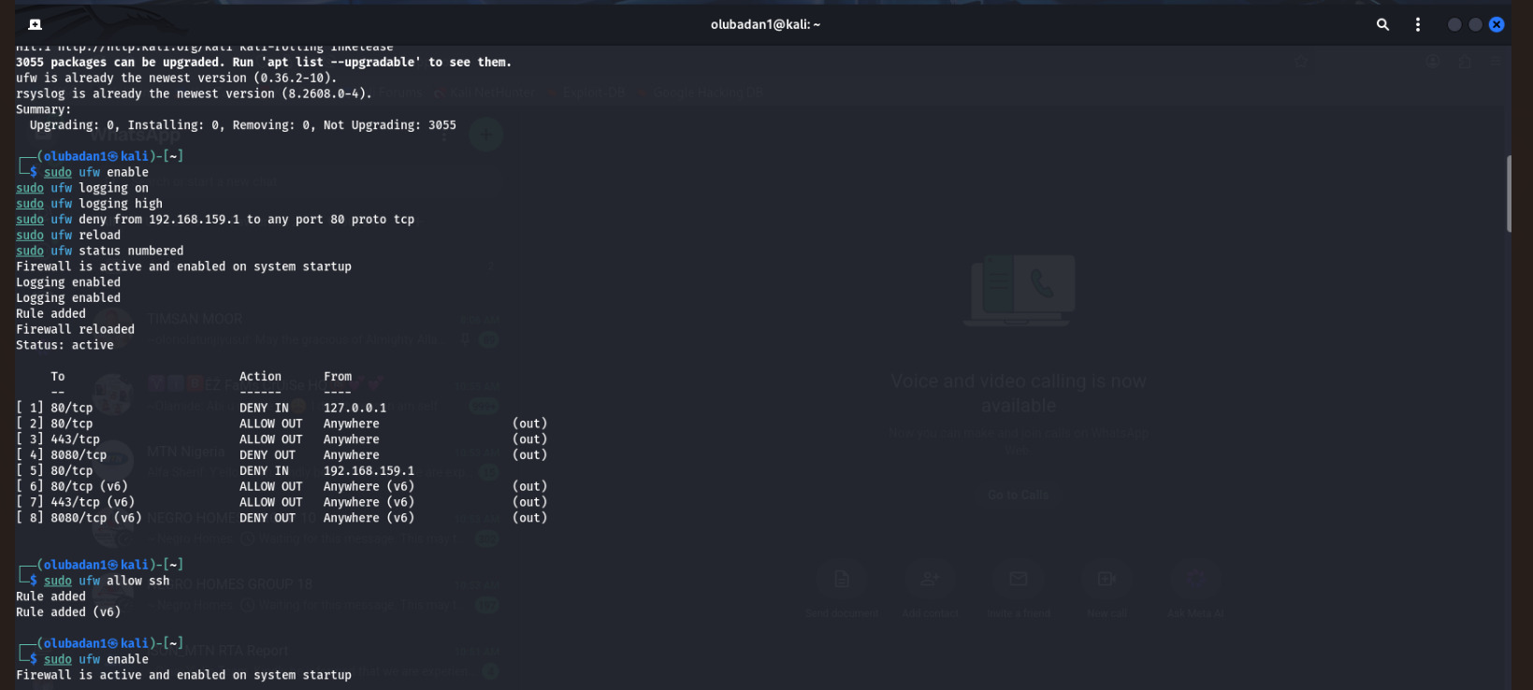Screenshot 1: UFW rule list
Click here, delete this grey text, then use Insert > Pictures.
Figure 1: sudo ufw status numbered, showing the deny rule for port 80 from 192.168.159.1.
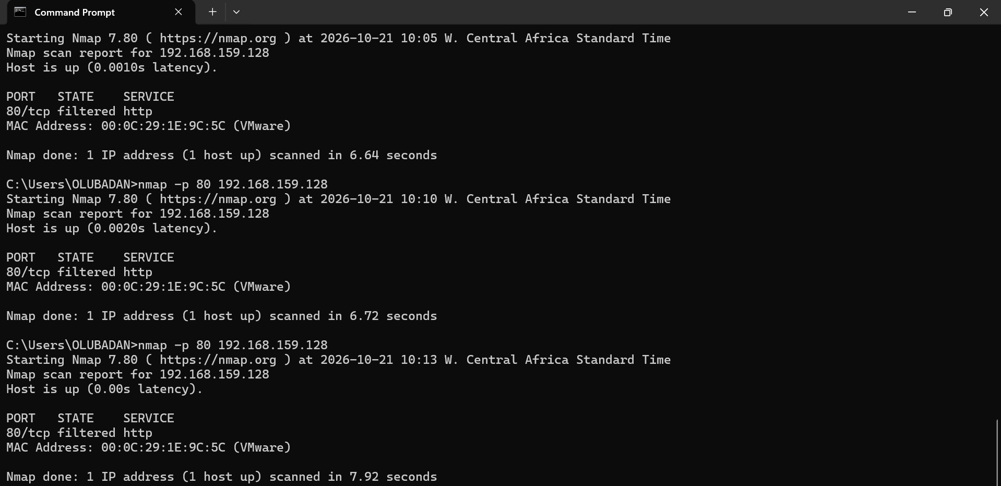
Figure 2: nmap -p 80 192.168.159.128, showing port 80 as filtered.
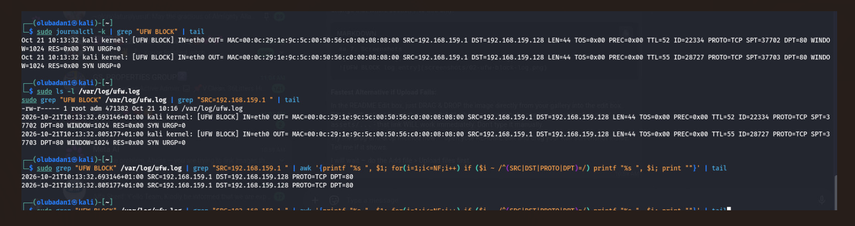
Figure 3: UFW BLOCK entry showing the source IP (SRC), the targeted port (DPT=80) and the timestamp.

7. Mitigation and Recommendations
- Keep the source blocked and keep monitoring for further scans from the same IP.
- Search the logs for other ports probed by the same source: sudo grep "SRC=192.168.159.1 " /var/log/ufw.log
- Escalate to the next tier with the indicators: source IP, destination IP, port and timestamp.
- Forward firewall logs to a central log system (SIEM) for correlation.
- When the investigation is finished, list the rules with sudo ufw status numbered and remove the rule with sudo ufw delete <rule number>.
- Logging level high produces a lot of data. After the lab, sudo ufw logging low reduces it.

8. Conclusion
- A port scan from 192.168.159.1 against port 80 on 192.168.159.128 was blocked by UFW and recorded in /var/log/ufw.log.
- The log entries show the source IP address, the targeted port and the timestamp, which are the details needed to investigate the scan.
- Port scanning can be an early sign that someone is mapping a system, so reviewing firewall logs and applying deny rules helps defenders detect and block it.

9. References
- UFW manual: man ufw
- Nmap documentation: https://nmap.org
- Course lab handout: Log Analysis Basics, Network-Based Attack Detection Using UFW

