Does incorporating nontidal data improve prediction of tidal Enterococcus?
Blue Water Baltimore Ambient Water Quality Monitoring Program, 2013-2024. Draft results section.

Question
I tested whether nontidal (upstream stream) monitoring data helps predict Enterococcus at the tidal harbor stations (Patapsco / Baltimore Harbor). Gwynns Falls and Jones Falls drain into the harbor, so their water quality could be an early indicator of harbor bacteria.

Approach
A nested-model comparison, holding the samples, cross-validation folds, and model fixed:
Model | Predictors | Purpose
T1 (base) | Season, station location and site, and the harbor’s own in-situ panel (nutrient chemistry plus surface sonde: temperature, pH, conductance, salinity, DO) | Harbor-only baseline
T2 (+ nontidal) | T1 plus the upstream stream network: stream Enterococcus (network mean and max, and per-watershed), plus stream turbidity, total phosphorus, DO, nitrate, conductance, temperature | Test of added value
T3 (nontidal only) | Season, location, and upstream stream data (no harbor chemistry) | Can upstream data alone predict the harbor?
Target: harmonized Enterococcus, modeled as log10(MPN+1) for regression and as exceedance of the 104 MPN/100 mL single-sample standard for classification. Matching: harbor and stream samples rarely fall on the same day, but the nearest stream survey is within 1 day for the median harbor sample and within 7 days for about 87% of them. Each harbor sample is matched to the nearest stream reading within 7 days; a backward-only match gives the same result. Validation: year-blocked cross-validation, holding out whole calendar years so no sampling week is split across train and test. All metrics are out-of-fold.

Results
Adding upstream data improves the harbor model on every metric. On the matched subset (harbor samples with an upstream survey within 7 days; n = 3,121, exceedance rate 16.6%):
Model | R² (log₁₀) | RMSE | ROC-AUC | PR-AUC
T1, harbor in-situ WQ (base) | 0.165 | 0.904 | 0.746 | 0.357
T2, plus nontidal data | 0.278 | 0.841 | 0.802 | 0.496
T3, nontidal only | 0.224 | 0.872 | 0.788 | 0.450
Change (T2 minus T1) | +0.113 | −0.063 | +0.056 | +0.139
On the full harbor sample (n = 3,581) the improvement is smaller but in the same direction (R² +0.024, AUC +0.053, PR-AUC +0.121). The added block is significant: with year fixed effects, regression of log10(Enterococcus) rises from adjusted R² 0.335 to 0.386 (partial-F = 22.4, p < 0.001), and exceedance pseudo-R² rises from 0.273 to 0.344 (likelihood-ratio chi² = 200, p < 0.001). The improvement is stable across random seeds and models (Random Forest change in R² = +0.116, Gradient Boosting +0.072).
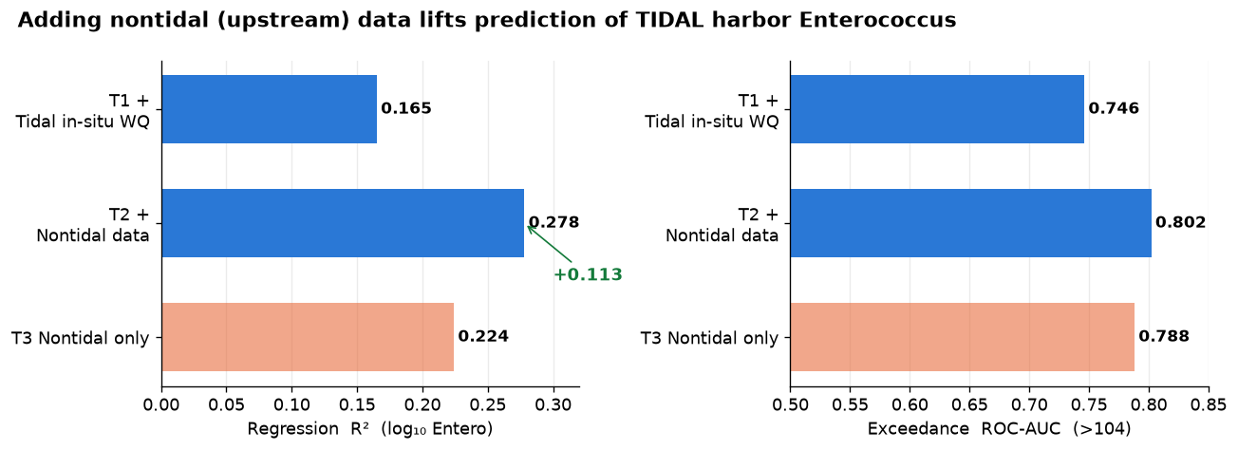
Figure 1. Nested-model comparison on the matched subset, year-blocked cross-validation. Adding upstream nontidal data raises both regression skill and exceedance AUC over the harbor-only baseline.
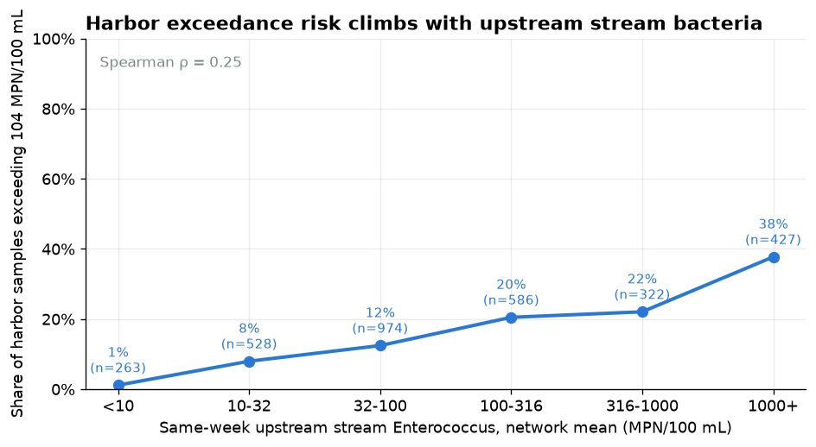
Figure 2. The share of harbor samples exceeding 104 MPN/100 mL rises steadily with same-week upstream stream Enterococcus, from about 1% to about 38%.
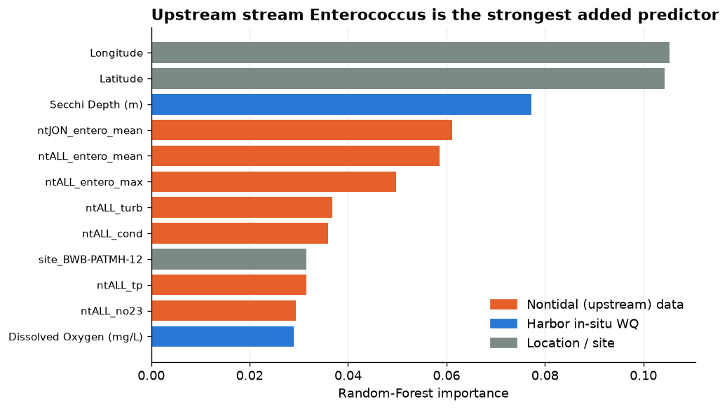
Figure 3. Random-Forest importance. Upstream stream Enterococcus (Jones Falls, pooled network) is the strongest added predictor, followed by stream turbidity and phosphorus.

Interpretation
Adding nontidal stream data clearly improves prediction of harbor Enterococcus, and upstream data alone (T3) predicts almost as well as the harbor’s own chemistry, which is useful where harbor chemistry is limited. The strongest signal is the streams’ own bacteria, consistent with the streams carrying a load that the harbor then registers.
One caveat: upstream bacteria are rain-driven, so some of this improvement may overlap with the antecedent-rainfall signal that was strong in the harbor in Section 1. Adding the rainfall term to the baseline before comparing T1 and T2 would separate the stream-transport effect from shared weather, and is the recommended next step. The daily USGS discharge series, once available, plugs into the same upstream feature set to test whether streamflow adds anything on top of stream chemistry.

