To implement Firebase in your iOS app, follow these steps:

1. Set up Firebase Project:

- Go to **https://console.firebase.google.com/**.

- Create a new Firebase project or select an existing one.

2. Add Your App to Firebase:

- Click "Add app" and select the appropriate platform (iOS in your case).

- Follow the setup instructions, which will include downloading a configuration file (GoogleService-Info.plist) for your app.

3. Install Firebase SDK:

- You can use CocoaPods, Carthage, or manual integration to install Firebase SDK. CocoaPods is a common choice. To use CocoaPods, create a `Podfile` in your project's directory with the following content:

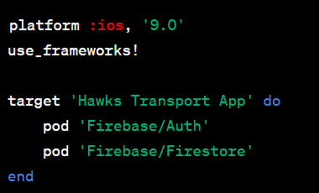

- If you haven't already initialized CocoaPods for your project, run the command `pod init`

- Run `pod install` to install the Firebase SDK.

4. Configure Firebase in Your App

- In your Xcode project, add the `GoogleService-Info.plist` file you downloaded from the Firebase Console.

- Open your AppDelegate.swift and import Firebase:

**import Firebase**

- In the `application(_:didFinishLaunchingWithOptions:)` method, configure Firebase with the following line:

**FirebaseApp.configure()**

Your AppDelegate should look like this:

**import UIKit**

**import Firebase**

**@UIApplicationMain**

**class AppDelegate: UIResponder, UIApplicationDelegate {**

**func application(_ application: UIApplication, didFinishLaunchingWithOptions launchOptions: [UIApplication.LaunchOptionsKey: Any]?) -> Bool {**

**FirebaseApp.configure()**

**return true**

**}**

**}**

5. Use Firebase Services:

- You can now use various Firebase services in your app, such as Firebase Authentication, Firestore, Realtime Database, Cloud Storage, and more. Import the necessary Firebase modules and follow the documentation for each service you want to use.

**import FirebaseAuth**

**Auth.auth().signIn(withEmail: email, password: password) { (user, error) in**

**if let error = error {**

**// Handle authentication error**

**} else {**

**// User signed in**

**}**

}

6. Rules and Security:

- Configure security rules for Firebase services to ensure data security. Firebase offers a set of rules that you can customize to control access to your data.

7. Test and Debug:

- Test your app to ensure that Firebase is integrated correctly and that your app interacts with Firebase services as expected.

8. Monitor and Optimize:

- Use Firebase's built-in analytics and monitoring tools to keep track of your app's performance and user behavior. Optimize your app based on the data collected.

Remember to consult the [official Firebase documentation](https://firebase.google.com/docs/ios/setup) for more detailed information and specific guidance on each Firebase service you want to use in your app.