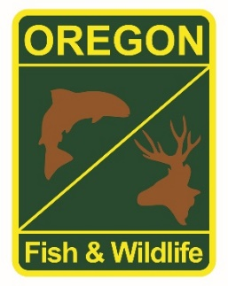

**State Fisheries Genomics Lab Tissue Sample Intake Form**

Please complete the top part of this form and send to: [kathleen.omalley@oregonstate.edu](mailto:kathleen.omalley@oregonstate.edu)

Make arrangements with us prior to dropping off the tissue samples and include a copy of this form with your samples.

**Date of Drop off (Month/Day/Year):** November 22, 2022

**Contact Person for samples:** John Spangler

**Phone:**  **Email:** John.J.SPANGLER@odfw.oregon.gov

**Project dropping off samples:** Paul Olmstead (Paul’s last day was November 30 2022)

**Date samples Collected: (Month/Year):** June 21st 2022 – November 4, 2022

**Description of samples (e.g. species, collection locations, collection dates, collection methods, number of samples, life stage; may attach spreadsheet):**

291 Steelhead samples collected at the Siletz trap at Valsetz Falls

**If applicable, known origin (e.g. natural or hatchery):** NOR

**Sample type (e.g. fin tissue, scale, muscle, etc):** Fin clip

**Storage method (e.g. dry, 95% ethanol, RNA later, etc):** Individual vials filled with 95% ethanol