Flatmod theory and testing
TO 010828

General (To be extended later)
Flatmod is a two2 finite difference model to compute stationary groundwater flow in a single layer. It has been used for several years and proved extremely useful in many situations.
There are two versions: Flatmodmeshctrd and Flatmodblockctrd. The first deals with mesh-centred finite difference networks and the second with a block-centred network. There are also versions explicitly made for radial symmetric flow.
The models have been thoroughly checked against analytical solutions. These tests are present in the syllabus of the PAO course on modelling without ready-cooked models (Delft, 1999, 2000)
Flow towards a point in a corner of an arbitrary network checked against single layer confined aquifer.
Rectangle network with precipitation to further check given flow input.
Flow towards a point in a semi-confined aquifer in arbitrary network to check arbitrary general head boundaries, checked with De Glee solution
Flow in multilayer 3D network checked against analytical multi-layer solution with matrix functions.
Check given head at an arbitrary cell against solution with given flow
Check water balance
Check anisotropy along the main axes, by back-transformation to an isotropic network.

Transient flow (2D for implementation in the 2D steady-state Matlab models)
We want to solve the following differential equation for the head φ [L]:
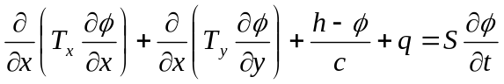
where T [L²/T] stands for transmissivity in the x and y directions respectively, h [L] the external head, which is connected to the groundwater through the resistance c [T]. q [L/T] is flux density, S [-] is storage coefficient. This equation includes boundary conditions, namely the given flow and the external head h. After discretisation we have the following equation for an arbitrary cell of the model:
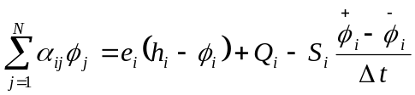
where φ is the head in the cells φ_{i} the head in the considered cell, α_{ij} [L²/T] are the conductances between adjacent cells with indices i and j. e_{i} [L²/T] is the conductance between the cell and the external world with given head h_{i}. Note that 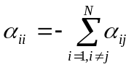, where a_{ii} is a positive and a_{ij} therefore are negative numbers.
It is easy to see that general head boundaries may be multiple boundaries connected to a single cell and how they are dealt with in the model. Given M general head boundaries connected to cell i, we have:
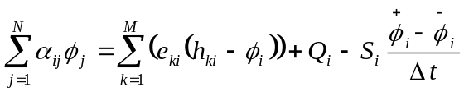,
so that
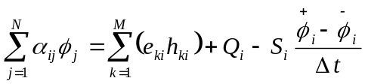
with 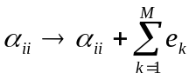
so the right hand contains the known terms
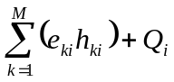
Hence, to introduce multiple general head boundaries in a cell, we add all the conductances connected to the cell, i.e. 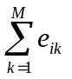, to a_{ii} and add the known value 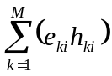 to the right hand side of the equation.

Direct solution of transient flow
The transient solution can be done explicitly and implicitly. In the transient situation the head φ is the head at some point during the time step, for which the equation is valid. Because we do not know this point, we can assume one, for instance halfway the time step, or at time 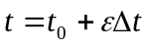, where t₀ is the start of the time step, Δt its length and ε [-] a positive number between 0 and 1. So, 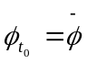, 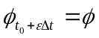, 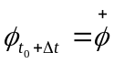.
For the explicit situation we assume that 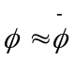, so that
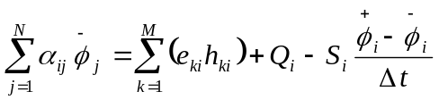 (note the bare above φ !)
so that the head is approximately equal to that at the start of the time step and therefore known. Hence, we can directly compute that head at the end of the time step
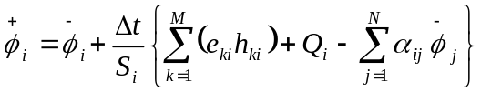
can be directly computed, without having to solve a system of equations.
This explicit manner of computing is, however, only stable if time steps are small enough and storage coefficients large enough, in relation to the mesh-size. It is therefore applicable in certain situations only. In those situations, it can be very efficient. Note that in transient situations, Q and h will both generally depend on time.

Implicit solution of transient flow
For the implicit computation we have to assume something about the unknown at the end of the time step in order to be able to compute φ during the time step (or vice versa). It’s usual to assume that φ changes linearly from to . So that
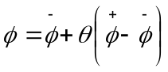 so that 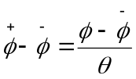
So that the difference equation becomes
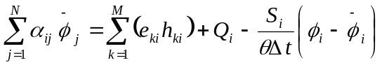
Which now is changed into
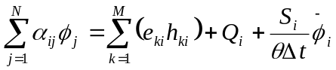
with α_{ii} changed again by adding a term:
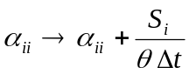
and the known remainder of the transient kept at the right hand side of the equation, which only contains known terms, or terms known at the beginning of each time step.
The resulting difference equation can be solved the same way as is done in the steady-state case. After having thus computed the head at 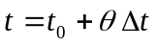, the head at the end of the time step follows from
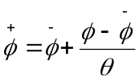
which then becomes the head at the start of the next time step.

Implementation of the direct solution
The direct solution was tried, but was completely unstable. It was, therefore abandoned further in favour of the implicit solution. The latter was tested against a Theis solution (see testflatblockctrdt, currently in project HY219).

