Beste Kees en Kick

Comparing the analytical solution of (Hemker & Maas, 1987) and (Maas, 1987a) considering gradual release from storage form aquitards with traditional solutions that do not take storage in aquitards into consideration

The implemented analytical solution by (Hemker & Maas, 1987) and (Maas, 1987a) produced a remarkable difference with the numerical outcome obtained with MODFLOW and with and alternative Matlab implemented finite difference program fdm2ct (see figures1-3). Yet the numerical values from the analytical solution for the published case and the same Stehfest N=10 produced exactly the same outcomes as the published table 1 in (Hemker & Maas, 1987), showing correct implementation (in Matlab) of the mentioned multi-layer solution.

It was expected that the analytical drawdown curve should initially follow the Theis drawdown for the pumped layer alone, which it does not. This might seem counter-intuitive at first, but the difference is entirely due to the more advanced foundations of the analytical solution by (Hemker & Maas, 1987) and (Maas, 1987a) compared with the Theis solution and the simplistic approach taken in the finite difference models if only one layer is used to simulate each aquitard. The analytical solution takes the gradual release of water from adjacent aquitards fully into account. This implies that the release from the aquitards at the top and bottom of a pumped aquifer initially release much more water than later as a consequence of the initially (very) large gradient in the aquitards at their interface with the pumped aquifer. The one-layer numerical approach cannot simulate this.

This advanced analytical approach implies also a delay or the drawdown in overlaying and underlying aquifers, as it take time for the drawdown to penetrate through the aquitards. Therefore, only at a later stage, with drawdowns increasing slow enough to be followed by that in adjacent aquifers, will the solution agree with that of systems without storage in the aquitards (with storage coefficient attributed to the aquifers to be consistent) or with storage in aquitards but neglecting their internal transient behavior. A time estimate for the release of water from an aquitard may be given as



Which is independent of the thickness of the aquitard, or rather, the dependence of the thickness of the aquitard is fully incorporated in its total storage coefficient *S* and its total hydraulic vertical resistance *c*.

For the aquitard between the pumped layer in the example and its overlaying neighbor it is 0.04 days in the studied case. This time seems to correspond well with the behavior of the drawdowns, especially with the onset of the drawdown in the overlying aquifer. This drawdown can only occur after that in the aquitard has paved its way through the aquitard, for which the above time is a measure (about half time). The MODFLOW drawdown in the pumped layer, which uses only a single cell layer with storage to simulate the aquitard, misses the recharge from the initially steep gradients at the aquifer-aquitard interface and, therefore, resembles Theis initially, which also neglects such influx. The pumped aquifer in the MODFLOW model only gradually receives water from the aquitard in accordance with the gradient between the two aquifers, also initially. In the analytical model, this gradient will stabilize when the internal transient effect within the aquitard approaches its steady gradient, which has halfway proceeded at the above given time. This too is illustrated by the characteristic time in combination with the drawdowns computed in different ways as shown in figure 1.

(Notice that the drawdown in the pumped layer is also influenced by the influx form the underlying aquitard, which in this case has the same properties as the overlaying one and, therefore doubles the initial vertical influx to the pumped layer reducing its influx-halftime by two).

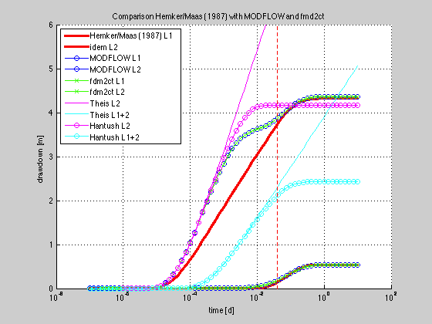

Figure : Comparison analytical solution Hemker/Maas (1987) with MODFLOW, fmd2ct, Theis and Hantush. See text. The problem is D in figure 3. The dashed vertical red line corresponds with the characteristic time of the aquitards above the pumped layer, t=S’(2)*c(2)/4;

Figure 2 shows the analytical and numerical MODFLOW results on double logarithmic axes.

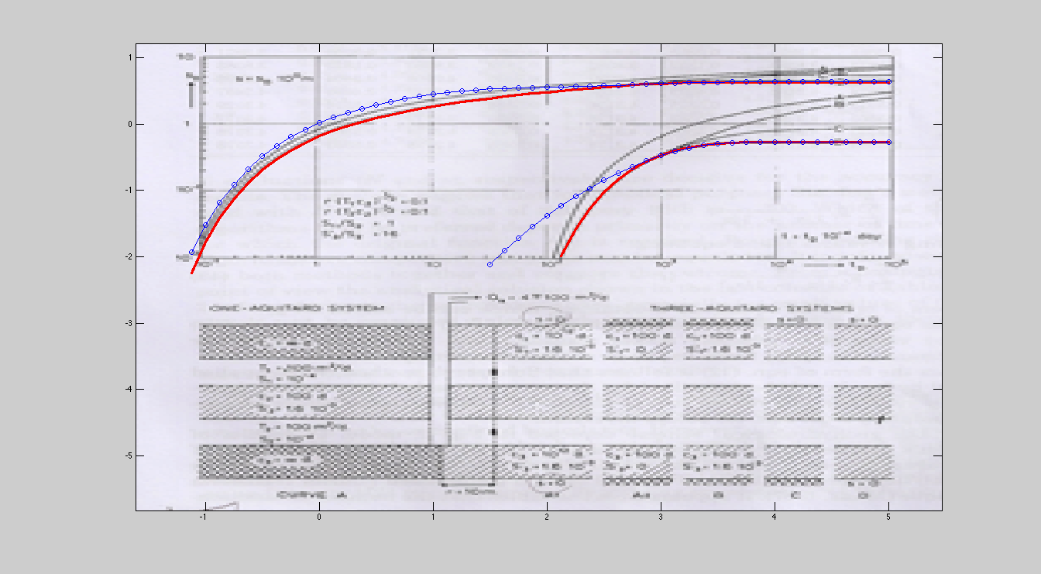

Figure Figure 2 from Hemker/Maas (1987) with double log curves directly plotted on the figure. Red lines are the analytical solution for case D, the blue lines with the circles are the MODFLOW solution for the same case. These curves are the same as in figure 1 and figure 2 drawn on half-log scale.

Numerical model setup: The problem is given in figure 1 with the thick red line the analytical solution according to the Matlab implementation of (Hemker & Maas, 1987) while the other lines are finite difference model outcomes as indicated in the legend. The MODFLOW and fdmc2t numerical implementations are completely independent and yield the same result. Both numerical models are axially symmetric. Both have all aquifer and aquitard layers and an extra aquifer on the top and the bottom to allow fixing the head. The aquifers have *kv*=1e6, *kh*=D/T and *Ss*=Sf/D. The aquitards have *kv*=*d/c* and *kh*=0, and *Ss*=*S­t/D*. The head is fixed on top of the top aquitard and at the bottom of the lowest aquitards, as mentioned. The right hand side of the model is not fixed as it is far enough away (10000 m). The horizontal grid is logarithmic with 51 points between 0.1 and 10000 m. Extraction takes place in the second aquifer only at the rate *Q* = 4*pi*100 as published. The drawdowns are given for r=10 m as indicated in fig2 of (Hemker & Maas, 1987). The Theis curve is for the pumped layer only, and the Hantush curve is for the pumped layer with 1/c=1/c2+1/c3 and lambda = sqrt(*kD2c*). As expected the numerical drawdowns in the pumped layer initially follows both Theis and Hantush until sufficiently influx from adjacent layers occurs. The final drawdown of Hantush is somewhat larger than the two-layer solutions due to the drawdown in the first layer. At some point, the Theis-Hantush curve bends towards that of the two-layer solution and finally follows it closely. As can also be seen, the Theis and Hantush drawdown for the sum of layers 1 and 2 becomes parallel to that of the two-layer solution.

The difference between the analytical and numerical approach taken above is the dynamic storage inside the aquitards given by the governing diffusion equation determining the transient progress of the drawdown inside the aquitards, which is neglected in the numerical model when using only one cell layer to simulate each aquitard. Hence, to compare the both approaches, we can proceed in two ways:

1) adapt the parameters of the analytic model such that it mimics the more simplistic numerical approach and

2) extend the numerical approach with more layers per aquitard to mimic more realistically the analytical behavior inside the aquitards.

# Approach 1: simplify analytical model input

The first approach can be implemented by setting the aquitard storages to a very small value (1e-8), and attributing half of the storage of each aquitard to its overlaying aquifer and half to its underlying aquifer. The results are shown in figure 3. Figure 4 shows the curves on double logarithmic scale. In this case, the analytical behavior is essentially equal to that of the somewhat simplistic numerical model.

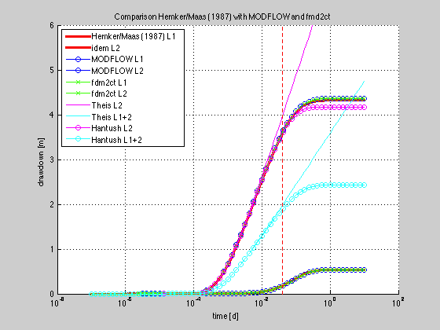

Figure Same as figure one, but with storage of aquitards attributed to their adjacent aquifers.

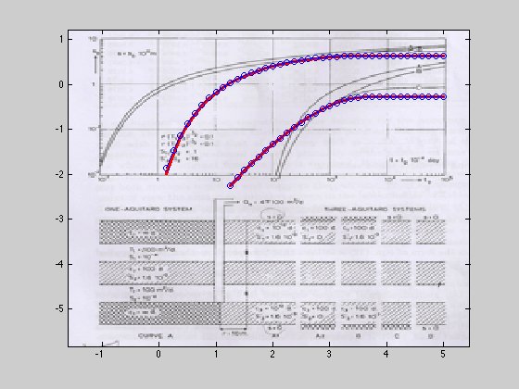

Figure : Same comparison as figure 3, but on double logarithmic scales.

# Approach 2, more layers per aquitard

Approach 2 is by setting the number of model layers simulating aquitards larger than 1. The results are given in a series of figures each with an increasing number of aquitards, i.e. 1, 3, 6, 10, 20.

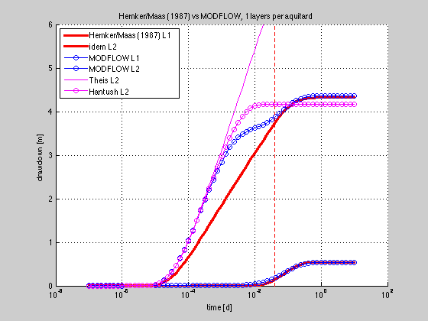

Figure : 1 layers per aquitard

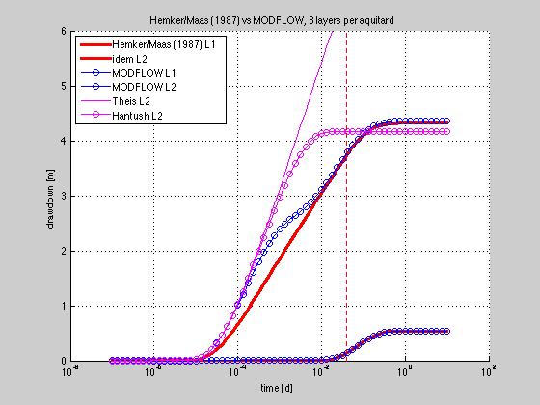

Figure : 3 layers per aquitard

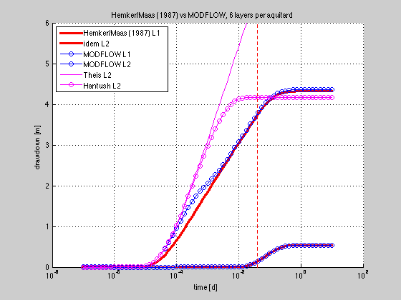

Figure : 6 layers per aquitard

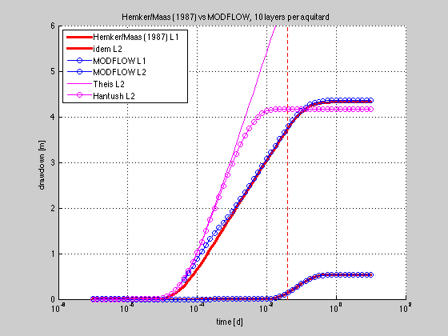

Figure : 10 layers per aquitard.

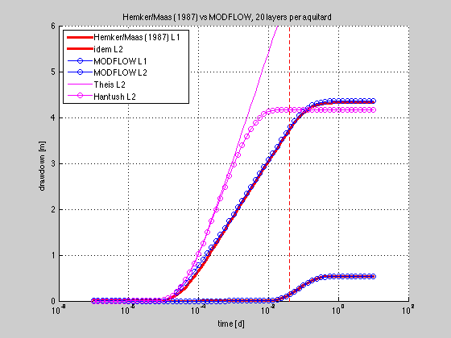

Figure : 20 layers per aquitard

# Conclusions

The analytical multilayer solution with storage both in aquifers and aquitards and full transient drawdown simulation within the aquitards was compared and verified with two numerical finite difference models. The models fully agree when as long as their concepts are fully honored and adequately implemented. It was noted that a substantial number of sublayers is required to simulate internal transient behavior with in aquitards with sufficient accuracy. Even with 20 sublayers per aquitard, some difference remains in early times, when the gradients in the aquitard at the interface with the pumped layer may reach very high values and thus cause short-term influx from the aquitard of substantial rate.

Whenever the characteristic time of a aquitard is within the time of interest, i.e. early time drawdown of pumping tests, this difference matters. In the case studied here, this time is not negligible with 0.04d or about 1 hour. The effect may still be visible up to several times this value, that is, during the first hours. One may also conclude from the difference as is illustrated in figures 1 and 2, that delayed drawdown as compared to Theis applied on the pumped layer is likely due to this effect, unless storage within the well and borehole is masking it. The characteristic time of this delay can be estimated at the emptied volume divided by the pump flow:



Where h is the drawdown in the well bore that has occurred within the previously defined characteristic time of the aquitard, r2 is the radius of the well casing and r1 that of the pipe through which the water is pumped up. With 3 m drawdown at 10 m from the wells as observed in the observation well, and with *Q*=1260 m3/d, *T*=100 m2/d and *rw*=0.25, 7.4 m extra drawdown is to be expected between piezometer and well, not including skin losses. Setting the total drawdown within 0.04 days characteristic time, yields t=0.8 minutes, which is much smaller than the characteristic time of the aquitard and can, therefore be neglected generally. The effect of the pump having to accelerate to its cruising rate also takes much smaller that the characteristic time of the aquitard. Therefore, indeed, initially somewhat delayed drawdown in the pumped aquifer relative to applying Theis can be attributed to aquitard release effects.

Probably there remains much to be discussed on the real behavior of aquitards, whether leakage is largely due to preferential zones or more or less uniform vertical flow rates. Where preferential flows being dominant, little delay would be expected with respect to the onset of drawdown in adjacent aquifers. So this delay, if measured carefully could be a means to deduce about such phenomena. On the other hand, early time release from aquitards into pumped aquifers due to short-time large gradients is likely to generally influence early drawdown in the pumped layer in most cases, even when the resistance is relatively high as masked by preferential flow.

Finally, the analytic solution is far superior to simplistic modeling approaches that use only one layer per aquitard or to other analytic solutions that do not take the internal dynamics of aquitards into consideration.

The work by (Hemker, 1984; 1985; 1999a; Hemker & Bakker, 2006; Hemker & Maas, 1987; Hemker, Maas, & Cheng, 1994; Maas, 1986; 1987b; 1987a) which as essentially accomplished in the nineteen eighties effectively tackled all known different analytical solutions that so many smart mathematically oriented hydrologists have derived at such great effort over more than one and a half centuries. Indeed, the paper by (Hemker, 1999b) shows that the single analytical multilayer approach is able to simulate all other known analytical solutions. His work materialized in the MLU software package, to be obtained through www.microfem.com.

Theo Olsthoorn, 5 October 2013

Table: Numerical values from the analytical solution (Stehfest, N=10)

indicated with MH, the MODFLOW outcomes indicated with MFL and the

outcomes for the Matlab finite difference model fdm2ct.

columns 2 and 3 match digit by digit the numbers in Hemker and Maas (1987, table 1, for Stehfest N=10.

Time [d] MH L1 MH L2 MFL L1 MFL L2 fdm2ct L1, L2

1e-05 0.0000 0.0165 0.0000 0.0287 0.0000 0.0331

2e-05 0.0000 0.0957 0.0000 0.1549 0.0000 0.1529

5e-05 0.0000 0.3590 0.0000 0.5732 0.0000 0.5521

0.0001 0.0000 0.6585 0.0000 1.0509 0.0000 1.0268

0.0002 0.0000 1.0044 0.0000 1.6020 0.0000 1.5744

0.0005 0.0000 1.4872 0.0002 2.3455 0.0002 2.3192

0.001 0.0000 1.8541 0.0009 2.8502 0.0010 2.8206

0.002 0.0000 2.2168 0.0034 3.2409 0.0036 3.2191

0.005 0.0000 2.6891 0.0160 3.5264 0.0161 3.5263

0.01 0.0030 3.0419 0.0416 3.6232 0.0413 3.6214

0.02 0.0358 3.3921 0.0914 3.7222 0.0903 3.7190

0.05 0.1822 3.8382 0.2111 3.9318 0.2060 3.9201

0.1 0.3404 4.0997 0.3394 4.1258 0.3307 4.1111

0.2 0.4679 4.2488 0.4590 4.2762 0.4506 4.2661

0.5 0.5315 4.3130 0.5299 4.3516 0.5322 4.3539

1 0.5362 4.3178 0.5367 4.3584 0.5367 4.3570

2 0.5362 4.3178 0.5370 4.3587 0.5369 4.3576

5 0.5363 4.3178 0.5370 4.3587 0.5368 4.3573

# Bibliograpy

Hemker, K. (1984). Steady groundwater flow in leaky multiple aquifer systems. *Journal of Hydrology*, *72*(3-4), 355–374.

Hemker, K. (1985). Transient well flow in leaky multiple-aquifer systems. *Journal of Hydrology*, *81*(1-2), 111–126.

Hemker, K. (1999a). Transient well flow in vertically heterogeneous aquifers. *Journal of Hydrology*, *225*(1-2), 1–18.

Hemker, K. (1999b). Transient well flow in layered aquifer systems: the uniform well-face drawdown solution. *Journal of Hydrology*, *225*(1-2), 19–44.

Hemker, K., & Bakker, M. (2006). Analytical solutions for whirling groundwater flow in two-dimensional heterogeneous anisotropic aquifers. *Water Resources Research*, *42*(12), 12. doi:10.1029/2006WR004901

Hemker, K., & Maas, K. (1987). Unsteady flow to wells in layered and fissured aquifer systems. *Journal of Hydrology*, *90*(3-4), 231–249.

Hemker, K., Maas, K., & Cheng, A. H. D. (1994). Comment on: “multi layered leaky systems, 1, pumping wells solutions” by AH-D. Cheng and O.K. Morhunfola. *Water Resources Research*.

Maas, K. (1986). The use of matrix differential calculus in problems of multiple-aquifer flow. *Journal of Hydrology*, *88*(1-2), 43–67.

Maas, K. (1987a). Groundwater flow to a well in a layered porous medium: 2. Nonsteady multiple-aquifer flow. *Water Resources Research*, *23*(8), 1683–1688.

Maas, K. (1987b). Groundwater flow to a well in a layered porous medium: 1. Steady flow. *Water Resources Research*, *23*(8), 1675–1681.