RBTLST = left subtree, isRchild(n): n = n→p→r
RightRotate(node):
parent = node→p
LST = node→l
node→l = LST→r
LST→p = parent
if (parent == NIL) { root = LST }
else
if (isRChild(node)) { parent→r = LST }
else { parent→l = LST }
LST→r = node
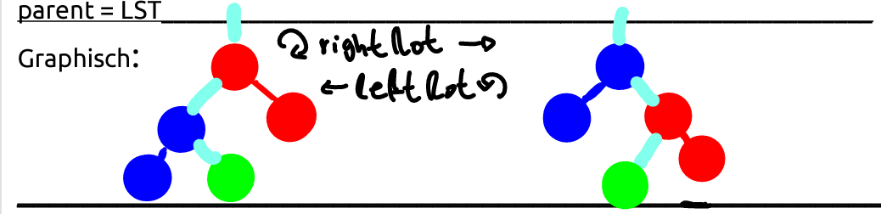
Insert
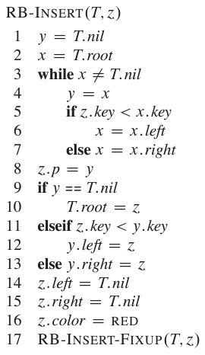
1) “BST”-Insert
2) color node RED
3) fixup
uncle is in opposite tree half...

case 0: node is root → color it BLACK

case 1: uncle’s RED
→ parent.col = uncle.col = BLACK
grandpa.col = red [propagate coloring uppards, g might now violate RBT property]

case 2 (3eck): uncle’s BLACK, node is right child
→ Lrot(parent)
→ now ge get case 3

case 3 (Linie): uncle’s BLACK, node is left child
→ parent = BLACK
grandpa = RED
Rrot(grandpa)
→ tree is now balanced
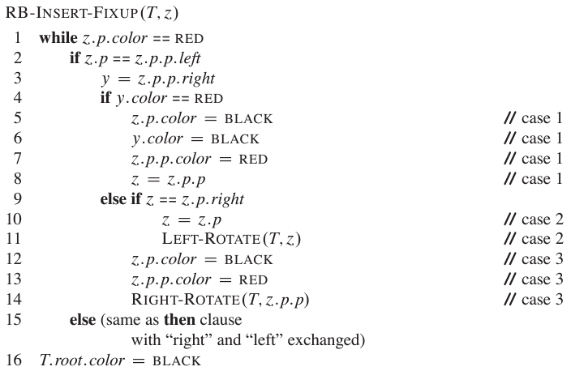
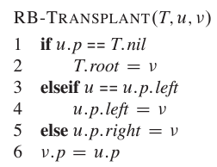
Tree-Traversals:
inorder: leftroot-right [print]
preorder: rootleft-right [root/l/l/l...r/r, copy tree]
postorder: leftright-root [delete tree]
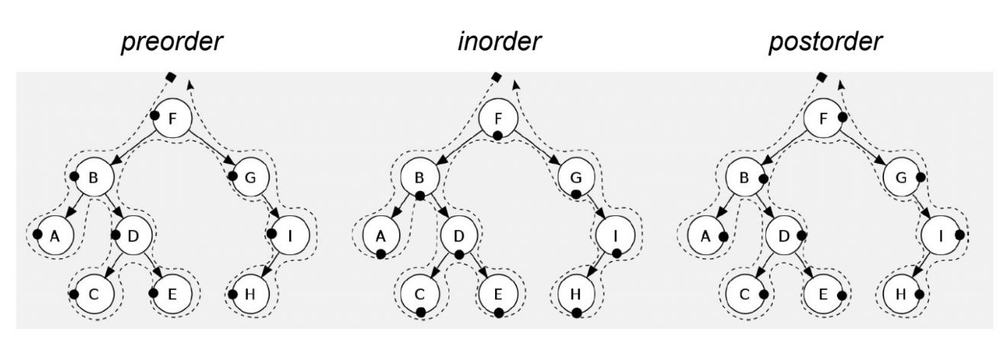
Delete
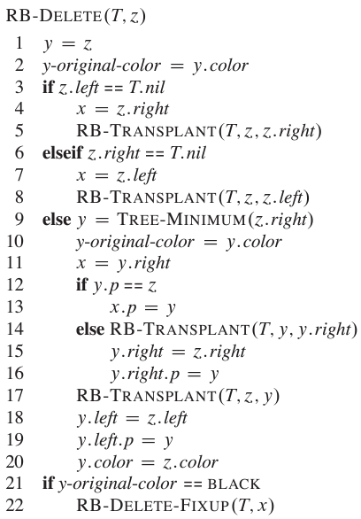
case 1: bro’s RED
→ bro = BLACk
parent = RED
Lrot(parent)
→ we get case 2/3 or 4

case 2: bro’s BLACK, both children of node are BLACK
→ bro = RED
set node = parent
if (parent=RED) parent = black

case 3: bro’s BLACK, leftChild of bro is RED, rightChild of bro is BLACK
→ bro→l = BLACK
bro = RED
Rrot(bro)
set bro = bro→l
→ we get case 4

case 4: bro’s BLACK, rightChild of bro is RED
→ bro.col = parent.col
parent.col = bro→r.col = BLACK
→ tree is now balanced
case 4 illustrated:
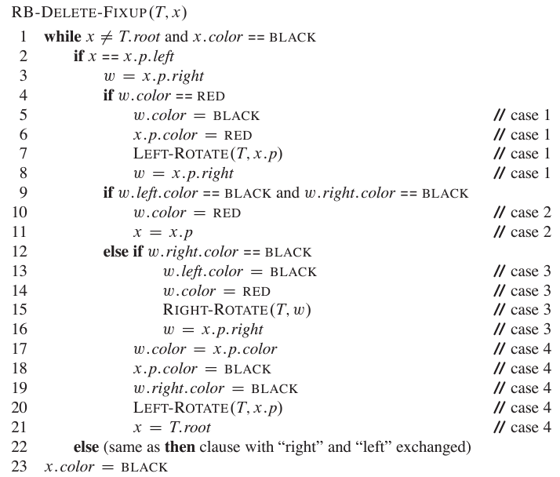
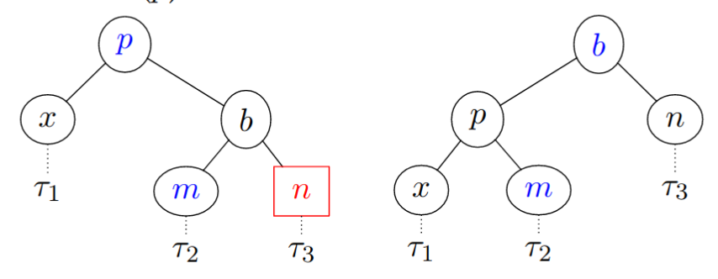
__________________________________
Heap → O(nlog(n))
→issa complete tree: fill up from left to right (MaxHeap: parent > children)

heapify(A,n,i):
max = I;lChild = 2i+1;rChild = 2i+2
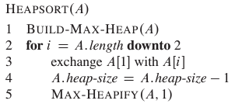
if (A[l] > A[max] && l<n) then: { max = l }
if (A[r] > A[max] && r<n) then: { max = r }
if (max != I) then:
swap(A[i], A[max])
heapify(A,n,max)

builMaxHeap(A,n): for( i=n/2; i>=0; i—) do: { heapify(A,n,i) }

BST

print in ‘reversed order’ → O(n)
printTree(root):
if root != NIL then:
printTree(root→right) // print biggest values
print(root→key)
printTree(root→left) // print other values
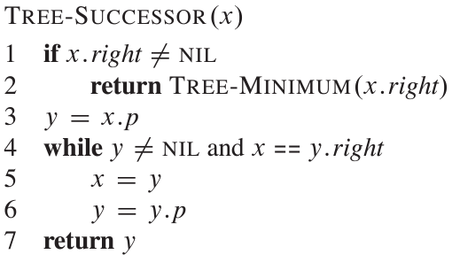
sibling(idx):
if ( idx == root) return NULL
if (idx%2 = 1) { return idx-1 }
if (idx=n) { return -1}
else{ return idx+1 }

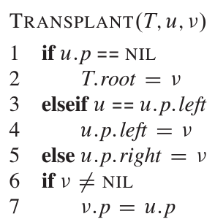
Insertion
Tree-Insert(T, node):
back = NIL; temp = T→root
// find correct place to insert new node
while (temp != NIL) do:
back = temp
if (node→key < temp→key): { x = x→left }
else { x = x→right }
// insert node
node→parent = back
if (back == NIL): { T→root = node } // tree was empty
else if (node→key < back→key): { back→left = node }
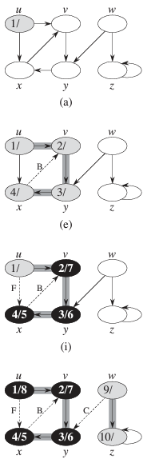
else { back→right = node }

Deletion
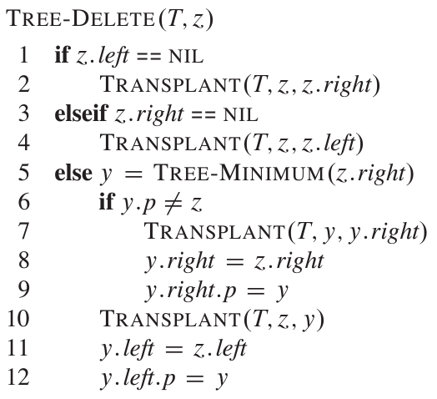

Graphs
Kante = Paar v. Knoten | gerichteter Graph: Kante (u,v) [ != {u,v} ]
vollständiger G.: Jeder Knoten hat ne Verbindung zu allen anderen Knoten
DFS →Θ(|V| + |E|)
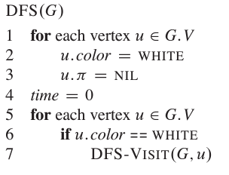
→Alle Knoten in G werden besucht

DFS-Visit(G,v):
// markier v als besucht
for each (v,w) € E(dges) do:
if (“w noch nicht besucht”) then: DFS-Visit(G,w)
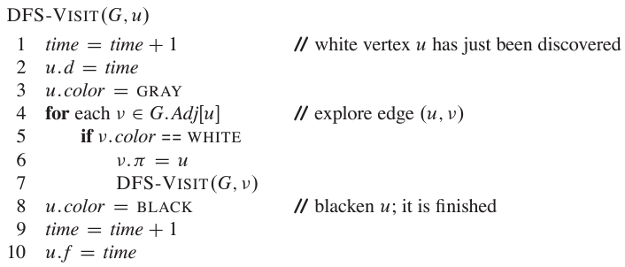
BFS → good for shortest path, social networks →vlt nicht alle Knoten besucht
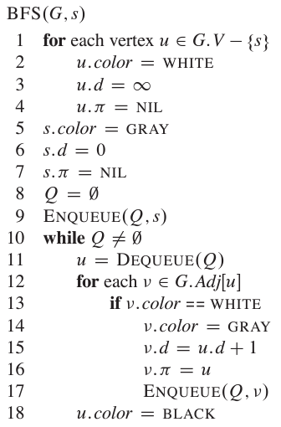
1) init nodes (ex make’em white)
2) init ADT (ex init(Q))
3) bearbeite Knoten in ADT
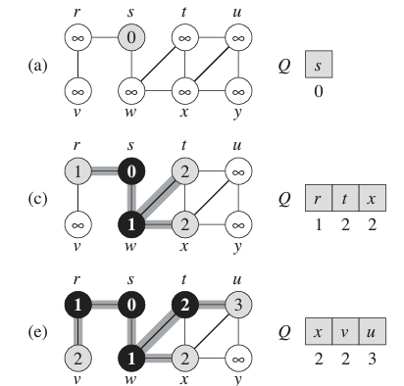

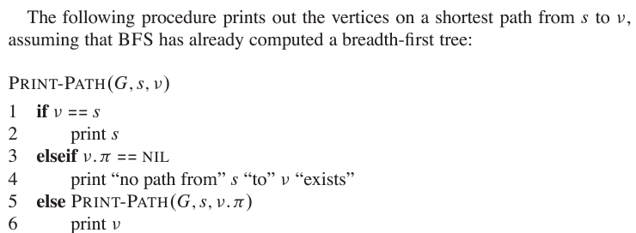
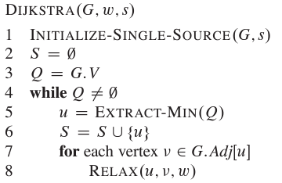
Other Graph algos._________________
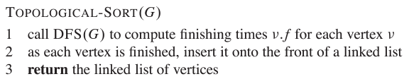
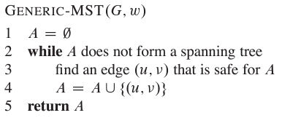
Topo-s: gut um zu wissen, in welcher Reihengole Aufgaben abgearbeitet werden müssen
Bsp: kleider anziehen
Shirt→Tie→Jacket
Put in LL:
←Jacket←Tiey-Shirt
LL: 1.)Shirt2.)Tie 3.) Jacket
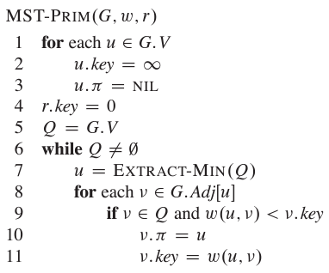
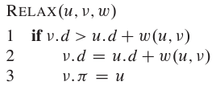
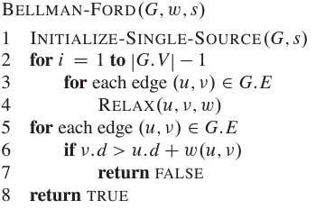
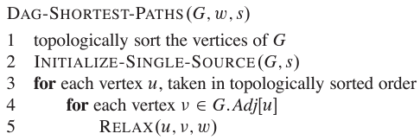
Adj. Matrix:
Θ(|V|²)
Adj. List:
Θ( |V| + |E| )

Recurrences
Master-Meth: T(n) = aT(n/b) + f(n) [n^(log_b(a) = x]
case 1: f(n) < x → O(x)
case 2: = → O(x*log(n))
case 3: f(n) > x → =(f(n)
Binary search(A, l, r): → O(log(n)), da Baum..! | worst/insert/del: O(n)
if ( l < r): return NIL
mid = (low + high)
if(A[mid] > value): return BS(A, value, l, mid-1)
else if(A[mid] < value): return BS(A, value, mid+1, r)
else: return mid_______________________________________________________
Quicksort →O(nlg(n)) | worst O(n²)
QS(Q, p, r):
if( p < r ) then:
q = partition(A, p, r)
QS(A, p, q-1) // linke partition
QS(A, q+1, p)
Hoarce(A, p, r):  i = p-1; j = r+1; p = A[l]  while(true) do:  while(A[j] > A[p]) { j-- }  while(A[i] < A[p]) { i++ }  if( I < j ) { swap(A[j], A[i]) }  else { return j } // position of new pivot | Lomuto(A, p, r):  for( j=l to r-1) do:  if( A[j] <= p) then:  i++  swap(A[i], A[j])  swap(A[i+1], A[r])  return i+1
Mergesort(): →O(nlg(n)) Merge():
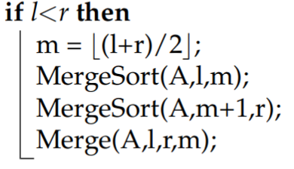
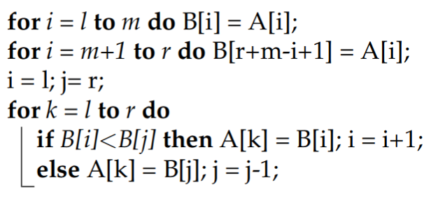
DP_______________________________
Vorgehen:
1) Tabelle aufstellen
-Dimensionen? Bedeutung eines Slots?
2) Wie berechnet man nen Slot?
3) Berechnungs-Reihenfolge
welche Einträge müssen vorhanden sein für current slot?
4) wie Lösung aus Tab. Herauslesen?

Matrix
Für 1 slot - FORMEL:
cost = m[i,k]+m[k+1,j]+dim_(i-1)*dim_k*dim_j
I = leftmost index, j = rightmost index, k = inbetween index of parenthesis

MatrixChainDP(d): → O(n³) ->3x for loops
from i=1 to n do: m[i,i] = 0 //init Diagonale zu 0
from “currLen”=1 to n (tot.length) do:
from left=1 to currLen do:
right = left + 1
m[l,r] = ‘infinity’
from k=left to right do:
cost = FORMEL
if (cost < m[l,r] ) then: // if cheaper version found
m[l,r] = cost
klammern[l,r] = k // Klammer setzen bei k
return (m(Konstentabelle), klammern)
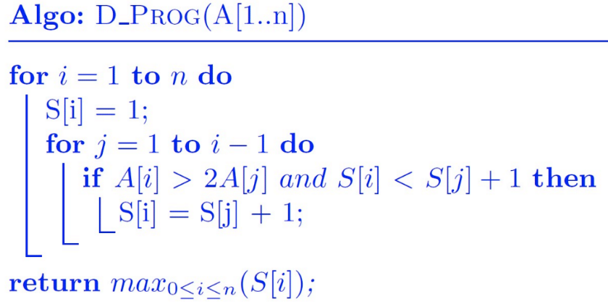
Longest common increasing subsequence
Fibonacci
base case: f_1=1, f_2=1 →if (n<=2) return 1
Formel: f_n = f_(n-1) + f_(n-2) → f_n = fibo(n-1) + fibo(n-2)
fiboRec(n):  if (n<=2): return1  return fibo(n-1) + fibo(n-2) | fiboMemo(n): [top-down]  // check if already stored  if (memo[n] != NIL): return memo[n]  // suscht berächne  if (n<=2): memo[n] = 1  else: memo[n] = fiboMemo(n-1) + fiboMemo(n-2)  return memo[n] | fiboMemo(n): [bottom-up]  memo[1] = 1; memo[2] = 1;  from i=3 to n do:  memo[i] = memo[i-1] + memo[i-2]  return memo
→ O(n), Platz: acuh n!
Longest common subsequence
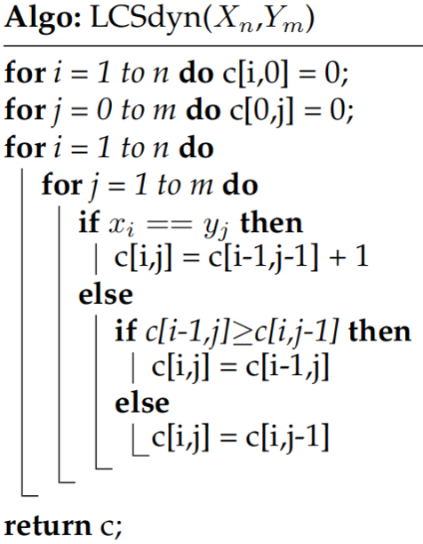

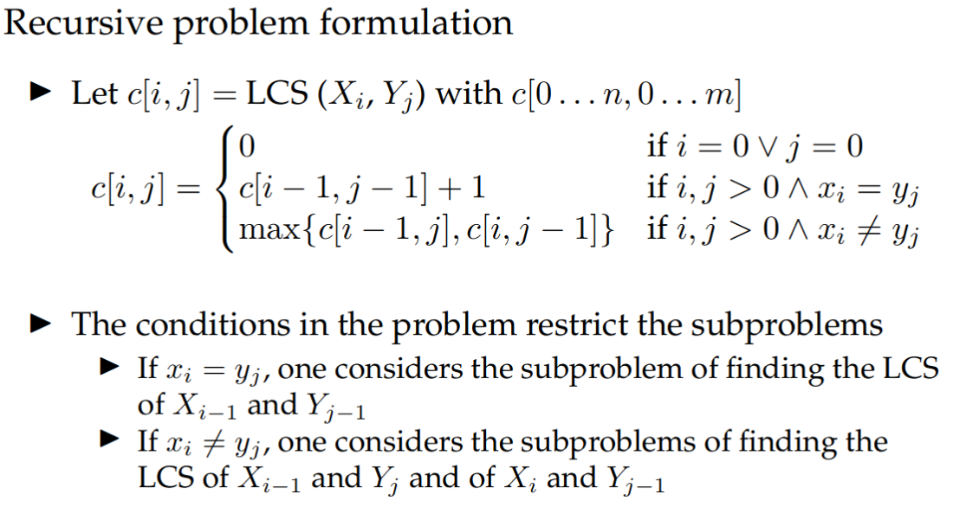
Wine profit
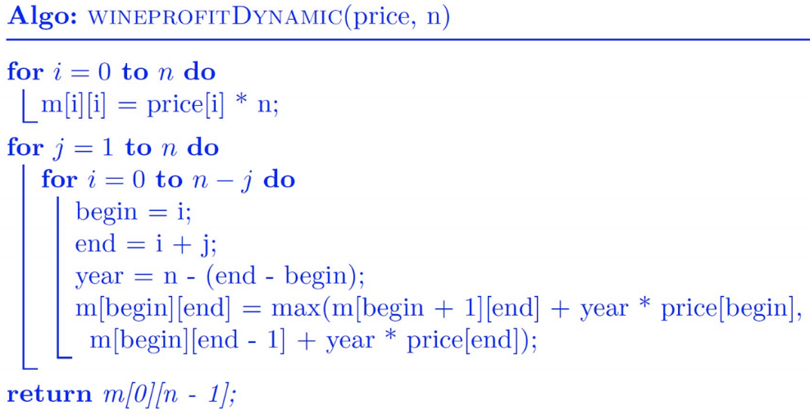
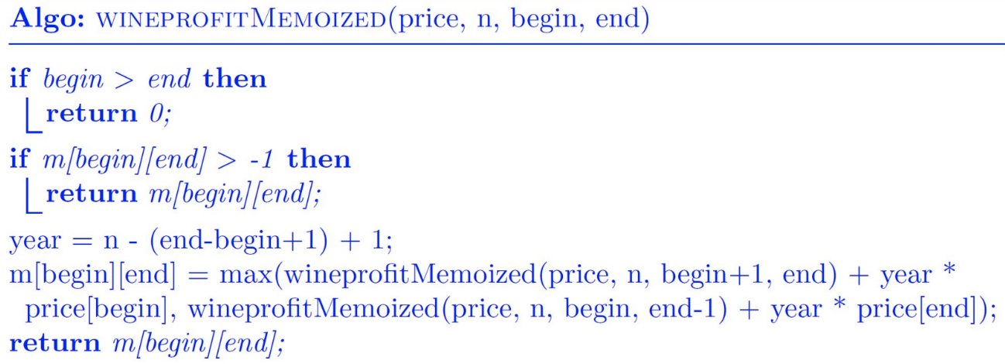
Knapsack

KSRec( tot.itelms(n), capa(city) ):
// if no items or no capa (remaining) // base case
if (n <= 0 || capa <= 0) then: result = 0
// if weight exceeds capa
else if (weights[n] > capa) then:
result = KSRec(n-1, capa) // go to next item in the array
else:
// what’s better? To put item in KS or nah?
x1 = KSRec(n-1, capa)
x2 = values[n] + 1KSRec(n-1, capa – weights[n])
result = max{ x1, x2 }
return result

KSMemo(n, capa):
// base case: same as KSRec()
// check if we’ve already got that optimum
if ( !(results[n-1, capa]) ):
results[n-1, capa] = calculate(n-1, capa)
// item doesn’t fit in the bag
if (w[n] > capa):
results[n, capa] = results[n-1, capa] // take previous optimum
else:
// calc costs with current item
if ( !( results[n-1, capa-w[n]] ):
results[n-1, capa-w[n]] = calculate it()
// result = max of with/without current item
results[n, capa] =
max{ r[n-1, capa], r[n-1, capa-w[n] + values[n]) }
return results[n, capa]

KSBottomUp(n, capa, cost, profit):
results[n, capa] “R”
// init base cases
for( i=0 to n ): R[i][0] = 0
for( c = 0 to capa ): R[0][c] = 0
// fill up table
for( i = 0 to n ):
for( c = 0 to capa ):
if( cost[i-1] > capa ): R[i, c] = R[i-1, c]
else:
R[i, c] =
max{ R[i-1, c], R[i-1, (capa-cost[i-1]) + profit[i-1] }
return R(esults)

Recursive definition
f(x, capa “c”) =
0 if x = 0 or capa = 0
f(x-1, c) if cost[x] > capa
max{ f(x-1, c), f(x-1, c-cost[x])+profit[x] } else

HT → sichern konstanter Zugriff auf Elemente

Hash functions
Division: h(k) = k mod m
Multiplication: h(k) = m*(kA mod 1) | abgerundet, A=((sqrt(5)-1)/2

Collision resolution
-Chaining: use linked list
-lin.probing: h(k,i) = (h’(k)+ic) mod m
c = constant (= 1 unless stated otherwise)
i gets incremeted every time there’s a collision
-()² probing: h(k,i) = (h’(k) + c_1(i) + c_2(i)²) mod m
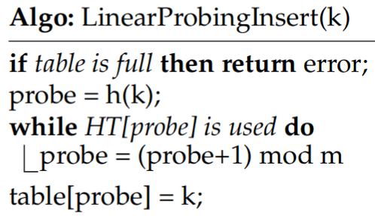
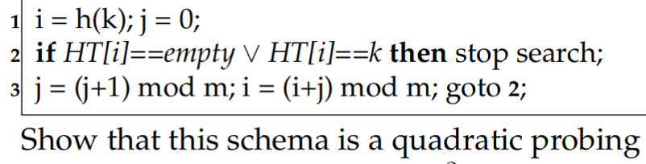
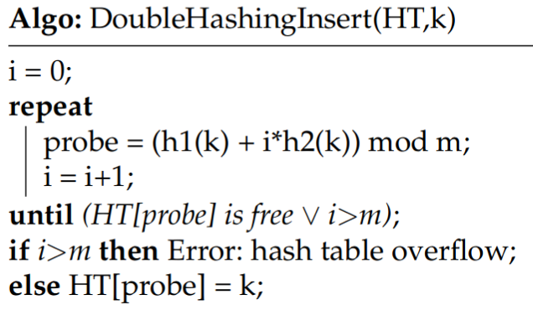
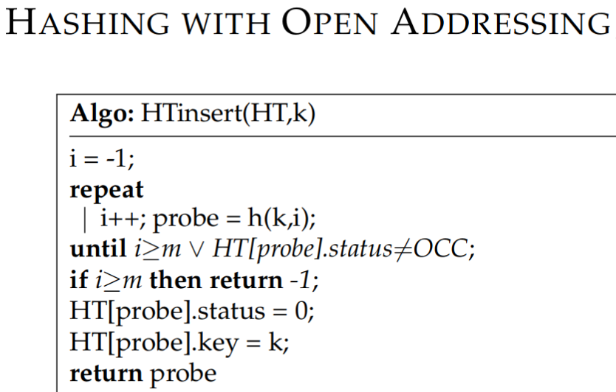
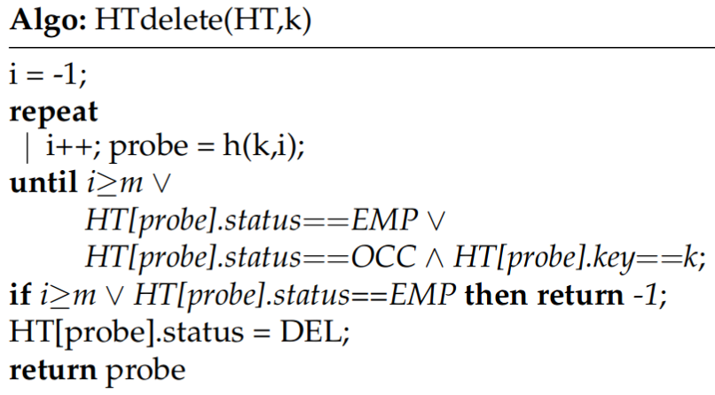
-double hashing: h(k,i) = (h_1(k) + ih_2(k)) mod m

