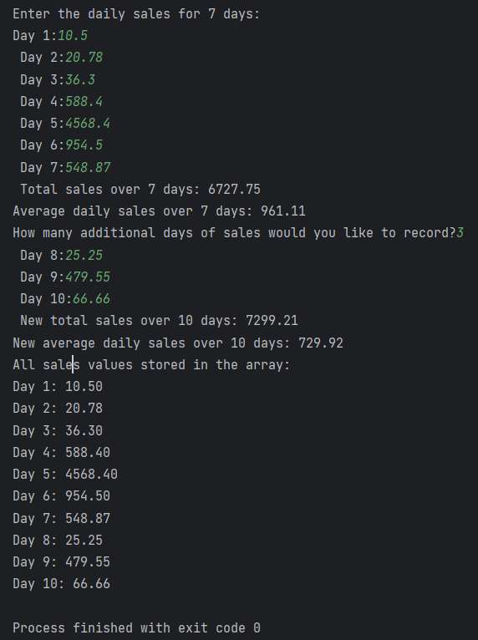

#include <stdio.h>
int main() {
float sales[7];
float total = 0;
float average;
printf("Enter the daily sales for 7 days:\n");
for (int i = 0; i < 7; i++) {
printf("Day %d: ", i + 1);
scanf("%f", &sales[i]); // Adding inputed value to the array
total += sales[i]; // Adding inputed value to the total sales
}
average = total / 7; // Calculating the average sales
printf("Total sales over 7 days: %.2f\n", total);
printf("Average daily sales over 7 days: %.2f\n", average);
int additionalDays;
printf("How many additional days of sales would you like to record? ");
scanf("%d", &additionalDays); // Getting the number of additional days
float newTotal = total;
for (int i = 7; i < 7 + additionalDays; i++) {
printf("Day %d: ", i + 1);
scanf("%f", &sales[i]); // Adding inputed value to the array
newTotal += sales[i]; // Adding inputed value to the total sales
}
average = newTotal / (7 + additionalDays); // Calculating the average sales
printf("New total sales over %d days: %.2f\n", 7 + additionalDays, newTotal);
printf("New average daily sales over %d days: %.2f\n", 7 + additionalDays, average);
printf("All sales values stored in the array:\n");
for (int i = 0; i < 7 + additionalDays; i++) { // Looping through the array
printf("Day %d: %.2f\n", i + 1, sales[i]); // Printing all the values in the array
}
return 0;
}

