

Project

Subject: English

Topic: Baroque art & Architecture

Worked by: Oltion Bardhoci A-1-E

Accepted by: Anjeza Brahja

The Origin Of The Term  
The term Baroque probably ultimately derived from the Italian word *barocco*, which philosophers used during the [Middle Ages](https://www.britannica.com/event/Middle-Ages) to describe an obstacle in schematic [logic](https://www.britannica.com/topic/logic). Subsequently the word came to denote any contorted idea or involuted process of thought. Another possible source is the Portuguese word *barroco* (Spanish *barrueco*), used to describe an irregular or imperfectly shaped [pearl](https://www.britannica.com/topic/pearl-gemstone), and this usage still survives in the jeweler’s term [*baroque pearl*](https://www.britannica.com/art/baroque-pearl).

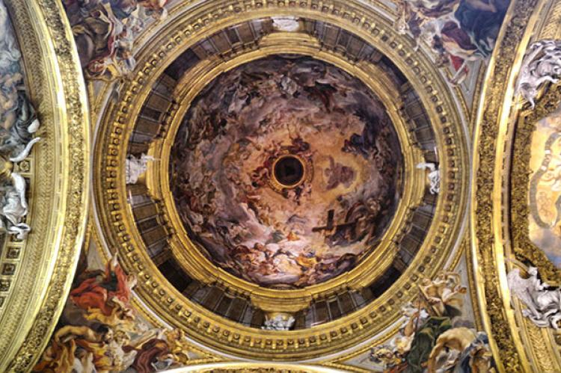

In [art criticism](https://www.britannica.com/art/art-criticism) the word Baroque came to be used to describe anything irregular, bizarre, or otherwise departing from established rules and proportions. This [biased](https://www.merriam-webster.com/dictionary/biased) view of 17th-century art styles was held with few modifications by critics from [Johann Winckelmann](https://www.britannica.com/biography/Johann-Joachim-Winckelmann) to [John Ruskin](https://www.britannica.com/biography/John-Ruskin) and [Jacob Burckhardt](https://www.britannica.com/biography/Jacob-Burckhardt), and until the late 19th century the term always carried the [implication](https://www.merriam-webster.com/dictionary/implication) of odd, grotesque, exaggerated, and overdecorated. It was only with [Heinrich Wölfflin](https://www.britannica.com/biography/Heinrich-Wolfflin)’s pioneer study *Renaissance und Barock* (1888) that the term Baroque was used as a stylistic [designation](https://www.merriam-webster.com/dictionary/designation) rather than as a term of thinly veiled abuse, and a systematic formulation of the characteristics of Baroque style was achieved.

Three Main Tendencies Of The Era

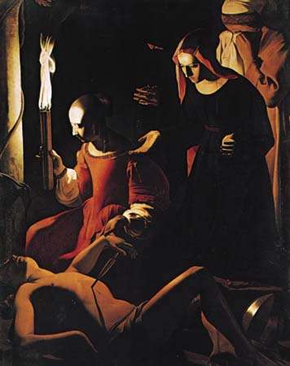Three broader cultural and [intellectual](https://www.merriam-webster.com/dictionary/intellectual) tendencies had a profound impact on Baroque art as well as [Baroque music](https://www.britannica.com/art/Baroque-music). The first of these was the emergence of the [Counter-Reformation](https://www.britannica.com/event/Counter-Reformation) and the expansion of its domain, both territorially and intellectually. By the last decades of the 16th century the refined, courtly style known as [Mannerism](https://www.britannica.com/art/Mannerism) had ceased to be an effective means of expression, and its inadequacy for religious art was being increasingly felt in artistic circles. To counter the inroads made by the [Reformation](https://www.britannica.com/event/Reformation), the [Roman Catholic](https://www.britannica.com/topic/Roman-Catholicism) Church after the [Council of Trent](https://www.britannica.com/event/Council-of-Trent) (1545–63) adopted a [propagandistic](https://www.britannica.com/topic/propaganda) stance in which art was to serve as a means of extending and stimulating the public’s faith in the church. To this end the church adopted a conscious artistic program whose art products would make an overtly emotional and sensory appeal to the faithful. The Baroque style that evolved from this program was paradoxically both sensuous and spiritual; while a naturalistic treatment rendered the religious image more accessible to the average churchgoer, dramatic and illusory effects were used to stimulate piety and devotion and convey an impression of the splendour of the divine. Baroque church ceilings thus dissolved in painted scenes that presented vivid views of the [infinite](https://www.merriam-webster.com/dictionary/infinite) to the observer and directed the senses toward heavenly concerns.

The second tendency was the consolidation of [absolute](https://www.britannica.com/topic/absolutism-political-system) [monarchies](https://www.britannica.com/topic/monarchy), accompanied by a simultaneous crystallization of a prominent and powerful middle class, which now came to play a role in art patronage. Baroque palaces were built on an expanded and monumental scale in order to display the power and grandeur of the centralized state, a phenomenon best displayed in the royal palace and gardens at [Versailles](https://www.britannica.com/topic/Palace-of-Versailles). Yet at the same time the development of a picture market for the middle class and its taste for [realism](https://www.britannica.com/art/realism-art) may be seen in the works of the brothers [Le Nain](https://www.britannica.com/biography/Le-Nain-brothers) and [Georges de La Tour](https://www.britannica.com/biography/Georges-de-La-Tour) in France and in the varied schools of 17th-century Dutch painting. (For a detailed discussion of this phenomenon, *see* [Rembrandt van Rijn](https://www.britannica.com/biography/Rembrandt-van-Rijn).)

The third tendency was a new interest in nature and a general broadening of human intellectual horizons, spurred by developments in science and by [explorations](https://www.britannica.com/topic/European-exploration) of the globe. These simultaneously produced a new sense both of human insignificance (particularly abetted by the [Copernican](https://www.britannica.com/science/Copernican-system)displacement of the [Earth](https://www.britannica.com/place/Earth) from the centre of the universe) and of the unsuspected complexity and infinitude of the natural world. The development of 17th-century [landscape](https://www.britannica.com/art/landscape-art) painting, in which humans are frequently portrayed as minute figures in a vast natural setting, is indicative of this changing awareness of the human condition.

Architecture, Painting, And Sculpture

The arts present an unusual [diversity](https://www.merriam-webster.com/dictionary/diversity) in the Baroque period, chiefly because currents of [naturalism](https://www.britannica.com/topic/naturalism-art)and [classicism](https://www.britannica.com/art/Neoclassicism) coexisted and intermingled with the typical Baroque style. Indeed, [Annibale Carracci](https://www.britannica.com/biography/Annibale-Carracci)and [Caravaggio](https://www.britannica.com/biography/Caravaggio), the two Italian painters who decisively broke with [Mannerism](https://www.britannica.com/art/Mannerism) in the 1590s and thus helped usher in the Baroque style, painted, respectively, in classicist and realist modes. A specifically Baroque style of [painting](https://www.britannica.com/art/painting) arose in [Rome](https://www.britannica.com/place/Rome) in the 1620s and culminated in the monumental painted ceilings and other church decorations of [Pietro da Cortona](https://www.britannica.com/biography/Pietro-da-Cortona), [Guido Reni](https://www.britannica.com/biography/Guido-Reni), [Il Guercino](https://www.britannica.com/biography/Il-Guercino), [Domenichino](https://www.britannica.com/biography/Domenichino), and countless lesser artists. The greatest of the Baroque sculptor-architects was [Gian Lorenzo Bernini](https://www.britannica.com/biography/Gian-Lorenzo-Bernini), who designed both the [baldachin](https://www.britannica.com/technology/baldachin-architecture) with spiral columns above the altar of [St. Peter’s](https://www.britannica.com/topic/Saint-Peters-Basilica) in Rome and the vast [colonnade](https://www.britannica.com/technology/colonnade-architecture) fronting that church. Baroque [architecture](https://www.britannica.com/topic/architecture) as developed by Bernini, [Carlo Maderno](https://www.britannica.com/biography/Carlo-Maderno), [Francesco Borromini](https://www.britannica.com/biography/Francesco-Borromini), and [Guarino Guarini](https://www.britannica.com/biography/Guarino-Guarini) emphasized massiveness and monumentality, movement, dramatic spatial and lighting sequences, and a rich [interior decoration](https://www.britannica.com/art/interior-design) using contrasting surface textures, vivid colours, and luxurious materials to heighten the structure’s physical immediacy and evoke sensual delight.

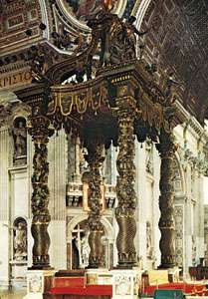

Pronounced classicizing tendencies subdued the Baroque impulse in France, as is evident in the serious, logical, orderly paintings of [Nicolas Poussin](https://www.britannica.com/biography/Nicolas-Poussin) and the somewhat more sumptuous works of [Charles Le Brun](https://www.britannica.com/biography/Charles-Le-Brun) and the portraitists [Hyacinthe Rigaud](https://www.britannica.com/biography/Hyacinthe-Rigaud) and [Nicolas de Largillière](https://www.britannica.com/biography/Nicolas-de-Largilliere). French architecture is even less recognizably Baroque in its pronounced qualities of subtlety, elegance, and restraint. Baroque tenets were enthusiastically adopted in staunchly Roman Catholic Spain, however, particularly in architecture. The greatest of the Spanish builders, [José Benito Churriguera](https://www.britannica.com/biography/Jose-Benito-Churriguera), shows most fully the Spanish interest in surface textures and lush detail. He attracted many followers, and their [adaptations](https://www.merriam-webster.com/dictionary/adaptations) of his style, labeled [Churrigueresque](https://www.britannica.com/art/Churrigueresque), spread throughout Spain’s colonies in the Americas and elsewhere. (For a detailed discussion of the Baroque in [Latin America](https://www.britannica.com/place/Latin-America), *see* [Latin American art](https://www.britannica.com/art/Latin-American-art).) [Diego Velázquez](https://www.britannica.com/biography/Diego-Velazquez) and other 17th-century Spanish painters used a sombre but powerful naturalistic approach that bore little direct relation to the mainstream of Baroque [painting](https://www.britannica.com/art/painting).

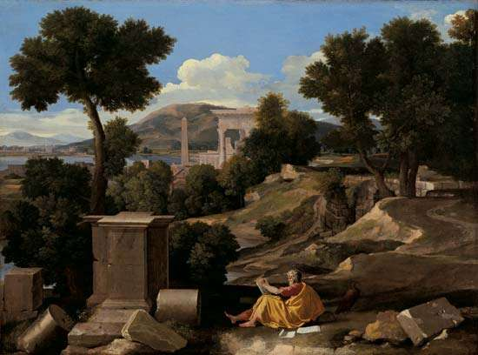

The Baroque made only limited inroads into northern Europe, notably in what is now Belgium. That Spanish-ruled, largely Roman Catholic region’s greatest master was the painter [Peter Paul Rubens](https://www.britannica.com/biography/Peter-Paul-Rubens), whose tempestuous diagonal [compositions](https://www.merriam-webster.com/dictionary/compositions) and ample, full-blooded figures are the [epitome](https://www.merriam-webster.com/dictionary/epitome) of Baroque painting. The elegant portraits of [Anthony van Dyck](https://www.britannica.com/biography/Anthony-Van-Dyck) and the [robust](https://www.merriam-webster.com/dictionary/robust) figurative works of [Jacob Jordaens](https://www.britannica.com/biography/Jacob-Jordaens) emulated Rubens’s example. Art in the Netherlands was conditioned by the realist tastes of its dominant middle-class patrons, and thus both the innumerable [genre](https://www.merriam-webster.com/dictionary/genre) and landscape painters of that country and such towering masters as [Rembrandt](https://www.britannica.com/biography/Rembrandt-van-Rijn) and [Frans Hals](https://www.britannica.com/biography/Frans-Hals) remained independent of the Baroque style in important respects. The Baroque did have a notable impact in England, however, particularly in the churches and palaces designed, respectively, by [Sir Christopher Wren](https://www.britannica.com/biography/Christopher-Wren) and [Sir John Vanbrugh](https://www.britannica.com/biography/John-Vanbrugh).

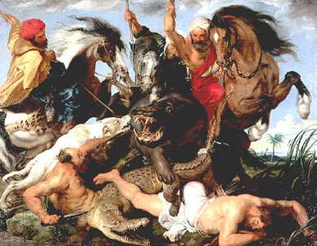

*The Hippopotamus Hunt*, oil on canvas by Peter Paul Rubens, *c.* 1615–16; in the Alte Pinakothek, Munich.*Alte Pinakothek, Munich; photograph, Joachim Blauel/Artothek*

The last flowering of the Baroque was in largely Roman Catholic southern Germany and Austria, where the native architects broke away from Italian building models in the 1720s. In ornate churches, monasteries, and palaces designed by [J.B. Fischer von Erlach](https://www.britannica.com/biography/Johann-Bernhard-Fischer-von-Erlach), [J.L. von Hildebrandt](https://www.britannica.com/biography/Johann-Lucas-von-Hildebrandt), [Balthasar Neumann](https://www.britannica.com/biography/Balthasar-Neumann), [Dominikus Zimmermann](https://www.britannica.com/biography/Dominikus-Zimmermann), and brothers [Cosmas Damian Asam](https://www.britannica.com/biography/Cosmas-Damian-Asam) and [Egid Quirin Asam](https://www.britannica.com/biography/Egid-Quirin-Asam), an extraordinarily rich but delicate style of [stucco](https://www.britannica.com/technology/stuccowork) decoration was used in combination with painted surfaces to evoke subtle illusionistic effects.

# **10 Masterpieces of Baroque Architecture**

Baroque architecture flourished between the late 16th and mid-18th century. The architectural style which emerged in Italy soon spread to the rest of Europe and by the 17th century, Spanish Baroque style (also referred to as Churrigueresque) reached Latin America. Initially used to express the triumph of the Roman Catholic Church over Protestant Reformation, the architectural style later also came to be used as a visual demonstration of absolutist regime in the form of magnificent palaces. Listed below are 10 masterpieces of Baroque architecture, both religious and secular.

## San Carlo alle Quattro Fontane, Rome

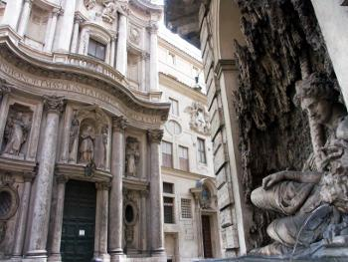

Designed by one of the leading Baroque architects Francesco Borromini (1599-1667), the San Carlo alle Quattro Fontane (also known as the Church of Saint Charles at the Four Fountains) is one of the finest examples of Baroque architecture. The Roman Catholic church was built between 1638 and 1646 when it was consecrated, while the facade was completed in the 1670s by Borromini’s nephew Bernardo.

## St. Peter's Square, Vatican

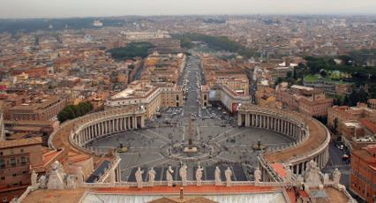The St. Peter’s Square and its imposing colonnades with 140 statues of saints are the work of Gian Lorenzo Bernini (1598-1680) who was next to Francesco Borromini one of the most prominent architects of the Baroque era. He also built the left fountain largely following the design of the earlier Carlo Maderno’s fountain (on the right) to create a symmetry. In the center of the square stands an ancient Egyptian obelisk which was erected on its current site in 1586 by Domenico Fontana.

## Les InvalidesLes Invalides, Paris

Les Invalides is one of the greatest masterpieces of French Baroque architecture. Most of the complex was built by French architect Liberal Bruant (1635-1697), while the spectacular chapel dome was completed by Jules Hardouin Mansart (1644-1708). Built as a retirement home and hospital for veterans between 1671 and 1678, Les Invalides is today home to the museum of the French Army, museum of military models and museum of contemporary history. But it is also the final resting place of several French national heroes including Napoleon Bonaparte.

## Palace of Versailles, Versailles

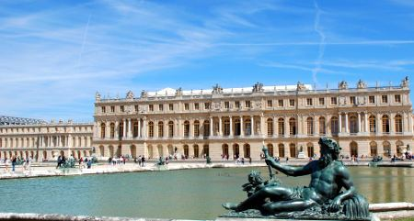The Palace of Versailles, one of the grandest palaces ever built is the finest example of secular Baroque architecture. Commissioned by Louis XIV (1643-1715) in the 1660s, most of the palace including its spectacular Hall of Mirrors was designed by architect Jules Hardouin Mansart. The Sun King’s successors made some alterations but the magnificent palace and its gardens are just as impressive as they were in the time of Louis XIV. Since 1837, the Palace of Versailles is open to the public as a museum.

## KarlskircheKarlskirche, Vienna

The beautiful Baroque church is one of Vienna’s most admired buildings. It was commissioned by the Holy Roman Emperor Charles VI (1685-1740) who vowed to build a church after the last major plague outbreak in the early 18th century. Karlskirche was built between 1716 and 1737 after the design of Austrian architect Johann Bernhard Fischer von Erlach (1656-1723) who won the competition for design of the church. He died before completion of his masterpiece which was completed by his son Joseph Emanuel.

## Schönbrunn Palace, Vienna

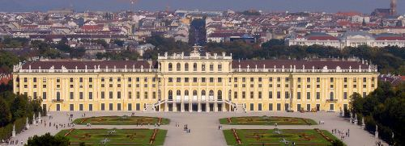

The Schönbrunn Palace is a former summer residence of the Habsburg monarchs that was built in late Baroque style. Just like Karlskirche, the Austrian version of the Palace of Versailles is the work of architect Johann Bernhard Fischer von Erlach although it later went through some changes. After the collapse of Austria-Hungary and the downfall of the Habsburgs in 1918, the palace became owned by the Republic of Austria and was eventually opened to the public as a museum.

## St Paul's CathedralSt Paul's Cathedral, London

Built on a site of an earlier church that was severely damaged in the Great Fire of London in 1666, the St Paul’s Cathedral is widely considered as one of the finest examples of English Baroque architecture. The design is the work of the celebrated English architect Sir Christopher Wren (1632-1723) who was also commissioned to rebuilt over 50 churches that were damaged in the Great Fire and many notable secular buildings across England. From 1710 when completed until 1962, St Paul’s was the tallest building in London.

## Winter Palace, Saint Petersburg

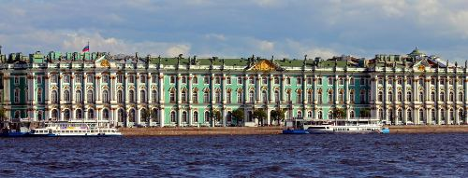

The Winter Palace was built as the residence of Peter the Great (1672-1725) in Saint Petersburg and served as the official residence of the Romanov monarchs from 1732 until the Russian Revolution of 1917. Peter’s palace which was designed by Swiss Italian architect Domenico Trezzini in the so-called Petrine Baroque style, however, was altered considerably by his successors. Most of its present-day appearance dates from the late 1830s when it was rebuilt due to damage caused by a fire. The Winter Palace was also severely damaged during the Siege of Leningrad (1941-44) but was later restored in its former grandeur.

## Cathedral of Santiago de Compostela, Western Facade

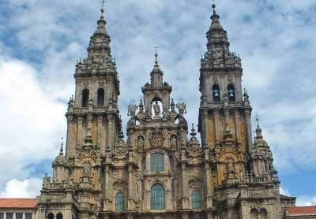One of Spain’s most famous cathedrals and a pilgrimage site since the Middle Ages, the Cathedral of Santiago de Compostela is a Romanesque building. But the later added western facade of Obradoiro is widely considered as one of the most beautiful examples of Spanish Baroque style or Churrigueresque (named after Spanish architect Jose Benito de Churriguera). The facade was built in the 18th century by architect Fernando de Casas Novoa.

## Zacatecas Cathedral, Zacatecas

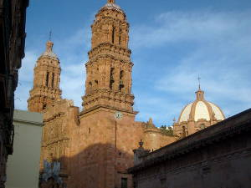The Zacatecas Cathedral in the city of Zacatecas, Mexico, is regarded as one of the finest examples of Mexican Baroque architecture. The cathedral basilica was built between 1730 and 1760 by an unknown architect on a site of an earlier 16th century church. In addition to reflecting the influence of the Spanish Churrigueresque, the cathedral also reflects incorporation of indigenous decorative elements. In 1993, it was inscribed in the list of UNESCO World Heritage Sites as a part of the Historic Center of Zacatecas.

Table of Content

* The Origin Of The Term
* Three Main Tendencies of the Era
* Architecture,Painting, and Sculpture
* Examples of Baroque Architecture