Exercise.

Chapter 6. Loops

1. Write a program that prints on the console **the numbers from 1 to N**. The number **N** should be read from the standard input.

using System;

namespace detyra1

{

class Program

{

static void Main(string[] args)

{

Console.Write("Enter first number: ");

int length = Int32.Parse(Console.ReadLine());

for (int i = 1; i < length; i++)

Console.WriteLine(i);

}

}

}

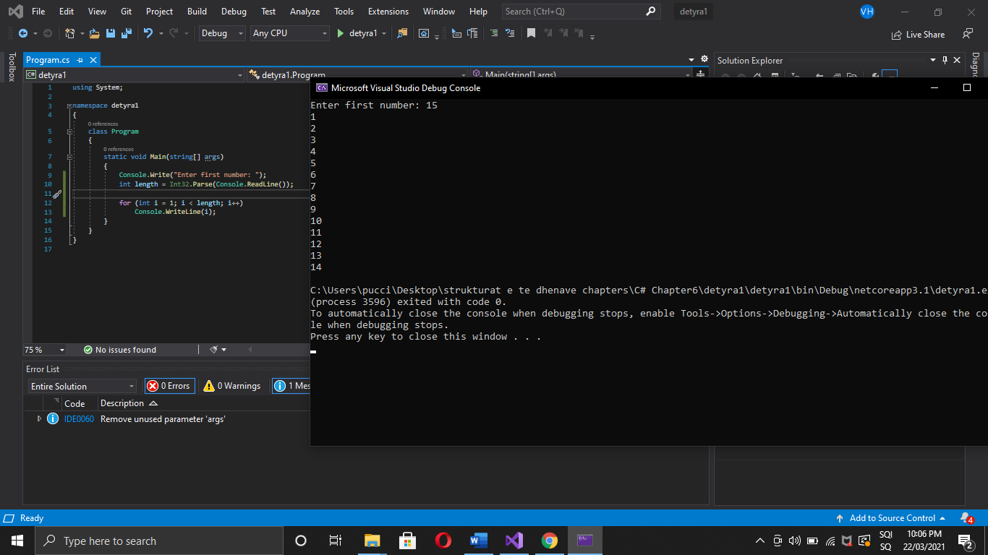

1. Write a program that prints on the console the numbers from 1 to N, which are **not divisible by 3 and 7 simultaneously**. The number N should be read from the standard input.

using System;

namespace detyra2

{

class Program

{

static void Main(string[] args)

{

Console.Write("Enter N: ");

int length = Int32.Parse(Console.ReadLine());

for (int i = 1; i < length; i++)

{

if (i % (3 * 7) != 0) Console.WriteLine(i);

}

}

}

}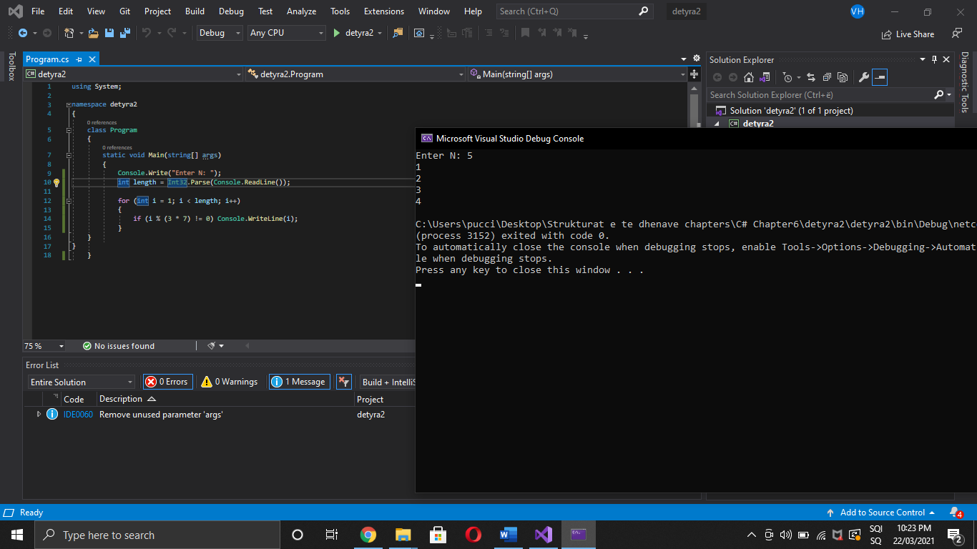

1. . Write a program that reads from the console a series of integers and prints the **smallest** and **largest** of them.

using System;

namespace detyra3

{

class Program

{

static void Main(string[] args)

{

int lowest = 0, highest = 0, input;

Console.Write("Enter numbers length: ");

int lenght = Int32.Parse(Console.ReadLine());

for (int i = 0; i < lenght; i++)

{

Console.Write("Enter number: ");

input = Int32.Parse(Console.ReadLine());

if (i == 0) lowest = highest = input;

else

{

if (lowest > input) lowest = input;

if (highest < input) highest = input;

}

}

Console.WriteLine("Lowest - {0}, Highest - {1}", lowest, highest);

}

}

}

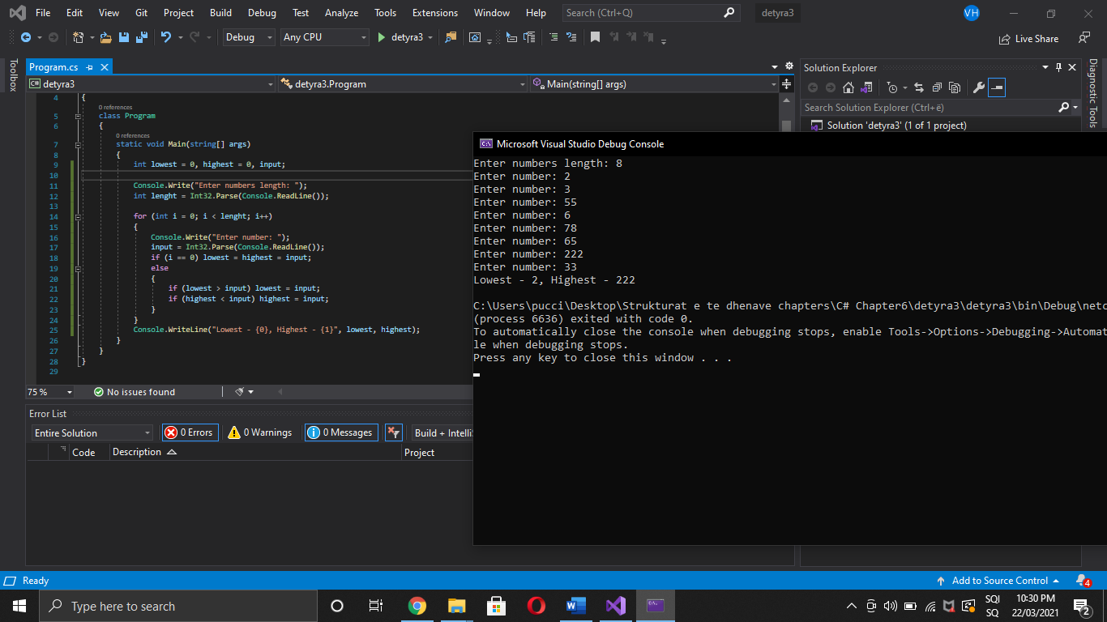

1. Write a program that prints **all possible cards from a standard deck** of cards, without jokers (there are 52 cards: 4 suits of 13 cards)

using System;

namespace detyra4

{

class Program

{

static void Main(string[] args)

{

for (int i = 0; i < 4; i++)

{

if (i != 0) Console.WriteLine();

for (int j = 0; j < 13; j++)

{

switch (i)

{

case 0: Console.Write("Hearts "); break;

case 1: Console.Write("Diamonds "); break;

case 2: Console.Write("Spades "); break;

case 3: Console.Write("Clubs "); break;

}

switch (j)

{

case 0: Console.WriteLine("2"); break;

case 1: Console.WriteLine("3"); break;

case 2: Console.WriteLine("4"); break;

case 3: Console.WriteLine("5"); break;

case 4: Console.WriteLine("6"); break;

case 5: Console.WriteLine("7"); break;

case 6: Console.WriteLine("8"); break;

case 7: Console.WriteLine("9"); break;

case 8: Console.WriteLine("10"); break;

case 9: Console.WriteLine("J"); break;

case 10: Console.WriteLine("Q"); break;

case 11: Console.WriteLine("K"); break;

case 12: Console.WriteLine("A"); break;

}

}

}

Console.ReadLine();

}

}

}

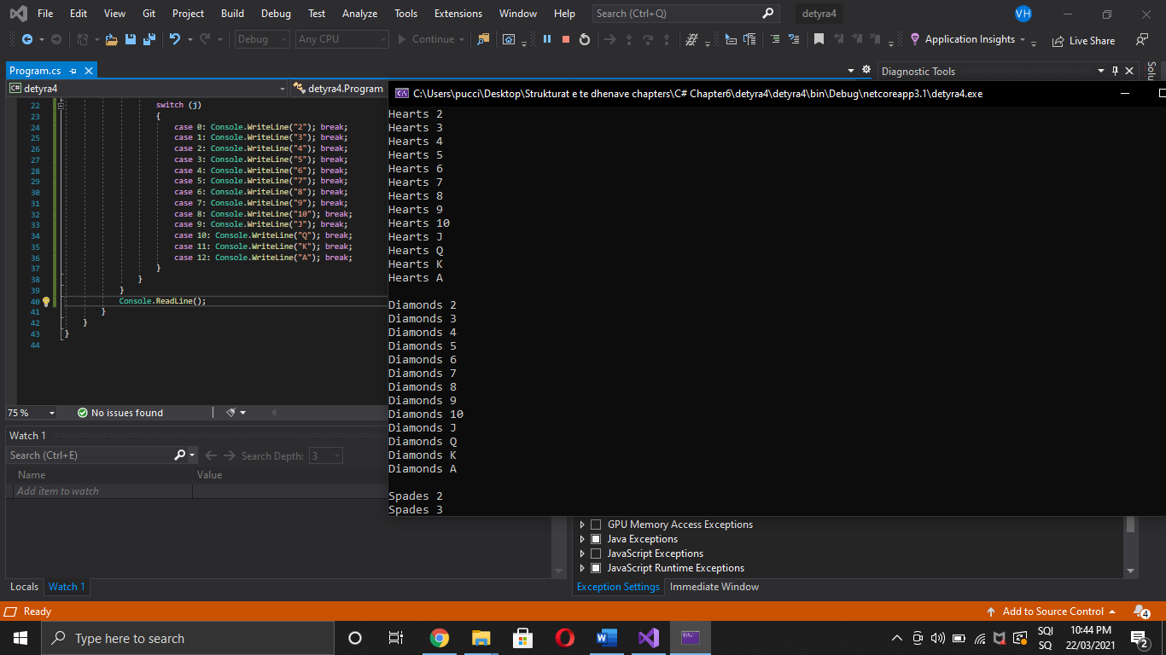

1. Write a program that reads from the console number N and print the sum of the first N members of the **Fibonacci sequence**: 0, 1, 1, 2, 3, 5, 8, 13, 21, 34, 55, 89, 144, 233, 377

using System;

namespace detyra5

{

class Program

{

static void Main(string[] args)

{

int firstN = 0, secondN = 1, thirdN = 0;

Console.Write("Enter N: ");

int length = Int32.Parse(Console.ReadLine());

Console.Write("0, 1,");

for (int i = 2; i < length; i++)

{

thirdN = firstN + secondN;

Console.Write(" {0},", thirdN);

firstN = secondN;

secondN = thirdN;

}

}

}

}

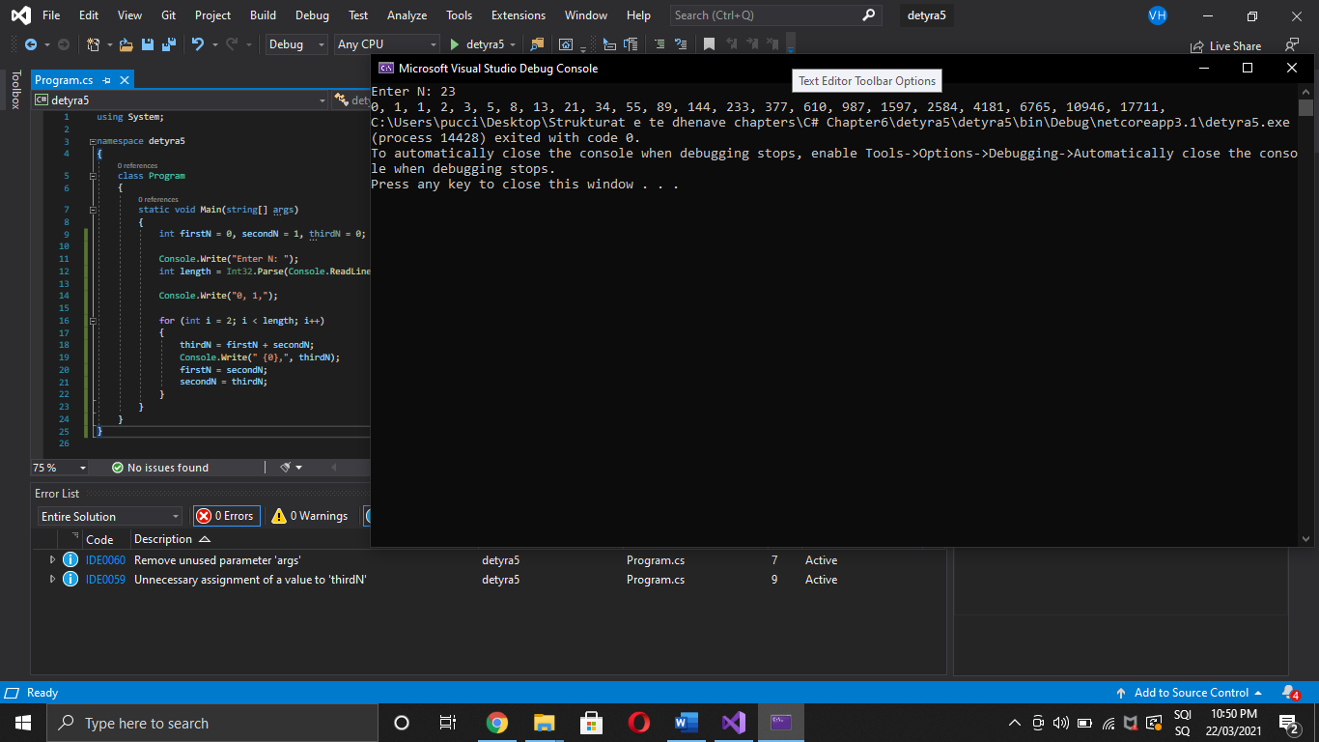

1. Write a program that calculates **N!/K!** for given N and K (1 < K < N).

using System;

namespace detyra66

{

class Program

{

static void Main(string[] args)

{

Console.Write("Enter N: (1<K<N) ");

int n = Int32.Parse(Console.ReadLine());

Console.Write("Enter K: (1<K<N) ");

int k = Int32.Parse(Console.ReadLine());

for (int i = n - 1; i > 0; i--)

{

n *= i;

}

for (int i = k - 1; i > 0; i--)

{

k *= i;

}

n /= k;

Console.WriteLine("Result is {0}", n);

}

}

}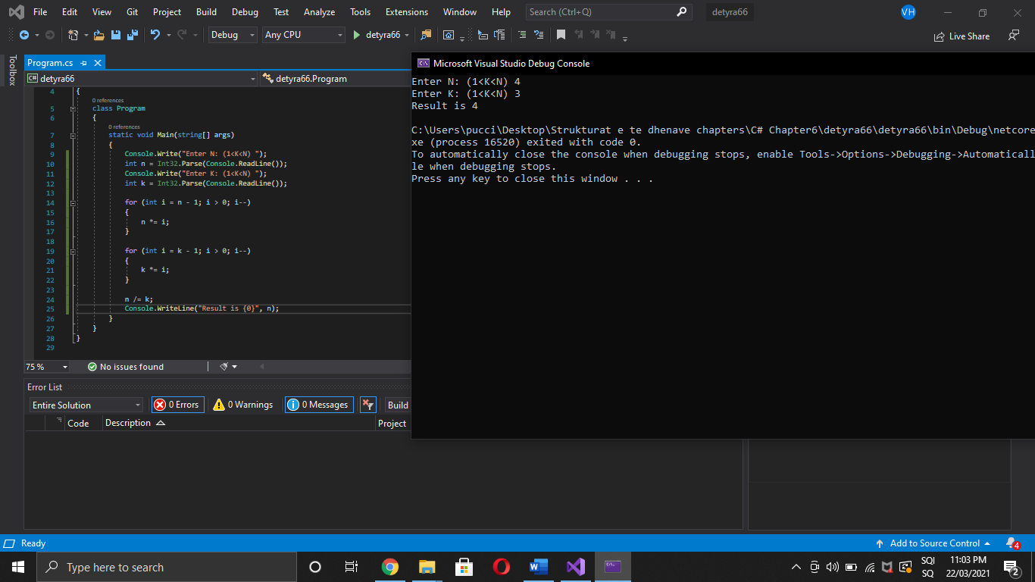

1. Write a program that calculates **N!*K!/(N-K)!** for given N and K (1 < K < N).

using System;

namespace detyra7

{

class Program

{

static void Main(string[] args)

{

Console.Write("Enter N: (1<K<N) ");

int n = Int32.Parse(Console.ReadLine());

Console.Write("Enter K: (1<K<N) ");

int k = Int32.Parse(Console.ReadLine());

int nMinusK = n - k;

for (int i = n - 1; i > 0; i--) n *= i;

for (int i = k - 1; i > 0; i--) k *= i;

for (int i = nMinusK - 1; i > 0; i--) nMinusK *= i;

Console.WriteLine("Result is {0}", n * k / nMinusK);

}

}

}

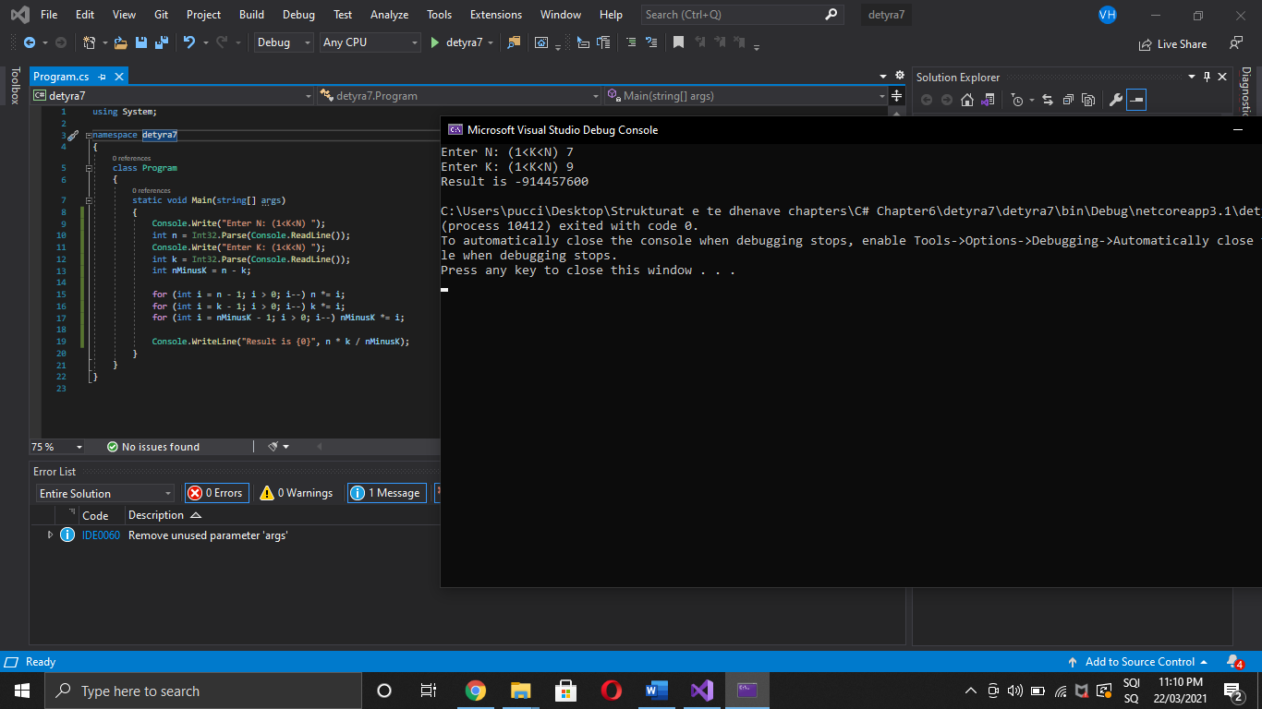

1. In combinatorics, the Catalan numbers are calculated by the following formula:  
   , for n ≥ 0.  
   Write a program that calculates the n-th Catalan number by given n.

using System;

namespace detyra8

{

class Program

{

static void Main(string[] args)

{

Console.Write("Enter N: (N >=0 ) ");

int n = Int32.Parse(Console.ReadLine());

int fact2N = 2 * n, factNplus1 = n + 1;

for (int i = fact2N - 1; i > 0; i--) fact2N *= i;

for (int i = factNplus1 - 1; i > 0; i--) factNplus1 *= i;

for (int i = n - 1; i > 0; i--) n *= i;

Console.WriteLine("Result is {0}", fact2N / (factNplus1 * n));

}

}

}

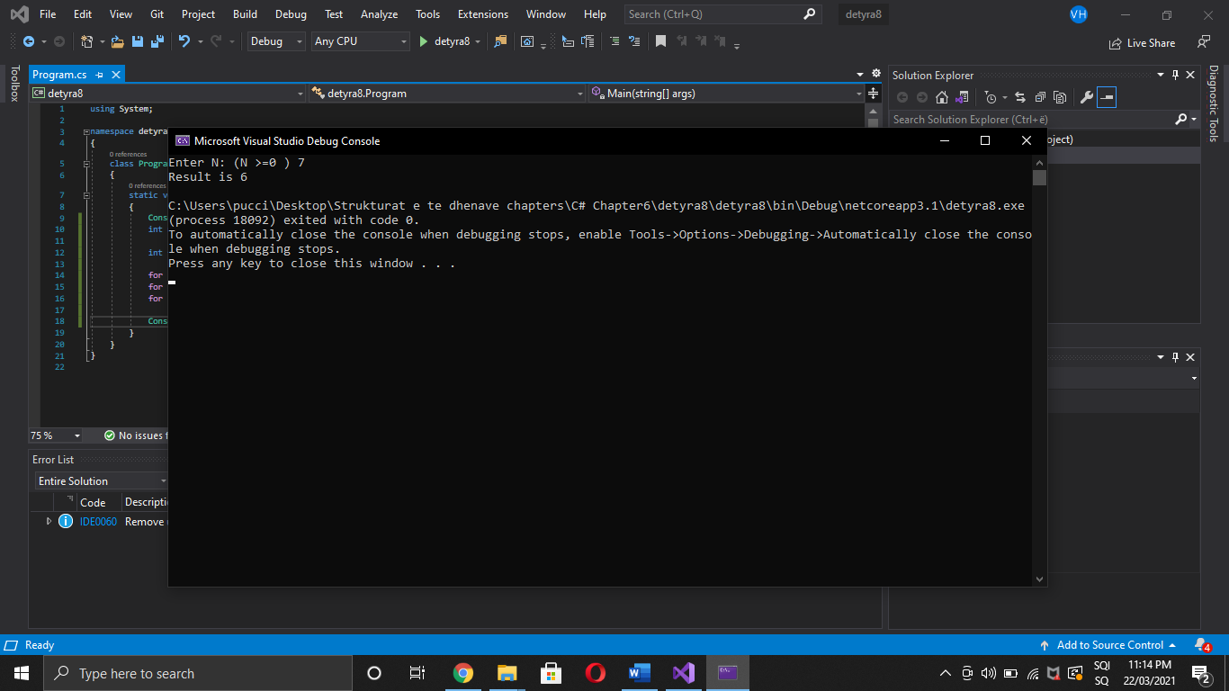

1. Write a program that for a given integers **n** and **x**, **calculates the sum**: 

using System;

namespace detyra9

{

class Program

{

static void Main(string[] args)

{

int sum = 1, temp = 1;

Console.Write("Enter n: ");

int n = Int32.Parse(Console.ReadLine());

Console.Write("Enter x: ");

int x = Int32.Parse(Console.ReadLine());

for (int i = 1; i <= n; i++)

{

temp *= i / x;

sum += temp;

}

Console.WriteLine("Result is {0}", sum);

}

}

}

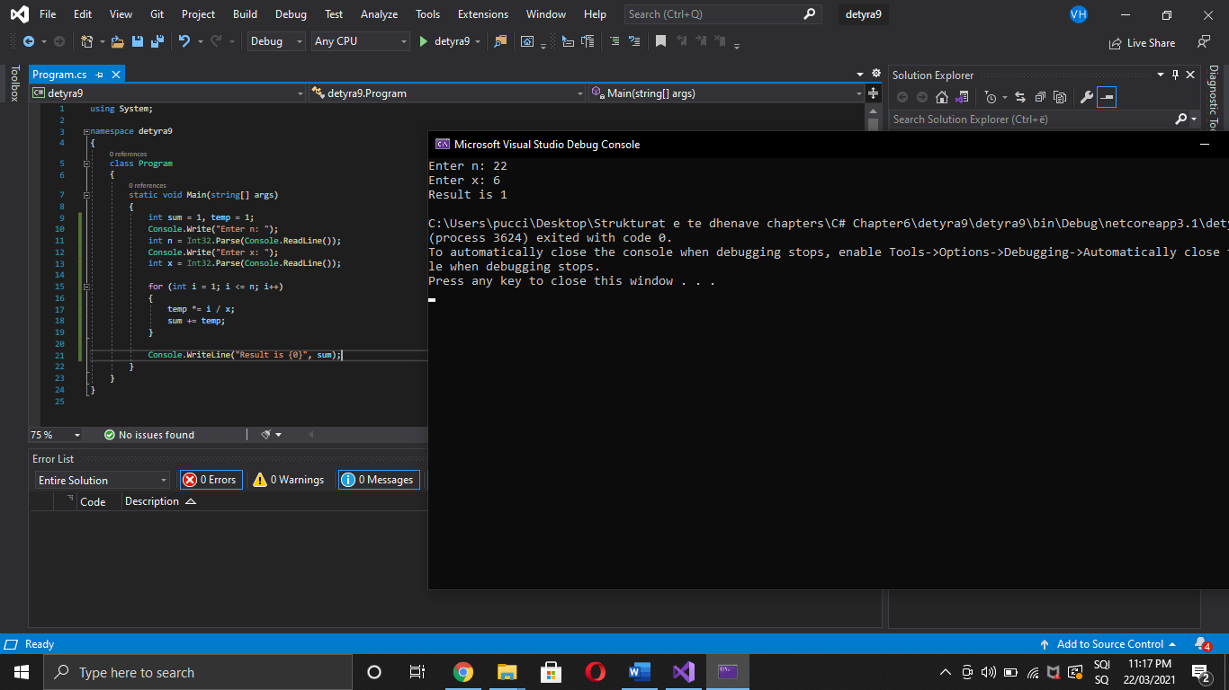

1. Write a program that reads from the console a **positive integer number N** (N < 20) and prints a **matrix** of numbers as on the figures below:

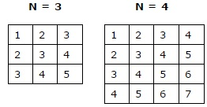

using System;

namespace detyra10

{

class Program

{

static void Main(string[] args)

{

Console.Write("Enter N: (N < 20) ");

int n = Int32.Parse(Console.ReadLine());

for (int i = 1; i <= n; i++)

{

for (int j = i; j <= i; j++)

{

Console.Write("{0} ", j);

}

Console.WriteLine();

}

}

}

}

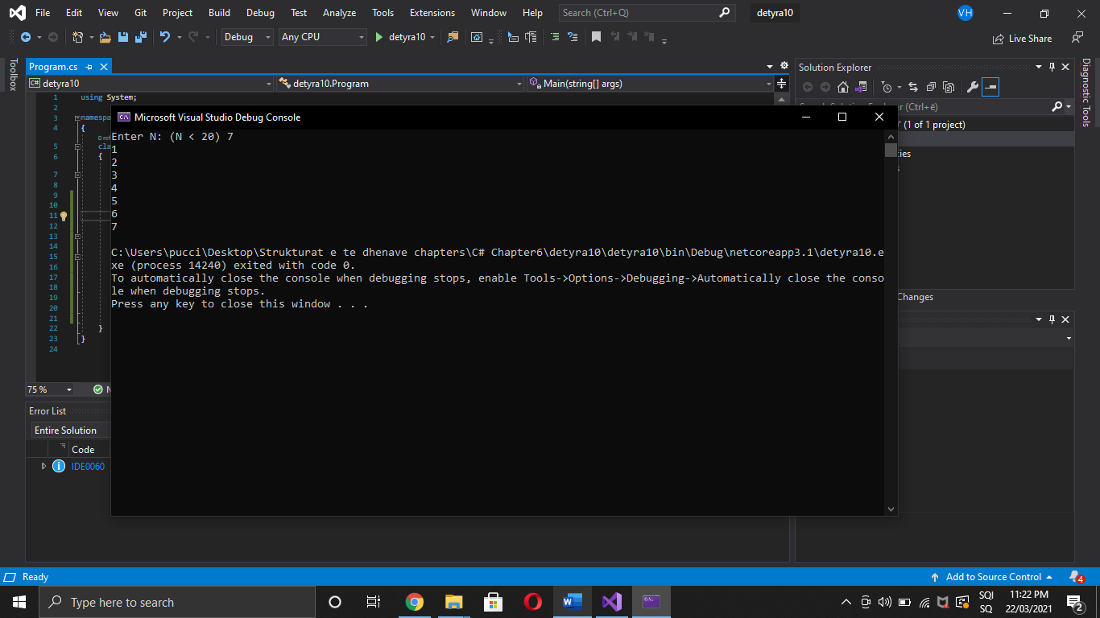

1. Write a program that calculates with **how many zeroes the factorial of a given number ends**. Examples:  
   N = 10 -> N! = 36288**00** -> 2  
   N = 20 -> N! = 243290200817664**0000** -> 4

using System;

namespace detyra11

{

class Program

{

static void Main(string[] args)

{

Console.Write("Enter N: ");

decimal n = Int32.Parse(Console.ReadLine());

int zeroes = 0;

for (int i = (int)(n - 1); i > 0; i--)

n *= i;

Console.Write("N! is {0} and it ends ", n);

do

{

n /= 10;

zeroes++;

} while (n % 10 == 0);

Console.WriteLine("with {0} zeroes.", zeroes);

}

}

}

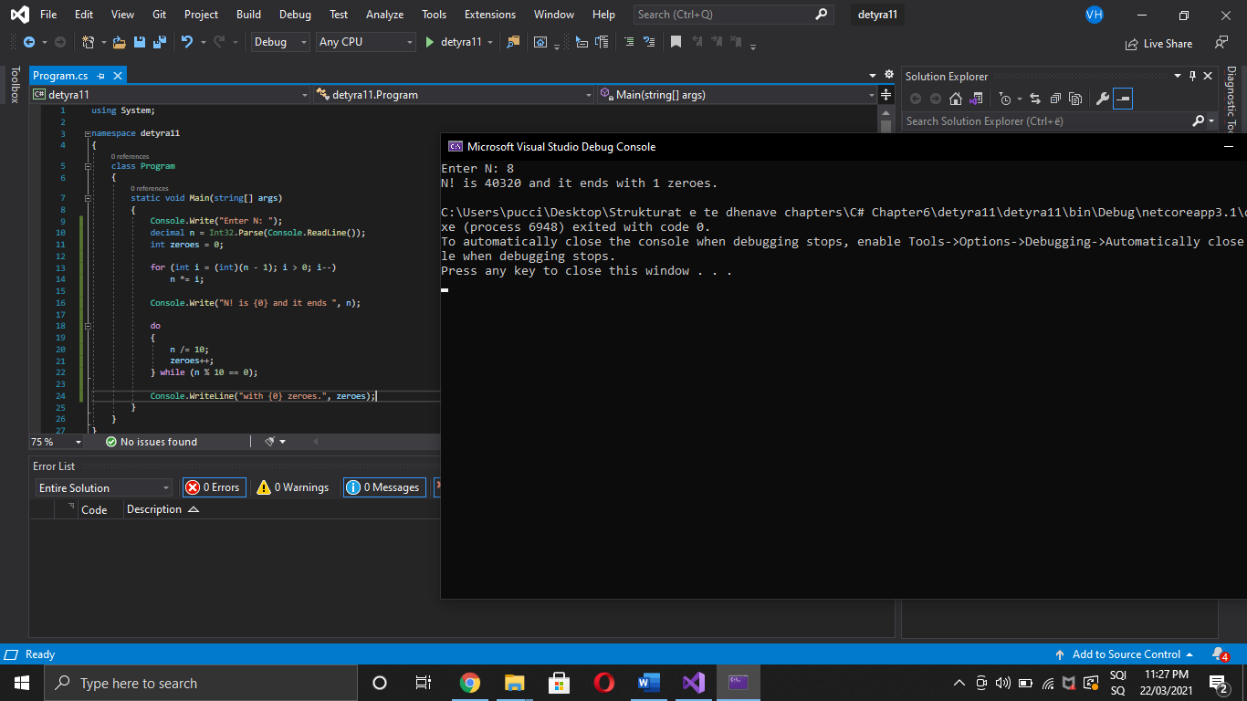

1. Write a program that converts a given number **from decimal to binary notation** (numeral system).

using System;

namespace detyra12

{

class Program

{

static void Main(string[] args)

{

Console.Write("Enter number: ");

int n = Int32.Parse(Console.ReadLine());

string binary = Convert.ToString(n, 2);

Console.WriteLine("Result is {0}", binary);

}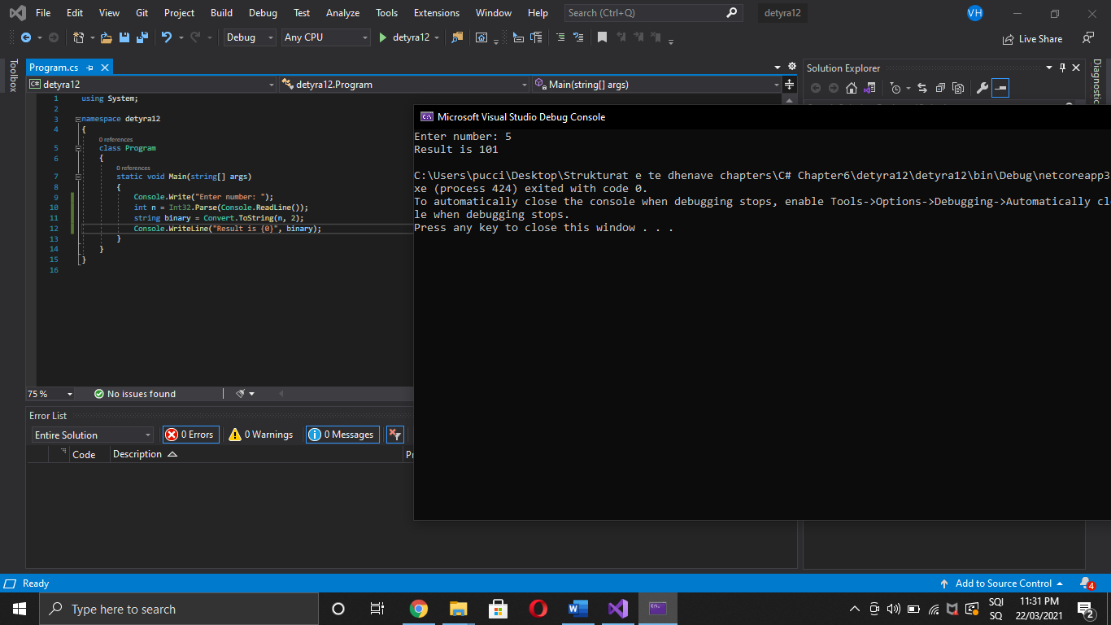

}

}

1. Write a program that converts a given number **from binary to decimal notation**.

using System;

namespace detyra133

{

class Program

{

static void Main(string[] args)

{

Console.Write("Enter binary number: ");

int n = Int32.Parse(Console.ReadLine());

string toDecimal = Convert.ToString(Convert.ToInt32(n, 2), 10);

Console.WriteLine("Result is {0}", toDecimal);

}

}

}

14. Write a program that converts a given number **from decimal to hexadecimal notation**.