Cross-Validation Report — Diabetes Risk Prediction
Diabetes_ML · Pima Indians Diabetes dataset · stratified 5-fold cross-validation on a Dask distributed cluster (4 worker processes). Author: Oluchi-Otuadinma.

1. Dataset
768 rows x 9 columns (54 KB in memory), no duplicates. Class balance: 500 non-diabetic / 268 diabetic (34.9% positive) — moderately imbalanced, handled with class weighting and stratified folds. Biologically impossible zeros treated as missing: Insulin 48.7%, SkinThickness 29.6%, BloodPressure 4.6%, BMI 1.4%, Glucose 0.7%. Feature engineering raises the table to 25 features (missingness flags, median imputation, insulin-resistance composites Glucose x Age / Insulin x BMI / QUICKI, clinical bins).

2. Protocol
StratifiedKFold (5 folds, prevalence preserved at ~34.9% per fold; test folds n=154/153). Models: RandomForest (400 trees, class_weight=balanced) vs Logistic Regression (C=1, balanced). Chi-squared feature selection at k = 8 / 12 / all-25. 30 train/score jobs fanned out to the cluster via client.map. High-recall screening mode: per-fold decision threshold tuned on out-of-fold training predictions to reach recall >= 0.90, applied untouched to the test fold (no leakage).

3. Default-threshold performance (mean over 5 folds)
model (k) | roc_auc | pr_auc | balanced_acc | f1
logreg (k=all) | 0.8415 | 0.7226 | 0.7517 | 0.6797
rf (k=all) | 0.8359 | 0.7317 | 0.7563 | 0.6852
logreg (k=12) | 0.8353 | 0.7188 | 0.746 | 0.6724
rf (k=12) | 0.8347 | 0.7363 | 0.7572 | 0.6843
rf (k=8) | 0.8317 | 0.7385 | 0.76 | 0.6881
logreg (k=8) | 0.8153 | 0.6839 | 0.7284 | 0.6541

Logistic Regression on all 25 features leads ROC-AUC (0.8415); RandomForest k=12 leads PR-AUC (0.736) and balanced accuracy (0.757).

4. High-recall screening mode (target recall >= 90%)
model (k) | recall_hr | precision_hr | f1_hr | threshold
logreg (k=all) | 0.8991 | 0.541 | 0.6752 | 0.3429
logreg (k=12) | 0.8991 | 0.5234 | 0.6607 | 0.3453
logreg (k=8) | 0.8953 | 0.526 | 0.6621 | 0.3392
rf (k=12) | 0.8843 | 0.5366 | 0.6667 | 0.291
rf (k=8) | 0.8804 | 0.5225 | 0.6545 | 0.2895
rf (k=all) | 0.8694 | 0.5449 | 0.6684 | 0.3016

Logistic Regression (all features, threshold 0.343) is the only configuration that meets the screening target: recall 0.899, precision 0.541 — a 1.55x lift over the 34.9% base rate.

5. Before vs after the screening threshold (all folds, n = 768)
model (k) | recall @0.5 | recall @HR | precision @0.5 | precision @HR | FN @0.5 | FN @HR | FP @0.5 | FP @HR
logreg (k=all) | 0.757 | 0.899 | 0.619 | 0.541 | 65.0 | 27.0 | 127.0 | 205.0
logreg (k=8) | 0.739 | 0.895 | 0.592 | 0.526 | 70.0 | 28.0 | 141.0 | 218.0
logreg (k=12) | 0.75 | 0.899 | 0.611 | 0.523 | 67.0 | 27.0 | 129.0 | 221.0
rf (k=all) | 0.743 | 0.869 | 0.639 | 0.545 | 69.0 | 35.0 | 115.0 | 197.0
rf (k=8) | 0.75 | 0.88 | 0.639 | 0.523 | 67.0 | 32.0 | 115.0 | 218.0
rf (k=12) | 0.743 | 0.884 | 0.64 | 0.537 | 69.0 | 31.0 | 114.0 | 207.0
totals | FN @0.5 | FN @HR | FP @0.5 | FP @HR
 | 407 | 180 | 741 | 1266

Switching to the screening threshold cuts missed diabetics by 56% (407 -> 180); the price is +71% false alarms (741 -> 1,266) — ~2.3 extra false alarms per additional diabetic caught.
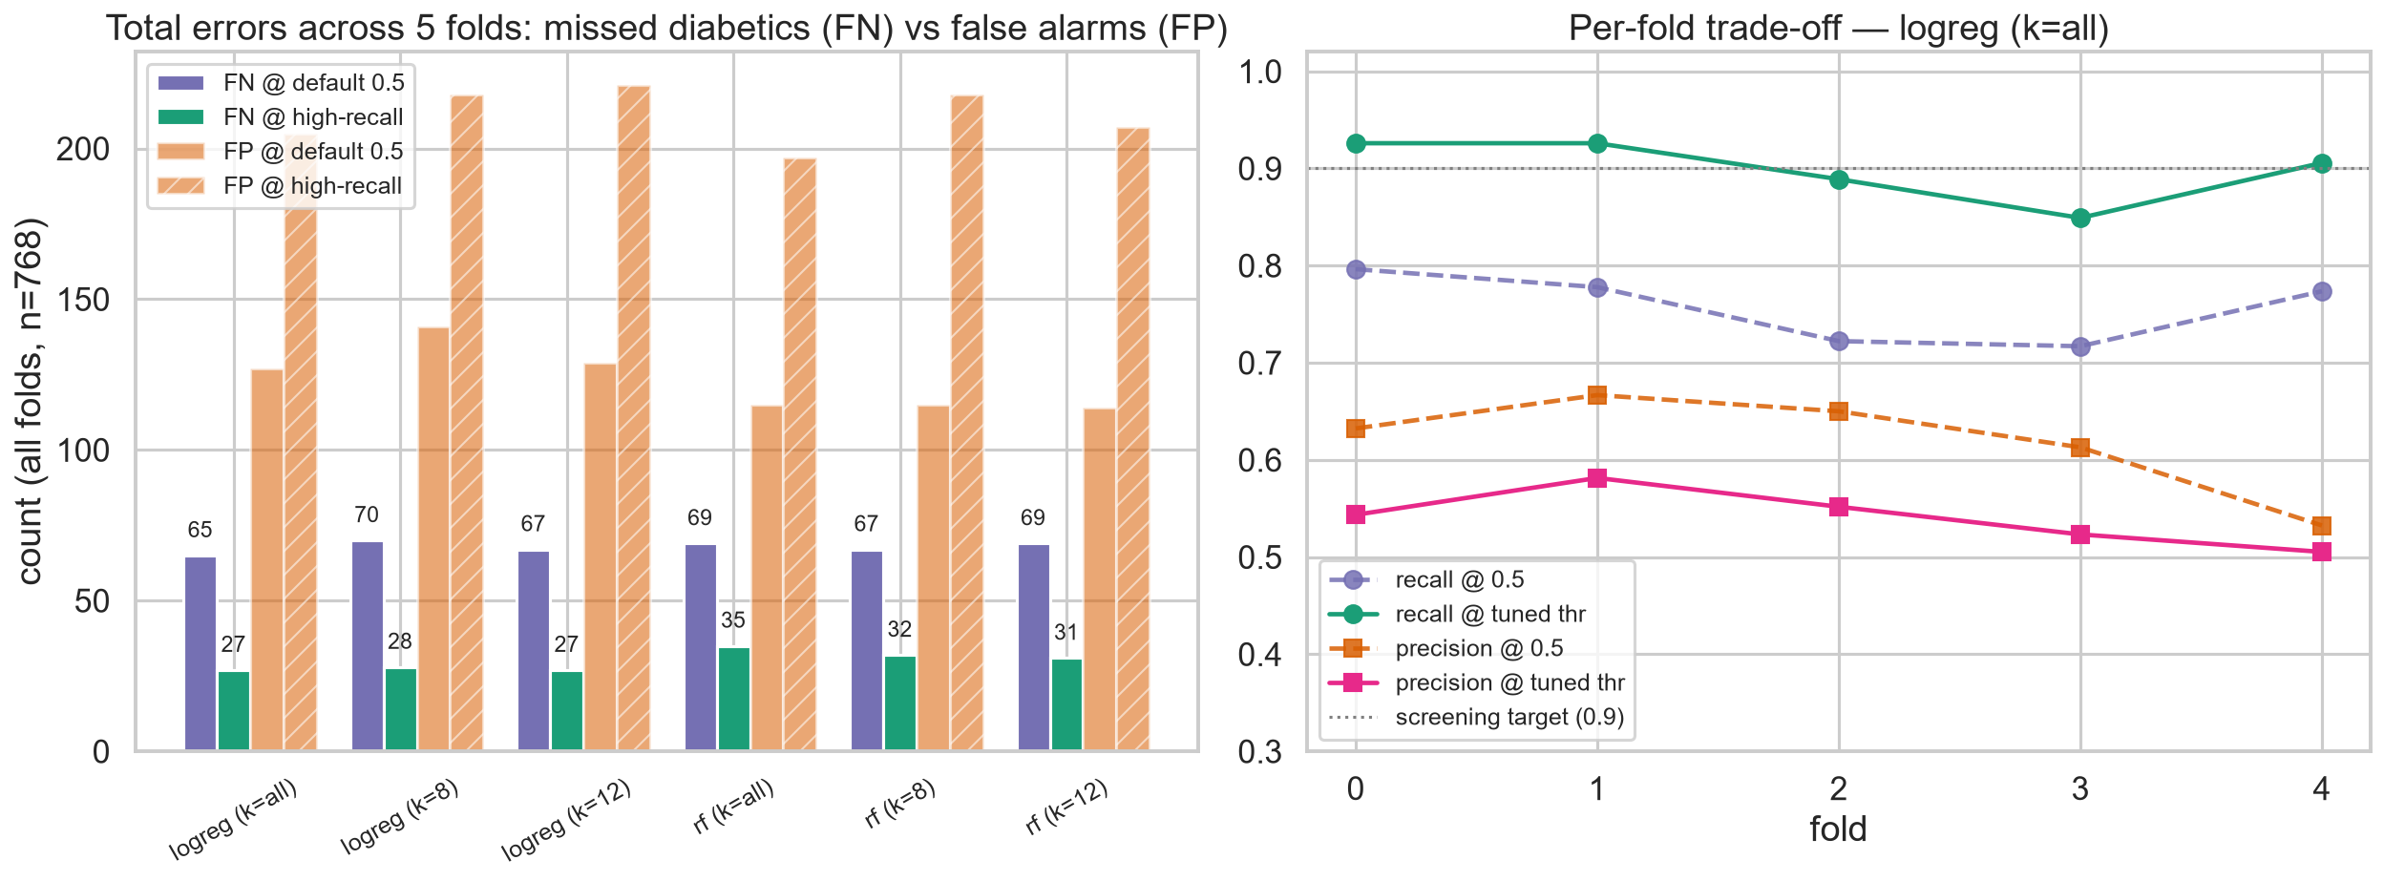

6. Model comparison — is the difference real?
Per-fold paired differences (LogReg all-features minus RF k=12): ROC-AUC +0.007 ± 0.021, F1@0.5 −0.005 ± 0.036, recall@HR +0.015 ± 0.055, F1@HR +0.009 ± 0.022. The sign flips across folds and the spread dwarfs the mean gaps, so the two models are statistically indistinguishable on averaged metrics.
Model choice is therefore an objective decision, not an accuracy decision.

7. Model strengths and weaknesses
Logistic Regression (all 25 features) — strengths:
- Highest ROC-AUC overall (0.8415); only config reaching the 90% screening target (recall 0.899)
- Lowest missed-diabetic count (27 per 5 folds) and best F1 at the screening operating point (0.675)
- Simple, fast, interpretable: coefficients give per-feature effect direction (Glucose, Pregnancies, BMI strongest positives); smooth probabilities make threshold tuning reliable
Logistic Regression — weaknesses:
- Slightly lower PR-AUC (0.723) and balanced accuracy (0.752) than RF at the default threshold
- Linear/additive structure can under-fit interactions — mitigated here by explicit interaction features, but a risk if features were reduced to the raw 8
RandomForest (k=12) — strengths:
- Best PR-AUC (0.736) and balanced accuracy (0.757); marginally best F1 at 0.5 (0.684)
- Captures nonlinearities and interactions without hand-built features; robust to outliers
RandomForest — weaknesses:
- Recall at the screening threshold only reaches 0.869-0.884: it misses the 90% target, i.e. it leaves more diabetics undetected — the exact error a screening tool must minimise
- Coarse tree-vote probabilities make fine threshold tuning harder; heavier to train; weaker interpretability

8. Overall performance and verdict
Ranking quality is statistically tied (~0.84 ROC-AUC for both model families). For the stated medical screening objective (minimise missed diabetics), the recommended model is Logistic Regression on all 25 engineered features with the 0.343 screening threshold: recall 0.899, precision 0.541, and missed cases reduced from 407 to 180 across five folds. RandomForest k=12 remains the better choice for a precision-oriented triage setting. The LogReg-over-RF margin is not proven at this sample size (5 folds, 768 rows); repeated stratified CV (e.g. 10x5) is the natural next step.
Key risk-trend finding: observed diabetic prevalence climbs monotonically with glucose (~5% at 50-90 mg/dL to ~82% above 155 mg/dL) and with Glucose x Age and BMI; QUICKI (insulin sensitivity) is flat/non-monotonic in this cohort.

