SQL HEALTHCARE CAPSTONE PROJECT DOCUMENTATION
HEALTHCARE DATA ANALYSIS FOR FAITH SPECIALIST HOSPITAL
Problem Statement:
Faith Specialist Hospital is a bustling healthcare facility serving a diverse population. Over the years, the hospital has accumulated a wealth of patient data, ranging from demographic details to admission records and health outcomes. However, the hospital is facing significant challenges in leveraging this data effectively.
The management has noticed an increasing number of patients being discharged against medical advice, a rising trend in chronic diseases as well as a concerning mortality rate among certain patient groups.
Objective:
The goal of this analysis is to examine Faith Specialist Hospital’s patient data and provide insights that can help address the challenges faced by the hospital such as increasing discharge against medical advice rates(DAMA), rising chronic illnesses and mortality rates.
- Analyze patient demographics in relation to hospital outcomes.

- Determine the main cause of death across age groups.

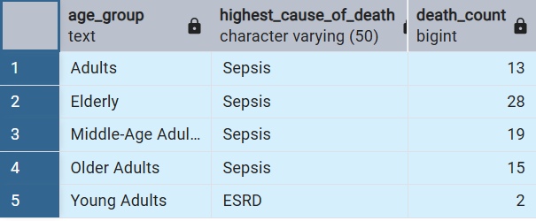
I categorized patients age into 5 age groups and found out that the elderly have the highest mortality rate with sepsis being the main cause, followed by middle-aged youths, older adults, adults and young adults with sepsis topping the list as the main cause of deaths.

- Identify common reasons for discharge against medical advice (DAMA)
- Identify the general reasons for DAMA.
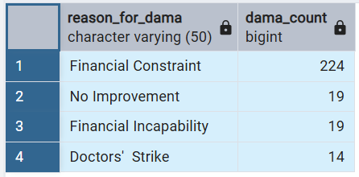
The main reasons for patients getting discharged against medical advice are financial constraints, no improvement over time, financial incapability and doctors going on strike.

- Occupation vs DAMA
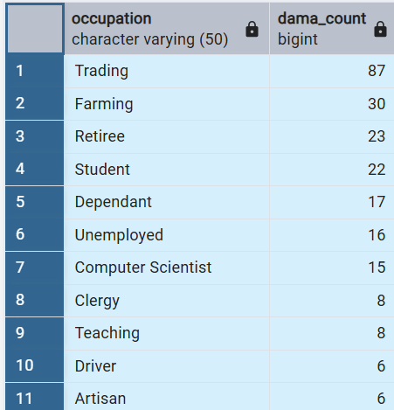
Traders, farmers, retirees, students, dependents, unemployed and computer scientist are more likely to be discharged against medical advice due to economic factors.

- Examine the prevalence and impact of chronic illnesses among patients.
- Prevalence of chronic illnesses among patients
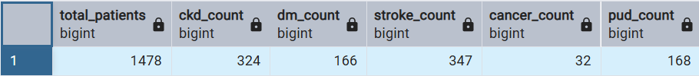
Stroke, Chronic Kidney Disease, Peptic Ulcer Disease, Diabetes Mellitus and Cancer were the most prevalent chronic illnesses among patients in the hospital.

- Impact of chronic illnesses among patients.
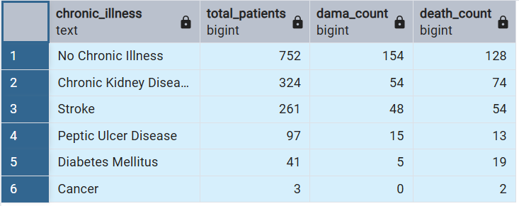
In as much as a lot of patients do not have chronic illness, other patients with chronic illness make up 50% of the population.

- Assess the impact of lifestyle factors on hospital outcomes.
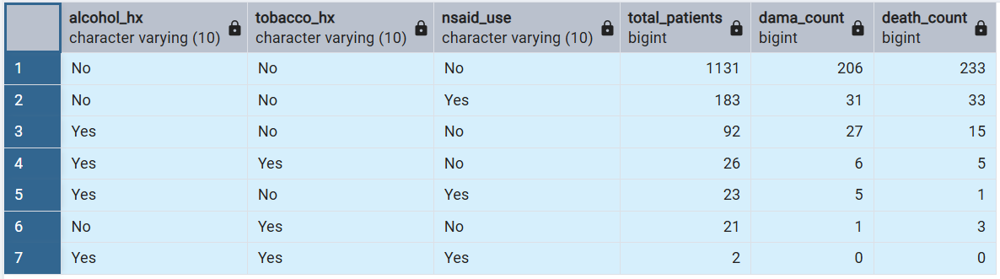
The table above shows the impact of lifestyle factors on hospital outcomes. In as much as most patients do not have alcohol, tobacco and NSAID use, other patients with the history of NSAID use has a higher DAMA and DEATH rate, followed by alcohol.

- Evaluate the performance of the doctors based on specialization and workload.
- Patient distribution against specialization: The table below shows the workload distribution in the hospital across different specializations with Emergency medicine, nephrology and cardiology units topping the list.
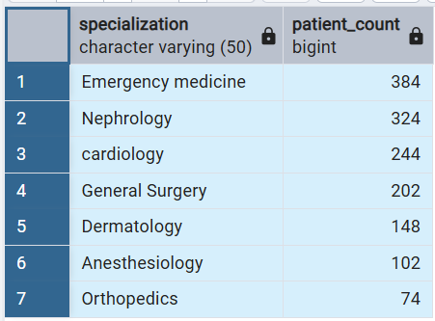

Evaluating hospital outcomes based on specialization
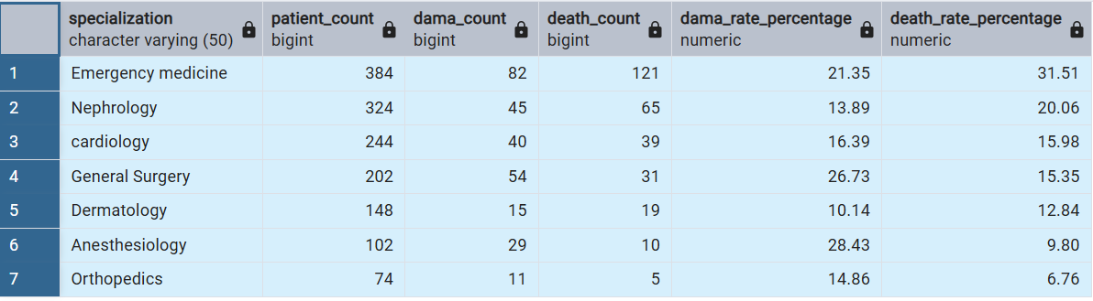
This table shows the DAMA and DEATH rate distribution across specializations.
Anesthesiology, General Surgery and Emergency medicine have the highest DAMA rates.
Then Emergency Medicine, Nephrology, Cardiology and General Surgery have the highest Death Rates which indicated that these units have more serious cases and more workload as well.

INSIGHTS GENERATED
Age and health outcomes: The elderly are at the highest risk of death which means there is need for targeted interventions and more care for this group.
Chronic illness prevalence and impact: Chronic illnesses like Chronic kidney Disease, Stroke and Peptic Ulcer Disease contribute significantly to hospital mortality and should be the focus of preventive care.
DAMA factors: Financial factors are the main factors influencing discharge against medical advice which means that there is need for financial support systems especially Traders, farmers, retirees, students, dependents, unemployed and computer scientist.
Lifestyle Factors: NSAID and alcohol use contributed to the DAMA and DEATH rates. Which requires lifestyle modification programs.
Doctor Performance: Different Specializations are burdened with workload with emergency Medicine, Nephrology and Cardiology topping the list and they should also be monitored for high mortality and DAMA rates.

RECOMMENDATIONS
- Improved support for elderly patients: More resources should be allocated for taking care of geriatric patients.
- Health promotion programs: There should be programs and webinars on lifestyle focusing on NSAID use, alcohol and tobacco.
- Better Post-Discharge Support: For patients who are prone to the risk of getting discharged against medical advice should be integrated into systems for financial aids like insurance schemes.
- Increased Monitoring of High-risk Specialization: The hospital should focus on improving hospital outcomes, especially Emergency Medicine,
- Target education: Providing program and workshops on how to manage chronic diseases for both patients and healthcare professionals.

CONCLUSION
This analysis provides comprehensive insights into the current challenges faced by Faith Specialist Hospital. By understanding patient demographics, the prevalence and impact of chronic illnesses, influence of lifestyle factors , the hospital management can implement data-driven solutions to improve patient care, reduce mortality and optimize the allocation of resources.

