TDI PYTHON DOCUMENTATION BY ARUA OLUCHUKWU LAWRENCIA
ZARA SALES ANALYSIS REPORT
ABOUT THE DATASET
This dataset, called Zara Sales for EDA, was created by combining several public fashion datasets from GitHub and Kaggle. It focuses on Zara products and includes information such as Product ID, Product Position, Promotion, Product Category, Seasonal, Sales Volume, brand, URL, name, description, price, terms, section, season, material and origin columns. This dataset explores Zara’s apparel from fabrics and styles to sales performance providing insights into how material, design and consumer demand shape modern fashion.
PROBLEM STATEMENT
ZARA, one of the leading global fashion companies, aims to understand the key drivers of sales volume across its product categories among influencing factors like the product material, display position, promotions, seasonal trends and gender preferences. ZARA also wants to identify patterns and trends that can optimize produce position, marketing strategies and inventory management to drive profitability and customer satisfaction.
OBJECTIVES
- To determine which product sub-category generates the highest sales volume.
- To evaluate the influence of product position on sales volume.
- To analyze the effect of promotions like discounts on product sales volume.
- To identify gender-based preference across product sub-categories.
- To explore the materials preferred by customers in product sub-category and season.
- To uncover top-performing products.
DATA CLEANING
First, I imported Pandas as pd, NumPy as np, Matplotlib.pyplot as plt and Seaborn as sns. Then I went ahead to return the first 5 columns to get a glance of what the dataset looks like and I used “df.info()” to get a general information regarding the datatypes and null values and there were no null values and duplicates and the data types are consistent and accurate.
I went ahead to change some column names for easy analysis and dropped the URL, description column.

EXPLORATORY DATA ANALYSIS (EDA)
- Top 10 Performing Product Names
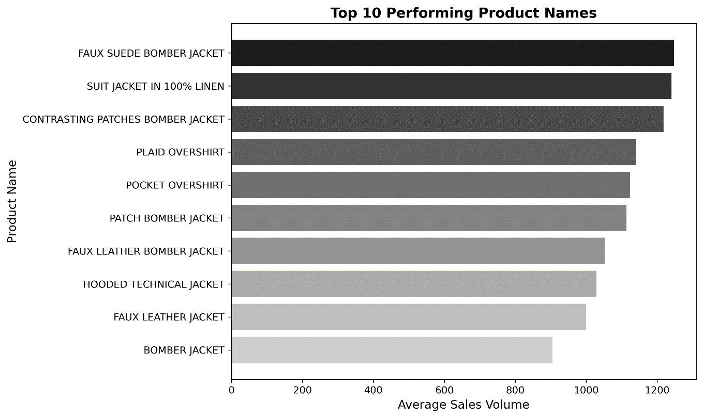

The top 5 performing product names had the average sales volume significantly above the company mean (1097) which suggests that this “hero” products drive a significant portion of the total revenue generated and this can be used as a guide for product restocking.

- Product Sub-Category Performance by Total Sales Volume
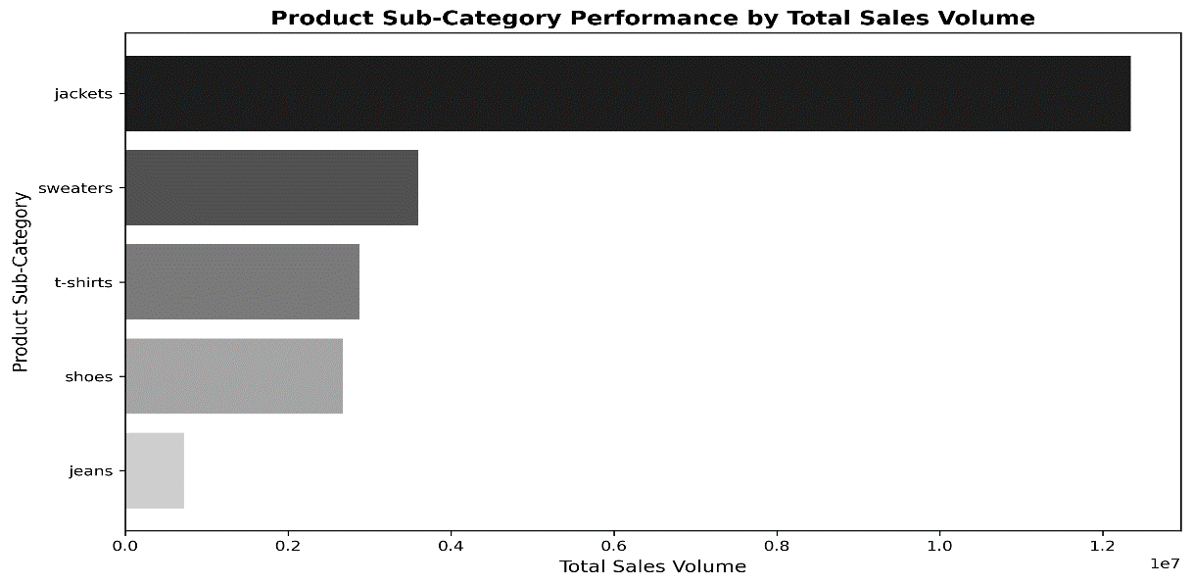
Jackets generated the highest sales volume followed by sweaters, T-shirts, shoes and jeans.
- Which Product Sub-Category has the highest display distribution and its relationship with the sales volume?
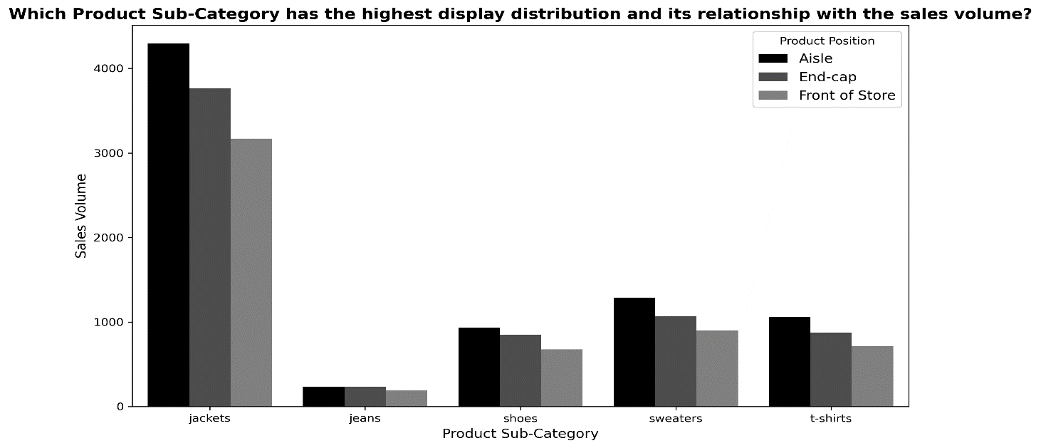
Products displayed on the aisle recorded the highest sales volume while those displayed at the endcap or front of the store showed lower engagement and lower sales volume.
- Does Product Sub-Category Promotion improve Sales?
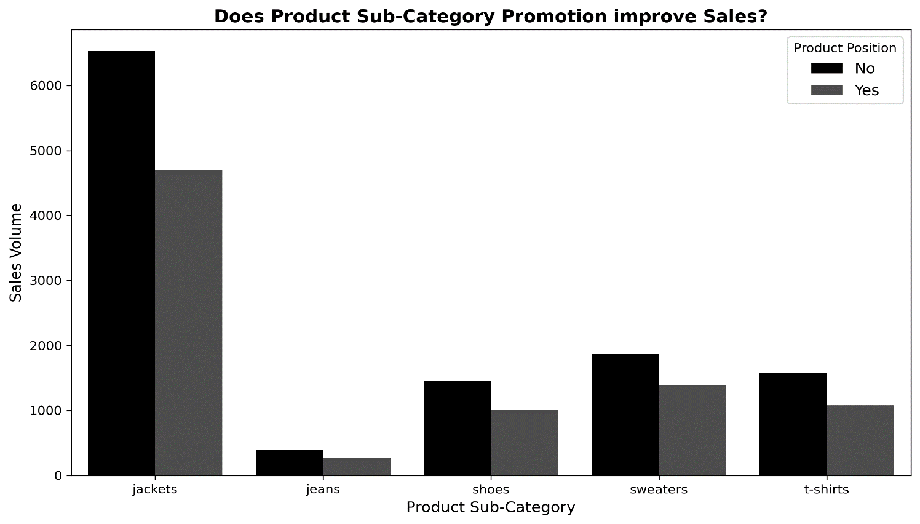
Promotion like discounts of Products has negative impact on the sales volume which implies that while promotions were a little bit effective, certain products do not require heavy discounting to sell as some customers might see it as having a lesser quality.
- Seasonal Sales Drive
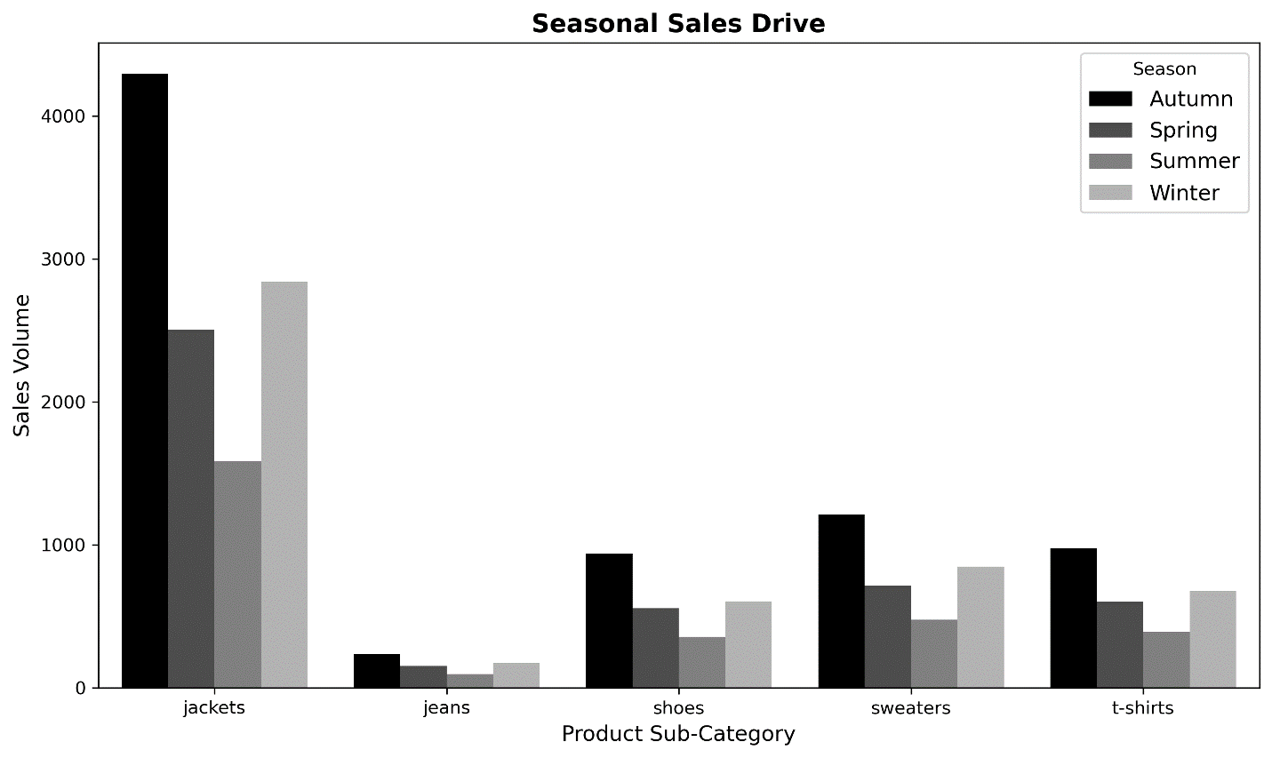
Autumn season showed a clear spike in total sales volume followed by winter, spring and summer generating the lowest sales volume. The product demand was kind of uniform with jackets having the highest demand, then, sweaters, t-shirts, shoes and jeans.

- Gender preferred Product Sub-Category
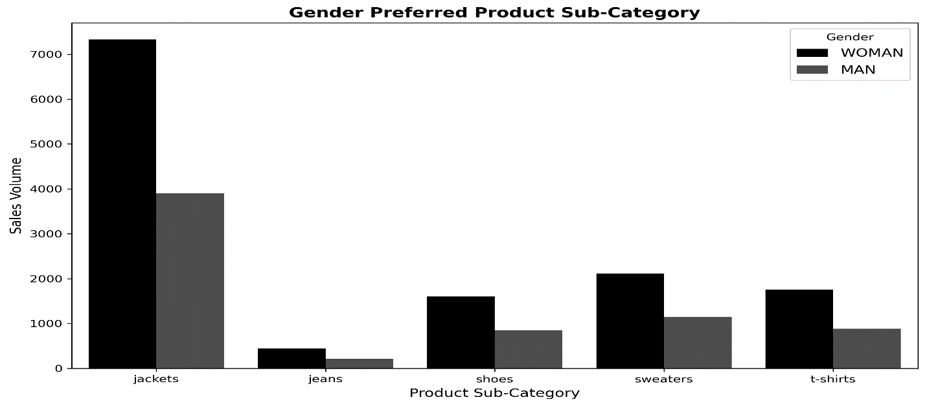
The analysis revealed that women generally shopped more and the preference goes in this order; jackets, sweaters, t-shirts, shoes and jeans. This gender-based segmentation helps tailor marketing campaigns.
- Which Product-Sub-Category- Material Combination performs best?
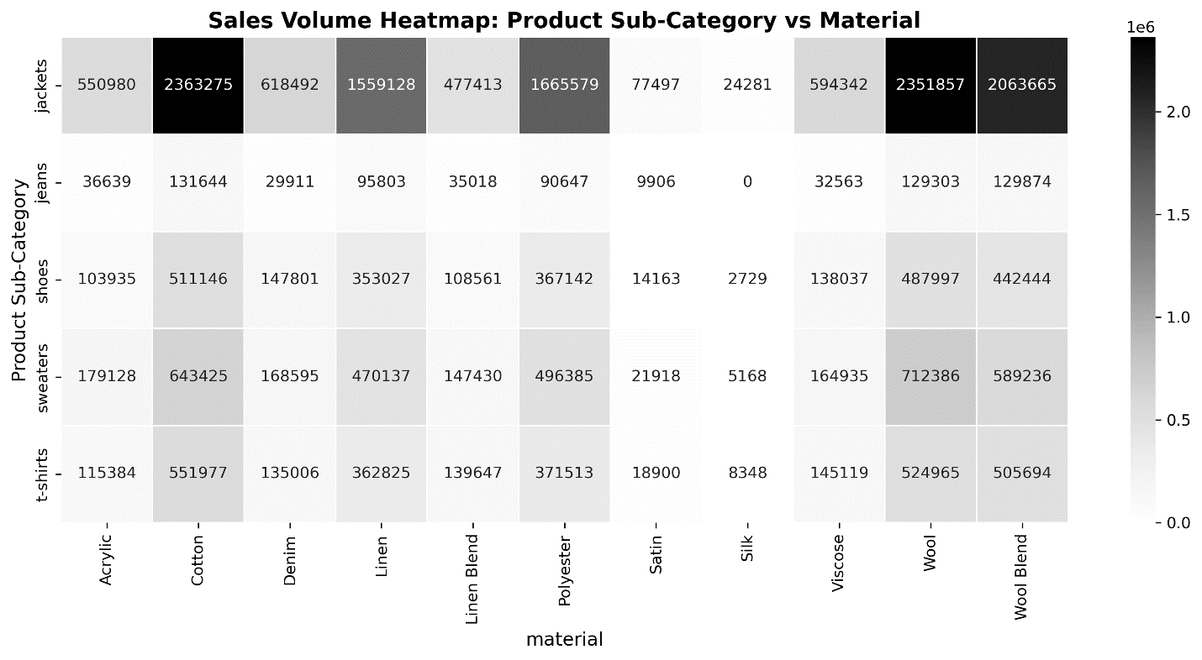
- For Jackets, the cotton, wool and wool blend materials generated the highest sales volume
- For Jeans, the cotton, wool and wool blend materials generated the highest sales volume
- For shoes, the cotton, wool and wool blend materials generated the highest sales volume
- For sweaters, the wool, cotton and wool blend materials generated the highest sales volume
- For t-shirts, the wool, cotton and wool blend materials generated the highest sales volume
This is used to optimize material sourcing and maintain its consistency in high-selling categories.
- Preferred Clothe Material by Season
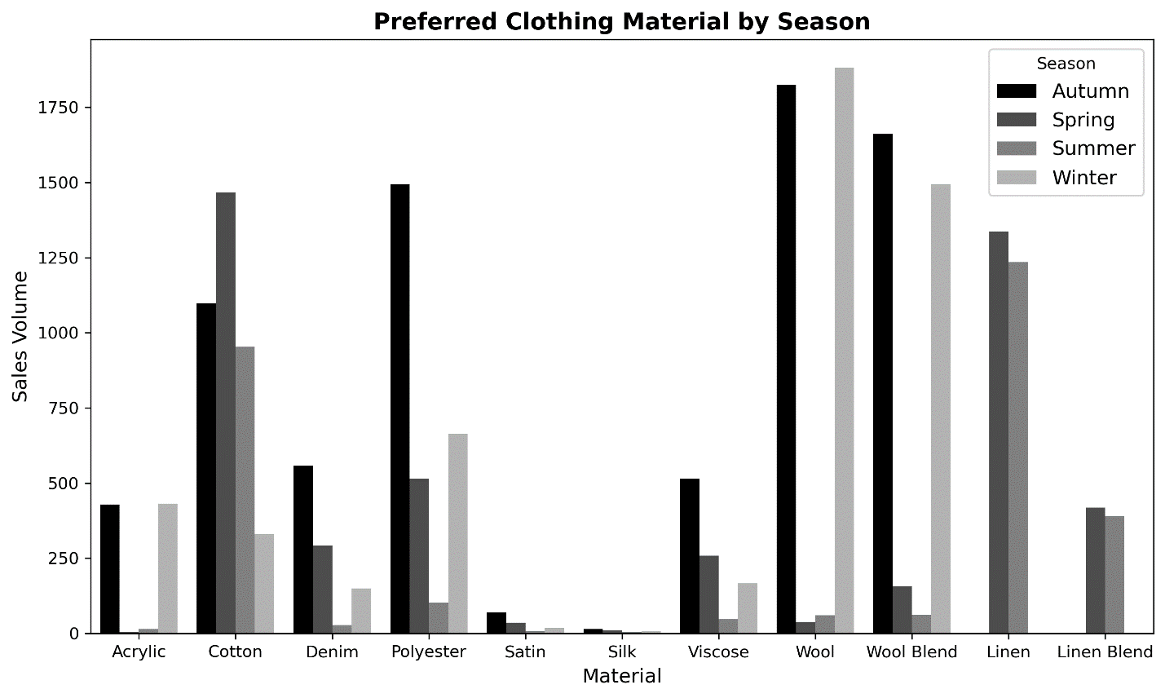
- During the Autumn Season, Wool has the highest sales volume, then wool blend, polyester, cotton, denim, viscose and acrylic materials while the satin, silk, linen and lined blend has the lowest sales.
- During the Spring Season, Cotton has the highest sales volume, then linen, polyester, linen blend, denim, viscose and wool blend while the wool, acrylic, silk, satin has the lowest sales.
- During the Summer Season, Linen has the highest sales, then cotton, linen blend while polyester, viscose, wool, wool blend, denim, acrylic, satin and silk has the lowest sales.
- During the Winter Season, Wool has the highest sales, then wool blend, polyester, acrylic, cotton, while denim, viscose, satin, silk, linen and linen blend.
This is used to optimize material sourcing during the different seasons.
- Gender preference on Material
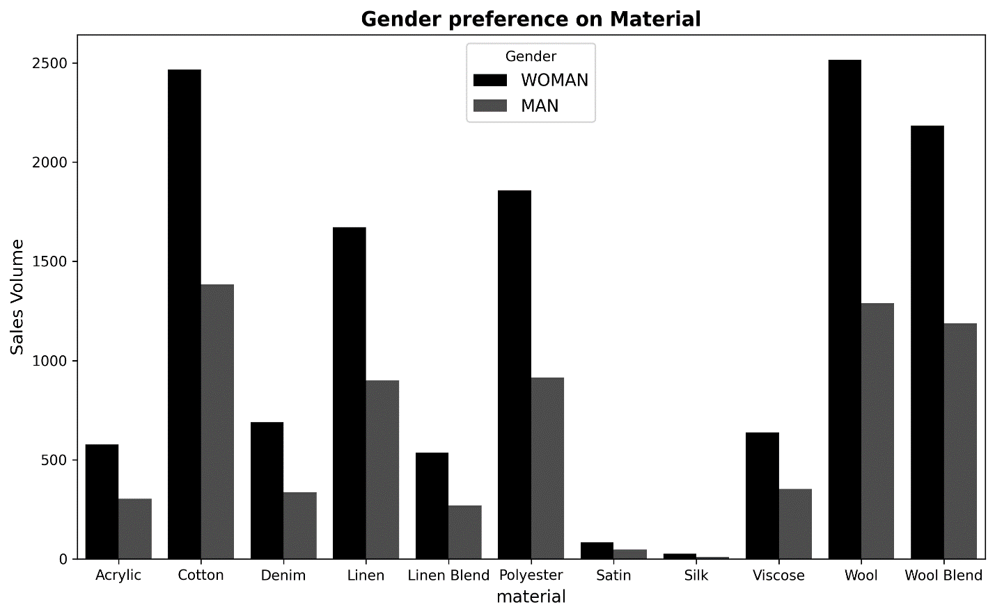
Women prefer clothes made of wool, cotton, wool blend, polyester and linen materials, while men prefer clothes made of cotton, wool, wool blend, linen and polyester materials.

RECOMMENDATIONS
- Restock top 10 Product Names: Restock Product Names with the highest sales volume, more than the others as this will generate more sales and greater revenue. The styling and materials should also be replicated for upcoming collections.
- Optimize product display: Place the best-selling products at the aisle and rotate underperforming ones to the aisle to boost sales.
- Promotional strategies: In as much as discounted products don’t generate greater sales than non-discounted products, the company should focus discounts and campaigns on products with low sales and seasonal products and limit discounts for top-performing products to maintain profitability.
- Seasonal inventory planning: Increase production of clothes made with wool, wool blend, polyester, cotton, denim and viscose during the Autumn season.
- Clothes with cotton, linen, polyester, linen blend, denim and viscose during the Spring season.
- Clothes with linen, cotton, linen blend during the summer season.
- Clothes with wool, wool blend, polyester, acrylic, cotton during the Winter season.
The seasonal campaigns should align with the seasonal material trends. Avoid making clothes made with materials not preferred in the seasons
- Gender-Based Marketing: The company should launch gender-focused collections on special occasions or weeks featuring products aligning with the preferred sub-category and material aligning with seasons. They should also be segmented during campaigns and magazine marketing, like, “this week for women and another week for men” kind of ads.
- Material Procurement: Negotiate better supplier terms for high sales volume clothes like cotton, wool and others and reduce the purchase of materials with low sales volume or create an ad campaign to boost their sales in the preferred season.
- Further Analysis: Further analysis should be done to know if there are repeat customers and to determine the RFM analysis, that is, the Recency, Frequency and Monetary Value as this helps to tailor marketing strategies to specific groups to increase customer retention and increase revenue generation.
CONCLUSION
The ZARA Sales Analysis reveals product visibility, promotional impact, seasonal trends and material preference. By applying data insights and recommendations, ZARA will enhance marketing efficiency, optimize inventory management and sustain their brand profitability while giving their customers premium satisfaction. It also makes ZARA aware of the customer trends and preferences as this will help them reduce overstocking and improve overall profitability in a highly competitive fashion market.

