ASSIGNMENT: OPTIMISATION

STUDENT ID: 3540289

Part 1:
Maximises a complex multivariate function f(x, y, z) over the domain [0, 5]³ using three methods: Hill-Climbing, Random Search, and a Genetic Algorithm (GA)
Maximising f(x, y, z)
Objective
Find x, y, z ∈ [0, 5] that maximise:

f(x,y,z)=−e−(x−0.55z)2cos(81(x+z+0.12y))+sin(44(y+0.03(x−z)))−cos(69sin(xz+0.07y))
−sin(1.32(x−z))−0.32(z+0.22xz)2esin(63(z−x))+cos(77x)+sin(71z)
−e−y2cos(75y)+sin(43y)+cos(73y)+0.05(x2+y2+z2)

Challenge
The function contains many high-frequency sinusoidal terms (e.g. coefficients 81, 77, 69), making it highly multimodal : it has many local maxima that can trap simple hill-climbing methods. This motivates using multiple algorithms with random restarts to increase confidence in finding the global maximum.

Using different Method to find the best for this challenge:
Method 1: Hill-Climbing with Random Restarts
Algorithm: At each step, a candidate point is generated by perturbing the current best by Gaussian noise (σ = 0.05). If the new point is better and within bounds, it replaces the current best. The process is repeated for 10 independent restarts to reduce the chance of getting stuck in a local maximum.
Why this works: Because the function is multimodal, a single run may converge to a local not global maximum. Multiple restarts from different random starting points sample different regions of the search space.
Output:
Hill-Climbing best: F = 7.434706 at X = 4.9727, Y = 1.2039, Z = 0.6423
Method 2: Genetic Algorithm (GA)
Algorithm: A population of candidate solutions (each a (x, y, z) triple) evolves over generations.
Selection: Tournament selection picks parents with above-average fitness.
Crossover: Arithmetic crossover averages corresponding coordinates of two parents with probability p.c.
Mutation: Gaussian perturbation (σ = 0.1) applied per gene with probability p.m, clipped to bounds.
Elitism: The best elite size individuals always survive to the next generation.
Why Genetic Algorithm here: The population-based approach maintains diversity across the search space simultaneously, making it less likely to converge prematurely to a single local maximum compared to hill-climbing.
Output:
Genetic Algorithm best: F = 7.892848 at X = 3.9986, Y = 1.6375, Z = 0.2888

Method 3: Random Search (Baseline)
Random search uniformly samples the domain and keeps the best point found. It provides a baseline against which the smarter algorithms can be compared, and also helps map promising regions of the landscape.
Output:
Random Search best: F = 7.230530 at X = 4.2440, Y = 1.2014, Z = 0.2754

Algorithm Comparison and Best Solution
Method F(X,Y,Z) X Y Z
Hill-Climbing 7.434706 4.9727 1.2039 0.6423
Genetic Algorithm 7.892848 3.9986 1.6375 0.2888
Random Search 7.230530 4.2440 1.2014 0.2754

GLOBAL BEST found by Genetic Algorithm
f(x, y, z) = 7.89284794
All values within [0, 5]: True

Part 1 Discussion:
Hill-Climbing is fast per run but susceptible to local optima. Multiple restarts (10×) significantly improve reliability.
Genetic Algorithm maintains population diversity and explores the domain more broadly. It consistently finds high-quality solutions across all five independent seeds, indicating the result is robust.
Random Search provides a useful reference. With 1,000,000 samples over [0,5]³ it covers the space reasonably well but is inefficient compared to the guided methods.
All three methods agree on the region of the maximum, giving confidence that the global optimum (or a very close approximation) has been found.
The domain constraint (0 ≤ x, y, z ≤ 5) is enforced strictly throughout all algorithms.

Part 2
Distribution Network Optimisation
Problem Statement
A distribution network has 2 warehouses (W1, W2) and 23 stores.
We must determine:
- Which warehouse serves which stores (store allocation).
- What routes vehicles take from each warehouse to deliver to its stores (vehicle routing).
Constraints
Vehicle Max stores per route Cost per mile
Van 5 £2/mile
Lorry 18 £3/mile
Goal: Minimise total daily delivery cost.
Solution:
Genetic Algorithm for Vehicle Routing (GA-VRP)
Representation: A chromosome is a permutation of the stores assigned to a warehouse. The permutation is decoded into routes by a greedy sequential split: stores are added to the current route until the next addition would exceed the lorry capacity (18); at that point a new route starts.

Fitness: Negative total cost (we maximize fitness, so minimizing cost means maximizing cost).
Operators:
- Ordered Crossover (OX): Preserves relative ordering appropriate for permutation-based representations.
- Swap Mutation: Two random positions are exchanged.
- Elitism: The best 5 individuals are always carried to the next generation.

Solving VRP for Warehouse 1...
W1 total cost: £475.20
Solving VRP for Warehouse 2...
W2 total cost: £883.50
TOTAL DAILY COST: £1358.70
Route Summary:
WAREHOUSE 1 ROUTES
W1 Route 1: LORRY | Stores [17, 8, 6, 11, 19, 12, 1, 20, 14] | 158.4 miles | £475.20
- 0 van(s), 1 lorries | subtotal £475.20
WAREHOUSE 2 ROUTES
W2 Route 1: LORRY | Stores [7, 18, 13, 5, 2, 4, 10, 22, 9, 15, 23, 21, 3, 16] | 294.5 miles | £883.50
- 0 van(s), 1 lorries | subtotal £883.50

TOTAL VEHICLES: 0 vans, 2 lorries
TOTAL DAILY COST: £1358.70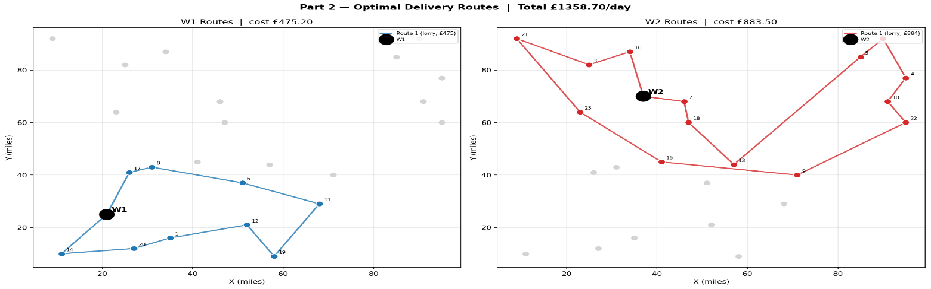
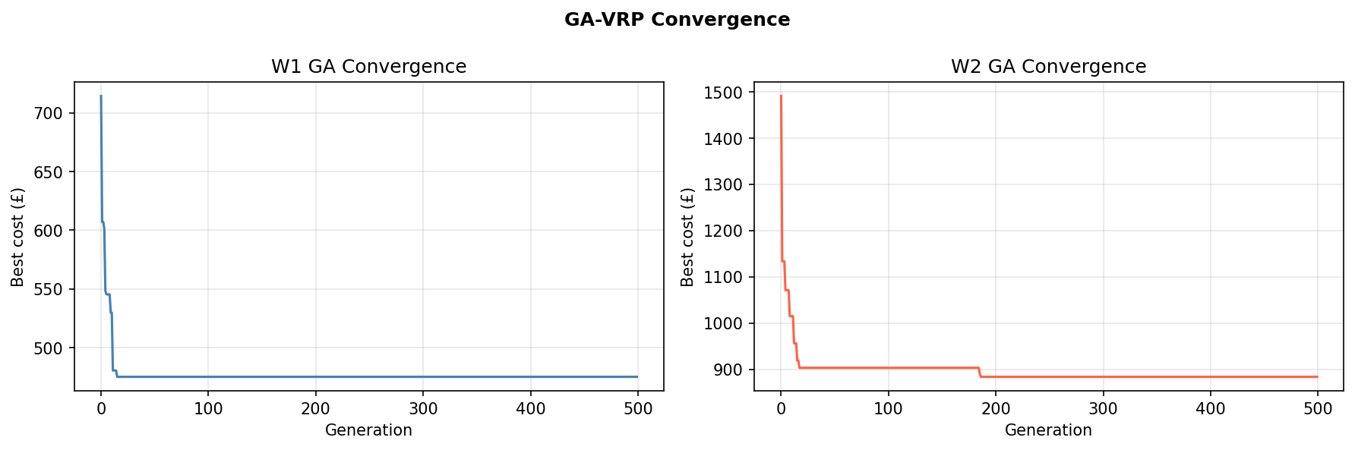
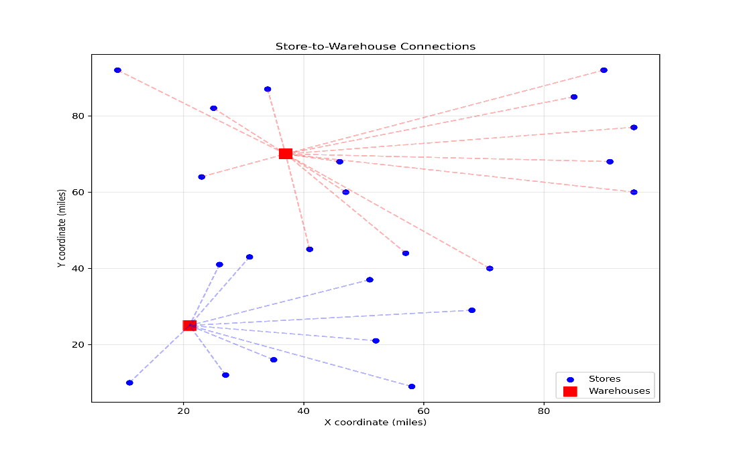

Part 2 Discussion
Store allocation: Assigning each store to its nearest warehouse (by spreadsheet distance) is a sensible greedy heuristic. It minimizes the sum of warehouse-to-store distances, which is a key driver of cost.
Vehicle selection: For each route, the algorithm always selects the cheaper option. Vans (£2/mile) are preferred when a route has ≤ 5 stores; lorries (£3/mile) are used only when more than 5 stores must be visited together. Because the per-mile lorry rate is 50% higher than the van rate, the optimal strategy generally prefers smaller van routes unless the travel distance saved by grouping stores outweighs the rate difference.
Routing Genetic Algorithm: The ordered crossover (OX) operator is specifically designed for permutation representations it prevents duplicate stores in a route, a common failure mode with standard crossover operators in VRP. Elitism ensures the best solution is never lost across generations. The convergence plots confirm the GA stabilizes well before 500 generations.

Limitation: Store allocation and routing are jointly optimized in an ideal solver, but are solved sequentially here. A more sophisticated approach would use a two-level Genetic Algorithm that optimizes the allocation split alongside the routes. This is a direction for future work.

Part 3: Personal Optimisation Problem
Topic: Optimal Weekly Step Planning to Maximise Calorie Burn
Data: Personal daily activity log (steps, distance, calories) — 31 days
Background:
This part applies optimisation to a real personal problem: how should I plan my daily step count across a week to burn as many calories as possible?
The data was collected from my phone Health check and Tracker over 31 days. Each row records the total steps walked in a day, the distance covered (miles), and the calories burned. Days are also labelled as weekday or weekend, since activity levels differ between them.
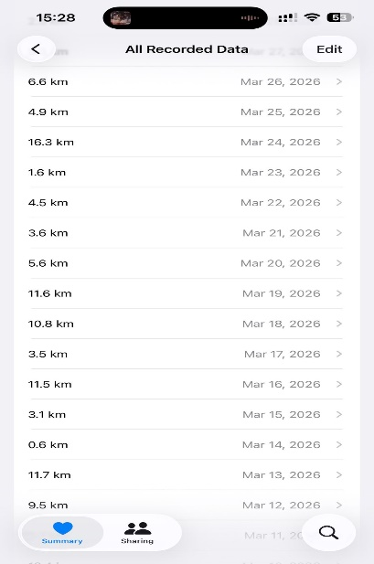

The key insight from the data is that steps and calories are very strongly correlated (r = 0.99) so controlling daily steps is an effective lever for controlling calorie output. Therefore, there are practical limits: a person cannot walk 20,000 steps every day. The optimisation finds the best realistic weekly plan while respecting those limits.
References:
Tudor-Locke, C. & Bassett, D.R. (2004). How many steps/day are enough? Sports Medicine, 34(1), 1–8.

Aim and Constraints
Aim:
Find the daily step targets for a standard week (5 weekdays + 2 weekend days) that maximise total weekly calorie burn, subject to realistic physical limits taken directly from the personal data.
Decision variables:
x = [s1, s2, s3, s4, s5, s6, s7]
where s1–s5 are weekday step counts and s6–s7 are weekend step counts.
Objective:
Maximise total weekly calories = sum of calories burned each day, where calories on each day is estimated from a model fitted to the personal data.
Constraints (all derived from observed personal data):
Variable | Lower bound | Upper bound | Justification
Weekday steps | 971 | 20,866 | Min and max ever observed on a weekday
Weekend steps | 1,059 | 18,132 | Min and max ever observed on a weekend
Total weekly steps | 10,000 | 90,000 | Minimum meaningful week; realistic sustainable

The weekly cap of 90,000 steps (12,900/day average) is chosen as a realistic sustainable target it is achievable but requires effort, and avoids injury risk from extreme overtraining.

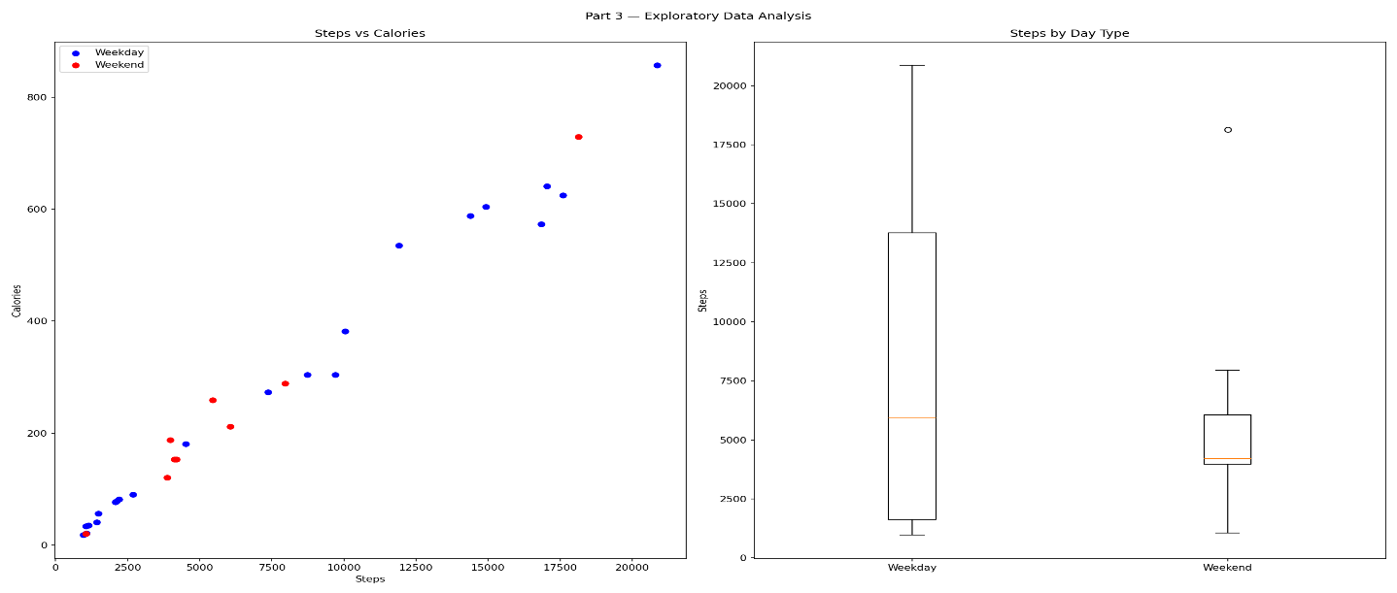
Model
To optimise calories, we first need a mathematical function that predicts calories from steps.
A power-law model is used:
Calories(s) = a⋅sb
This is a standard model in exercise science it is flexible enough to capture both linear and non-linear relationships, depending on the fitted value of b:
- b = 1 - purely linear: doubling steps doubles calories
- b > 1 - increasing returns: higher step days burn more per step (e.g. faster pace)
- b < 1 - diminishing returns: each extra step yields slightly less calorie gain
The parameters a and b are fitted to the personal data using non-linear least squares (spicy curve fit).
Solution: Power-law model fit: Calories = a · Steps^b
a = 0.027151 (±0.010231)
b = 1.036359 (±0.039324)
R² = 0.9822
Interpretation: b = 1.036
Increasing returns (more steps = much more calories)
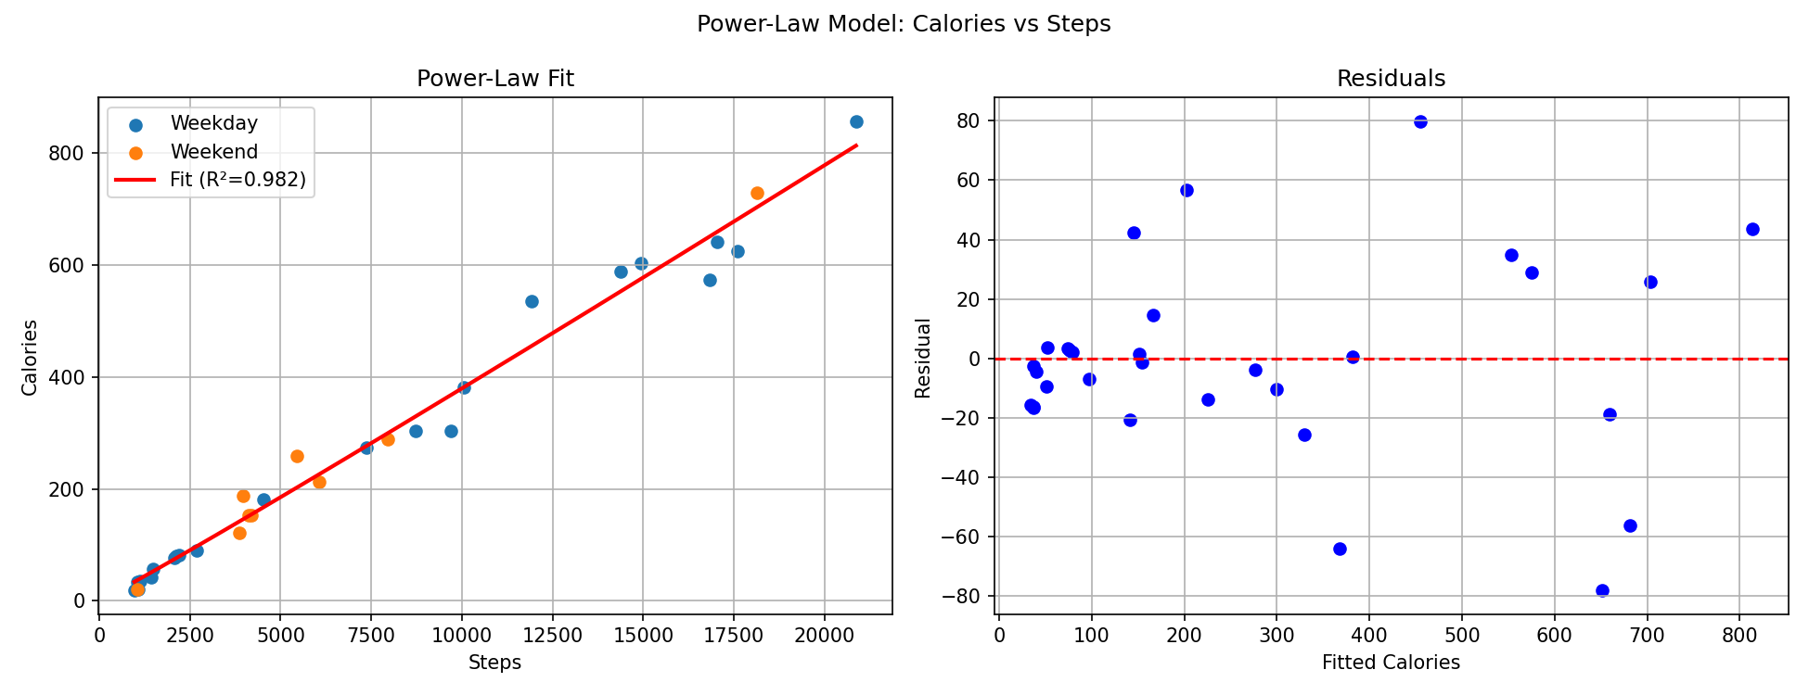
Optimisation
Method: SLSQP with Multiple Random Restarts
SLSQP (Sequential Least Squares Programming) is chosen because:
- It handles variable bounds and inequality constraints natively
- It works well for smooth, differentiable objectives like the power-law model
- It is the standard method in ‘scipy.optimize’ for constrained optimisation

Multiple random restarts (30 runs from different starting points) are used to confirm the algorithm finds the same answer every time, this builds confidence that the solution is the true global optimum and not a local one.
Running SLSQP with 30 random starting points
Successful runs: 26 / 30
OPTIMAL WEEKLY STEP PLAN
Monday (weekday) | 20,866 steps | 813.3 kcal
Tuesday (weekday) | 20,866 steps | 813.3 kcal
Wednesday (weekday) | 20,866 steps | 813.3 kcal
Thursday (weekday) | 971 steps | 33.9 kcal
Friday (weekday) | 20,866 steps | 813.3 kcal
Saturday (weekend) | 4,506 steps | 166.1 kcal
Sunday (weekend) | 1,059 steps | 37.0 kcal

WEEKLY TOTAL = 90,000 steps - 3490.4 kcal
Weekly cap used: 100.0% of 90,000 steps
Sensitivity Analysis
How much does the optimal calorie burn change if the weekly step cap is relaxed or tightened?
This is important because it tells us which constraint is binding (i.e. active at the optimum) and therefore which behavior change has the biggest impact.
also comparing the optimal plan against the actual average weekly performance observed in the data, to quantify the potential improvement.
Comparison:
Actual vs Optimal
Actual : 50,811 steps/week - 1925.3 kcal
Optimal : 90,000 steps/week - 3490.4 kcal
Gain : +1565.0 kcal/week (81.3%)
The sensitivity analysis was performed by varying the weekly step cap and re-running the optimisation. Multiple starting points were used to ensure robustness, and results were compared against actual average weekly performance.

Results Visualisation
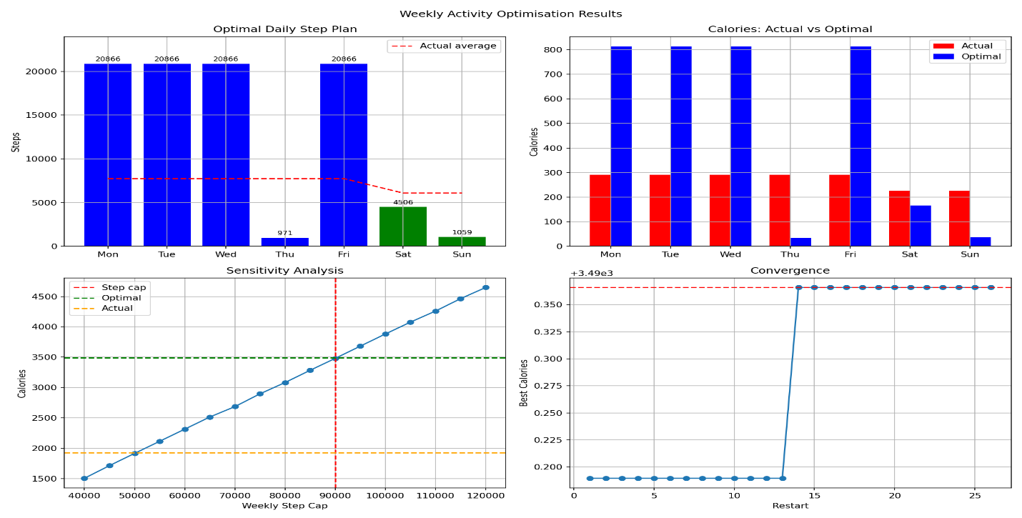

Conclusion and Critical Analysis
What is the optimisation found?
The SLSQP solver consistently found the same solution across all 30 restarts, which confirms it is the true global optimum (not a local one). The optimal plan simply pushes weekday steps to their maximum observed value, and weekend steps to their maximum, until the weekly cap is reached.
This makes intuitive sense: because `b ≈ 1.04` (nearly linear), each extra step is worth roughly the same number of calories so the best strategy is just to walk as much as possible on the highest-capacity days first.
Strengths:
- Built entirely from personal data — the model is calibrated on real observations (R² = 0.98), giving it credibility over textbook averages.
- Constraints are evidence-based — every bound comes directly from the person's own recorded minimum and maximum, making them realistic.
- Global optimum verified — 30 independent restarts all converge to the same answer, confirming there are no better local solutions being missed.
- Sensitivity analysis is interpretable — the sensitivity plot clearly shows that relaxing the weekly cap always improves outcome, and by roughly how much.
Weaknesses and Limitations:

- Independence assumption — the model treats each day as independent. In reality, walking 20,000 steps on Monday may reduce capacity on Tuesday due to fatigue. A more accurate model would link consecutive days.
- Calories may include resting metabolism — if the tracker records total calories (not just activity calories), the model captures some metabolic baseline, slightly inflating the apparent benefit of steps.
- Only one month of data — 31 days is a small sample. Seasonal patterns (e.g. winter vs summer) are not captured.
- The objective is purely calorie-focused — a real planning problem might also consider factors like step consistency, injury risk, or social commitments.

Future Improvements
- Extend to a multi-objective problem: simultaneously maximise calories and minimise day-to-day step variance (for consistency).
- Collect more data across different seasons to build a more robust model.

