“Kira” (killer)

A program that enables the user to use instructions to complete the shooter game.

Olugbenga Akinduro
20308003

CS171 Computer Systems I

B.Sc.

Computer Science and Software Engineering



Department of Computer Science
Maynooth University
Maynooth, Co. Kildare
Ireland.

Declaration:
I hereby attest that this assignment, which I will be submitting for assessment as part of my grade for my CS171 Computer Systems module, is my own work and has not been taken by others, this assignment has been cited on the web and has been acknowledged throughout the document.

Signed by: Olugbenga Akinduro. Date: 13-12-2020

Acknowledgement: I would like to thank Peter Mooney for suggesting the project idea and senior computer science students for assisting me in areas where I was confused, also the YouTube videos that were referenced below as I was advised to use by other students.

Abstract: This report describes the development of a program that is effective for gamers to play a simple third person shooter game. The report includes testing of the program and ends with suggestions for future work. I mostly used the internet to source the information and ideas for this project. I also used previous labs to help me in certain areas a lab that played a big factor in this project was lab 3, as this is where I gathered my code for movement. Another lab that helped me a lot was lab 8 as this was the lab that we worked with mainly music.

- Introduction
Many gamers love playing a variety of different games, my personal favorite is any type of shooter game, which is why I decided to do my project on a shooter game I named Kira which means killer in Japanese. My aim for my project is to develop software that assists a player to complete the game that I have created using the material I have research and learned from this module.

- Research
There are many different examples of shooter games on the internet which I have researched, Call of Duty or better known as C.O.D, is my biggest inspiration for this project. I used the thought of its well-known game mode zombies to make a simple shooter game. There are other examples that fueled my idea for this project, which are shown in the figure 1.1.
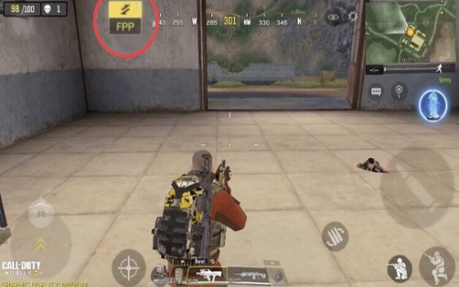
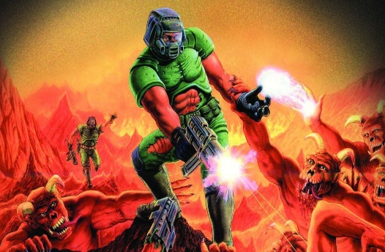
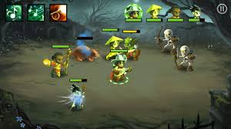
Figure 2.1: A few games that inspired my idea.

- Technical background and problem statement/Solution
I ran into many problems making this project, even while using many different sources which have been referenced in my report. One of the problems I ran into were, that when I ran the project the game did not show up as I used a GIF for the background and when I added the GIF into the program, I did not add the necessary requirements for a GIF background.
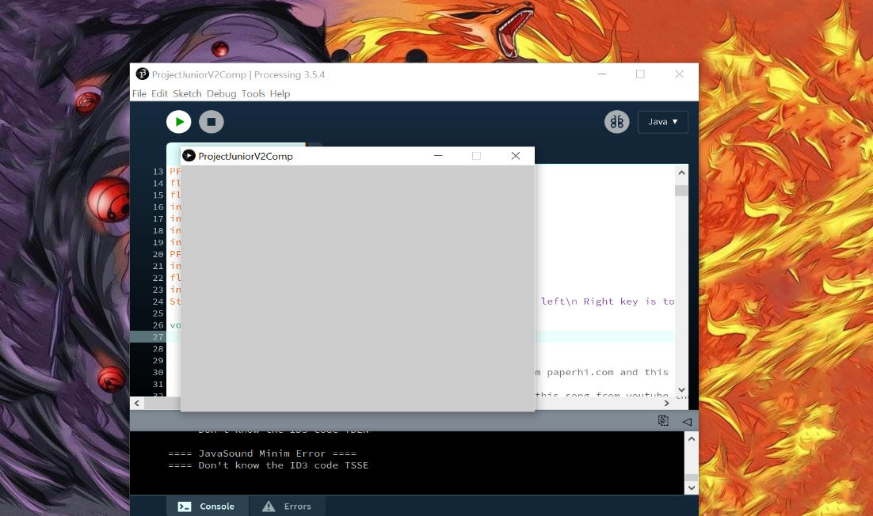
This problem also affected my sprites as even when the background began to work the program would run but the sprites would disappear off the screen even though the game is being run. The way I solved both problem was by add P2D to the size of the program (size(640, 480,P2D);).
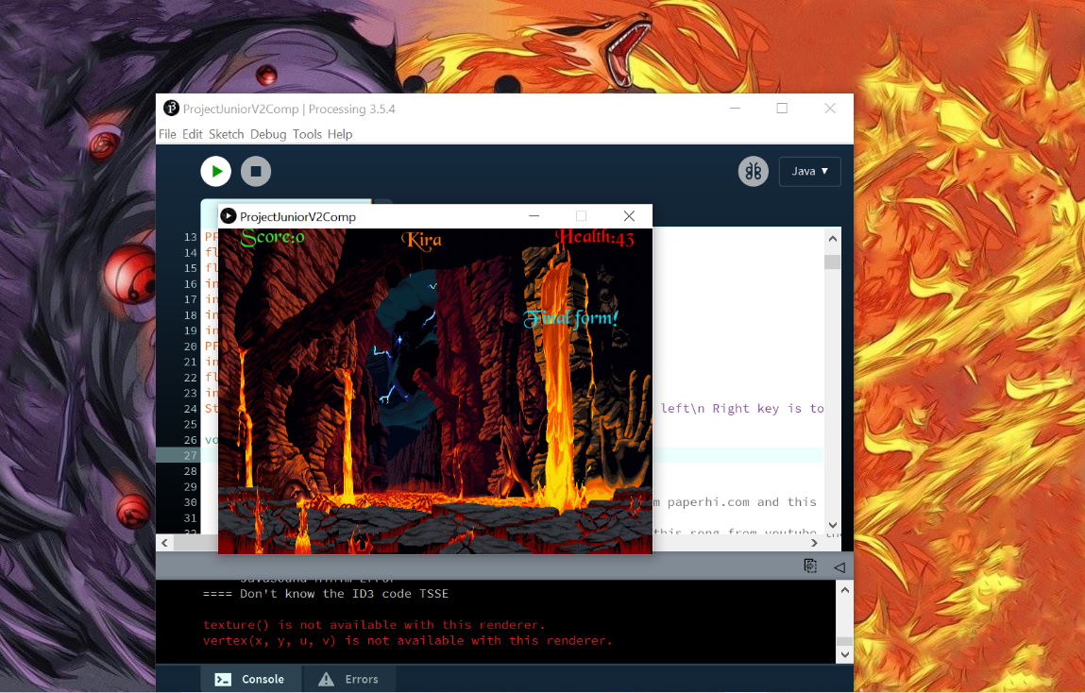

Another problem I had with my sprites was, aligning the sprites when creating the program. When I tried to position the sprites, they were positioned underneath the ground which was a minor problem as I just needed to change the position from (400) to (300).
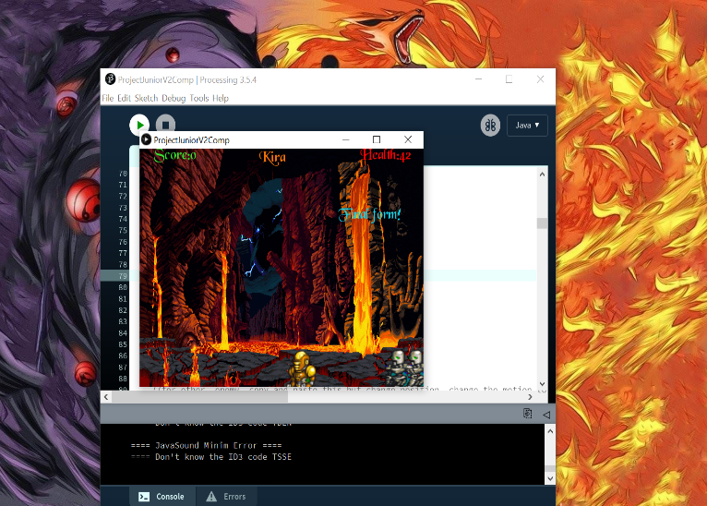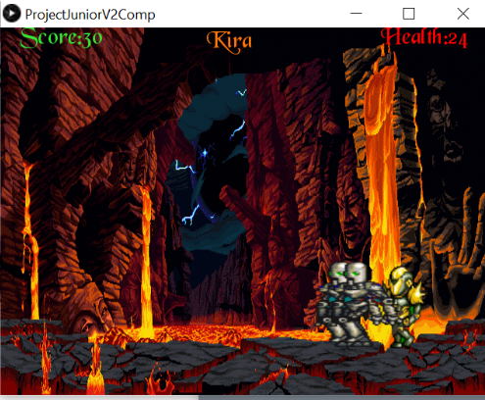
Figure:3.1 Figure:3.2
Figure 3.1 is where I positioned the sprites to (400).
Figure 3.2 is where I positioned the sprites to (300).

The next problem I ran into was of the frame of the character. Since I have worked with code that makes a game with a sprite, I used the same code to create the movement for my sprite in this program. The problem I ran into with this step, was that if I did not move the sprite would disappear which is the opposite of what I wanted for my game so from research and from me continuously trying different things to get exactly what I was looking for, I finally found the solution which was by changing the frame which was originally frame<=16 to frame <=4. By doing this it made the sprite completely visible throughout the game.
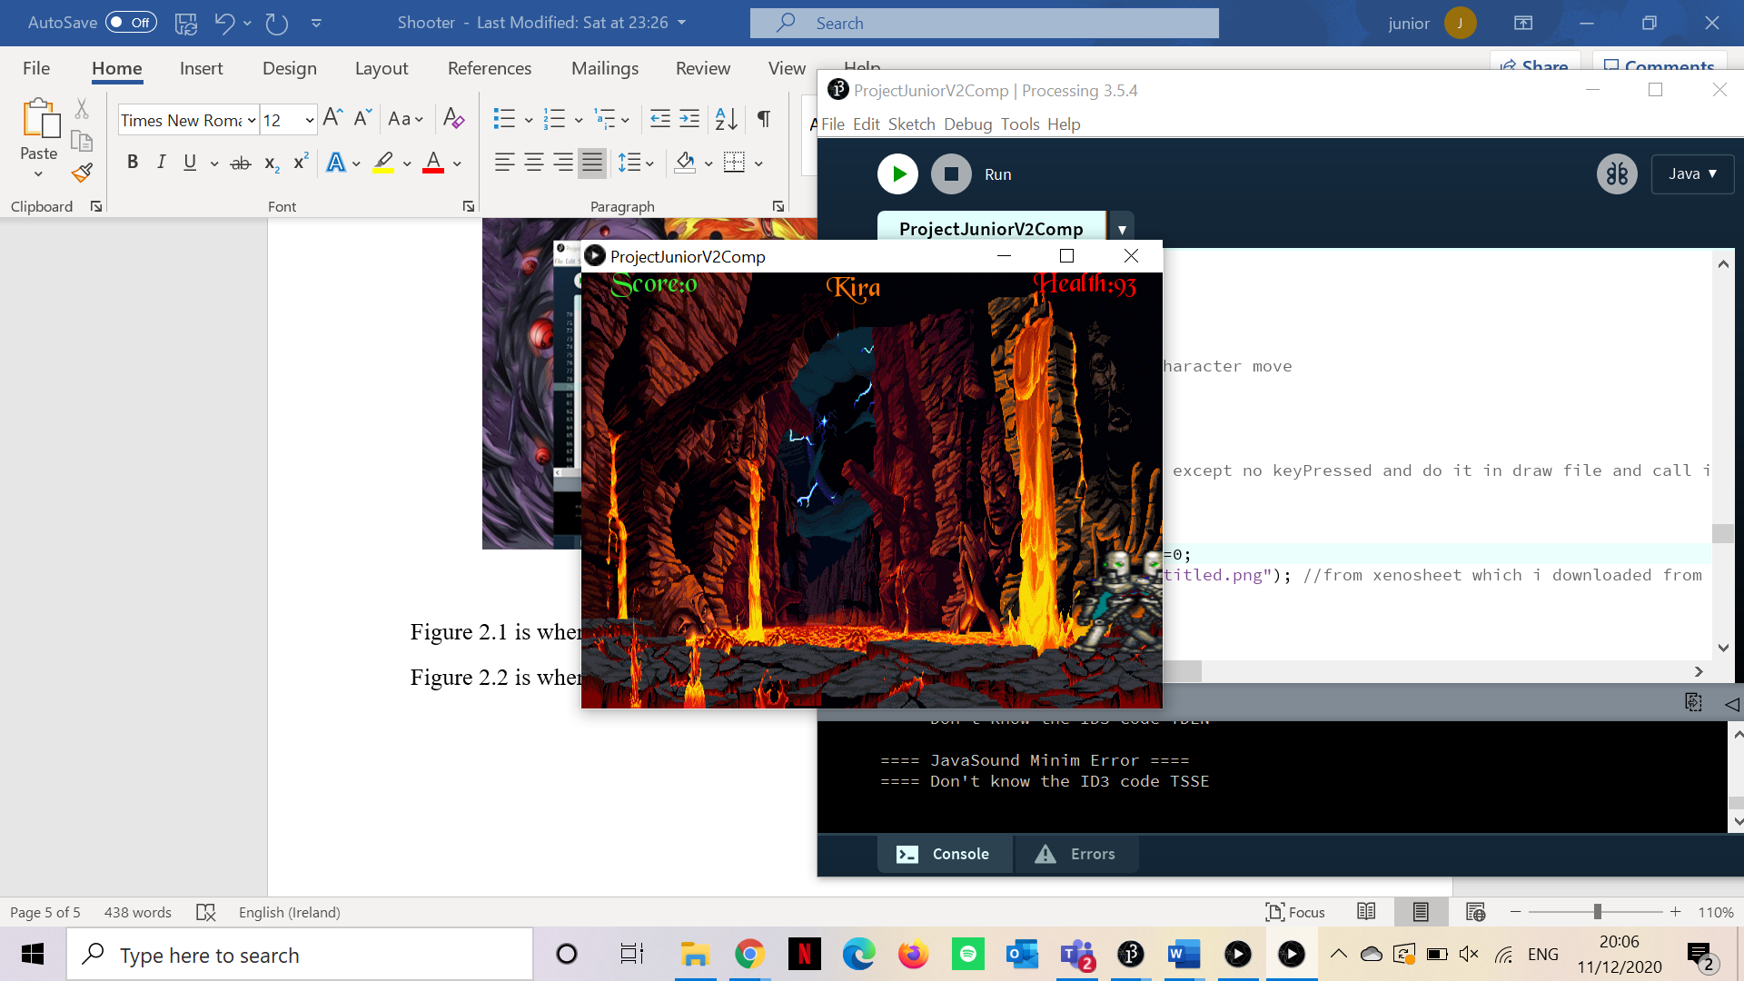

4. Evaluation
The program tested several different times with many different scenarios, which led to different results for example as shown in the text above, I changed many pieces of code around which all gave different results until finally getting the result that I felt made the game move smoother and have a cleaner look to it. I will provide two different test cases that will show how the results of two of the scenarios differ.
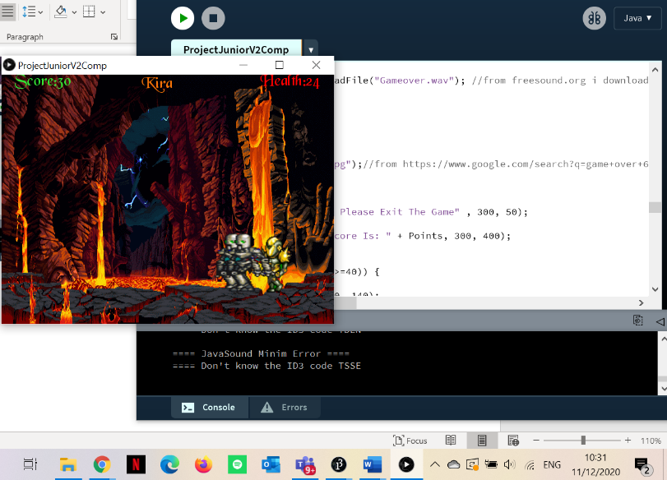
Figure: 4.1
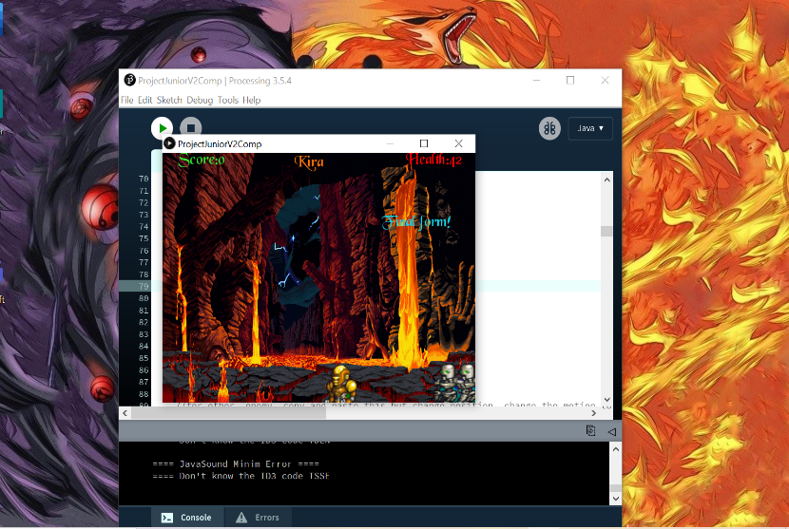
Figure: 4.2
Figure 4.1 and 4.2 are two different scenarios of the outcome of my code. The first code is running exactly how I want it to the second code is an error that I had to change multiple times to get the write positioning.

5.Conclusion
A program has been created that is effective for gamers to play a simple third person shooter game. A future development in this code could be addition of levels such as, a level two and a boss level. This code could be extended to reach such ambitions. Another addition that could be made to this code is adding another transformation to the character as the levels progress making it easier for the gamer to clear levels as they gain an experience in the game.

References
[1] Website – (https://opengameart.org/content/xeon-ultimate-smash-friends)
[2] Website – (https://www.youtube.com/watch?v=y6Lwzhc2-q0)
[3]
Website- (https://www.youtube.com/watch?v=q8rP6R0LCss&feature=youtu.be)
[4] Website – (https://forum.processing.org/two/categories/summer-of-code-2018)
[5] Website – (https://opengameart.org/content/fighting-robot-for-ultimate-smash-friends)
[6]
Website- - (https://youtu.be/kmAMnQXIVnI?list=PLKQWNXwX2zTkYUBbLPaTwYpDBIcFnDch3)
[7]
Website- - (https://www.google.com/search?q=game+over+640x480&tbm=isch&hl=en&sa=X&ved=2ahUKEwiA2PeKrcHtAhWYZBUIHRPwDCkQBXoECAEQLA&biw=1263&bih=610#imgrc=DRv9TPCmhAKF8M)

Appendix A Source code listing
//CS171 Project
//Program that allows the user to play a third person shooter game
// Olugbenga Akinduro
//Last edited: 15/12/20
import ddf.minim.analysis.*;
import ddf.minim.*;
Minim minim;
AudioPlayer musicplayer, musicplayer2;
int stage;
float bgrepeat;
PImage menu;
float y=1;
float x;
float speed =0.5;
PImage scene, player, player2, player3;
PFont wording;
float player_x=300, player2_x=50, player3_x=10;
float frame=0;
int direction=0, direction2=0, direction3=0;
int Points = 0;
int Health = 100;
int SuperHealth = 150;
PFont font;
int enemy=80, enemy2=80;
float frame2=0, frame3=0;
int quit_flag=0;
String instru="\nSpacebar is to Attack\n Left key is to move left\n Right key is to move right";
//Creating the scene for the game (size of the game, the background etc...)
void setup()
{
size(640, 480,P2D);
frameRate(30);
smooth();
scene = loadImage("BG1.gif");
//here is where i added music that i got from youtube etc
minim = new Minim(this);
musicplayer = minim.loadFile("8Bit.mp3"); // I downloaded this song from youtube the link is (https://youtu.be/kmAMnQXIVnI?list=PLKQWNXwX2zTkYUBbLPaTwYpDBIcFnDch3)
musicplayer.play();
player=loadImage("Untitled.png");//from xenosheet which I downloaded from (http://opengameart.org/content/xeon-ultimate-smash-friends)
player2=loadImage("newrun.png");//from this website (http://opengameart.org/content/fighting-robot-for-ultimate-smash-friends)
player3=loadImage("newrun.png");//from this website(http://opengameart.org/content/fighting-robot-for-ultimate-smash-friends)
textureMode(NORMAL);
blendMode(BLEND);
noStroke();
font = createFont("BLKCHCRY.TTF", 30);
stage=1;
}
void draw()
{
if (stage==1)
{
menu=loadImage("gamegb.gif");
background(menu);
textFont(font);
fill(255, 255, 255);
text("Press Enter To Start", 200, 200);
fill(255,0,0);
text("Instructions: " + instru, 80, 300);
fill(255,128,0);
text("Kira",300, 30);
if (keyCode==ENTER)
{
stage=2;
}
}
if (stage==2)
{
background(scene);
textAlign(CENTER);
//if(key==ENTER) move to other image
{
float left=frame/4;
float right=(frame+1)/4;
if (direction==1)
{
float temp=left;
left=right;
right=temp;
}
pushMatrix();
translate(player_x, 300);
beginShape();
texture(player);
vertex( 0, 0, left, 0);
vertex(124, 0, right, 0);
vertex(124, 124, right, 1);
vertex( 0, 124, left, 1);
endShape(CLOSE);
popMatrix();
}
//for other enemy, copy and paste this but change position, change the motion to random

if (direction2 == 0)
{
player2_x+=4;
frame2++;
if (frame2>=35) frame2=0;
}
if (player2_x >= 570)
{
direction2=1;
}
if (direction2 == 1)
{
player2_x+=-4;
frame2++;
if (frame2>=35) frame2=0;
}
if (player2_x<=1)
{
direction2=0;
}
if (direction3 == 0)
{
player3_x+=4;
frame3++;
if (frame3>=35) frame3=0;
}
if (player3_x >= 570)
{
direction3=1;
}
if (direction3 == 1)
{
player3_x+=-4;
frame3++;
if (frame3>=35) frame3=0;
}
if (player3_x<=1)
{
direction3=0;
}
{
float left2=frame2/35;
float right2=(frame2+1)/35;
if (direction2==1)
{
float temp2=left2;
left2=right2;
right2=temp2;
}
pushMatrix();
translate(player2_x, 300);
beginShape();
texture(player2);
vertex( 0, 0, left2, 0);
vertex(124, 0, right2, 0);
vertex(124, 124, right2, 1);
vertex( 0, 124, left2, 1);
endShape(CLOSE);
popMatrix();
}
{
float left3=frame3/35;
float right3=(frame3+1)/35;
if (direction3==1)
{
float temp3=left3;
left3=right3;
right3=temp3;
}
//I used the same code for the first enemy while changing some variables
pushMatrix();
translate(player3_x, 300);
beginShape();
texture(player2);
vertex( 0, 0, left3, 0);
vertex(124, 0, right3, 0);
vertex(124, 124, right3, 1);
vertex( 0, 124, left3, 1);
endShape(CLOSE);
popMatrix();
}
{
fill(255,128,0);
textFont(font);
text("Score:"+Points, 80, 20);
fill(255, 0, 0);
text("Health:"+Health, 555, 20);
fill(#F77407);
text("Kira", 300, 25);
fill(#F70509);
if (Health<1)
{
stage=3;
}
if (player_x >=570)
{
player_x=1;
}
if (player_x <= 0)
{
player_x=550;
}
if ((player2_x+30 - player_x+30) >=0 && player2_x < player_x)
{
Health=Health-1;
} else if ((player_x+30 - player2_x+30) >=0 && player_x < player2_x)
{
Health=Health-1;
}
if ((player3_x+30 - player_x+30) >=0 && player3_x < player_x)
{
Health=Health-1;
} else if ((player_x+25 - player3_x+25) >=0 && player_x < player3_x)
{
Health=Health-1;
}
if (quit_flag==1)
{
musicplayer=minim.loadFile("Gameover.wav"); //from freesound.org I downloaded it from their website
musicplayer.play();
delay(3000);
exit();
}
if (Health<0) {
quit_flag=1;
menu=loadImage("go.jpg");//from https://www.google.com/search?q=game+over+640x480&tbm=isch&hl=en&sa=X&ved=2ahUKEwiA2PeKrcHtAhWYZBUIHRPwDCkQBXoECAEQLA&biw=1263&bih=610#imgrc=DRv9TPCmhAKF8M
background(menu);
textFont(font);
fill(255, 255, 255);
text("You Have Died, Please Exit The Game" , 300, 50);
fill(81,255,0);
text("Your Highest Score Is: " + Points, 300, 400);
}
}
if ((Health<50 && Health>=40)) {
fill(255,128,0);
text("Final form!", 520, 140);
}

if ((Health<=20) && Health>=1)
{
fill(255, 0, 0);
text("High Damage!", 200, 140);
}
// this was to make my character move
if (keyPressed==true)
{
if (keyCode==RIGHT)
{
// Do the exact same except no keyPressed and do it in draw file and call it direction 2/3/4 etc
direction=1;
player_x+=8;
frame++;
if (frame>=4) frame=0;
player=loadImage("Untitled.png"); //from xenosheet which i downloaded from (http://opengameart.org/content/xeon-ultimate-smash-friends) which was stated in my references
}
if (Health<60)
{
frame++;
if (frame>=4) frame=0;
player=loadImage("SuperMode.png"); //its just an upgraded version from the same site i got the original sprites
}
if (keyCode==LEFT)
{
direction=0;
player_x-=8;
frame++;
if (frame>=4) frame=0;
player=loadImage("Untitled.png"); //from xenosheet which i downloaded from (http://opengameart.org/content/xeon-ultimate-smash-friends)
}
if (Health<60)
{
frame++;
if (frame>=4) frame=0;
player=loadImage("SuperMode.png");// from the same website i got the "untitled" sprite from as it is just an upgraded version of the sprite
}
if (key == ' ')
{
player=loadImage("Melee.png"); //from the same website I got the "untitled" image as it is an upgraded version of the sprite
musicplayer=minim.loadFile("electriccurrent.wav"); //from freesound.org I downloaded it from their website
musicplayer.play();
frame++;
if (frame>=4) frame=0;
//for the power up
if (Health<60)
{
frame++;
if (frame>=4) frame=0;
player=loadImage("SuperAttack.png"); // from the same website I got the "untitled" image as it is the same sprite but upgraded
musicplayer=minim.loadFile("electriccurrent.wav"); //from freesound.org I downloaded it from their website
musicplayer.play();
}
if ((player2_x+55 - player_x+55) > -20 && player2_x < player_x)
{
musicplayer=minim.loadFile("Damage.mp3"); //from freesound.org I downloaded it from their website
musicplayer.play();
enemy=enemy-10;
//println(enemy); //this was just for test purposes
} else if ((player_x+55 - player2_x+55) > -20 && player_x < player2_x)
{
musicplayer=minim.loadFile("Damage.mp3");//from freesound.org I downloaded it from their website
musicplayer.play();
enemy=enemy-10;
// println(enemy); //this was just for test purposes
}
if (enemy==0)
{
musicplayer=minim.loadFile("dyingrobot.wav"); //from freesound.org I downloaded it from their website
musicplayer.play();
Points=Points+10;
player2_x = random(0, 500);
enemy=150;
Health=Health+15;
musicplayer=minim.loadFile("Healthup.wav"); //from freesound.org I downloaded it from their website
musicplayer.play();

if ((player3_x+55 - player_x+55) > -20 && player3_x < player_x)
{
musicplayer=minim.loadFile("Damage.mp3"); //from freesound.org I downloaded it from their website
musicplayer.play();
enemy2=enemy2-10;
} else if ((player_x+55 - player3_x+55) > -20 && player_x < player3_x)
{
musicplayer=minim.loadFile("Damage.mp3"); //from freesound.org I downloaded it from their website
musicplayer.play();
enemy2=enemy2-10;
}
if (enemy2==0)
{
musicplayer=minim.loadFile("dyingrobot.wav"); //from freesound.org I downloaded it from their website
musicplayer.play();
Points=Points+10;
player3_x = 0;
enemy=150;
Health=Health+15;
musicplayer=minim.loadFile("Healthup.wav"); //from freesound.org I downloaded it from their website
musicplayer.play();
}
if (Points<30) {
speed=speed+1;
}
}
}
}
}
}

