SOFTWARE REQUIREMENTS SPECIFICATION
SIM — Security Incident Mapping
A campus security incident reporting platform for students, staff and landlords
SEN202 — Weekend Dev (Weekend 1)
Prepared by: Obajide Pelumi
Matric No: 241201174
Adekunle Ajasin University, Akungba-Akoko
Supervisor: Dr. O. O. Ajayi
Date: July 10, 2026

1. Introduction

1.1 Purpose
This document specifies the software requirements for SIM (Security Incident Mapping), a web-based platform that allows members of the Adekunle Ajasin University community — students, staff, and landlords hosting students off-campus — to quickly report security incidents occurring on or around campus. It describes the functional and non-functional requirements, system actors, and use cases that guide the design and implementation of the system.

1.2 Scope
SIM allows registered or anonymous users to report incidents such as stabbing, sexual assault, theft/stealing, murder, assault, and other suspicious activity, along with a location and description. Reports are made visible to campus security personnel and administrators, who can verify, track, and resolve them. The system aims to reduce underreporting of campus crime by making reporting fast, accessible, and optionally anonymous, and to give security personnel a centralized, real-time view of incidents.

1.3 Definitions, Acronyms and Abbreviations
- SIM — Security Incident Mapping
- SRS — Software Requirements Specification
- Reporter — any student, staff, or landlord submitting an incident report
- Admin — a system administrator responsible for managing users and reports
- Security Personnel — campus security staff who verify and act on reports

1.4 Overview
Section 2 describes the system at a high level. Section 3 lists functional requirements. Section 4 lists non-functional requirements. Section 5 presents the use case diagram and descriptions. Section 6 presents the Ishikawa problem analysis that motivated the system design. Appendices list the core system objects and reference the source code repository.

2. Overall Description

2.1 Product Perspective
SIM is a new, standalone web-based system. It is not a replacement for emergency services but a complementary reporting and situational-awareness layer for the campus community, intended to sit alongside existing security operations.

2.2 Product Functions (High Level)
- Allow reporters to submit incident reports, optionally anonymously
- Display reported incidents as a live list/map to authorized viewers
- Allow security personnel to verify, update, and resolve reports
- Notify/alert relevant parties of new high-severity incidents
- Allow search and filtering of incidents by type, location, and date
- Allow admins to manage user accounts and generate incident analytics

2.3 User Classes and Characteristics
- Community Member (Student / Staff / Landlord): primary reporters; require a simple, low-friction interface and the option to remain anonymous.
- Security Personnel: verify and act on reports; require a clear, prioritized incident feed.
- System Administrator: manages accounts, oversees data integrity, and generates reports.

2.4 Operating Environment
SIM runs as a responsive web application accessible via mobile and desktop browsers, given the prevalence of mobile-only internet access among students. No native app installation is required.

2.5 Design and Implementation Constraints
- Must remain lightweight given limited submission time and campus network/data constraints
- Must support anonymous submission without compromising the ability to verify report legitimacy
- Must be deployable on low-cost or free hosting for a student project

2.6 Assumptions and Dependencies
- Users have access to an internet-enabled device
- Campus security has staff available to monitor and act on the incident feed

3. Functional Requirements
The table below lists the core functional requirements (FR) of the system.
ID | Requirement | Description | Priority
FR1 | Report Incident | The system shall allow a reporter to submit an incident with type, location, and description. | High
FR2 | Anonymous Submission | The system shall allow a reporter to submit a report without attaching their identity. | High
FR3 | View Incident Feed | The system shall display submitted incidents in a list view with severity and status. | High
FR4 | Search & Filter | The system shall allow users to filter incidents by type, location, and date. | Medium
FR5 | Verify Report | The system shall allow security personnel to mark a report as verified or dismissed. | High
FR6 | Update Status | The system shall allow security personnel to update a report's status (new, under review, resolved). | Medium
FR7 | Notifications | The system shall alert relevant staff when a new high-severity report is submitted. | Medium
FR8 | User & Report Management | The system shall allow an admin to manage user accounts and view analytics of reports. | Medium
FR9 | Registration/Login | The system shall allow community members to register and log in to track their (non-anonymous) reports. | Low

4. Non-Functional Requirements

4.1 Security & Privacy
Anonymous reports must not store any identifying metadata (e.g., account ID) against the report. All data in transit shall be encrypted (HTTPS).

4.2 Performance
The incident feed shall load within 3 seconds on a typical mobile 3G/4G connection. Report submission shall be confirmed within 2 seconds.

4.3 Usability
The reporting form shall be completable in under 60 seconds and shall be usable without prior training, given the urgency of most reports.

4.4 Availability & Reliability
The system shall target 99% uptime, as reporting must remain available at all times, including nights and weekends when campus incidents are most likely.

4.5 Scalability
The system shall be able to handle report volume growth as adoption spreads across hostels and off-campus housing without redesign.

4.6 Compatibility
The interface shall be responsive and function correctly on common low- to mid-range Android devices, the primary device class on campus.

5. Use Case Diagram
The diagram below shows the three actors of SIM — Community Member, Security Personnel, and System Admin — and their interactions with the system.
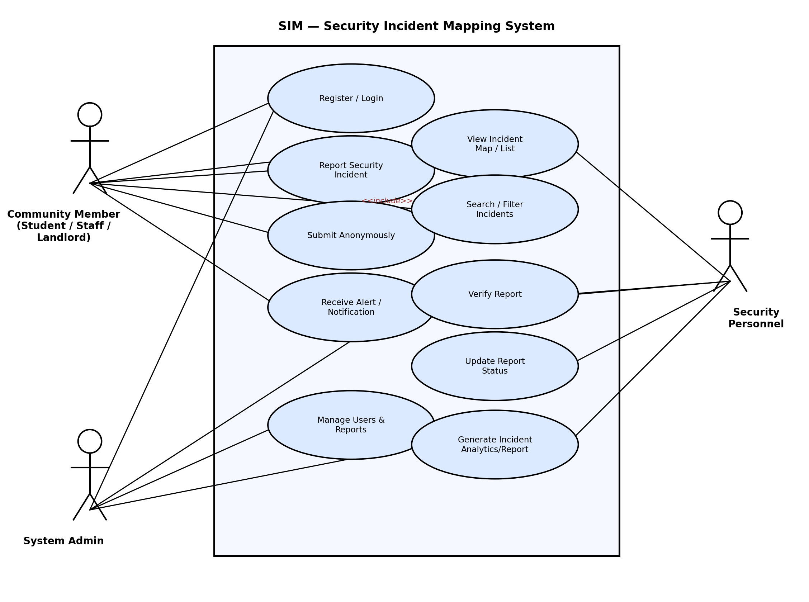
Figure 1: SIM Use Case Diagram

5.1 Key Use Case Descriptions
Use Case | Report Security Incident
Actor | Community Member
Precondition | Reporter has access to the SIM web app.
Main Flow | 1. Reporter opens the report form. 2. Selects incident type and location. 3. Enters description. 4. Optionally toggles anonymous submission. 5. Submits the report.
Postcondition | Report is added to the incident feed with status 'New'.

Use Case | Verify Report
Actor | Security Personnel
Precondition | At least one unverified report exists in the feed.
Main Flow | 1. Security personnel opens the incident feed. 2. Reviews a report. 3. Marks it verified and updates its status.
Postcondition | Report status is updated and visible to other viewers.

6. Problem Analysis — Ishikawa (Fishbone) Diagram
Before designing SIM, the root causes of underreported and unresolved campus security incidents were analyzed using an Ishikawa diagram across six categories: People, Process, Technology, Environment, Policy/Management, and Communication.
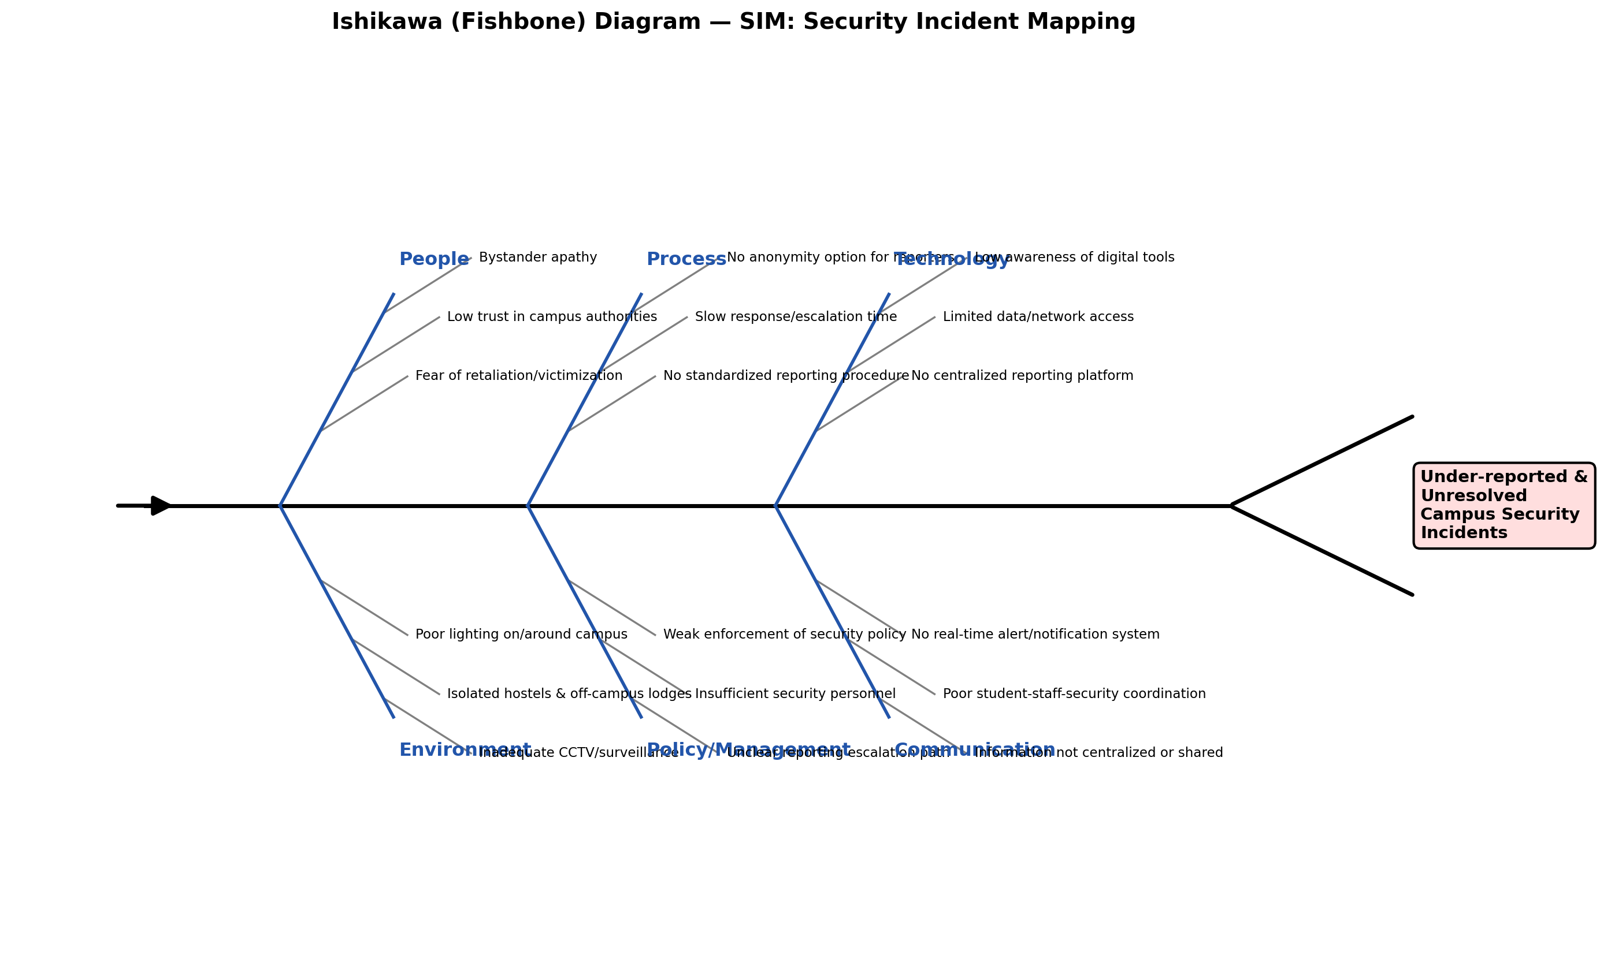
Figure 2: Ishikawa Diagram — Causes of Underreported Campus Security Incidents
This analysis directly informed SIM's design: anonymous submission addresses the People-side fear of retaliation, a centralized platform addresses the Technology gap, and a verifiable status pipeline addresses the Process and Communication gaps identified above.

Appendix A: Object Listing
Core objects/entities used by the SIM system prototype:
Object | Attributes
Incident | id, type, location, description, reporterRole, isAnonymous, severity, status, timestamp
User | id, name, role (Student/Staff/Landlord/Security/Admin), email
Notification | id, incidentId, recipientRole, message, sentAt
Report Status | enum: New, Under Review, Resolved
Severity | enum: High, Medium, Low

Appendix B: Code Listing
The full source code for the SIM mini web interface prototype is included in the accompanying GitHub repository (see README) and printed separately per submission instructions. The prototype is a single-page HTML/CSS/JavaScript application implementing the incident report form and live incident feed described in Sections 3 and 5.
Repository structure:
- index.html — mini web interface (report form + incident feed)
- docs/ishikawa.png — Ishikawa diagram
- docs/usecase.png — Use case diagram
- docs/SRS.docx — this document
- README.md — project overview and setup instructions

Appendix C: Full Code Listing — index.html
<!DOCTYPE html>
<html lang="en">
<head>
<meta charset="UTF-8">
<meta name="viewport" content="width=device-width, initial-scale=1.0">
<title>SIM — Security Incident Mapping</title>
<style>
:root{
--ink:#0e1a2b;
--panel:#132238;
--line:#24384f;
--paper:#f4f6f8;
--alert:#e2543a;
--alert-dim:#3a2620;
--safe:#3fae7b;
--muted:#7f93a8;
--text:#e9eef3;
}
*{box-sizing:border-box;}
body{
margin:0;
font-family:'Segoe UI',Roboto,Helvetica,Arial,sans-serif;
background:var(--paper);
color:var(--ink);
}
header{
background:var(--ink);
color:var(--text);
padding:22px 28px;
display:flex;
align-items:center;
justify-content:space-between;
border-bottom:3px solid var(--alert);
}
header .brand{display:flex; align-items:center; gap:12px;}
header .mark{
width:38px;height:38px;border-radius:8px;
background:var(--alert);
display:flex;align-items:center;justify-content:center;
font-weight:800; font-size:15px; color:#fff;
flex-shrink:0;
}
header h1{font-size:18px; margin:0; letter-spacing:.3px;}
header p{margin:2px 0 0; font-size:12px; color:var(--muted);}
.layout{
display:grid;
grid-template-columns:380px 1fr;
gap:0;
min-height:calc(100vh - 78px);
}
@media(max-width:860px){ .layout{grid-template-columns:1fr;} }

.panel{
background:var(--panel);
color:var(--text);
padding:26px;
}
.panel h2{
font-size:13px; text-transform:uppercase; letter-spacing:1.2px;
color:var(--muted); margin:0 0 18px;
border-bottom:1px solid var(--line); padding-bottom:10px;
}
label{display:block; font-size:12.5px; color:var(--muted); margin:14px 0 5px;}
select,input[type=text],textarea{
width:100%; background:#0e1a2b; border:1px solid var(--line);
color:var(--text); padding:10px 11px; border-radius:6px;
font-size:13.5px; font-family:inherit;
}
textarea{resize:vertical; min-height:70px;}
.toggle-row{
display:flex; align-items:center; gap:10px; margin-top:16px;
background:#0e1a2b; padding:10px 12px; border-radius:6px; border:1px solid var(--line);
}
.toggle-row input{width:auto;}
.toggle-row span{font-size:12.5px; color:var(--muted);}
button.submit{
margin-top:20px; width:100%; padding:12px; border:none; border-radius:6px;
background:var(--alert); color:#fff; font-weight:700; font-size:13.5px;
letter-spacing:.4px; cursor:pointer;
}
button.submit:hover{background:#c9482f;}
.hint{font-size:11px; color:var(--muted); margin-top:10px; line-height:1.5;}

main{padding:26px 30px;}
.stats{display:flex; gap:14px; margin-bottom:22px; flex-wrap:wrap;}
.stat{
background:#fff; border:1px solid #dde3e9; border-radius:8px;
padding:14px 18px; min-width:120px;
}
.stat .num{font-size:24px; font-weight:800;}
.stat .lbl{font-size:11.5px; color:#6b7b8c; text-transform:uppercase; letter-spacing:.5px;}
.stat.alert .num{color:var(--alert);}

main h2{font-size:14px; text-transform:uppercase; letter-spacing:1px; color:#4c5b6b; margin:0 0 14px;}
.feed{display:flex; flex-direction:column; gap:10px;}
.card{
background:#fff; border:1px solid #dde3e9; border-radius:8px;
padding:14px 16px; display:flex; gap:14px; align-items:flex-start;
}
.badge{
font-size:10.5px; font-weight:800; padding:5px 9px; border-radius:5px;
text-transform:uppercase; letter-spacing:.4px; white-space:nowrap; margin-top:2px;
}
.badge.high{background:#fde3de; color:#a8331d;}
.badge.med{background:#fff0da; color:#9a6300;}
.badge.low{background:#e2f3ea; color:#1f7a4d;}
.card .body{flex:1;}
.card .top-row{display:flex; justify-content:space-between; gap:10px; flex-wrap:wrap;}
.card .type{font-weight:700; font-size:14px;}
.card .meta{font-size:11.5px; color:#7f8fa0; margin-top:2px;}
.card .desc{font-size:12.8px; color:#3a4a5a; margin-top:6px; line-height:1.45;}
.status{
font-size:10.5px; font-weight:700; padding:4px 9px; border-radius:20px;
border:1px solid currentColor; height:fit-content;
}
.status.new{color:#a8331d;}
.status.review{color:#9a6300;}
.status.resolved{color:#1f7a4d;}
.empty{color:#8899a8; font-size:13px; padding:20px 0;}
</style>
</head>
<body>

<header>
<div class="brand">
<div class="mark">SIM</div>
<div>
<h1>Security Incident Mapping</h1>
<p>AAUA Akungba-Akoko — Campus Safety Reporting</p>
</div>
</div>
<div class="hint" style="text-align:right; color:#9fb0c2;">Prototype — SEN202 Weekend Dev</div>
</header>

<div class="layout">
<div class="panel">
<h2>Report an Incident</h2>
<form id="reportForm">
<label for="reporterRole">You are reporting as</label>
<select id="reporterRole">
<option>Student</option>
<option>Staff</option>
<option>Landlord / Off-campus Resident</option>
</select>

<label for="type">Incident type</label>
<select id="type" required>
<option value="">Select type…</option>
<option>Stabbing</option>
<option>Sexual Assault / Rape</option>
<option>Stealing / Theft</option>
<option>Murder</option>
<option>Assault / Fight</option>
<option>Suspicious Activity</option>
<option>Other</option>
</select>

<label for="location">Location on/near campus</label>
<input type="text" id="location" placeholder="e.g. Behind Fajuyi Hall, off-campus at Oke-Agbede" required>

<label for="desc">What happened?</label>
<textarea id="desc" placeholder="Briefly describe the incident: what, when, who was involved…" required></textarea>

<div class="toggle-row">
<input type="checkbox" id="anon" checked>
<span>Submit anonymously — my identity is not attached to this report</span>
</div>

<button type="submit" class="submit">Submit Report</button>
<p class="hint">Reports are routed to campus security for verification. If this is a life-threatening emergency, contact security directly first.</p>
</form>
</div>

<main>
<div class="stats" id="stats"></div>
<h2>Live Incident Feed</h2>
<div class="feed" id="feed"></div>
</main>
</div>

<script>
let incidents = [
{type:"Stealing / Theft", location:"New Hostel B, AAUA", desc:"Laptop reported missing from room during evening prep.", role:"Student", anon:true, status:"review", time:"2h ago", sev:"med"},
{type:"Suspicious Activity", location:"Back gate, off-campus route", desc:"Unknown persons loitering near the back gate after dark for the past 3 nights.", role:"Landlord / Off-campus Resident", anon:true, status:"new", time:"5h ago", sev:"low"},
{type:"Assault / Fight", location:"Cafeteria area", desc:"Physical altercation between two students, resolved by security on duty.", role:"Staff", anon:false, status:"resolved", time:"1d ago", sev:"high"},
];

const sevMap = {
"Stabbing":"high", "Sexual Assault / Rape":"high", "Murder":"high",
"Assault / Fight":"high", "Stealing / Theft":"med", "Suspicious Activity":"low", "Other":"low"
};

function render(){
const feed = document.getElementById("feed");
const stats = document.getElementById("stats");

const total = incidents.length;
const high = incidents.filter(i=>i.sev==="high").length;
const newCount = incidents.filter(i=>i.status==="new").length;

stats.innerHTML = `
<div class="stat"><div class="num">${total}</div><div class="lbl">Total Reports</div></div>
<div class="stat alert"><div class="num">${high}</div><div class="lbl">High Severity</div></div>
<div class="stat"><div class="num">${newCount}</div><div class="lbl">Awaiting Review</div></div>
`;

if(incidents.length === 0){
feed.innerHTML = `<div class="empty">No incidents reported yet.</div>`;
return;
}

feed.innerHTML = incidents.map(i => `
<div class="card">
<span class="badge ${i.sev}">${i.sev === 'high' ? 'High' : i.sev === 'med' ? 'Medium' : 'Low'}</span>
<div class="body">
<div class="top-row">
<div>
<div class="type">${i.type}</div>
<div class="meta">${i.location} · reported by ${i.anon ? 'Anonymous' : i.role} · ${i.time}</div>
</div>
<span class="status ${i.status}">${i.status === 'new' ? 'New' : i.status === 'review' ? 'Under Review' : 'Resolved'}</span>
</div>
<div class="desc">${i.desc}</div>
</div>
</div>
`).join("");
}

document.getElementById("reportForm").addEventListener("submit", function(e){
e.preventDefault();
const type = document.getElementById("type").value;
const location = document.getElementById("location").value;
const desc = document.getElementById("desc").value;
const role = document.getElementById("reporterRole").value;
const anon = document.getElementById("anon").checked;

incidents.unshift({
type, location, desc, role, anon,
status:"new", time:"just now", sev: sevMap[type] || "low"
});

this.reset();
document.getElementById("anon").checked = true;
render();
});

render();
</script>

</body>
</html>

