**Kelvin**

**Design**

This experiment was done in vitro on a petri dish.

Dose and treatment was incorporated it into the media; (what we called Poisoned food), because it has to be homogenous and mimic field conditions.

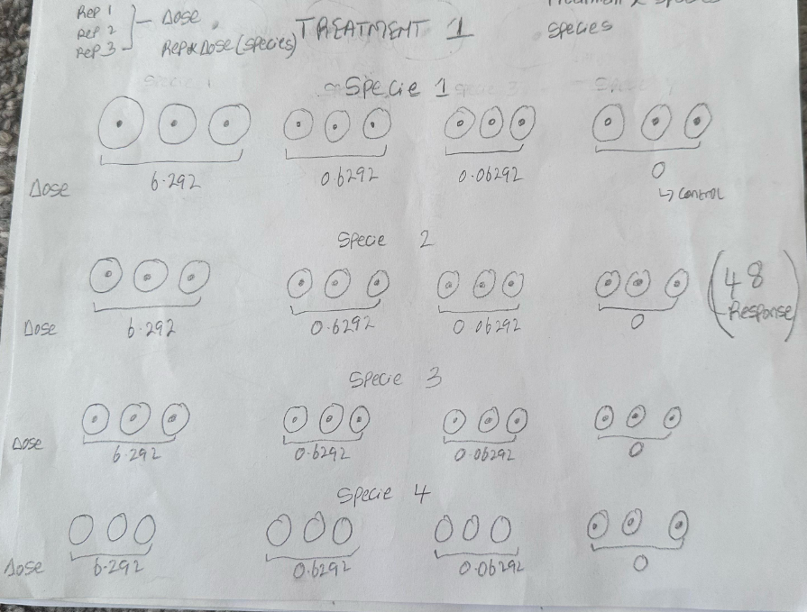

|  |  |  |  |
| --- | --- | --- | --- |
| **Treatment 2** | **Treatment 3** | **Treatment 4** | **Treatment 5** |
| * 4.9128 * 0.49128 * 0.049128 * 0 | * 4.011 * 0.4011 * 0.04011 * 0 | * 5.7975 * 0.57975 * 0.057975 * 0 | * 6.1036 * 0.61036 * 0.0161036 * 0 |

* 4 Measurements per replicate (growth is not a perfect circle, so they measured the spread from the center to the top, bottom, left and right)
* Response Variable (growth) contains 16.25% of Zero’s

Interested in seeing

1. How different species respond to chemical treatments
2. How different doses of the chemical affect this response

**Skeleton ANOVA**

|  |  |
| --- | --- |
| **SV** | **239** |
| Treatment | (5-1) = 4 |
| Dose(Treatment) | (4-1)*5 = 15 |
| Species | (4-1) = 3 |
| Treatment*Species | (5-1)*(4-1) = 12 |
| Species*Dose(Treatment) | 3*15 = 45 |
| Error(Dish(Dose*Species*Treatment) (Random) | (3-1)*(4*4*5) = 160 |

**Data Type: Semi continuous**

**Model: Zero-Inflated Gamma**

The zero-inflated model used R “glmmTMB” to perform logistic regression modelling the probability of a fungus surviving, gamma regression modelling mean growth within fungus that survived, and combining the two models to analyze differences in overall mean growth. For this model, the probability that the pathogens grows outcome is modeled via logistic regression. Then the distribution of the non-zero outcomes i.e. average growth is modeled via gamma regression with a log-link for ZIG regression.

**Random Effects**

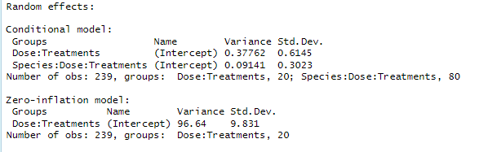

Conditional Model

In the conditional model, we included the random effect of dose nested in treatments (Dose:Treatments) and species crossed with treatments nested in dose (Species:Dose:Treatments) to capture their variability. The variation in the growth of the pathogens due to the random effect of dose nested within treatments is 0.3776 and the variation in the growth of the pathogens due to the random effect of species crossed with treatments nested within dose is 0.0914.

Zero-inflated Model

For this model i.e. the logistic regression modelling the probability of a fungus surviving, we included the random effect of dose nested within treatment, the variation in the growth of the pathogens due to this random effect was 96.64 which is quite large. This however suggests a large variability in the probability of observing no growth.

**Fixed Effects**

**Conditional Model**

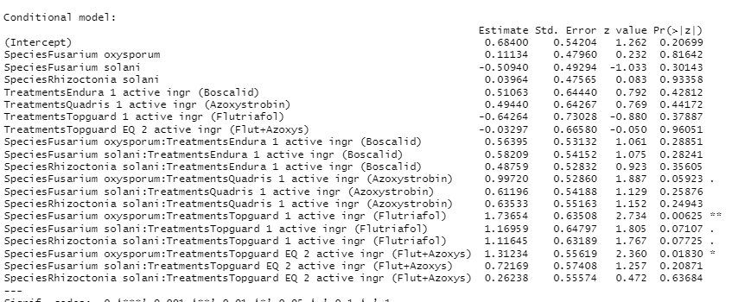

**Exponential of the above**

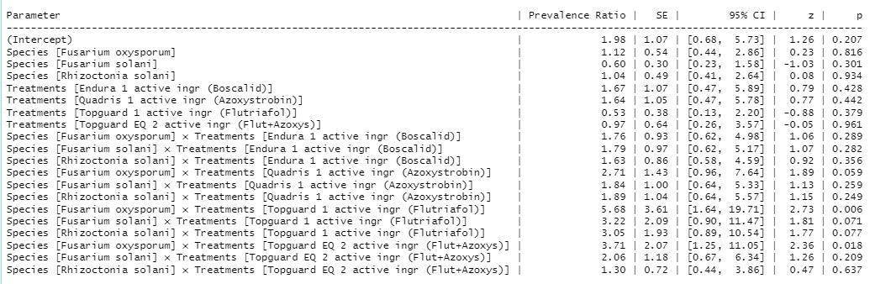

The fixed effect model included the main effect of species, treatments and their interactions on the mean fungal growth of surviving pathogens. We observed a significant interaction between the treatments and species, indicating that the fungicide effectiveness varies based on the species of the pathogen (fungus). There was a significant interaction between species “Fusarim oxysporum” and treatment “Topguard 1 active ingr (Flutriafol)”. The result showed that species Fusarium oxysporum significantly has a higher growth when treated with Topguard 1 active ingr (Flutriafol) compared to DelaroComplete 3 active ingr (Proth+Trif+Fluop) (β = 5.68, p = 0.006).

Also, there was a significant interaction between Species “Fusarium oxysporum” and Treatments “Topguard EQ 2 active ingr (Flut+Azoxys)”. The result showed that species Fusarium oxysporum significantly has a higher growth when treated Topguard EQ 2 active ingr (Flut+Azoxys) compared to DelaroComplete 3 active ingr (Proth+Trif+Fluop) (β = 3.71, p = 0.018).

We observed no significant effects of treatments on the fungal growth of others as they all have a significance value greater than 0.05.

**Zero-Inflation Model**

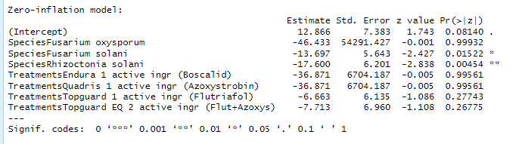

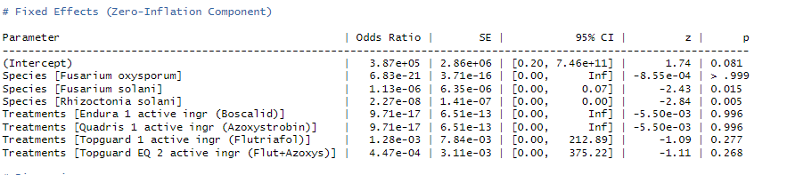

Should I be concerned about the confidence interval which starts from 0 to infinity?

This zero-inflated model examined the likelihood of zero growth across different species and fungicide treatment. The reference treatment was Diaporthe longicolla. The result showed that two species (Fusarium solani and Rhizoctonia solani species) showed significantly lower chances of zero growth compared to the reference species; Fusarium solani: β = -13.697, SE = 6.201, z = -2.838, p = .005; Rhizoctonia solani: β = -17.600, SE = 6.201, z = -2.838, p = .005. The fungicide treatments did not significantly influence the likelihood of zero growth (all p values > .05). This suggests that while species of the pathogens significantly affects the likelihood of zero growth, the type of fungicide treatments do not show a statistically significant impact on zero growth of fungus.

**Dispersion Model**

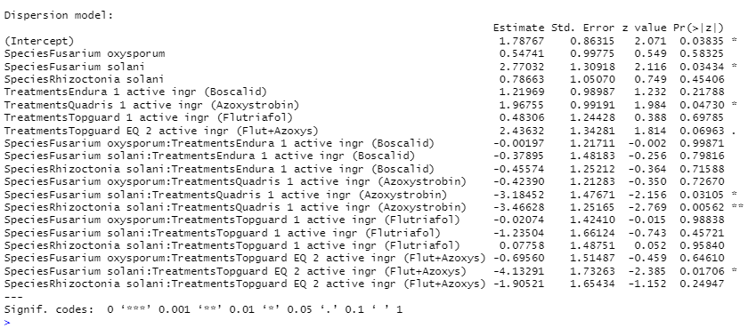

The dispersion model looks at the variability in the non-zero in the non-zero counts i.e. how different treatment combination introduces heterogeneity in the response. This contains the main and interaction effect of species and treatment. Fusarium solani exhibited significantly higher dispersion compared to Diaporthe longicolla (β = 2.770, p = 0.034), indicating greater variability in its growth across treatments. Quadris (Azoxystrobin) had a significant positive effect on dispersion compared to Diaporthe longicolla (β = 1.968, p = 0.047), suggesting more variability in fungal growth under this treatment. The treatment Quadris 1 active ingr (Azoxystrobin) showed higher dispersion compared to DelaroComplete 3 active ingr (Proth+Trif+Fluop) (β = 2.436, p = 0.070), indicating that this treatment contribute to variability in growth responses. Additionally, the interaction between species “Fusarim oxysporum” and treatment “Quadris 1 active ingr (Azoxystrobin)”, ” Rhizoctonia solani” and “Quadris 1 active ingr (Azoxystrobin)” & “Fusarium solani” and “Topguard EQ 2 active ingr (Flut+Azoxys)” showed that they contribute to the variability in growth responses among the pathogens.